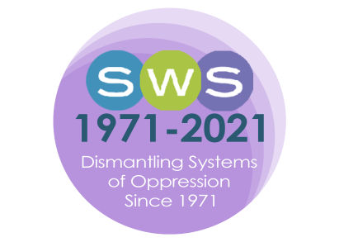

NETWORK NEWS
2022 Issue 3 - SUMMER/FALL

Editor’s Desk  Dear SWSers,  As we conclude the year 2022 and set our intentions for 2023, I am pleased to share this combined Summer/Fall issue of Network News with you. This issue’s Timely Topics column highlights some exciting new initiatives, developments, and resources happening within our organization, the launch of the Latin+ Feminist Collective’s Website and blog, and a brief introduction to the President’s Task Force on Leadership.  In the pages that follow, there are many exciting Committee updates sharing news and recapping the amazing work being done by our members. For example, the new “Ask Alix!” column by the Career Development Committee! Our organization is ever evolving to address global feminist challenges; I am inspired as I compile each and every issue of this publication by the expansiveness of our members’ collective work. We celebrate the accomplishments of our colleagues in Member Announcements. And, as always, be sure to scan other sections of the newsletter for information about our members only virtual groups (writing, activism, community building, and support), professional resources, and opportunities for members that keep us connected as a feminist scholarly community year round. Columns from our leadership share important details about the upcoming 2023 Winter Meeting in New Orleans. See you there!  Please send news of your publications, accomplishments, feminist impact work, committee reports, inquiries for Timely Topics, etc. for the 2023 Winter Issue to swsnewsletter@socwomen.org by February 15, 2023.  In Solidarity,  Melissa D. Day  NN Editor (2021-2025)  President’s Column  Dear SWSers,  Let’s celebrate reaching the end of 2022 and wish that we can start 2023 with renewed hope!  It now feels like a very long time has passed since the end of our Summer 2022 SWS Meeting, which was particularly mobilizing due to the programming related to reproductive justice and the many thought-provoking sessions that were held.  The iconic bandanas of “the green tide is rising” were really a hit! Besides raising awareness on reproductive justice, they brought visibility to the great intersectional, transnational and applied work that SWSers and SWS are doing, |  | IN THIS ISSUE:  Editor’s Desk  President’s Column  Co-Presidents-Elect Message  From the Executive Officer  COMMITTEE NEWS & REPORTS  Academic Justice  Awards Committee  Career Development Committee  International Committee  Membership Committee  Nominations Committee  Social Action Committee  TIMELY TOPICS  President’s Task Force on Leadership  Latin+ Feminist Sociology Collective  MEMBER ANNOUNCEMENTS  Publications  Celebrations  Feminist Impact Work  PROFESSIONAL OPPORTUNITIES & RESOURCES  SWS Statements & Calls for Action  SWS Virtual Feminist Engagement Opportunities  SWS CHAPTER UPDATES  IN MEMORIAM  ESTHER NGAN-LING CHOW (1943-2022)  GENDER & SOCIETY  2023 WINTER MEETING  2022 SUMMER MEETING MEMORIES

and allowed us to identify allies among the gigantic space of the LA Convention Center. What’s more, we were able to raise funds for the National Latina Institute for Reproductive Justice, disseminate the content of the Emergency Plenary featuring Zakiya Luna, Andrea Boyles, Barbara Sutton, Ophra Leyser-Whalen, and Katrina Kimport, and the Marea Verde Workshop via the SWS YouTube Channel, and share the SWS Call to Action Opposing the Supreme Court Decision Overturning the Federal Right to Abortion.
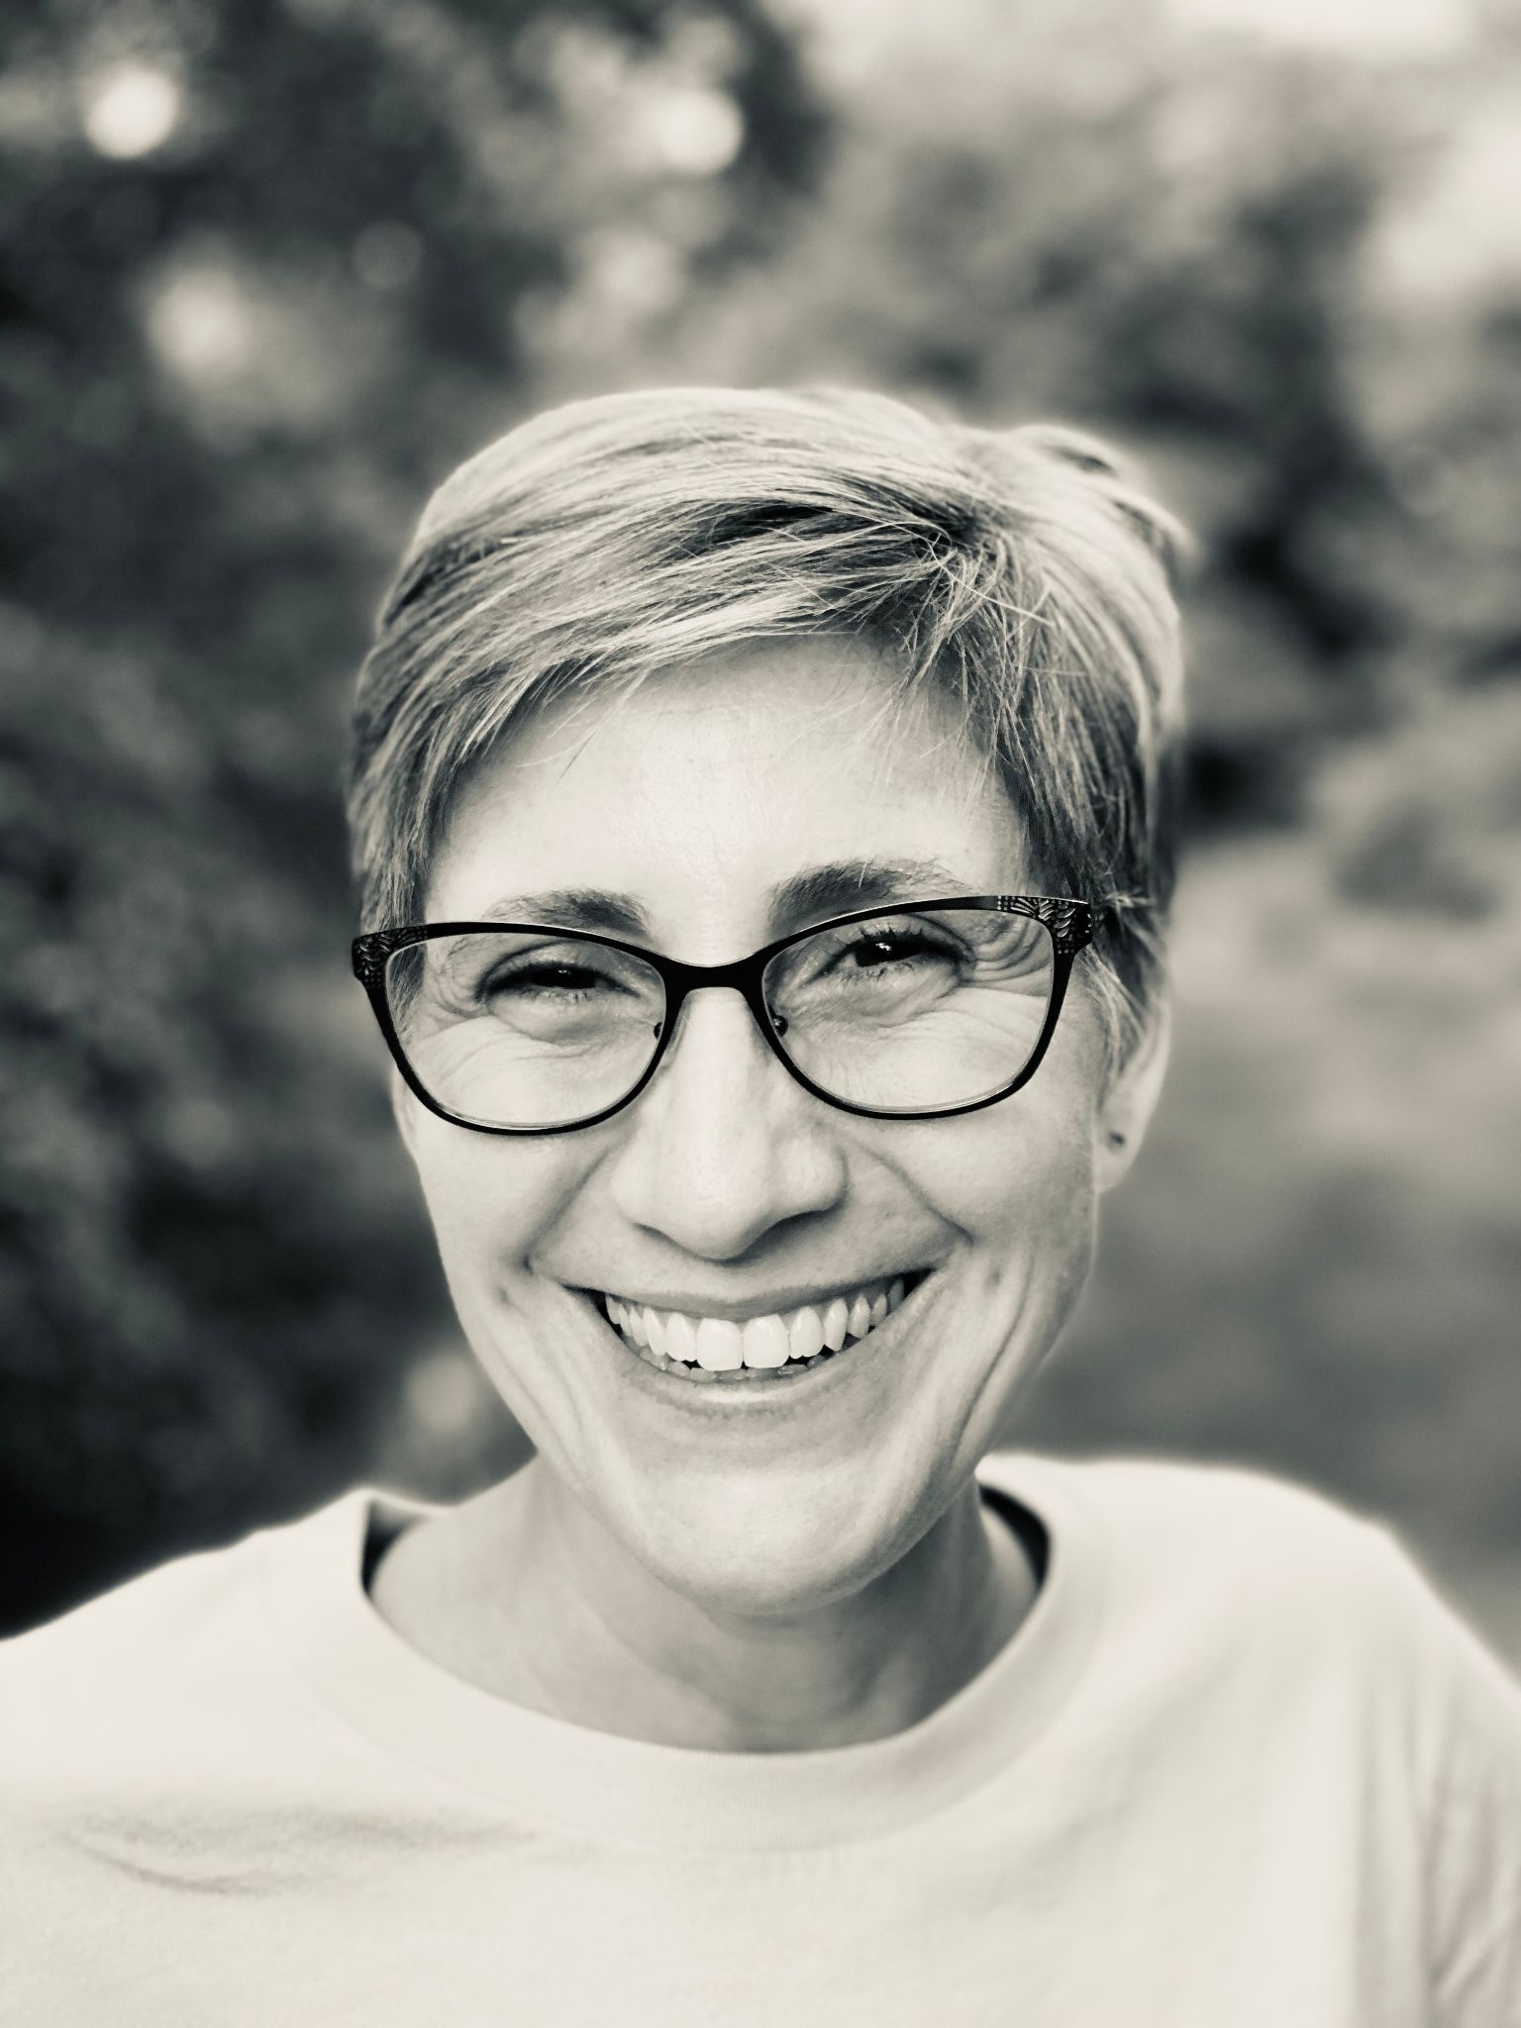
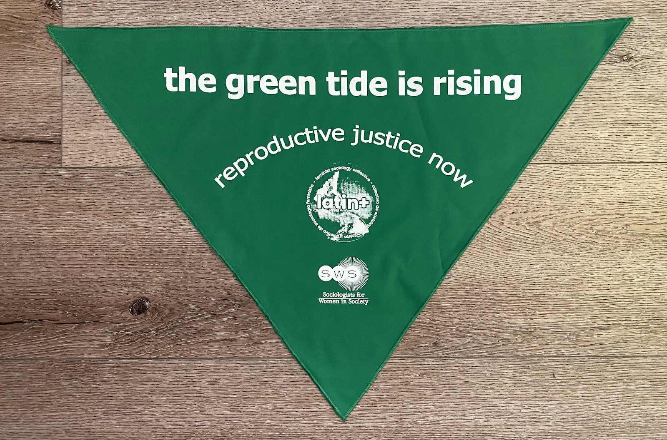

PHOTO: Roberta Villalón, SWS President PHOTO: Green Bandana

Another memorable moment that built on these efforts occurred during our Awards Banquet, where we learned and together performed the now global anthem of anti-gender violence movements, “Un violador en tu camino” (A Rapist in Your Way) by the Chilean group, Las Tesis. This activity allowed us to manifest our shared experiences, flexible solidarity and commitment to collective action across geographical and societal boundaries. The Banquet was also a joyful occasion as we celebrated the 2022 Summer Awardees in addition to awardees from 2020 and 2021 who were in attendance that we had not yet been able to celebrate with in person. Awardees included Florence Emilia Castillo, Cierra Sorin, Katherine Maldonado Fabela, Karina Santellano, Carieta Thomas, Minwoo Jung, Leslie Wood, and Carla Salazar Gonzalez, and Theresa Hice-Fromille. Kudos to all of you! We left the Banquet thinking about ways to strengthen our connections with all of them across institutions and organizations to build sustainable partnerships and collaborations over time.

Other highlights of the Summer Meeting included the plenary devoted to “Decolonizing and Reimagining Feminist Sociologies in the Era of Global Pandemics'' featuring Mary Romero, Carmela Roybal, Nancy López, and stef shuster, which complemented the plenaries held on this matter in the Winter Meeting, to be found in our YouTube Channel, as well as the two-part presidential panel “On Publishing: Q&A with Editors and Authors,” which provided very constructive information with the aim of demystifying the writing and publishing process. Together with other panels, workshops and roundtables, the Summer Program was enriching and stimulating despite competing with a vast ASA offer of also very interesting work. Last, but not least, the most endearing event of the Summer was, with no doubt, the plenary “Honoring Esther Chow’s Trajectory and Legacy,” with the participation of Esther’s colleagues, friends and recipients of her award: Minjeong Kim, Mary Osirim, Josephine Beoku-Betts, Bandana Purkayastha, Verónica Montes, Kristina Fullerton-Rico, Jennifer James, and Angie Mejia. Thank you Esther, always!

The Summer Meeting inspired me to create two new task forces, one devoted to Sustainable Leadership to ensure that leadership is both fostered within the organization in an equitable and fruitful fashion, and becomes sustainable in the short, middle and long term. This Task Force, formed by Tracy Ore, Carmela Roybal, hara bastas, Baker Rogers, Alexis Grant-Panting, and Mary Virnoche has been actively working and among other things, is planning a Leadership Retreat for New Orleans with the aim of fostering shared governance, flexible solidarity, institutional memory and leadership sustainability for SWS. The other Task Force is focused on Institutional Memory to improve the ways in which SWS records, preserves, and disseminates its history. Marlese Durr, Judith Lorber, Vicky Demos, Shiri Noy and Julie Shayne are in charge of this and will provide us with a recommendation on how to accomplish this fundamental goal in the near future.

The other two Task Forces that I had created have already borne fruits. The Task Force on Inclusivity, which led to the recruitment of a firm that will be hired by SWS to complete an intersectional diversity, equity and inclusion assessment of SWS. Join me in thanking Tiffany Taylor, Andrea Boyles, LaToya Council, Austin Johnson, Baker Rogers and Marcia Texler Segal for their service. On the other hand, the Task Force on Language Accessibility, after piloting interpretation and translations in the Winter and Summer Meetings, successfully proposed that SWS systematically take on this practice. Thus, I’m thrilled to announce that all future meetings will offer English/Spanish interpretation of featured sessions via Zoom, including live captioning, and sign language interpretation as needed. Other languages will be added if the speakers and global feminist partners need them. Moreover, interpreted sessions will be recorded and subtitled so they can be added to the SWS YouTube Channel. Again, let’s all appreciate the work done by these Task Force members, Verónica Montes, Özlem Altıok, Nancy López, Kris De Welde, and hara bastas!

To end, I’d like to share how happy I am for having been elected President of SWS. It has been an absolutely wonderful experience, filled with exciting challenges, hope and most refreshingly, real feminist comradeship that allowed for things to happen. Used to encountering barriers often, SWS surprised me as I found “Yes!,” “Sure!,” “That’s a great idea!,” and “Let’s see how we can do this,” as its most frequent answers, opening the road to collectively building feminist futures. So, as I approach my becoming a Past President, let me say Gracias, siempre, de corazón (A heartfelt thank you, always).

Roberta Villalón
SWS President

Co-Presidents-Elect Message

Mary J. Osirim & Melanie Heath

As the time draws near for us to meet in New Orleans for the 2023 SWS Winter Meeting, we want to thank our Program Committee for helping us to shape a dynamic program on Sexualities and Migrations in the Context of Global Justice, and our Local Arrangements Committee for helping to identify lots of great activities for you. Below you will find ten great reasons to join us for the Winter meeting. We are especially excited to offer you three amazing plenaries where we will hear from distinguished scholars Cecilia Menjívar, Rhacel Salazar Parreñas, Akosua Adomako Ampofo, Kwame Edwin Otu, and Pei-Chia Lan on “Gendered Migrations: Navigating Within the Neo-liberal State,” Héctor Carillo, Anima Adjepong, Salvador Vidal-Ortiz, Gowri Vijayakumar, and Melanie Heath on “Sexual Migrations and Migrating Sexualities,” and Carole Joffe, Zakiya Luna, Lakeesha Harris, Krystale Littlejohn, and Clare Daniel on “Reproductive Justice in the Post-Roe Era.”

Having our meeting in New Orleans presents both opportunities and challenges. We are angered and saddened by the state of abortion rights in Louisiana where abortion is now banned throughout the state except in extreme health situations.
While a united front of New Orleans officials has refused to enforce the state’s ban in their city, the legal risks for doctors performing abortions are great. We will have a plenary and a presidential panel involving key scholars, local activists, and student interns addressing the issues pregnant and potentially pregnant people face with this new draconian ban. In our events and panels, we will learn what we can do in scholarship and activism to support reproductive justice. In addition, we are so excited to be working with the Birthmark Doula Collective for our silent auction. The Birthmark Doula Collective is a doula-owned cooperative. As a birth justice organization, it is dedicated to supporting, informing, and advocating for pregnant and parenting people and their families in New Orleans. Please contribute and shop for items at our silent auction.

The Top 10 Reasons to Come to the 2023 SWS Winter Meeting in New Orleans:
1. To hear and discuss the latest, cutting-edge, national, and global research on sexualities, migrations, and reproductive justice from experts in these areas.
2. To meet the current and former ASA Presidents outside of a mega-ASA meeting.
3. To hear from scholars and local activists on the front lines of the struggle for reproductive justice.
4. To enjoy the best beignets and gumbo in the world!
5. To meet the authors of the latest, groundbreaking books on race, gender, sexuality, education, and migration.
6. To attend the one conference where you will find “free time” built into the program so you can explore the city!
7. To learn about all major aspects of life in the academy – from teaching your courses, to applying for grants, to publishing articles and books, to addressing challenges in higher education.
8. To multitask for a social justice purpose – you can participate in an auction while fundraising for a model reproductive health organization.
9. To listen to the only all-woman brass band in NOLA.
10. To enjoy live burlesque entertainment and dance the night away at our banquet.
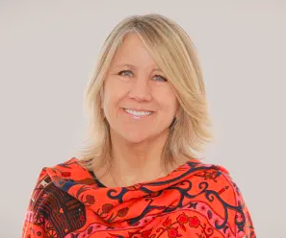
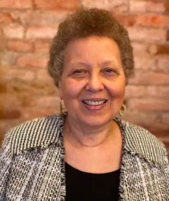
PHOTO: Mary J. Osirim, SWS Co-President-Elect PHOTO: Melanie Health, SWS Co-President-Elect

From the Executive Officer

Greetings from the SWS Executive Office!

As I reflect back on 2022, I am so grateful that we had the opportunity to meet twice this year - first in Santa Ana Pueblo, New Mexico, and second in Los Angeles, California. It has been so amazing getting to reconnect with so many friends and colleagues in person and to meet new SWS members who I have only ever met via Zoom or via email.

SWS is presently an organization with over 1,200 members. We continue to grow and I hope you will continue to spread the word to your friends, colleagues, and students about our mission and all of the programming that we provide throughout the year both in-person and virtually.

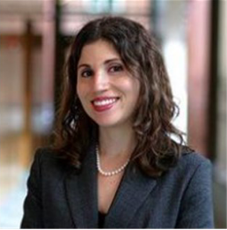
I am excited for the new year and some exciting changes that will help SWS to best serve our members. I am pleased that we will soon have a full-time Administrative Officer for SWS! Natasha Santana will be transitioning from her role as the Assistant to the Executive Officer to a full-time position. This change in the Executive Office will help SWS to grow even more as we will be able to more quickly respond to member needs and opportunities for growth through applying for grants and other funding opportunities, and for more attention to our website and public relations. I am also very excited that we have selected a firm to conduct our Organizational Intersectional Diversity, Inclusivity, and Equity Assessment. Our goal is to begin this work in February 2023 after the Winter Meeting.

I want to take this opportunity to thank all of the outgoing elected officers and to welcome the newly elected officers to their roles. It has been a pleasure to work with you all.
PHOTO: Barret Katuna, SWS Executive Officer

Please know that I am always happy to schedule a call - by Zoom or by phone - if you’d ever like to connect. I love hearing from our members and love your ideas. I look forward to seeing many of you in New Orleans this coming January 2023, in Philadelphia this August 2023, and throughout the year on Zoom.

Best wishes,
Barret Katuna
SWS Executive Officer
Barret’s email: swseo.barretkatuna@outlook.com, Barret’s cell: 860-989-5651

COMMITTEE NEWS & REPORTS

ACADEMIC JUSTICE

Co-Chairs: LaTonya Trotter and Andrea Hunt

For the past year, a group of SWS members have been meeting to share experiences and provide mutual support in response to the rising tide of austerity-minded campus policies we’ve been experiencing. We are now taking this year of hard-won knowledge and turning it into action! The group will move forward under a new name, the Higher Ed Action Team, or HEAT – as we turn up the HEAT on our campuses and within the academy, by mobilizing against the corporatization of higher education, and mobilizing for stronger union representation and other forms of true shared governance.

Want to learn more? Want to get involved? Want to share ideas? Contact LaTonya Trotter at ltrotter@washington.edu or Andrea Hunt at ahunt3@una.edu for more information.

AWARDS COMMITTEE

Chair: Maria Cecilia Hwang

SPRING AWARDS & DEADLINES

Awards with the April 1, 2023 at 11:59 pm Eastern Time deadline are:

- Esther Ngan-ling Chow and Mareyjoyce Green Dissertation Scholarship
- Beth B. Hess Memorial Dissertation Scholarship
- Barbara Rosenblum Dissertation Scholarship
- Social Actions Initiative Awards

The awards portal for these applications will open soon. Please stay tuned. For more information, visit our website: https://socwomen.org/awards/

**If you are interested in making a gift to support any of our awards or scholarships, please contact Barret Katuna, Executive Officer, at swseo.barretkatuna@outlook.com, or make a gift via this form: https://sws.memberclicks.net/donation-form.

Call for Applications for Campus Visit by

2021 Distinguished Feminist Activism Award Winner

Dr. Brittany Pearl Battle
Deadline to Apply EXTENDED: January 11, 2023
Committee Chair: Dr. Maria Cecilia Hwang (maria.hwang@mcgill.ca)
Selection Subcommittee Chair: Dr. Ghassan Moussawi (moussawi@illinois.edu)
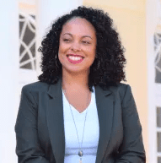
The 2021 SWS Feminist Activism Award Winner, Dr. Brittany Pearl Battle, Assistant Professor in the Sociology Department and the African American Studies Program at Wake Forest University and Co-Founder of Triad Abolition Project, will make one campus visit during the 2023 academic year. Brittany’s research agenda includes social and family policy, courts, social justice, and carceral logics. At Wake Forest University, she teaches courses on social justice, courts & criminal procedure, and abolition and (re)imagining justice. Her community work regularly includes political education, direct action, healing, and transformative justice work, and civic engagement. She is currently working on a book manuscript (under contract with NYU Press),“They’re Stealing My Opportunity to Be a Father:” The Child Support System and State Intervention in the Family, which examines the carceral logics of the state’s intervention in the family in this system. She is also working on a project examining the perspectives of abolitionist activists and organizers who were involved in the 2020 uprising, a project examining evictions in Forsyth County, North Carolina during the COVID-19 pandemic, and a project exploring the experiences of the criminal legal system defendants and asylum seekers under various forms of state surveillance and community confinement. PHOTO: Dr. Brittany Pearl Battle
Read more about Dr. Battle’s research and activism here on her website: https://www.brittanypbattle.com/ and about Triad Abolition Project: https://www.triadabolitionproject.org.
Applications from all types of institutions are welcome. Priority will be given to campuses with departments with a focus on feminist activism, social movements, sociological practice, and/or activist research, or those who are working towards building and centering these subfields. The selection subcommittee will look especially favorably on campuses that are committed to gaining the widest possible audience for these visits. This may be demonstrated by evidence of:
- Collaboration with other departments and programs on campus
- Multiple-campus cooperation
- Community partnerships
SWS will fund a portion of the expenses for the campus visit, thus institutions should not let resource scarcity prevent them from applying. SWS will fund up to $750 toward domestic travel and a maximum of $1500 toward international travel. The host campus is responsible for the costs associated with meals and lodging for the duration of the campus visit.
If you are interested in hosting a campus visit, please send your application by January 11, 2023 to: SWS Awards Committee Chair: Dr. Maria Cecilia Hwang maria.hwang@mcgill.ca
Please put “SWS Feminist Activist Campus Visit” in the email subject line.
The application should include the following information:
- An explanation of your interest in hosting Dr. Battle and the merits of awarding a campus visit at your institution.
- A description of the type of presentation you are interested in hosting
- The number of days you will ask the awardee to stay.
- The target audience or audiences for Dr. Battle’s presentation.
- A description of how local costs (lodging and meals) will be met.
- Tentative dates for Dr. Battle’s visit. Dr. Battle has a preference for April 2023.
Note: Due to public health concerns and travel challenges relating to COVID-19, we are committed to working with Dr. Battle and the campus visit host institution to identify suitable dates. SWS can extend the timeframe beyond the 2023 academic year for this visit to occur if travel and programming are not possible within this timeframe.

Congratulations to the 2022 Esther Ngan-ling Chow and Mareyjoyce Green
Dissertation Scholarship Award Winners!
Sociologists for Women in Society first established the Esther Ngan-ling Chow and Mareyjoyce Green Dissertation Scholarship at its annual meeting in February 2007. The primary purposes of the scholarship are: (1) To offer support to women and non-binary scholars of color who are from underrepresented groups and are studying concerns that women of color face domestically and/or internationally and (2) To increase the network and participation of students and professionals of color in SWS and beyond. The award is named after Esther Ngan-ling Chow and Mareyjoyce Green to acknowledge the contributions of these two SWS members who played an integral role in making SWS more inclusive of women of color. The awardee receives an $18,000 scholarship and a $500 travel stipend for the SWS 2022 Summer Meeting and SWS 2023 Winter Meeting. The Honorable Mention Awardees will each receive a $1,750 scholarship.
This year’s winner is Katherine Maldonado Fabela. The Honorable Mention Recipients are Karina Santellano and Carieta Thomas. You can read more about their work below.
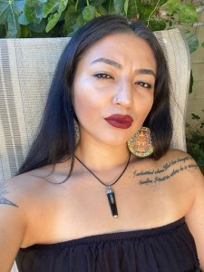
Special thanks to the Co-Chairs of the Sister to Sister Committee: Esther Hernández-Medina and Pallavi Banerjee and the Esther Ngan-ling Chow and Mareyjoyce Green Dissertation Scholarship Award Subcommittee Members: Alexia Angton, Elizabeth Hughes, Kristy Kelly, and Marisa Salinas.
Katherine Maldonado Fabela is a mother of three from South Central Los Angeles, and a PhD candidate in the Department of Sociology at the University of California, Santa Barbara. Katherine is a Pre-Doctoral Ford Foundation Fellow, American Sociology Association Minority Fellow and American Association of Hispanics in Higher Education fellow. Her research has been funded and recognized by grants including Abolitionist Teaching Network grant, Women’s Health, Gender and empowerment grant, among others. Katherine’s research has been published in the Journal of Critical Criminology, Aztlan Journal of Chicana/o Studies as well as multiple book chapters. She has been invited to speak to international audiences at the European University Institute, Graduate Institute of International and Development Studies, and the United Nations about gang-affiliated women’s experiences and hopes to develop collective care models through policy.
Her research interests include medical sociology, inequalities, critical criminology, and visual methodology. While at UCLA earning her B.A. in Chicana/o Studies, Katherine conducted research as a McNair research fellow on gang-affiliated mothers’ resistance through education. She received her Master’s degree in Sociology at UC Riverside where she examined the ways gang affiliated women experience institutional violence and developed a conceptual model on life course criminalization. She continues this line of work in her dissertation by examining the experiences of Chicana mothers with intersectional stigmatized statuses in the carceral system, specifically the Child Welfare system. The investigation centers the multi-institutional violence that mothers navigate via child welfare, how it affects their mental health, and the ways they resist and heal from multiple forms of criminalization through system- impacted motherwork. Throughout her dissertation the experiences of families after child welfare involvement underscore the complex interactions of social, psychological, and biological dimensions of health and healing. In addition to her research, Katherine is also involved with activist organizations where she supports formerly incarcerated and system impacted students and mothers. Read more about Katherine HERE.
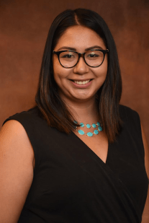
Karina Santellano is a first-generation college student and Chicana PhD candidate at the Department of Sociology at the University of Southern California. She earned her bachelor’s degree in Sociology and a certificate in Latino/a studies from Duke University. Karina is an American Association of Hispanics in Higher Education (AAHHE) Graduate Fellow, a Society for the Study of Social Problems (SSSP) Racial/Ethnic Minority Graduate Fellowship recipient, and most recently an American Association of University Women (AAUW) Dissertation Fellowship recipient.
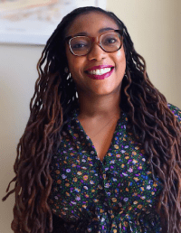
Karina’s desire to study Latinx life through an intersectionality framework is shaped by her own life as a low-income Chicana raised by immigrant parents in San Diego, California. In her dissertation, Karina is examining upwardly mobile Latinx populations and cultural life through the site of Latinx owned and inspired coffee shops in the Southern California region. She examines how race/ethnicity, gender, motherhood status, and class shape coffee shop owners’ entrepreneurial pathways and experiences particularly during the pandemic. You can learn more about Latinx-inspired coffee shops through her research Instagram: @Latinxcafecitos. Read more about Karina HERE.
Carieta Thomas (she/her) is a PhD candidate in the Sociology Department at the University of Calgary. She received a JD from New England Law|Boston with a specialization in immigration law, an MA in Pan African Studies from Syracuse University, and a BA in International Relations and Africana Studies from Agnes Scott College. Carieta has been an immigrant since the age of two, when her family moved from Guyana to the British Virgin Islands and then again to the U.S., where they fell out of status. Having attended a high school with students from 50 different countries, Carieta began to grapple with the particular struggles that Black immigrants face. She then became involved in refugee resettlement, post-conflict resolution, and later interned with legal aid organizations in immigration law. As such, Carieta’s research is a culmination of her educational background and lived experiences.
Her research examines the role pre-employment screening is playing in the management of undocumented Caribbean care workers within the labour force in the U.S. and Canada. Specifically, it explores the location of undocumented women from the Caribbean within the context of increased surveillance in the labour market. The study investigates these issues on three levels: the responses of undocumented women from the Caribbean to these approaches in employment screening (micro); the role of individual employers and employment agencies in deploying technologies that screen workers based on immigrant status (meso); and Canadian and U.S. immigration policies/regulations (macro). The Caribbean women at the center of the study are at the intersections of being low-wage, racialized women with precarious immigrant status. It is especially important to tell their stories because not doing so will result in incomplete policy advocacy and further marginalizes the people doing the much needed and important labour of caregiving. Read more about Carieta HERE.
SWS honored Katherine Maldonado Fabela, Karina Santellano, and Carieta Thomas with the other 2022 Summer Award recipients during our Awards Banquet at the 2022 Summer Meetings in Los Angeles.
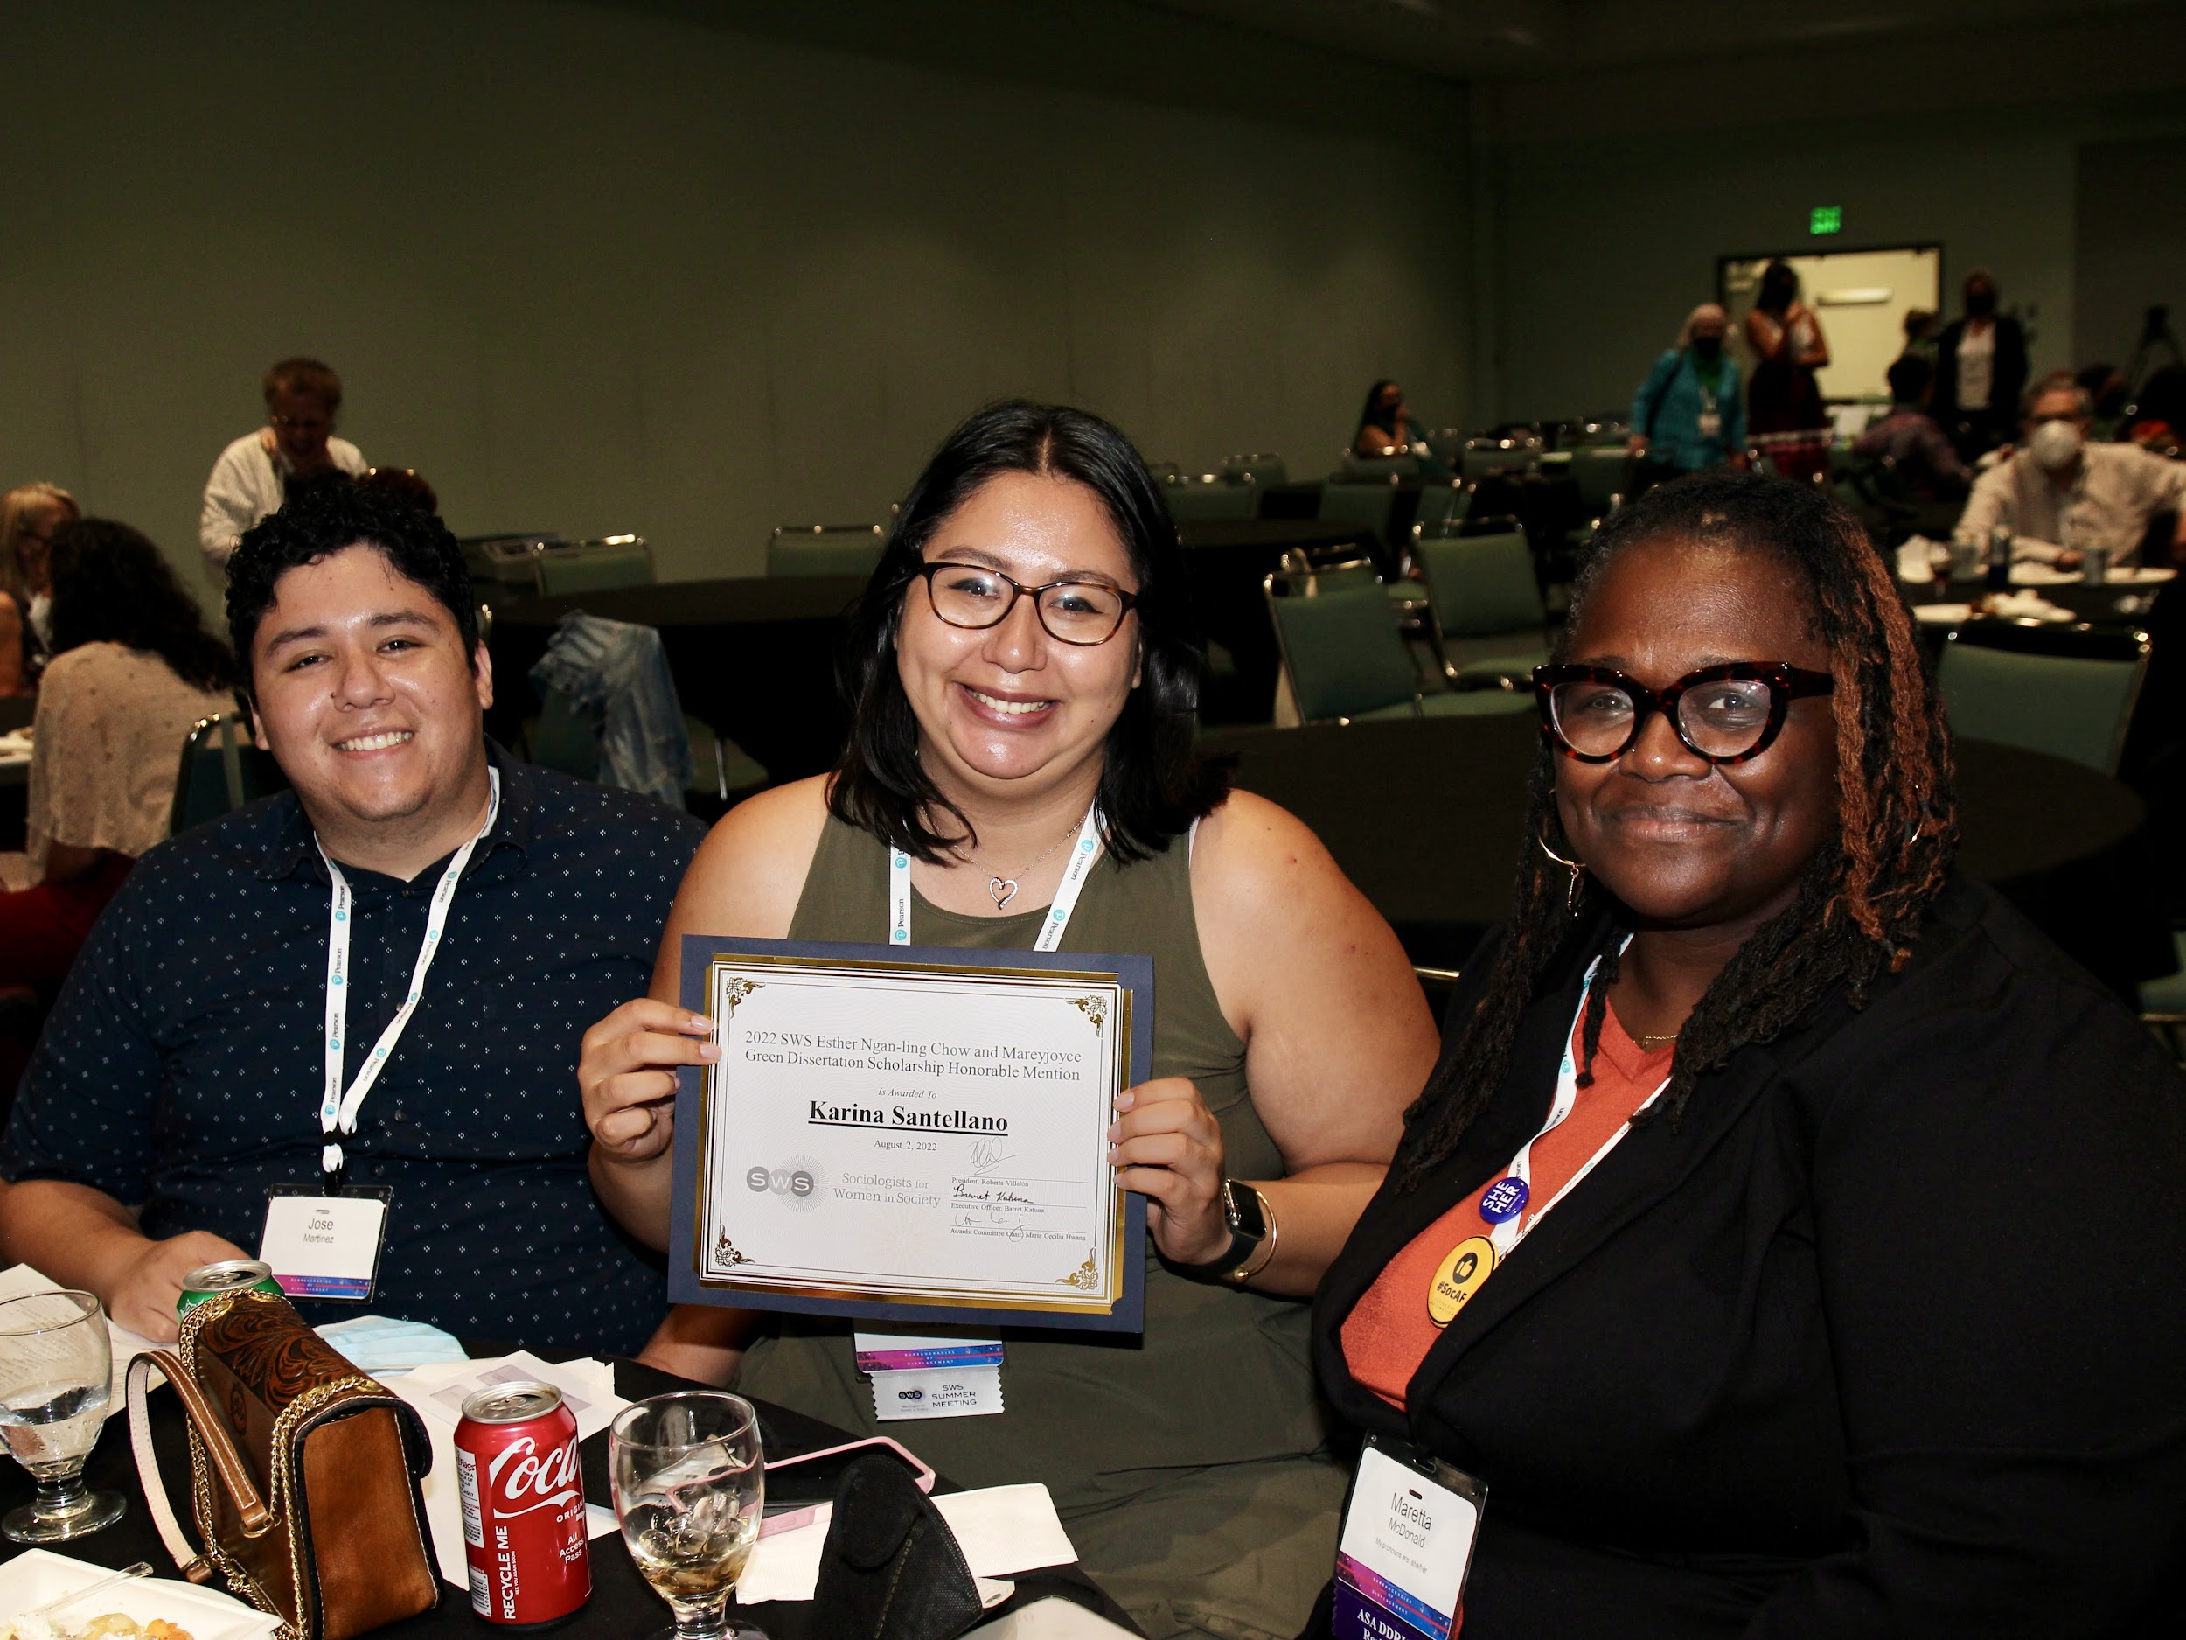
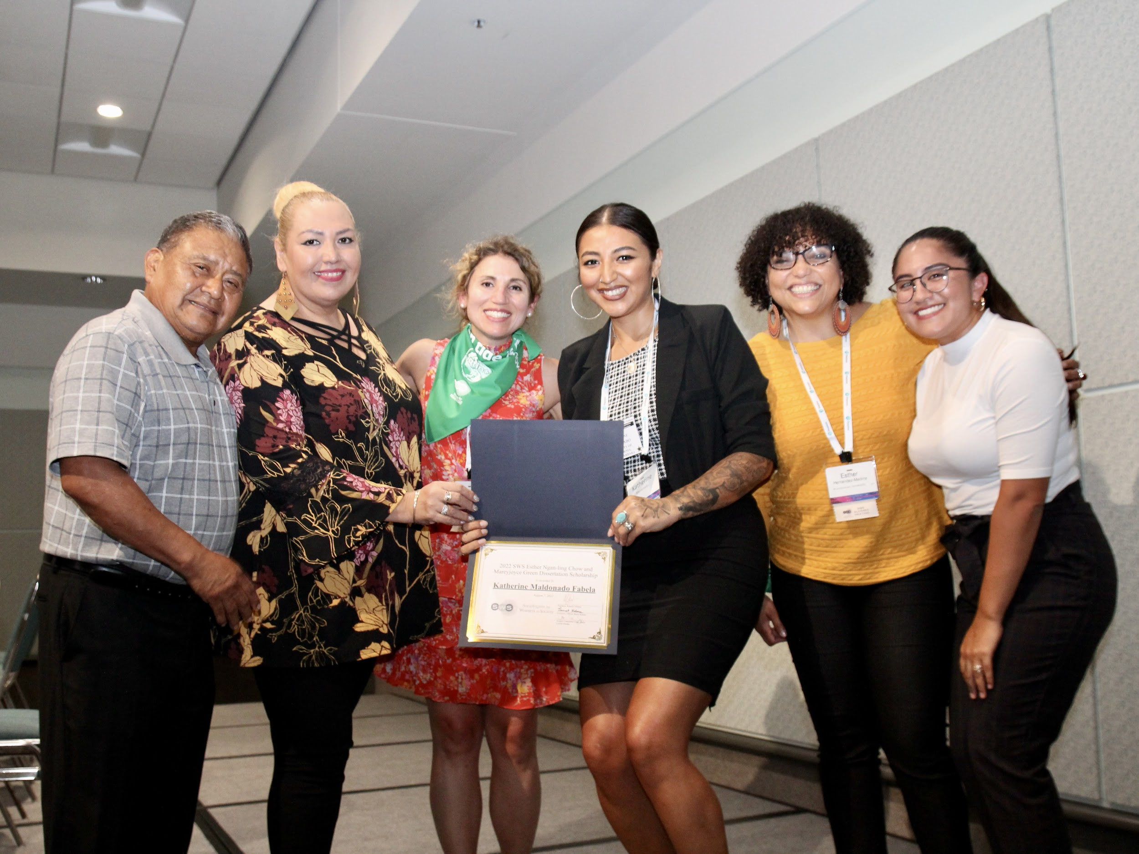
If you are interested in making a gift to support the Esther Ngan-ling Chow and Mareyjoyce Green Dissertation Scholarship, please contact Barret Katuna, Executive Officer, at swseo.barretkatuna@outlook.com, or make a gift via this form: https://sws.memberclicks.net/donation-form.
2022 Beth B. Hess Memorial Scholarship Award Winners:
Florence Emilia Castillo is the 2022 Beth B. Hess Memorial Scholarship Award Recipient
Cierra Sorin is the 2022 Beth B. Hess Memorial Scholarship Honorable Mention Awardee
The Beth B. Hess Memorial Scholarship Award was established in 2005 to support first generation college students who began their academic careers in a community college, have faced significant obstacles, are committed to teaching, and mentoring other less privileged students, and exemplify Beth’s commitment to professional service and social justice work through activism. Beth B. Hess was a President of SWS and one of our mentoring award winners; she was also the President of the Society for the Study of Social Problems (SSSP) and Secretary Treasurer of the American Sociological Association (ASA).
SSSP and ASA join SWS in supporting the Beth B. Hess Scholar each year given Beth’s significant contributions to SSSP and ASA. Advanced graduate students in sociology at the dissertation writing stage are invited to apply. In 2022, the subcommittee (Sarah Bruch, Chair; Myra Marx Ferree, Nancy Naples, Toni Calasanti, and Mairead Moloney) faced the challenge of selecting the winner. When there is more than one exceptionally strong candidate, an Honorable Mention Awardee is also selected. The Honorable Mention Awardee receives a $3,500 scholarship. The scholarship carries a stipend of $18,000 from SWS with travel assistance, $500 from SWS, $300 from SSSP, and $500 from ASA to support 2022 Summer Meeting travel, as well as one-year memberships in SWS, SSSP, and ASA. SSSP will celebrate the awardees at their Annual Meeting.
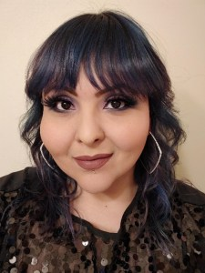
Florence Emilia Castillo is an activist researcher doing her dissertation on the effects of ethnic studies teaching on student learning at the University of New Mexico. As a first-generation college student, Emily worked and helped support her family even when she was enrolled in community college in Dallas, Texas. In New Mexico, she put her dedication to intersectional mentoring and activism to work. Her transformative teaching practices center on counter-narratives from the cultural resources that her low-income Black and Brown students bring into the classroom and have brought Emily nominations for college-wide awards.

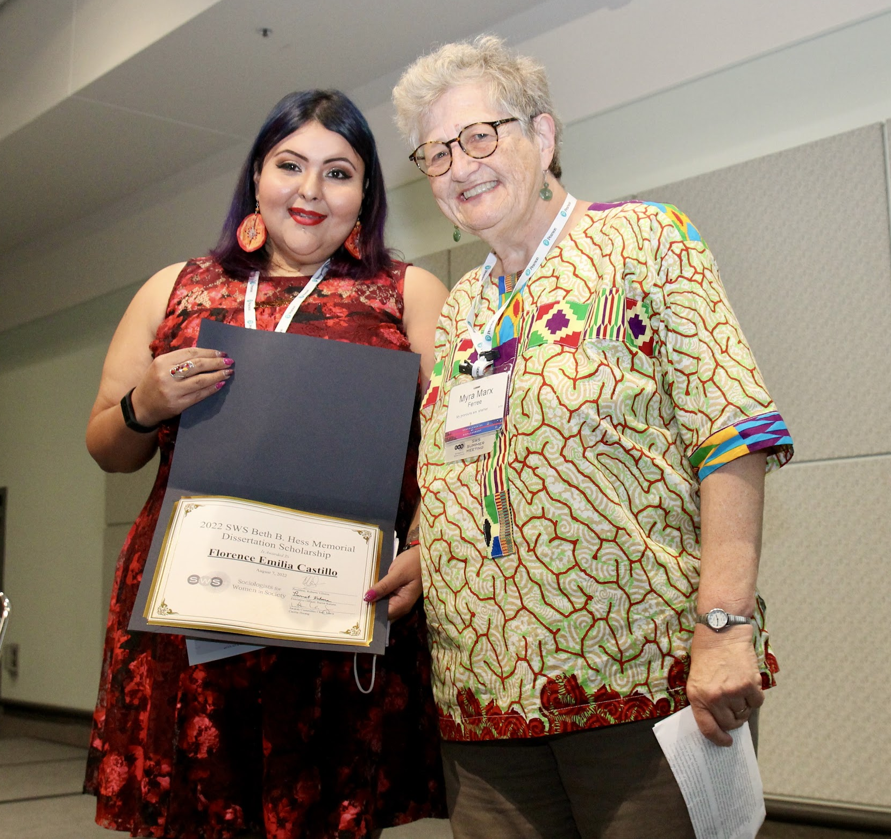
Emily’s activism at the University of New Mexico has included participating in both a campaign for a graduate requirement on race, ethnicity, intersectionality for all graduate students and the creation, analysis and action plan based on the climate survey in the sociology department itself, as well as being on the multi-university National Science Foundation (NSF)-funded team assessing how context diversity in teaching STEM subjects fosters increased minority inclusion and degree attainment. Emily’s activism outside the university has centered on involving young people in participatory action research, in one case challenging the policies that criminalize and incarcerate them, and in another case with a grassroots organization concerned about racism in the K-12 system.

Emily has built on this activist research project to construct her dissertation, which employs the Latin American feminist methodology of testimonio, that is, collecting the narratives and counter-narratives of those who experience an oppressive system from multiple standpoints to build a deeper understanding of the processes of exclusion and silencing in the collective knowledge thus produced. Using testimonial narratives from 30 activists in various roles in the creation of ethnic studies in the Albuquerque Public Schools, Emily is analyzing the connections between their analysis of white supremacy as systemic racism and their strategies of resistance to it. She has prior research experience using this testimonio methodology in the youth participatory action research project, showing it to be a means to empower youth, build self-esteem, and improve educational outcomes. Read more about Emily HERE.

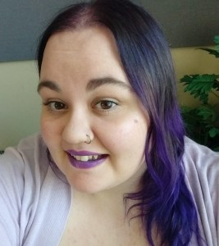
Cierra Sorin began her academic career at Cerritos College, a comprehensive community college in Norwalk, California. Her own experiences with interpersonal violence, coupled with the experiences of other women in her inner circle, prompted her to embark on her first social science research endeavor. Her multi-method project utilized surveys and interviews to better understand experiences of sexual violence and introduced her to the discipline of sociology. Cierra subsequently deepened her research and disciplinary foci, earning her B.A. in sociology from the University of California, San Diego before attending graduate school at the University of California, Santa Barbara (UCSB). Cierra is currently a doctoral candidate in sociology with an expected dissertation defense in 2023. Her research builds on her prior work and examines processes of consent within the context of pre-existing social inequities.
Despite myriad academic and family breadwinning responsibilities, Cierra is a highly productive scholar, having co-authored four publications and sole-authored one. We agree with Cierra’s mentor, Tristan Bridges, that she is “poised to make important contributions to our understandings of sexual consent” with the completion of her doctoral work and future endeavors. As an intersectional scholar of gender and sexualities continuously engaged in research, mentorship, and activism, Cierra embodies the spirit of the Beth B. Hess Memorial Scholarship Award, and we are pleased that the Honorable Mention funds will support her final year of dissertation writing. Read more about Cierra HERE.

SWS honored Florence Emilia Castillo and Cierra Sorin with the other 2022 Summer Award recipients during our Awards Banquet at the 2022 Summer Meetings in Los Angeles.
If you are interested in making a gift to support the Beth B. Hess Memorial Scholarship, please contact Barret Katuna, Executive Officer, at swseo.barretkatuna@outlook.com, or make a gift via this form: https://sws.memberclicks.net/donation-form.

CAREER DEVELOPMENT COMMITTEE

Co-Chairs: Heather Laube and Mindy Fried

The Career Development Committee is committed to supporting the professional development needs of all members as they navigate their careers.

We are thrilled that Susan Dietsch has taken on the role of editor of “Ask Alix!” (formerly “Hey Jane!”). We changed the name to be more inclusive and Susan has reimagined the format. We are updating popular topics and anticipating new ones that seek to answer our members’ common questions about “navigating all things career on all career paths.”

The Career Development Committee continues to develop team mentoring groups and to connect members one-to-one to help meet individual needs. We launched several peer mentoring teams for new assistant professors and look forward to expanding this aspect of the program to meet the needs of other groups. We offered a virtual “Critique Me” program for members who requested feedback on job market materials and are planning workshops on topics of interest to members at various career stages and diverse career types.

The committee held two well-attended introductory meetings for SWS members who want join a peer mentoring team focused on applied sociology. Chriss Sneed was the featured speaker in our second meeting, held in October 2022. We will have one more “intro” meeting in January, 2023 (date TBA), and then the small peer teams groups will launch!

You can view the recording of our panel, Career Paths in Applied and Public Sociology, Co-Sponsored by SSSP, HERE.

We are also preparing to launch an applied section of the SWS website, have been working on establishing an Applied Sociology Award, and will be presenting a session at the SWS Winter meeting about bringing applied sociology into academic departments.

Thank you so much to everyone who has volunteered to serve as a mentor in any capacity. This is meaningful work that not only supports individuals, but advances feminist sociology inside and outside the academy.

Please see the website to request mentoring support or to suggest a team – or email Heather (hlaube@umich.edu) or Mindy (friedmin@mit.edu) directly.

We welcome Sharla Alegria as the new Co-Chair of the Career Development Committee, along with Mindy Fried. Sharla will begin her term after the 2023 Winter Meeting.

Finally, we look forward to seeing many of you in person at the winter meetings. The Career Development Committee is collaborating with other committees on several exciting sessions. There will be a meet and greet with committee members on Friday morning (8:00am-9:00am). We would love to hear from you about your needs and encourage you to get involved!
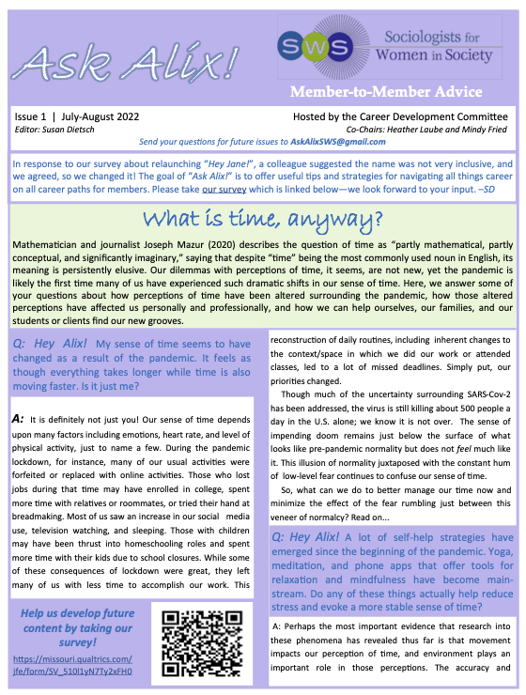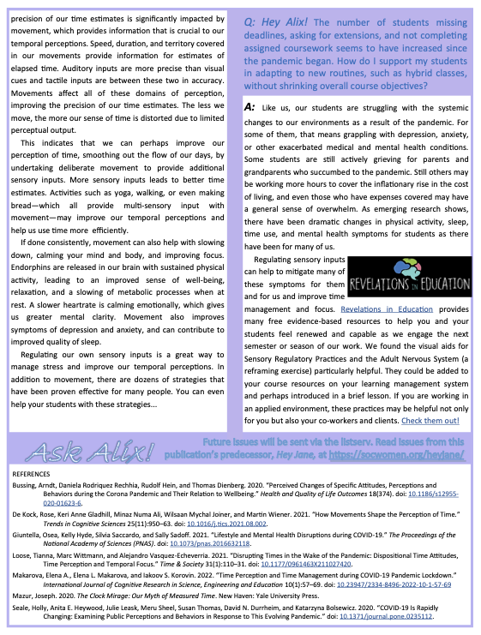

INTERNATIONAL COMMITTEE

Chair: Fumilayo Showers

Co-Chairs of the UN Subcommittees: Solange Simões and Francesca Degiuli

SWS at the UN Commission on the Status of Women (CSW65)

The 66th Session of the Commission on the Status of Women (CSW66) on the theme of “Achieving gender equality and the empowerment of all women and girls in the context of climate change, environmental and disaster risk reduction policies and programs” took place virtually from March 3-22, 2022.

Since 1999, SWS has been a Non-Governmental Organization (NGO) with consultative status with the United Nations (UN) Economic and Social Council (ECOSOC). Participation in the annual session of CSW is a major opportunity for SWS International Committee’s work at the UN. Every year SWS a) submits a Written Statement on the session’s theme, b) sends 20 delegates to the event, and c) organizes a panel as an NGOs parallel event.

For CSW66 we signed onto the Soroptimist International CSW Written Statement Responding to the Gendered Impacts of Climate Change Written Statement. You can read it here https://undocs.org/E/CN.6/2022/NGO/114.

Given the COVID pandemic, CSW66 was held virtually, and NGOs with consultative status were allowed to add more than the usual 20 delegates. SWS was represented at CSW66 by 27 delegates, faculty and students: Solange Simões, Lead Delegate to the UN Economic and Social Council (ECOSOC), Nicole (Nicky) Fox (ECOSOC), Mollie Pepper (ECOSOC), Andrea (Drea) S. Boyles (ECOSOC), Natascia Boeri (ECOSOC), Fumilayo Showers (International Committee, Chair), Hara Bastas (International Committee Chair, Past Chair), Fauzia Erfan Ahmed, Presley Alford, Ozlem Altiok, Jennifer Rogers-Brown, Maggie McCurdy, Manisha Desai, Edelweiss Murillo Lafuente, Francesca Degiuli , Jacqueline Goodman, Maricarmen Hernandez, Daniela Jauk, Kristy Kelly, Susan Lee, Monioluwa Ogunleye, Diana Papademas, Andre Pierre, Carmela Roybal, Kejsi Ruka, Carmen Poston-Farmer Travis and Shuchi Sanyal.

We would like to acknowledge and thank Mollie Pepper for working with the delegation in their registration with the UN and CSW66. We would also like to thank all delegates that represented SWS at CSW66, and Barret Katuna for always working closely with the SWS delegation.

In addition to attending the UN official meetings and parallel events, CSW66 SWS delegates also had the opportunity to participate in two special meetings:

1. United States Mission to the United Nations - Virtual Discussion on United States Priorities for CSW66: Ambassador Linda Thomas-Greenfield made a presentation with members of the United States Mission to the UN and they conducted the virtual discussion. As the SWS Lead delegate, Solange Simões received an invitation to participate in the meeting with US Ambassador Linda Thomas-Greenfield for a discussion on the United States Priorities for CSW66. This was the second year that the US Mission at the UN had a meeting with NGOs prior to CSW and to get input. We have seen these meetings with the US Mission at the UN, especially when held prior to CSW, as an opportunity to advocate for more inclusion and openness to US NGO’s participation. Solange Simões, representing SWS, and Susan Lee, representing the US Women’s Caucus at the UN, submitted written questions that were chosen to be addressed during the meeting. Both questions raised our concerns and suggestions for inclusion of NGO’s voice and proposals in the US delegation. Our questions were answered by Sofija Korac, the US gender negotiator at CSW66.

Reflecting on CSW66, Susan Lee pointed out: “I will say the most important thing for me at CSW was participating in the Agreed Conclusions negotiations process. We had better connections with the US gender negotiator, Sofija Korac, than in past years”.

2. A Virtual Town Hall Meeting with Women’s Civil Society and United Nations Secretary-General António Guterres: Moderated by UN Women Executive Director, Sima Bahous, the meeting was meant to provide an opportunity for women’s civil society organizations to engage with the Secretary-General on the session’s priority theme, Solange Simões was invited and attended representing SWS.

SWS Sponsored Parallel Event Panels
For the second year in a role, Nicole (Nicky) Fox (SWS UN/ECOSOC delegate) organized two parallel events, instead of the one event we organized in past CSWs. At CSW66, SWS panelshad the participation of faculty and graduate students presenting on their research on this year’s main theme. Both panels were very well attended with reflective engagement in the chat from participants and involved Q&A sessions from audience members (including feminist practitioners and women’s rights organizations activists). The panels were moderated by Nicky Fox and Fumilayo Showers. The ten presentations from SWS members included a range of case studies, from multiple geographic regions, utilizing various feminist methodologies, demonstrated the far reaching and diverse ways that feminist research can aide in better understanding women’s participation in all levels of political, economic and social life. Similarly to previous CSW panels, it was a proud day for SWS and feminists fighting for gender justice.

Panel I: Feminist Responses to Invisibility and Violence - These five presentations from feminist sociologist professors and doctoral students, highlighted the tactics and strategies that feminists and feminist organizations deploy to empower women and girls who have been marginalized and/or experienced violence. Panelists discussed the invisibility of: women of color in the research on environmental harm and reproductive injustice, women of color in the environmental movement, women with disabilities in academic scholarship, and specific dynamics of violence against women. Case studies describe resistance strategies to such invisibility and violence, including collective sisterhood networks, online activism and the creation of safe spaces.
Panelists:
1. Andrea S. Boyles: “A Black Feminist Take on Race, Resistance, and Erasure in the Fight for Climate Change and Environmental Justice.”
2. Edelweiss Murillo: “Spaces of Anti-ableist, Feminist Resistance.”
3. Selina Gallo-Cruz, Kerry Shortell and Emily Sullivan: “Restaging Private Abuse in Public Places: How Survivors Find the Courage to Leave.”
4. Allison Grossman: “Reproductive Justice, Environmental Toxins, and the Necropolitical Impact.”
5. Heba Sigurdardottir: “#IBelive: Grassroot Digital Activism Against Gender-based Violence.”

Panel II: Feminist Responses to Economic Inequality and Unhealthy Work Spaces - These five presentations from feminist sociologist professors and doctoral students evaluated a range of responses to the gendered dimensions of economic inequality and barriers women face that prohibit a safe and healthy workplace. Panelists discussed cases of sex work in New Delhi, sexual harassment in transnational enterprises, the lack of microloans for progressive Muslimmen, extreme climate conditions, and the contemporary North American work culture. Together these papers argued for an intersectional analysis of economic empowerment and addressed how reproductive justice, violence prevention, gender and cultural/religious ideologies shape access to economic resources and safe work places.
Panelists:
1. Popy Begum: ““God is my Customer”: The Role of Religion in the Lives of Sex Workers.”
2. Kim de Laat: “Living to Work (from Home): Gender Inequality and Work-family Devotion in the Age of Overload
3. Tianhan Gui: “Sexual Harassment and Chinese Transnational Enterprises.”
4. Adelle Dora Monteblanco: “The Climate Crisis Threatens Pregnancy and Newborn Health: A Focus on Extreme Heat.”
5. Fauzia Erfan Ahmed: “Progressive Masculinity: Microcredit, Islam, and Women’s Empowerment.”

US Women’s Caucus at the UN session: US Perspectives on Climate and Gender - This very important session was organized by SWS Delegate, Susan Lee, in her role as the Chair of the United States Women’s Caucus at the UN. The recording of the session is available at the US Women’s Caucus’ YouTube Channel: https://youtu.be/2g7aIOQTRpc
The three well accomplished and engaging panelists were:
- Jacqueline Patterson, the founder and executive director of the Chisholm Legacy Project: A Resource Hub for Black Frontline Climate Justice Leadership
- Katherine Quaid is Nez Perce, Cayuse, and Paiute, a citizen of the Confederated Tribes of Umatilla, Communications and Outreach Coordinator for the Women’s Earth and Climate Action Network (WECAN)
- Sherri Mitchell Weh’na Ha’mu Kwasset, an Indigenous rights activist involved in environmental justice issues for 25 years and founding director of the Land Peace Foundation dedicated to the global protection of Indigenous land and water rights.
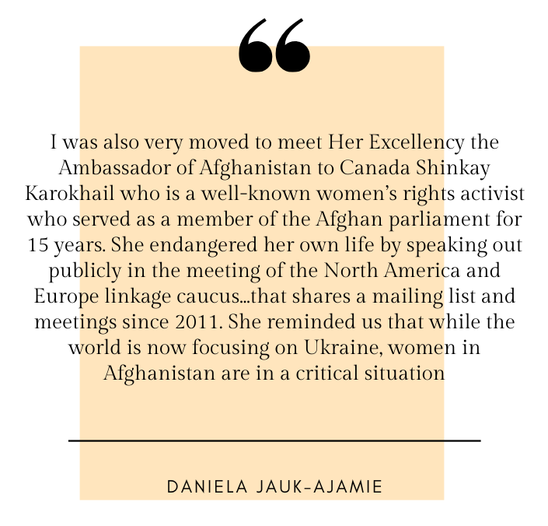
Delegate’s Reflections
We asked our delegates (faculty and students) to share their reflections with CSW66. The two reflections below provide us with critical and personal understandings as well as evaluations of the scope, impact, and relevance of CSW for transnational and trans-local feminism.

Daniela Jauk-Ajamie: The last time I attended the CSW was 10 years ago, in 2012, and I remember very clearly the discussion of the SWS delegation about using the word “feminist” in the title of our parallel event that seemed non-existent in the CSW parallel event universe. I was surprised to find out that a shift in discourse has taken place, and well over 60 side events had the word “feminist” in the title of this year’s almost 800 scheduled parallel events! With nine events specifically referring to “intersectional” perspectives on gender and climate justice in their title and a great diversity featured in the few panels I attended we can see how feminist sociological concepts have indeed entered the arena of global governance and are being applied and actionized for social change, even only on the fringes of decision making. I enjoyed how feminist sociologists are informing discourse around the CSW not only through SWS but also through a series of four parallel events the International Sociological Association had put together in collaboration with the Division of Women and Crime of the American Criminological Society, World Society of Victimology, and Criminologists without Borders. The panels featured ample scholarship from the global South and I found myself particularly impressed with a contribution from Dr. Nontyatyambo Pearl Dastile from Walter Sisulu University in South Africa. She described her research journey and findings from interviews with 60 women in three correctional facilities in South Africa. This stands out to me as incarcerated women are an invisible population even at the CSW, yet ever so relevant to consider for a country like ours that is the biggest incarcerator of women on the globe (2.1 million women and girls tangled up in the US criminal justice system, 220.000 incarcerated). Dr. Dastile provided a beautiful and honest account of her experiences in colonizing academia as she broke ties with her original advisor during her journey and followed her participants’ lead into more innovative and women centered methodological directions. I was also very moved to meet Her Excellency the Ambassador of Afghanistan to Canada Shinkay Karokhail who is a well-known women’s rights activist who served as a member of the Afghan parliament for 15 years. She endangered her own life by speaking out publicly in the meeting of the North America and Europe linkage caucus (attended by well over 100 participants) that shares a mailing list and meetings since 2011. She reminded us that while the world is now focusing on Ukraine, women in Afghanistan are in a critical situation. Afghanistan is riddled by severe famine, and people started to sell their daughters at the market for as little as 300 Canadian dollar. When she talked about the rampant practice of child marriage that affects girls under 10 years, she started crying. While education is theoretically compulsory in Afghanistan and women and girls are brought to prison when asking for education, women cannot move freely, and “everything is banned.” The Europe and North America CSW Caucus has in a follow up created a statement on Women and Girls in Afghanistan organizations and individuals can sign on to here: https://forms.gle/7r6XDNVBmcqzmyKB8.

Jacqueline Goodman provided critical observations and comments in her answers to the questions we asked SWS panelists to address in their reflections:

What have you learned that has changed your perspective of feminist movement organizing and what can you share with others about this? “I’ve learned that international organizations, local feminist groups in developing countries, and EU countries especially the Netherlands and Sweden are way ahead of the United States with regard to the Climate Crisis and feminism. The United States environmental groups are too segmented. I don’t see a strong feminist green movement. Why not? I believe the liberal-progressive left in the US needs to focus on unity in our groups fighting for democracy and solutions to the climate crisis.”

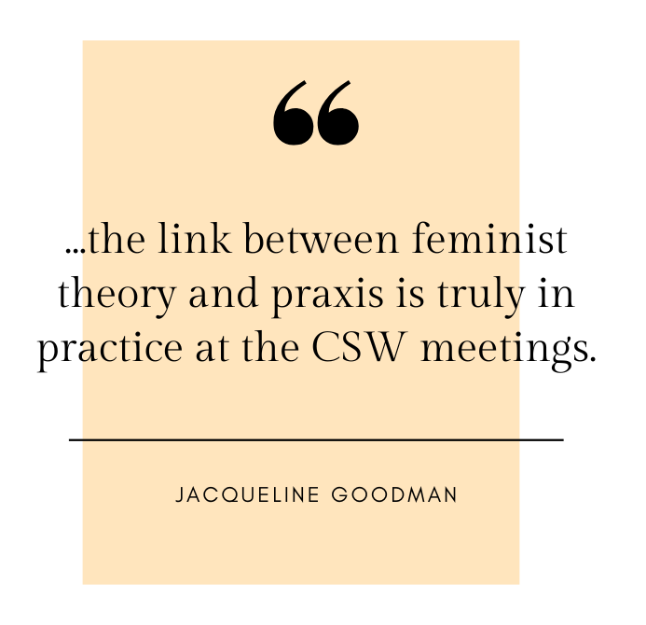
In what ways – negative or positive – do you think the virtual format impacted CSW66? “I personally like the virtual format. It is not as overwhelming, you can move freely from session to session, easy to receive documents immediately, easy to get in and out, take notes, meet people. With the virtual format the meeting flows much more smoothly. There’s much more participation from people all over the world. There’s much more participation from civil society groups.”

How would you recommend others interested in learning about the UN, feminist movement organizing, gender equality issues in global contexts, etc. use the CSW to build out research and teaching expertise? “I believe attending these CSW sessions is excellent for enhancing teaching and research. You get immediate insight into what’s going on around the world at the governmental, non-profit, and local levels. Most fascinating is to see the ways in which academic feminism has permeated these multiple levels of society around the globe. And the ways in which these different levels of society have
permeated academic feminism. In other words, the link between feminist theory and praxis is truly in practice at the CSW meetings.

International Committee Representation at the 2022 SWS Summer Meetings
In addition to our very important work with the United Nations, the International Committee continues to lead conversations and provide an important global perspective in feminist conversations within SWS. To that end, in the past summer meetings, we sponsored one panel and one workshop session.

In collaboration with the Sister to Sister Committee, the IC CEDAW sub-committee organized a panel, “The Right-Wing Anti-Gender Backlash around the World (Part 2): Trends and Possible Solutions.” This session examined the nature and implications of the right-wing backlash against women’s rights and those of other marginalized groups such as the LGBTQI community and people of color. The speakers were Solange Simoēs, Roseanne Njiru, and Tracy Weitz. Panelists spoke about the rise of right-wing regimes and the backlash against /retrenchment of women’s rights and the rights of LGBTQI populations. They focused their empirical case-studies on South America (Brazil), Africa (Kenya), and the United States, with a focus on reproductive justice in the wake of the Supremes’ court overturning of Roe vs Wade. The panelists were impressive, and they insightfully showed the connecting threads between these disparate regions. The audience, both in-person and virtual, contributed insightful questions which sparked a very productive discussion.

We also organized a workshop “Organizing and Advocacy from a Global Perspective: Feminist Organizing Within the United Nations System,” a more informal gathering at the SWS meetings. In this workshop moderated by Solange Simoēs, speakers, International Committee members Nicky Fox, Susan Lee, and Solange Simoēs, recollected their experiences within the International Committee, reflected on their participation in past CSW’s at the UN, and the community that they had formed within the committee. The panelists provided information for new and potential members, and the audience which comprised members, such as past SWS chair Josephine Beoku-Betts, also reflected on what the International Committee had meant for their careers.

We plan to continue to play an integral part in conversations within SWS and we look forward to the winter meetings. The theme of sexualities and migrations is global in scope and reflective of some of our interests as a committee.

MEMBERSHIP COMMITTEE

Chair: Mary Virnoche

Outreach Success And New/Continued Signature Initiatives - Led by Miriam Abelson, specialized outreach to the global south, high school teachers, applied professionals, HBCUs, and other disciplines generated 101 free one-year membership awards. Cristobel Asieda maintained connections with our local and regional SWS chapters. Alexis Grant-Panting kept us tied to student initiatives and needs.

With Vice President Veronica Montes stepping into leadership in January 2023, the committee will integrate the popular online Feminist Support gatherings into its portfolio of initiatives. Annie McGlunn-Wright and Trenton Haltom, along with student representative Pedrom Nasiri, will join the committee in January. Miriam, Christobel, and Alexis will continue on the committee through 2023. Penny Harvey and Julia Meszaros will complete their terms in January after facilitating welcome and hand initiatives for us in New Orleans. Mary Virncohe will also finish her term as Vice President and Committee Chair during the meeting transition of leadership.

NOMINATIONS COMMITTEE

Chair: Mignon Moore

Thank you to all who voted and to all who ran for SWS Elected Office in our recent election.

We would like to thank all the Nominations Committee Members, chaired by Mignon R. Moore, that included Tristan Bridges, Ranita Ray, Jaime Hartless, and Baker A. Rogers for all their work in putting together such a wonderful group of candidates for elected office.

On November 15, 2022, the SWS Executive Office, Barret Katuna, SWS Executive Officer and Natasha Santana, Assistant to the Executive Officer, confirmed the results of the SWS 2022 Election with Mignon R. Moore, SWS Past President and Nominations Committee Chair.

First, we are reporting that the proposed amendments to the SWS Bylaws will go into effect based on the affirmative vote for these amendments. These amendments will soon be reflected in the SWS Bylaws that we post on our website. The SWS Vice President will now Chair the Committee on Committees and we will discontinue the survey of ASA Candidates. Please see the attached file for your reference that was part of the 2022 Election Ballot.

Congratulations to the Newly Elected SWS Officers!

Their official terms will begin during the SWS 2023 Winter Meeting.

President-Elect – S. Crawley
Vice President – Veronica Montes
Treasurer-Elect – Tracy Ore
Student Representative-Elect – Pedrom Nasiri
*The above 4 individuals will join SWS Council
Career Development Committee Co-Chair – Sharla Alegria
Committee on Discrimination Co-Chairs – Beatriz Padilla and Marisela Martinez-Cola
Sister to Sister Committee Co-Chair – LaToya Council
Social Action Committee Co-Chair – Evonnia Woods
Membership Committee Members – Trenton Haltom and Anne McGlynn-Wright
Nominations Committee Members – Sasha Drummond-Lewis and Amy Stone
Publications Committee Members – Marlese Durr and Laurel Westbrook

SOCIAL ACTION COMMITTEE

Co-Chairs: Kris De Welde & Heather R. Hlavka

The Social Action Committee has been busy this Fall hosting our new virtual Sustaining Activism Gatherings for all SWS members interested in generative conversations about activism and supporting each other. Please stay tuned for announcements on new Spring dates/times. Community Sustains Us!

And a big thanks to our members and volunteers who submitted and reviewed applications for our Fall Social Actions Initiative Awards (SAIA) and annual Undergraduate Social Action award: Bee Khallouq, Susan Dietsch, Melody Huslage, and Marley Olson. Please get ready to submit your applications for the Spring SAIA cycle deadline of April 1.

Don’t forget the silent auction in your preparations for the winter meeting! Read more about the Silent Auction HERE.

Congratulations to the 2022 Summer SWS Social Actions Initiative Award Winners:
Minwoo Jung and Leslie Wood

In 2016, SWS Council approved the Social Action Committee’s (SAC) proposal to support more direct social action of SWS members. The Social Actions Initiative Awards provide a way for the SAC to directly support and encourage the social activism of SWS members. Awards are given out twice per year on a competitive basis until funds run out. The social actions represented by this initiative are central to advancing the mission of SWS. Thanks to the Social Actions Initiative Award Subcommittee: Kris De Welde (Co-Chair), Heather Hlavka (Co-Chair) Rebecca P., Kira Escovar, Natascia Boeri, Rosalind Kichler and Kristy Kelly.
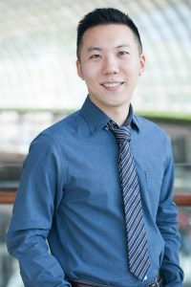
“Queer Feminist Climate Justice in Asia” Proposed by Minwoo Jung: Minwoo Jung is an Assistant Professor of Sociology and Women’s Studies and Gender Studies at Loyola University Chicago. His research investigates the impacts of global and regional geopolitics on political, economic, and social life of marginalized groups and individuals. Minwoo worked on a multi-sited research project on how global politics impact the conditions of queer activism in various parts of Asia, including South Korea. During Minwoo’s fieldwork, he became involved in the work of Solidarity for LGBT Human Rights in Korea, a Korean queer activist organization. Solidarity Korea and Minwoo proposed educational workshops on transnational climate justice and queer feminist action for Korean queer and feminist activists. The workshops will provide a space for transformative education for Korean queer and feminist activists who seek to build coalitions between climate justice activism and queer and feminist activism in South Korea and across Asia. They will work with local climate justice organizations to create educational resource and identify shared issues, challenges, and agendas related to the uneven impact of the climate crisis on vulnerable women, as well as queer and trans people. During the workshop, they will also seek to form coalitions with feminist and queer movements in other Asian countries, particularly Taiwan and Japan, to address regional-scale climate challenges. With these workshops, Minwoo plans to bring the important issue of how impacts of climate change have been and will continue to be unequal to the attention of activist communities so that we can better understand climate injustices form a queer and feminist perspective, as well as discuss possible action plans for queer and feminist sustainability that challenges heteronational and reproductive futurism.
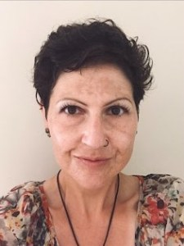
“Boots on the Ground Initiative to Increase Public Awareness of Harm Reduction and Treatment Resources for Underserved Communities” Proposed by Leslie Wood: Leslie Wood (she/her) is a Ph.D. candidate at Kent State University. Her current work focuses on the social aspects of drug use, harm reduction, and experiences and perceptions surrounding the recovery community. Over the past 5 years, she has volunteered with and built relationships with numerous grassroots organizations and individuals in Akron, Ohio. Leslie’s proposed social action is a targeted campaign towards specific neighborhoods in Akron, Ohio where there is limited access to or awareness of local resources for harm reduction and treatment for people who use drugs. The work will provide education about and access to resources for harm reduction and recovery to specific neighborhoods where these vital tools are rarely provided. This campaign will be implemented by a team of local advocates primarily composed of people with who have lived experience with drug use, harm reduction and/or recovery. Ultimately, the team hopes to increase the services available directly within these underserved neighborhoods where funding does not seem to reach and decreasing the fear of asking for help and reducing the stigma of talking about drug use.

SWS honored Minwoo Jung and Leslie Wood with the other 2022 Summer Award recipients during our Awards Banquet at the 2022 Summer Meetings in Los Angeles. You can read more about the awardees’ work HERE.

Congratulations to Dr. Kirsten Dellinger, the 2023 SWS Feminist Activism Award Winner!

The SWS Feminist Activism Award, established in 1995, is presented annually to an SWS member who has notably and consistently used sociology to improve conditions for women in society. The award honors outstanding feminist advocacy efforts that embody the goal of service to women and that have identifiably improved women’s lives. This year’s Feminist Activism Award Subcommittee included Ghassan Moussawi (Subcommittee Chair), Brittany Battle, LaToya Council, and Rocio Garcia. The Subcommittee selected Kirsten Dellinger as the SWS 2023 Feminist Activism Award Winner.
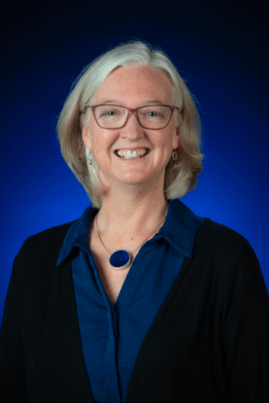
Kirsten Dellinger is a Professor of Sociology and the Associate Dean for Diversity, Equity, and Inclusion in the College of Liberal Arts at the University of Mississippi. She brings a feminist sociological approach to bear on efforts to identify and address racial, gender, and sexual inequalities in department and university settings. She has helped build the Pathways to Equity plan for the College of Liberal Arts to create policies and practices that support faculty, staff, and students in their work. As part of this effort, she is leading the first cluster hire initiative to bring diverse and cutting-edge research, teaching, and scholars to the College at the University of Mississippi.

Her research and teaching interests focus on gender and sexuality through intersectional and qualitative lenses to better understand the dynamics of workplace culture, inequality, and social change. She has mentored over 50 graduate students in their research on these and related topics. She co-edited a book with Christine L. Williams entitled Gender and Sexuality in the Workplace (Emerald). She has published articles on workplace culture and sexual harassment, the construction of masculinities in organizations, workplace dress norms, and the dynamics of gay-friendly workplaces, in journals such as the Annual Review of Sociology, Gender & Society, Social Problems, Gender Issues, Sexuality Research and Social Policy and Sociological Spectrum. She has also published work on the methodological implications of disaster research in the context of Hurricane Katrina and a variety of articles on the Global South. She recently served on the executive committee for the Southern Sociological Society and has been an editorial board member for academic journals including Gender & Society, Social Problems, and Social Contexts.

Kirsten’s central nominator, Christine Williams indicated, “For the past four years, Kirsten has held the position of Associate Dean for Diversity, Equity, and Inclusion in the College of Liberal Arts at the University of Mississippi. She is the first person to occupy this position. In this role, Kirsten has engaged in strategic planning and built an infrastructure for DEI programming from the ground up. Providing direct support for the hiring, promotion, and retention of Black faculty is central to her work. To this end, she has instituted cluster hires, improved the faculty search process, and increased available resources for faculty research. She also supports Black students from recruitment to graduation and beyond. Kirsten uses her significant background and expertise in sociology to promote feminist social change at the University of Mississippi.”

Kirsten has been a leader in promoting gender equity at the University of Mississippi. Through her service on the Pay Equity committee (part of the Chancellor’s Commission on the Status of Women), she co-wrote a report which led to increases in pay for many women faculty on campus. That report also looked at the impact of racial inequality on pay. With other feminists, she started “Equal Pay Day” - handing out “payday” candy bars at the Student Union. The Provost at the time, Carolyn Staton (the first and only woman Provost at the University) implemented the recommendations of the report.
As a faculty member and as Chair, Kirsten is a highly visible proponent and supporter of feminist and anti-racist student groups. As her CV attests, she has participated in numerous panels related to gender and race equality and diversity. She makes herself available to student groups working for equality on campus and participates in student-led protests to support their work. For example, the movement to combat sexual assault on her campus is growing in part thanks to the emergence of a student group on campus called RASA (Rallying Against Sexual Assault). This group was founded by one of her students in her Sociology of Gender course.

You can read more about the esteemed work of our awardee HERE.

We hope you will join us in congratulating Kirsten and that you will make plans to join us for the 2023 Winter Meeting Awards Banquet and Reception to be held on Saturday, January 14 starting at 5:15 pm. Please register here for the 2023 Winter Meeting where you will have the opportunity to attend this celebration.

TIMELY TOPICS

PRESIDENT’S TASK FORCE ON LEADERSHIP

By Mary Virnoche

In Fall 2022, President Roberta Villalón convened a task force to develop leadership and institutionalize plans for supporting long-term diverse leadership of SWS. She appointed to the task force Hara Bastas, Alexis Grant-Panting, Tracy Ore, Baker Rogers, Carmela Roybal, and Mary Virnoche.

The group is currently focused on planning a leadership retreat as part of the 2023 Winter Meeting in New Orleans for continuing, incoming, and outgoing members of Council and Committee Co-Chairs. The goals of the retreat include building a stronger community among leadership, supporting transition of leadership roles, and creating an initial forum for discussing opportunities, challenges, and dreams for SWS leadership. These ideas will seed a leadership strategic plan to be developed further with broader membership participation.

LATIN+ FEMINIST SOCIOLOGY COLLECTIVE

The Latin+ Feminist Sociology Collective Launches its site! https://www.latinplusfeministcollective.org

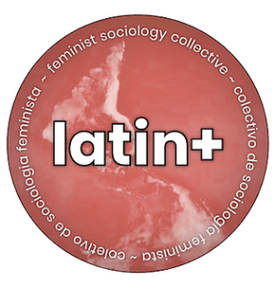
The Latin+ Feminist Sociology Collective launched its own website (www.latinplusfeministcollective.org) on July 1, 2022. The Latin+ Feminist Sociology Collective was created in 2020 by Drs. Erika Busse-Cardenas, Nancy López, Verónica Montes, and Roberta Villalón in the context of the Sociologists for Women in Society 2020 Winter Meeting as a community group. Since then, the Collective has been offering workshops and virtual gatherings, and dozens of Latin+ feminists joined enthusiastically, emphasizing the pressing need of building this community.

The Latin+ Feminist Sociology Collective is a space to share, validate, reflect, and coproduce knowledge for liberation about being a critically conscious Latin+ Feminist Scholar in the Global North. The Collective is guided by our ethical and political commitments to a Latin+ antiracist intersectional feminist liberatory praxis that acknowledges the heterogeneity of our lived experiences and the legacies of the Latin American and Caribbean diaspora. Intersectionality as inquiry and praxis is a fundamental pillar of our collective because it departs from the premise that systems of oppression/resistance are imbricated, simultaneous and overlapping (white supremacy, heteropatriarchy, capitalism, nativism, etc.). It also acknowledges that we are all implicated in these systems through our intersectional social locations in grids of power, positionalities through our ethical and political commitments as well as our experiences and narratives of identities or stories we tell about our Latin+ communities in the Global North and beyond.

Accordingly, the Collective cultivates convergence spaces for conversation, coexistence, reflection, accompaniment, and flexible solidarity as essential to its praxis. Moreover, it follows a set of basic agreements to build a safe space including mutual respect, inclusivity, constructiveness, openness, commitment, and multilingualism. Regarding the latter, it has so far utilized English, Spanish and Portuguese in its gatherings, documents and communications, but is open to include as many languages as necessary by providing as much interpretation and translations as possible to ensure mutual comprehension. Simultaneously, the Collective acknowledges that its physical location and the geopolitical, educational and cultural legacies of migrations in the United States and the Global North has resulted in the use of English as lingua franca, which is the reason why its site is mostly written in that language while including Spanish and Portuguese versions of some but not all content.

Borrowing from the terminology developed by non-binary social movements (from LGB to LGBTQIA+), the Collective adopts the term “Latin+” using the plus sign as a means to highlight its commitment to intersectional inquiry and praxis that centers the simultaneity and co-constructed nature of systems of oppression/resistance. The Collective is committed to cultivating flexible solidarity and alliances across geopolitical and sociocultural borders and boundaries and embrace our difference in race, gender, class, sexuality, age, ability and other as part of our intersectional praxis. By utilizing the term Latin+, the Collective attempts to commit to on-going critical reflexivity and work toward praxis (action and reflection) that strives to overcome the paralysis that confrontations about the variations Latin@, Latine, and Latinx have brought. It believes that the term Latin+ can help the Collective be more inclusive and inviting, while also implying a literally positive turn given that plus means addition, development, multiplicity and incorporation.
The Latin+ Feminist Sociology Collective has developed several initiatives reflecting the needs and interests that emerged in our various workshops and monthly gatherings:
- Latin+ Feminist Blog
- Latin+ Feminist Podcast
- Build on Latin+ Feminist Scholars
- Latin+ Feminist Scholars Speakers
- Counter-hegemonic Pedagogical Tools

You can learn more about the Collective and its initiatives at its newly launched site: www.latinplusfeministcollective.org and of course, by joining its future virtual monthly gatherings.

Green Bandana Fundraiser
As you may recall, in response to the reversal of Roe v. Wade, SWS shared a statement on June 27, 2022 and organized two emergency sessions for the Summer Meeting: a panel on reproductive justice and a workshop on the Marea Verde (both of which you can watch at the SWS YouTube Channel). Also, the Latin+ Feminist Sociology Collective made the iconic green bandanas with SWS support and collected donations to cover costs and support the National Latina Institute for Reproductive Justice.

The National Latina Institute for Reproductive Justice fights for equal access to reproductive health for Latina/x communities. The mission of The National Latina Institute for Reproductive Justice: National Latina Institute for Reproductive Justice (the Latina Institute) builds Latina/x power to fight for the fundamental human right to reproductive health, dignity, and justice. We center Latina/x voices, mobilize our communities, transform the cultural narrative, and drive policy change. We amplify the grassroots power and thought leadership of Latinas/xs across the country to fuel a larger reproductive justice movement. For more information on the organization, visit: https://www.latinainstitute.org/.

We are excited to announce that we were able to fully cover the costs of making the bandanas and give a total of $284 to the National Latina Institute for Reproductive Justice raised from the Marea Verde bandana fundraiser. Thanks to everyone who participated in this fundraiser! If you are still interested in raising additional funds, SWS has a limited supply of bandanas remaining from the summer. SWS is asking for a suggested donation of $6 per bandana and a minimum of 5 bandanas per order so we can ship them to you. Please contact Natasha Santana, nsantana@socwomen.org for further details and logistics.
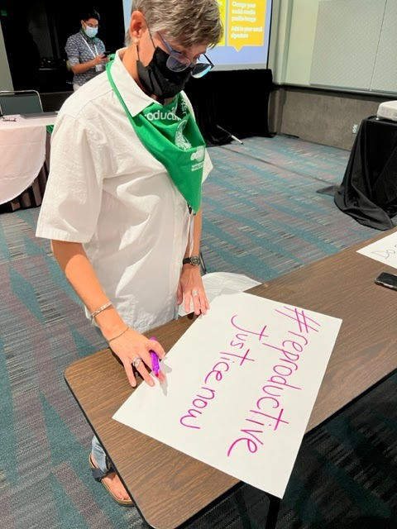
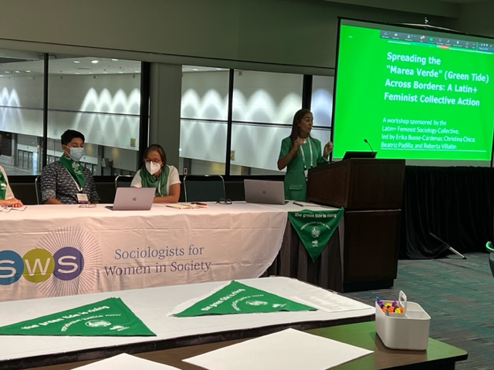

NEW! On The Latin+ Feminist Blog
“Vulnerabilities in the Academy: Experiences and Latin+ Strategies” by Roberta Villalón & Erika Busse-Cárdenas
“A case for the "e" in gender neutral Spanish” by Christina Chica
“Latin America's Marea Verde's Lessons to Fight against Roe v. Wade's Reversion” by Roberta Villalón, Verónica Montes, y Erika Busse-Cárdenas
“Digital Tools and Latin+ Feminist Pedagogy” by Verónica Montes
“Latin-qué?” by Roberta Villalón

MEMBER ANNOUNCEMENTS

Publications

ARTICLES
- Shannon Malone Gonzalez and Faith M. Deckard, "'We Got Witnesses': Black Women’s Counter-Surveillance for Navigating Police Violence and Legal Estrangement" in Social Problems.

- Gina Marie Longo, “Moral lines of credit: Forging race projects, citizenship, and nation on online U.S. spousal reunification forums” in Migration Politics.

- Kathryn Godburn Schubert, Chloe E. Bird, Katy Kozhimmanil, and Susan F. Wood, “To Address Women’s Health Inequity, It Must First Be Measured” in Health Equity.

NEW BOOKS
- Victoria Reyes (2022). Academic Outsider: Stories of Exclusion and Hope. Stanford University Press.

- Roberta Villalón (2022). Migration, Health, and Inequalities: Critical Activist Research across Ecuadorean Borders. Bristol University Press. For review copies, and press inquiries, contact: bahar.muller@bristol.ac.uk. To get a 25% discount on all Bristol University Press and Policy Press books, sign up for the newsletter here. Please contact Roberta directly if you are interested in organizing a book talk. Check out the open website of the project in Spanish at www.saludymigracion.com.

- M. Cristina Alcalde and Mangala Subramaniam, Eds. (2022). Dismantling Institutional Whiteness: Emerging Forms of Leadership in Higher Education. Purdue University Press. Use discount code (Purdue30) for 30% off when ordered through the publisher’s website.

- Monica Liu (2022). Seeking-Western Men: Email-Order Brides under China's Global Rise. Stanford University Press.

- Love without Bounds: An IntersectionAllies Book about Families, New Children’s book Co-Authored by LaToya Council

Celebrations - Congratulations!!!
- LaTonya J. Trotter was awarded the Foundation for the Sociology of Health and Illness Book Prize for her book More Than Medicine: Nurse Practitioners and the Problems They Solve for Patients, Health Care Organizations, and the State.

- Michelle M. Jacob (Yakama), Professor of Indigenous Studies at the University of Oregon, was awarded the 2022 Strong Voice Award by United Academics and the 2022 Equity and Inclusion Award by the University of Oregon’s College of Education.

Feminist Impact Work

- Gina Marie Longo published “As We Lament Elon Musk's Twitter Takeover, We Miss the Bigger Problem for U.S. Democracy," in Ms. Magazine.
- Chloe E. Bird published “Doubling NIH Funding For Women’s Health Would Yield Substantial Return On Investment” at Health Affiars, briefed Pfizer UK corporate affairs on this work, and was featured in the August 8th newsletter by Caroline Criado-Perez, British feminist journalist and author of “Invisible Women: Data Bias in a World Designed for Men.”
- Meghan Krausch published at Truthout, “Grassroots Defense Committees Support Criminalized Survivors of Violence,” about how participatory defense campaigns focused on freeing one person at a time can get everyone closer to freedom; “Amid Wave of Right-Wing Terror, Trans Communities Are Keeping Each Other Safe” about ways that communities, and particularly trans people themselves, are finding ways to affirm and support trans lives amidst a wave of terror and a struggle for bodily autonomy; and “COVID Has Become Indefinite. We Need New Practices to Keep Each Other Safe,” on how consent and healthy boundaries can be applied as tools for equitable community building, particularly in this time as institutions offer no support around COVID, and features interviews with Cierra Raine Sorin and Molly Roach.
- Julie Shayne published “Teaching Students to Write Their Rage” and “The Healing Power of Bikini Kill” in Ms. Magazine
- Özlem Altıok shares a piece for the Policy Press' Transforming Society blog on #MahsaAmini and gender-based violence against women in and beyond Iran and gave an exclusive interview based on her scholarship about her chapter on gender-based violence against women as a social justice issue in the Global Agenda for Social Justice 2 with Applied Worldwide.
- The new Our Bodies Ourselves (OBOS) Today website just launched! You may be familiar with the book version of Our Bodies Ourselves. This new iteration is a fully online resource for health and sexuality that provides women, girls, and gender-expansive people trustworthy resources and holistic information about their bodies. Amy Agigian, an SWS member is the Executive Director of this new iteration of OBOS, and Mindy Fried, SWS member, lead the “Growing Older” panel of experts for this amazing resource! Other SWS’ers are also involved with the production of this resource - check it out!
- Stacy Torres shares an Opinion piece in The Washington Post, “The world might be done with Covid, but I’m still keeping my distance,” and an essay for the Everyday Sociology Blog, “Lonely at the Top: The Toll of “High Functioning” Depression and Our Pandemic Mental Health Crisis”.
- Mindy Fried was interviewd by GBH News to discuss the careging crisis in America.
- Nazanin Shahrokni published at Truthout, “Students in Tehran Protest Gender Segregation in University Dining Hall” about how students in Iran are fighting to reclaim everyday life by resisting state-imposed gender segregation on campus.
- Marisela Martinez-Cola was featured in an article by the Battle Creek Enquirer, “Battle Creek native, author tackles diverse history of legal battles before Brown v. Board, critical race theory”
- Listen to S. L. Crawley discuss their article, “Smithing Queer Empiricism: Engaging Ethnomethodology for a Queer Social Science,” in Sociological Theory on the Sociological Theory Podcast.

PROFESSIONAL OPPORTUNITIES & RESOURCES

- Applied Worldwide Partnering with Sociologists for Women in Society: Applied Worldwide has forged a new partnership with Sociologists for Women in Society (SWS) to highlight and connect feminist applied professionals. SWS members have been invited to submit Applied Worldwide profiles that are also linked to the SWS website and feminist applied professionals are encouraged to join SWS. Applied Worldwide is a content production and media company focused on enhancing a vision of applied sociology. They provide their audience with high-quality content, services, and partnerships that center sociology on its practical knowledge and skills. By partnering with professional organizations, university departments, and individuals, we represent the work and ideas of over 100 sociologists and students from over 20 countries. To learn more about Applied Worldwide, you can visit the website at https://www.appliedworldwide.com.

- SWS LISTSERVS: SWS has a number of listservs available for members. You can manage your subscriptions to them in your MemberClicks Profile. To subscribe to the general listserv, send an email to: sws@lists.socwomen.org. If you have questions about your listserv setup, please email Natasha Santana at: nsantana@socwomen.org.

- The Society for the Study of Social Problems (SSSP) is soliciting applications for the position of Editor of the Society’s flagship journal, Social Problems. The Editor’s three-year term will begin with the operation of the new editorial office at mid-year 2024. The new editor will be responsible for editing and promoting Volumes 72-74 (years 2025-2027). We seek a diverse pool of editorial candidates with strong scholarly records, previous editorial experience (e.g., service as journal editor or associate editor, editor of scholarly editions, etc.), and strong organizational and management skills. A familiarity with and commitment to Social Problems and the SSSP are required. Applicants must be members of the SSSP by the time of their application and throughout their tenure as editor. Click here for a full description of the position and application process. Please direct all questions, inquiries, nominations, expressions of interest, and application materials to: Dr. Yvonne Braun, Chair, SSSP Editorial and Publications Committee, ybraun@uoregon.edu. The deadline for applications is January 15, 2023.
- FEMINIST RESOURCE COLLECTIONS FOR COURSE PREP AND BEYOND: Looking for feminist resources for the (re)design of a course? Check out the following:
- SWS member crowdsourced list of Global Teaching Resources on COVID-19 and SWS’s list of Black Feminist Scholars.
- The Gender & Society blog's pedagogy project includes a series of teaching modules created by students from around the world that center topics important to the sociology of gender. Gender & Society authors and board members reviewed and edited these lesson plans to ensure that they will be helpful tools in building your syllabi.
- Signs has a collection of syllabi suggestions for some commonly taught courses in women's, gender, and sexuality studies.
- The SWS Convention on the Elimination of All Forms of Discrimination Against Women (CEDAW) has compiled a collection of teaching materials, “Applying the CEDAW Framework to Teaching About Women’s Struggles During the Time of COVID-19”

- The Society for the Study of Social Problems (SSSP) Awards and Funding Resources - COMPETITIONS: The Society for the Study of Social Problems (SSSP) is pleased to announce our 2023 Student Paper Competitions and Outstanding Scholarship Awards. In order to be considered for any of the Student Paper Competitions, applicants are required to submit their papers to a session through the Annual Meeting Call for Papers no later than 11:59 p.m. (Eastern Time) on January 15, 2023. Please note that students may only submit to one division and that each division has its own deadline and submission process. For more information contact sssp@utk.edu. FUNDING OPPORTUNITY: The Society for the Study of Social Problems (SSSP) is soliciting applications for the 2023 Racial/Ethnic Minority Graduate Fellowship. Persons identified as either American Indian or Alaska Native, Arab/Middle Eastern/North African, Asian/Asian-American, Black/African American, Hispanic/Latinx, Native Hawaiian or Other Pacific Islander, or, including Deferred Action for Childhood Arrivals (DACA) from one of the aforementioned groups, accepted into an accredited doctoral program in any one of the social and/or behavioral sciences are invited to apply for the $15,000 fellowship. Two students will be funded. Online applications must be received in their entirety no later than 11:59 p.m. (Eastern Time) on February 1, 2023. All applicants must be a 2023 SSSP member at the time of their application. Contact Dr. Felicia Arriaga, Chair, Racial/Ethnic Minority Graduate Fellowship Committee, with questions concerning the fellowship: felicia.arriaga@gmail.com.
- UMass Amherst ADVANCE Presents National Capstone Webinar Series - Faculty Collaboration and Equity: Collaboration can be a powerful tool for building faculty equity. This webinar series distills four years of UMass ADVANCE research and proven practices on how collaboration can be harnessed for greater equity among faculty including: with shared decision-making, during a pandemic, through peer mentoring, and on research teams. Since 2018, the UMass ADVANCE Institutional Transformation program has been working to transform higher education by cultivating faculty equity, inclusion, and success through the power of collaboration. Our workshops, tools and resources, and publications have all been aimed at creating more equitable and collaborative careers for STEM faculty. We invite you to sign up for these webinars, which will leave you with a clear set of tools to create more equitable work environments! Register HERE.
- Faculty Mentoring Practices & Plans, February 16, 2023, from 4:00-5:00pm, Zoom with Joya Misra and James Allan, UMass Amherst ADVANCE
- Equitable Collaboration Practices, April 4, 2023, from 4:00-5:00pm, Zoom with Laurel Smith-Doerr and Jennifer Normanly, UMass Amherst ADVANCE

- UPCOMING CONFERENCES AND SYMPOSIA:
- International Association of Maternal Action and Scholarship (IAMAS) 2023 Conference: March 11-13, 2023 (Chicago, IL USA or online ), “Mothering and Motherhood on the Home/Front” - Email Katie B. Garner at kbgarner@iamas.com for more information.
- Call for Submissions - Upstate NY Regional Symposium: The (up)Roaring 2020’s: Sociology’s Responsibility in Addressing Recurring Social Problems. The Department of Sociology, Criminology, and Human Services at Hartwick College hosts a one-day symposium on Saturday, April 1st, 2023, from 9:00am - 6:00pm. The conference's title is The (up)Roaring 2020’s: Sociology’s Responsibility in Addressing Recurring Social Problems. This is the link to the symposium website. If you have any questions, please, email chernyake@hartwick.edu.

- Society for the Study of Social Problems (SSSP) ANNUAL MEETING (and other announcements): The Society for the Study of Social Problems (SSSP) invites you to join us in Philadelphia, PA, August 18-20, 2023. The program theme selected by President Shirley A. Jackson is Same Problem, Different Day: Recognizing and Responding to Recurring Social Problems. Registration will open in early 2023. For more information contact sssp@utk.edu. CALL FOR PAPERS: The Society for the Study of Social Problems (SSSP) is accepting submissions for our 73rd Annual Meeting, to be held August 18-20, 2023, at the Sheraton Philadelphia Downtown Hotel in Philadelphia, PA. The program theme selected by President Shirley A. Jackson is Same Problem, Different Day: Recognizing and Responding to Recurring Social Problems. Papers or extended abstracts for presentations must be submitted via our online submission process no later than 11:59 p.m. (Eastern Time) on January 15, 2023 in order to be considered. For more information contact sssp@utk.edu.
- Call for Papers - Polarising Sexual and Gendered Lives: Divisions, Differences and LGBTQI+ Equalities: Organizers - Emily Kazyak, Associate Professor of Sociology and Women’s and Gender Studies, University of Nebraska-Lincoln, Kath Browne, Professor of Geography, University of College Dublin, Symposium Location: University of College Dublin, Symposium Date: June 21, 2023.
We are pleased to invite scholars to participate in the international symposium “Polarising Sexual and Gendered Lives: Divisions, Differences and LGBTQI+ Equalities.” The symposium will bring together leading and emerging scholars in multiple disciplines who explore, theorise and seek to address changing social, legal, and political LGBTQI+ landscapes. We are especially interested in scholars who explore processes of contestations and divisions that cut in various ways across these. In particular, we seek scholars who focus on people’s felt and lived experiences of polarisation around sexualities and genders. We welcome scholars who study a range of issues related to sexual and gender freedoms, who center a variety of geographical contexts, and who use a range of theoretical and methodological frameworks. The symposium will bring together scholars whose work grapples with difference, marginalisations, new vulnerabilities and othering to address the creation and problematics of difference, division and polarisations in creating more socially just societies.
The symposium will center intellectual discussions on a variety of arenas, from any related discipline or subject field, including but not limited to: Division and difference in contemporary and historical sexual and gendered landscapes; Opposition, ambivalence, or support for sexual and gender equalities and freedoms; Binaries and boundaries in nation, geography, race and ethnicity, and religion in debates about LGBTIQ+ rights and equalities; Narratives tied to temporality, progress, and polarisation in debates about LGBTIQ+ rights and equalities; Experiences of ‘backlash’ debates, assumptions and circulations around LGBTIQ+ lives and equalities, including Christian Right, Heteroactivism, Anti-Gender and other contestations; LGBTIQ+ equalities and how they emerge and are experienced as polarising topics; Circulation of legal norms and discourses that address gendered and sexualized freedom, rights, equality, and discrimination across nation and place; Effectively engaging with those opposed to sexual and gender freedoms; The effects of fear of polarisation/attack around LGBTQI+ issues; Creations of ‘culture war’ and experiences of these; Useful theoretical frameworks and methodological tools. We hope that the symposium will result in an open-access edited book published through an academic press.

For those interested in participating please submit an abstract here. Those who are accepted to participate in the symposium will then submit a full manuscript draft which will be circulated to all participants prior to the symposium. Participants are expected to read the manuscripts and come ready to discuss and engage. Following the symposium, the organizers will work with participants to revise and edit their manuscripts for inclusion in an edited volume. Timeline: Extended abstract due January 20, 2023; Submit abstracts here; Acceptance Notification: February 17, 2023; Full manuscript draft due: May 24, 2023; Symposium Format: The symposium will be held over two days, beginning with dinner on June 20, 2023 and an all-day symposium on the June 21, 2023. The symposium will be centered on intellectual exchange, dialogue, and workshopping of each other’s papers. For those who cannot attend in person, other arrangements will be made. Participants airfare and accommodations can be covered by the organizers, where appropriate. This can be discussed post abstract acceptance and will be related to individuals’ circumstances. Direct questions to: Emily Kazyak, ekazyak2@unl.edu.

- CALLS FOR PAPERS (CFP), ABSTRACTS & COLLECTIONS: View more details about these and other calls on SWS’s Learning Management System. The Learning Management System is accessible for all current members.

- Invitation to Contribute to Encyclopedias - Todd Shackelford (Psychology, Oakland University) is curating two new encyclopedias, and would like to extend an open invitation to prospective authors interested in contributing entries. Prospective authors are also encouraged to recommend colleagues or graduate students to contribute entries. The Springer Nature Encyclopedia of Domestic Violence will be a comprehensive encyclopedia of domestic violence and will include over 2,000 entries from authors across a wide array of disciplines. The Springer Nature Encyclopedia of Sexual Psychology and Behavior will be a comprehensive encyclopedia of evolutionary perspectives on sexual psychology and behavior, and will also include over 2,000 entries from authors across a wide array of disciplines. For additional information about either of these encyclopedias, or for a complete list of available entries, please contact Editor-in-Chief Todd Shackelford (shackelf@oakland.edu) or Section Editor Gavin Vance (gvance@oakland.edu).

- Big Feminism: The Fiftieth Anniversary Issue of Signs - Signs was founded in 1975 as part of an emergent tradition of feminist scholarship and has been publishing continuously ever since, establishing itself as a preeminent journal in women’s, gender, and sexuality studies. At the time of the journal’s conception, Signs’ founding editorial staff sought not only to raise consciousness and develop theories of women’s oppression but also to challenge the taken-for-granted and to strive for theoretical nuance and interdisciplinarity. To honor half a century of publication, our fiftieth-anniversary issue aims to generate new questions and critical discussion about “Big Feminism” – about the role and power of feminist theory – today and into the future. This special anniversary issue of Signs seeks to engage with the big feminist questions that remain outstanding after all these years. The deadline for submissions is February 1, 2023. Read the full call for submissions HERE.

SWS Statements and Calls for Action

"As a community of scholar-activists, we call each other in, to be in solidarity with Marquette students of color…” - Statement drafted by the SWS Social Action Committee and Student Caucus; SWS Council voted to endorse this statement (November 2022)

SWS Stands in Solidarity with Iranian Protestors, SWS Council Endorses NWSA Statement (November 2022)

SWS Call to Action Opposing the Supreme Court Decision Overturning the Federal Right to Abortion (July 2022)

SWS Virtual Feminist Engagement Opportunities

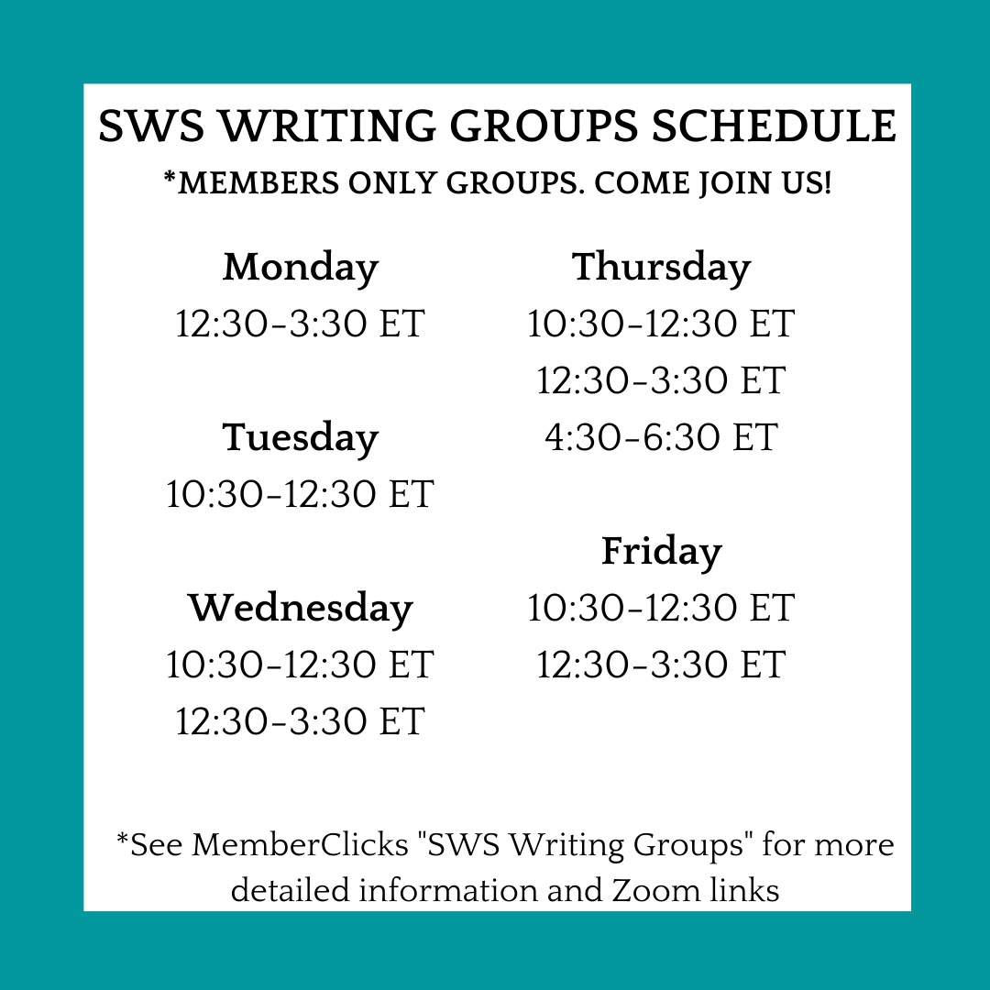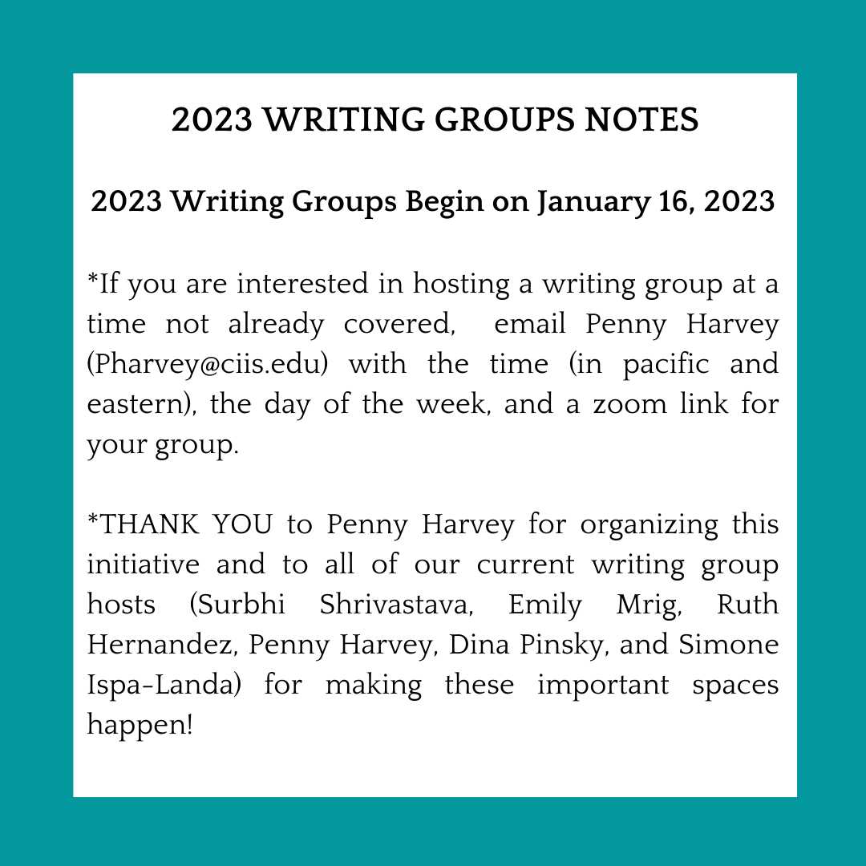

Winter Break Writing Groups!
Regular SWS writing groups are on hiatus until January 16, 2023. In the meantime, if you would be interested in attending a one-off break writing session (or more), please indicate here. This will likely be blocked off half or full days for people to come together and write in larger chunks of time. https://forms.gle/5AjkRQMCtmGe6oHm7

SWS Sexuality Researchers Workshop Group
If you are an SWS member and your research relates to sexuality, please consider joining the SWS Sexuality Researchers Workshop Group. We meet once a month to share our works in progress and give each other feedback. Our fall schedule has been the second Wednesday of each month at 3:30pm ET on Zoom. Typically, one person will distribute a paper or book chapter for discussion at each meeting. If you are interested in being added to our contact list and receiving a Zoom link, please contact Dina Pinsky pinskyd@arcadia.edu.

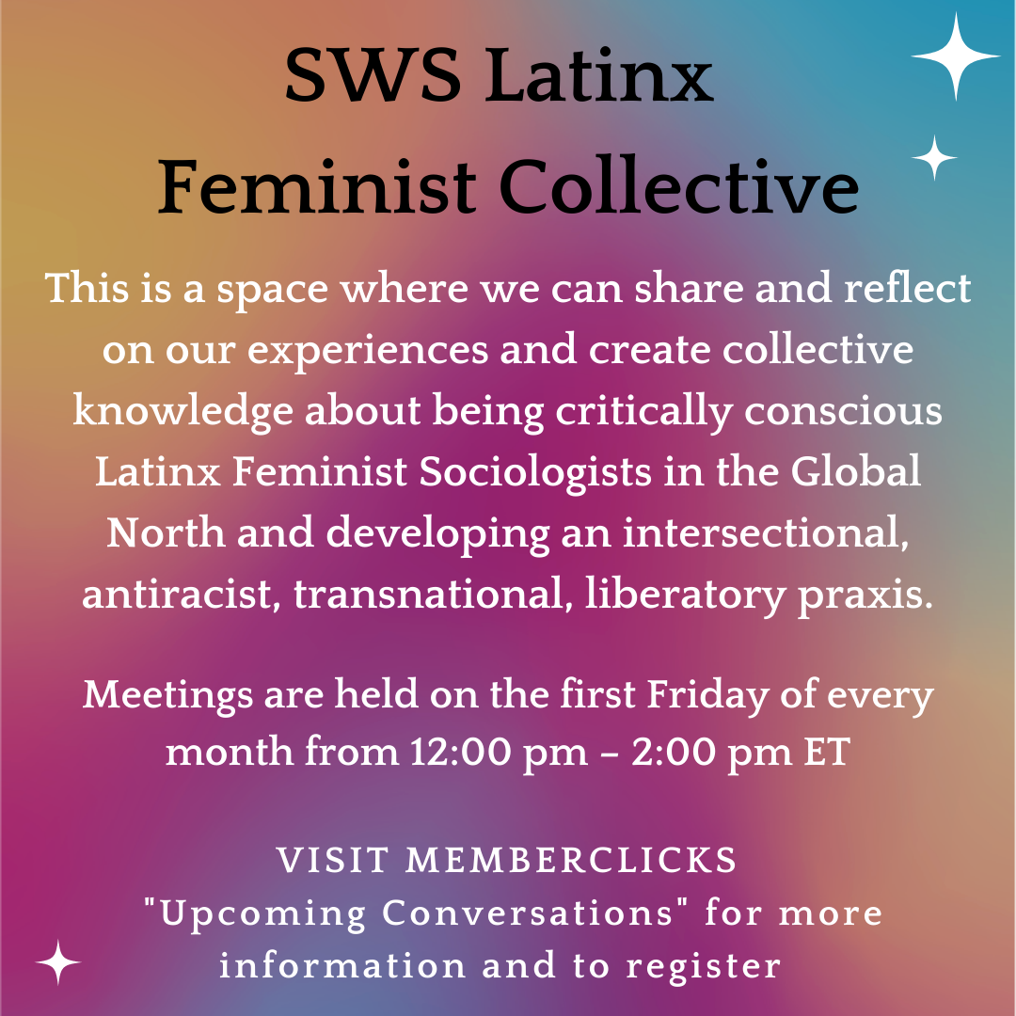

Learn more about the SWS Latinx Feminist Sociology Collective HERE.

More information about all of these opportunities and resources can be found on the
SWS Member Portal, MemberClicks: https://sws.memberclicks.net/

SWS CHAPTER UPDATES
SWS-South
Call for Graduate Student Paper Award on the Study of Gender

This award is given in odd-numbered years by the Sociologists for Women in Society-South to a paper written by a graduate student in the field of the sociology of gender. The purpose of this award is to encourage and support graduate students’ scholarship focused on gender.

Eligibility: The paper may be co-authored, but only by another graduate student. Faculty-graduate student papers are not eligible. Papers that have previously appeared in publication are also not eligible. Nomination packets should be sent to the SWS-South Awards Committee Chair by January 15, 2023. Nominees must be affiliated with SWS-South. Membership information can be found at https://socwomen.org/sws-south/.

Nominations: Self-nominations are accepted. Nominations are submitted electronically in one pdf document, and packets should include the following: One nomination letter detailing the merits of the nominee’s work, A copy of the paper to be considered for the award, The nominee’s current C.V.

The award winner will be recognized at the SWS-South business meeting, they will receive a check for
$300.00, a plaque and a one-year membership to SWS-South. An article about the winner’s work will appear in the association’s newsletter. Please send all nomination packets by January 15th directly to the SWS-South Awards Committee Chair: Rachel Allison at rallison@soc.msstate.edu.

SWS-North

Hello, SWS-North members!

We are delighted to see that several of our SWS-North members up here in Canada will be able to make it to the SWS Winter meetings in New Orleans, January 12-15. We look forward to seeing you all there.

SWS Executive Officer, Barret Katuna, has kindly agreed to make some space for us to meet up. We will have a Meet and Greet table for SWS-North at the Breakfast with Scholars on Friday morning. Please mark your calendars, and we’ll see you there. If you can’t make the Winter meeting, don’t worry! We are looking forward to planning our first, full in-person meeting at Congress in 2023. It will be so great to see you all then.

Tina Fetner and Pallavi Banerjee (co-chairs)

IN MEMORIAM

ESTHER NGAN-LING CHOW (1943-2022)

Over the course of the Summer and Fall seasons, we continued to honor the legacy of Dr. Esther Ngan-Ling Chow, Professor Emerita of Sociology at American University, who pioneered the analysis of the intersectionality of race, class, and gender in the lives of Asian American women.

Esther’s Memorial Service was held Sunday, October 16, 2022 at the Chinese Community Church in Washington, D.C.

Ester’s children, Paul and Jennifer, prepared a Memorial Tribute Video to honor her life and memory.

SWS’er Tracy Ore shares photography that features Esther's participation at SWS meetings throughout the years HERE.

SWS has started this Kudoboard for Esther that you can add to: https://www.kudoboard.com/boards/gX3g9uHD

The SWS Esther Ngan-ling Chow and Mareyjoyce Green Scholarship celebrates the legacies of Dr. Esther Ngan-ling Chow and the late Dr. Mareyjoyce Green.

Esther is also featured on the SWS YouTube Channel:
- Honoring Esther Chow's Trajectory and Legacy: https://www.youtube.com/watch?v=3yN1ZIrAj8w
- You can watch Esther speak as well on this YouTube video from the 2020 Summer Meeting that was our first virtual meeting (where we started celebrating our 50th Anniversary). Fast forward to around 25:00 to see Esther's contributions. https://www.youtube.com/watch?v=zl2H7pOA0rs

GENDER & SOCIETY

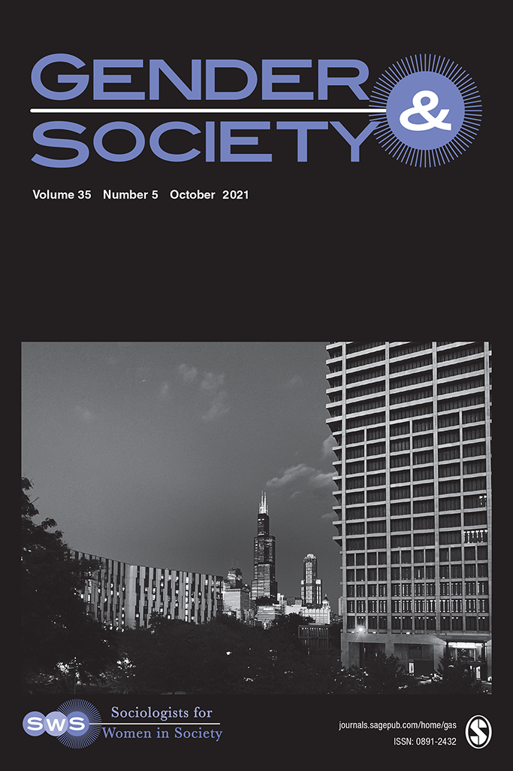
About Gender & Society: Gender & Society is a peer-reviewed journal, focused on the study of gender. It is the official journal of Sociologists for Women in Society and was founded in 1987 as an outlet for feminist social science. It is currently a top-ranked journal in sociology and women’s studies. Gender & Society publishes less than 10% of submitted papers. Articles appearing in Gender & Society analyze gender and gendered processes in interactions, organizations, societies, and global and transnational spaces. The journal primarily publishes empirical, theoretically engaged and methodologically rigorous articles, including qualitative, quantitative, and comparative-historical methodologies. Gender & Society also publishes reviews of books from a diverse array of social science disciplines.

EDITOR: Barbara Risman, University of Illinois at Chicago

ARTICLES IN THE CURRENT ISSUE:
Volume 36 Issue 6, December 2022

"Feminist Lecture: (Re) Imagining Gender-Based Violence as a Strategy for Enforcing Institutional Segregation and Reproducing Structural Inequalities” by Angela J. Hattery
"Weaponized Subordination: How Incels Discredit Themselves to Degrade Women" by Michael Halpin
“Just Let it Pass by and it Will Fall on Some Woman”: Invisible Work in the Labor Market by Amit Kaplan
"In Women We Trust? Gender-Status Mismatch and Trust in Professional Networks" by Eun Young Song, Antoine Vernet, and Stephen Pryke
"Does the Pandemic Affect Inequality Within Families?: The Case of Dual-Earner Couples in Israel" by Efrat Herzberg-Druker, Tali Kristal, and Meir Yaish
"Breadwinning, Occupational Sex Composition, and Stress: Examining Psychological Distress and Heavy Drinking at the Intersection of Gender and Race” by Wen Fan

NEW! On The Gender & Society Blog
“What’s it Like When She Earns More: Does Race Matter?” by Wen Fan
“Incels Identify as Victims to Justify Violence Against Women” by Michael Halpin
“Are Most U.S. Women Intensive Mothers? Perhaps Not.” by Jane Lanks
“Breaking Barriers? Unpacking Women’s Empowerment in Women’s Mixed Martial Arts” by Justen Hamilton
“When the ‘Ideal Worker’ is a White Man, Everyone Else Has to Work Harder” by Rachel M. Korn, Joan C. Williams, and Cecilia L. Ridgeway
“Why Are Cambodian Women Underrepresented in Labor Unions?” by Kirsty Ward

Gender & Society Podcast

Did you know G&S has a podcast?! Check it out here.

2023 WINTER MEETING

Sexualities and Migrations in the Context of Global Justice

Thursday, January 12 – Sunday, January 15, 2023

New Orleans, LA

Co-Presidents-Elect, Melanie Heath and Mary Osirim

THEME: The 2023 Winter Meeting will spotlight the theme of sexualities and migrations governed by global injustices. It will consider how movements between the Global South and North shape sexual identities in ways that do not necessarily depend on Western conceptions of the self but instead create a multiplicity of subjectivities. The intersections of migration, sexuality, and social justice in the context of globalizing processes necessitates challenging forms of knowledge and practices based on hierarchies of power that facilitate dominant Western discourses and neo-liberalism to assume universality. Likewise, nationality intersects with sexuality to create national norms that empower some political actors to marginalize migrant, racial, and sexual others. As SWS’s Call to Action articulates, the recent U.S. Supreme Court decision overturning the federal right to abortion also highlights the importance of bringing a reproductive justice framework to consider the collective dimension of reproductive matters. We must attend to forms of gender-based violence; sexual, racial, and ethnic hierarchies; immigration status; economic precarities; and religious norms in the criminalizing of abortion.

See the Full Program HERE

GENERAL INFORMATION:

The 2023 SWS Winter Meeting will be held at Sheraton New Orleans

Cost for Registration: SWS Meeting registration includes many networking opportunities that occur during mealtimes. We provide hearty hors d’oeuvres during the Thursday evening Welcome Reception, breakfasts on Friday and Saturday, lunch on Friday and Saturday, dinner on Saturday, and a light breakfast before your departure on Sunday. We will have a place on our registration form where you will be able to indicate any dietary needs and we will work with the catering staff at the hotel to ensure that we can meet your needs.
We recognize that meeting costs add up and SWS will subsidize the cost of 2023 Meeting Registration by 30%, 20% or 10% by those who request funds. If you can pay more than what we are asking, we will have the opportunity for members to add 30%, 20% or 10% to their registration fees if they can pay more.

Click HERE for the COVID-19, Airborne Communicable Disease, and Influenza Health and Safety Protocols

“Thank you!” to the 2023 Winter Meeting Program Committee Members:
Ophra Leyser-Whalen (Chair), Pallavi Banerjee, Paulina García-Del Moral, Alexis Grant-Panting,
Fumilayo Showers, Amy Stone

“Thank you!” to the 2023 Winter Meeting Local Arrangements Committee Members:

Lisa Wade (Chair), Andrea S. (Drea) Boyles, D’Lane Compton, Annie McGlynn-Wright, Mimi Schippers
**New Orleans Microsite: things to do, where to eat or drink, black-owned businesses in New Orleans**
**For the most up-to-date information about the meeting visit:

https://socwomen.org/2023-winter-meeting/

Questions??
Please direct questions to Barret Katuna, SWS Executive Officer, at swseo.barretkatuna@outlook.com.

2023 WINTER MEETING SILENT AUCTION
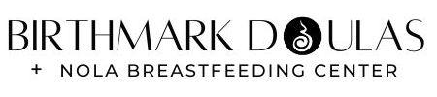
At our 2023 Winter Meeting in NOLA we will once again have our legendary silent auction! Aligned with our organizational values of feminist praxis, each year money raised from the silent auction is donated to a local organization (or more than one) that advances feminist goals in keeping with SWS’s mission. This year, our Presidents, Mary Osirim and Melanie Heath, have identified Birthmark Doula Collective as our beneficiary.

Here's a little bit of information on the Birthmark Doula Collective in their own words: The Birthmark Doula Collective is a birth justice organization dedicated to supporting, informing and advocating for pregnant and parenting people and their families in New Orleans. We respect family's choices, whether the plan is to have a baby at home or in a hospital, medicated or naturally, vaginally or via Cesarean. We are committed to individuals and their family throughout their journeys in pregnancy, childbirth and the very first stages of parenthood. We offer childbirth education, birth doula and postpartum doula services and lactation support. Birthmark Doula Collective is a doula-owned cooperative. We are committed to birth justice. In order to make our work accessible regardless of income, our services are also available on a sliding-scale for qualifying families. Effective 2021, the Birthmark Doula Collective and New Orleans Breastfeeding Center have teamed up to provide the best of prenatal, birth, and postpartum care!

We are hopeful to continue our tradition of strong support for our local community partner. Please consider contributing and shopping for items when that time comes. At the meeting, we will accept payment in three forms: 1) US cash, 2) US checks and 3) credit card.

Our silent auction will take place during the dinner banquet on Saturday evening of the meetings. As you venture out over the next couple of weeks, consider picking up a local scented candle, soap, jewelry, chocolate or other craft.

It would be enormously helpful if you complete a bid sheet (Silent Auction Bid Sheet ) and bring it with you. Of course, we will have extras on hand at the registration desk, where we will be accepting items for the auction. Each item gets its own bid sheet. WE WILL NO LONGER ACCEPT DONATED ITEMS WITHOUT A BID SHEET.

If you are not attending the meeting, but would like to send an item for the auction, you can send those directly to the hotel to arrive no sooner than January 9, 2023, to the following address: Barret Katuna (860-989-5651), c/o FedEx Office at Sheraton New Orleans, 500 Canal Street, New Orleans, LA, 70130, (SWS 2023 Winter Meeting)

If you are unsure of what to donate to the silent auction, here are some ideas: Jams and preserves; Jewelry, purses, accessories (please no broken jewelry or bags of discarded items); Pottery; Coffee and tea; Scarves, gloves, hats and fabrics; Chocolate and Candies; Local crafts; Vintage or recent books (signed editions); Art & crafts (yours or another person’s); Stickers/buttons (vintage ones sell well!); T-shirts. These products do not necessarily have to be new, but can be donated from something you own.

Please help us to run an efficient SWS Auction.
- No items will be accepted without a completed bid sheet.
- No bags, pouches, or boxes of mixed jewelry. Especially with jewelry, each item should be separated and with its own bid sheet.
Thank you in advance for your contributions and support! See y’all soon!

Kris De Welde & Heather Hlavka
SWS 2023 Winter Meeting Silent Auction Co-Chairs and Social Action Committee Co-Chairs

Summer Meeting Memories

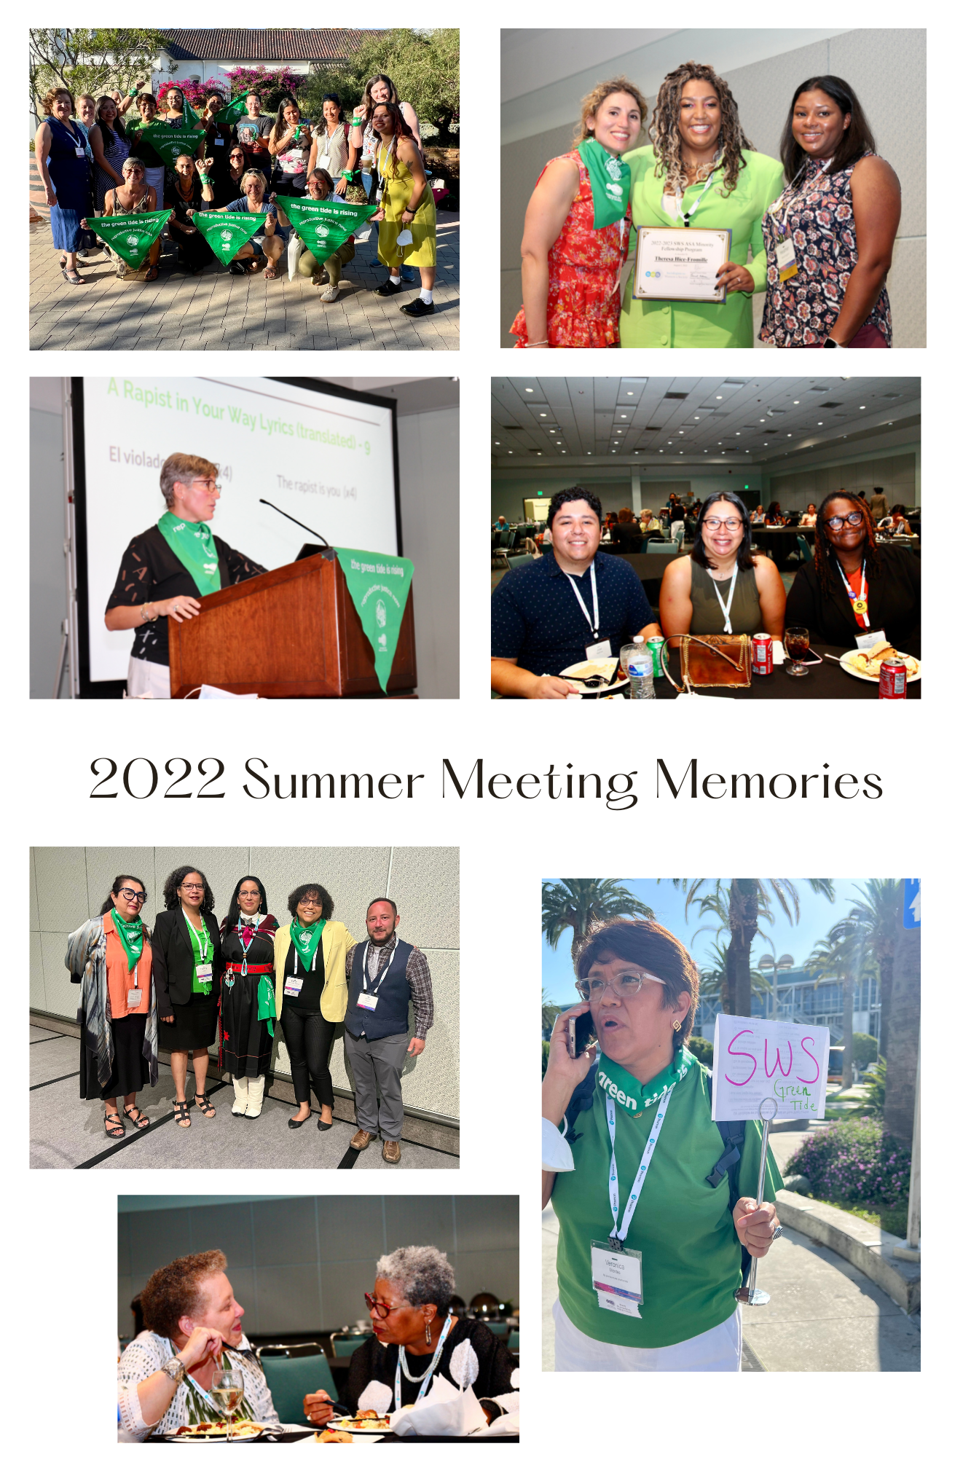

Members | SWS | Legal
- Join or Renew Today!  - MemberClicks  - Learning Management System | - About  - FAQs  - Contact  - Donate Now  - Membership  - 501 (c)(6) Information | - Terms of Use  - Privacy Policy

© 2023 Sociologists for Women in Society
Facebook
Twitter
Publication Team: Melissa D. Day (Editor), Natasha Santana (Assistant to the Executive Officer), Barret Katuna (Executive Officer of SWS)

