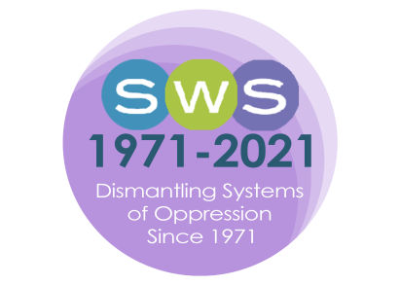

NETWORK NEWS

2021 Issue 3 - FALL
Editor’s Desk
Dear SWSers,
I share this issue with you from northern New England, where we are starting to experience shorter days and colder weather, which is balanced out by the beauty of all the change around us. I usually find Fall, the season that symbolizes transformation and impermanence, simultaneously energizing and humbling, but this season the humbling weight of changes and transitions feels more prominent than usual. If you are looking for community and connection during this season, you might consider checking out some of SWS’s many Virtual Feminist Engagement Opportunties.
This is a very full issue, as our members have been busy achieving LOTS of amazing things and engaging in deep reflection of our feminist work. You can read all about them in the Announcements section where we highlight the new publications, receipt of awards and other celebrations, and an impressive array of public feminist impact work being done by our membership. Also, in their report, the International Committee shares more of their collective reflections of the United Nations Committee on the Status of Women (UN CSW65) events. And, in this issue’s Timely Topics column, Jerry A. Jacobs and Niki von Lockette share reflections about a project they have been working on about whether feminist and intersectional scholarship tends to receive more recognition when published as academic articles or books.
All of this and MUCH more, such as news from SWS leadership about the upcoming 2022 Winter Meeting, can be found in this issue. Thank you to all of the contributors, and to Barret Katuna and Natasha Santana in the Executive Office for all of your publication related support.
Please send news of your publications and accomplishments, committee reports, inquiries for Timely Topics, etc. for the Winter Issue to swsnewsletter@socwomen.org by December 15th, 2021.
In Solidarity,
Melissa D. Day
NN Editor (2021-2025)

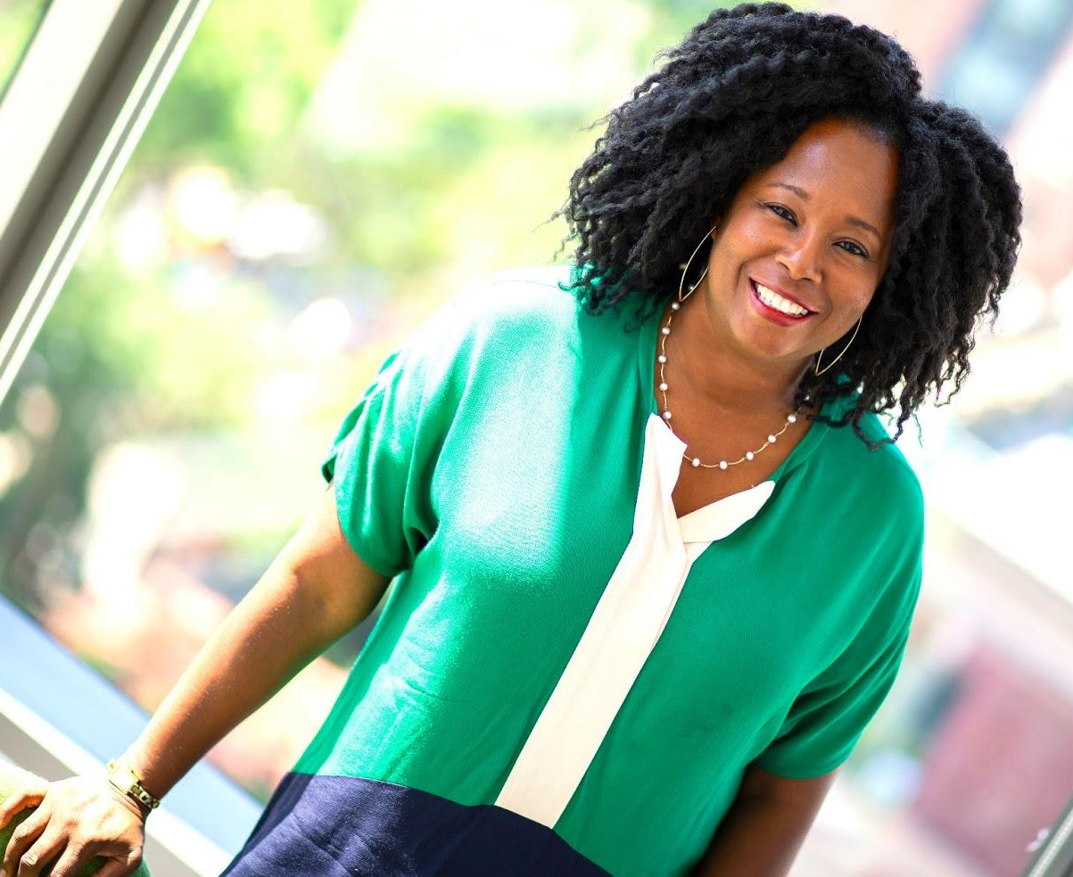
President’s Column

“I don’t feel no ways tired
I’ve come too far from where I started from;
Nobody told me the road would be easy
I don’t believe They brought me this far
To leave me”

I sang a portion of this old-time gospel song as I began my remarks this past Spring at the small ceremony for the 2021 graduates of the college where I work. For me, the lyrics captured the enormity of what we have experienced throughout this pandemic. The students made it to graduation, and some of us have been fortunate enough to continue with our lives. But not all of us: we mourn those we have lost. So whether you turn to spirituality, meditation, poetry, culture, communing with nature, or your own inner-self in times of uncertainty, know that there are others doing the same thing: taking one step at a time, or simply marking time until they are ready to move forward again.
This summer we began distributing financial support to members through the 2021 Member Emergency Fund, Victim Advocacy Fund, and Systemic Racism Fund, which the Council initiated to commemorate 50 years of SWS. We appreciate the leadership of our 2021 Council: Barret Katuna, Roberta Villalón, Josephine Beoku-Betts, Mary Virnoche, Kristy Shih, Jennifer Rogers-Brown, Andrea (Drea) S. Boyles, Veronica Montes, Kumiko Nemoto, Tristen Kade, and Alexis Grant-Panting. We offer a special word of thanks to Josephine Beoku-Betts, Katrina Bloch, Marni Brown, Emmanuel David, Kris De Welde, Esther Hernandez-Medina, Rosalind Kichler, Adelle Monteblanco, Dao Ng, Tracy Ore, Laura Simon, Suki Xiao, and of course Barret Katuna, for their work on the fund subcommittees. We appreciate the way everyone has come together to support our members during what has been a difficult time for many.

We owe tremendous gratitude to Past President Josephine Beoku-Betts and Executive Officer, Barret Katuna for continuing the care work they began under Josephine’s presidency, through the SWS Feminist Support Group meetings. They have offered their time every Tuesday to gather together with members and help one another navigate personal, academic and other challenges, and appreciate the safe space they have tried to provide.

Our 2021 Virtual Summer Meeting, “Retaining and Building an Inclusive Feminist Community” was anchored by the Presidential Plenary and honored the life and work of Sinikka Elliott, an SWS member who passed away this year. Organized by Jennifer Reich, Christine Williams, Ghassan Moussawi, Barret Katuna and myself, we listened as Sinikka’s students, colleagues and friends offered reflections on her life and imagined how her work and contributions will be carried forward.

We also had some fun, honoring the 2021 SWS student fellowship recipients at the Summer Awards Reception! I am continually impressed with how many ways SWS gives back to our community. Maretta McDonald (Louisiana State) and Evelyn Pruneda (UC-Riverside) are our new SWS ASA Minority Fellowship Program fellows; Roxanna Villalobos (UC-Santa Cruz) received the 2021 Esther Ngan-ling Chow and Mareyjoyce Green Dissertation Fellowship, and Kristina Fullerton Rico (Wisconsin-Madison) and Emilia Cordero Oceguera (North Carolina State) were the Honorable Mention Awardees; Jesse Kolber (UC-Davis) and Jessica Yorks (University of Connecticut) are this year’s winner and honorable mention for the Beth B. Hess Memorial Scholarship; Trang Thu Đỗ (Monash University in Australia) received the Barbara Rosenblum Scholarship for the Study of Women and Cancer; Lauren Garcia (University of Virginia), Jessennya Hernandez (University of Illinois-Urbana Champaign), and Bahar Aldanmaz (Boston University) won the Social Actions Initiative Award. We value the leadership of Rebecca Hanson, who chaired the 2021 Awards Committee. Thank you to the members of all of the selection committees for their work in selecting the recipients of these awards: Brittany Battle, Sarah Bruch, Toni Calasanti, Andrea Gómez Cervantes, Kris De Welde, Jean Elson, Kira Escovar, Myra Marx Ferree, Gloria Gadsden, Esther Hernández-Medina, Heather Hlavka, Jennifer James, Kristy Kelly, Rosalind Kichler, Ophra Leyser-Whalen, Gul Marshall, Elizabeth Seton Mignacca, Adelle Monteblanco, Nancy Naples, R. Plante, Ana Porroche-Escudero, Cierra Sorin, LaTonya Trotter, and Tashelle Wright.

In addition to our great programming of Summer Meeting sessions, workshops and roundtables, we also heard from Ophra Leyser-Whalen, the 2020 recipient of the Feminist Activism Award and we continued our new “Drinks with a Famous Feminist” event, interviewing Enobong (Anna) Branch, who encouraged us to consider governance and administrative roles in academia. We packed a great deal into our two days of meetings, and appreciate the hard work of the Summer Meeting Program Committee: Andrea Roman Alfaro, hara bastas, Alexis Grant-Panting, Rebecca Hanson, Ghassan Moussawi, LaTonya Trotter, and the excellent SWS Executive office, directed by Barret along with Natasha Santana, Shuchi Sanyal, and Christelle Lachapelle.

I count it a privilege to have led our organization during this tumultuous time. Change can generate innovation, and moving to a virtual meeting format opened up new ways of gathering as a feminist community. In the Winter 2021 meeting we offered virtual Book Salons for the first time, and we introduced “Drinks with a Famous Feminist” as a way to retain connections with one another. Hopefully these activities will have staying power. During my time as SWS President, I have learned a great deal about our world of sociology, the feminisms we practice, the advances we have made as an organization and the work we have yet to do. I hope to see many of you live and in-person at our 2022 Winter Meeting, headed by President-Elect Roberta Villalón. Until then, be well.

Mignon R. Moore
SWS President

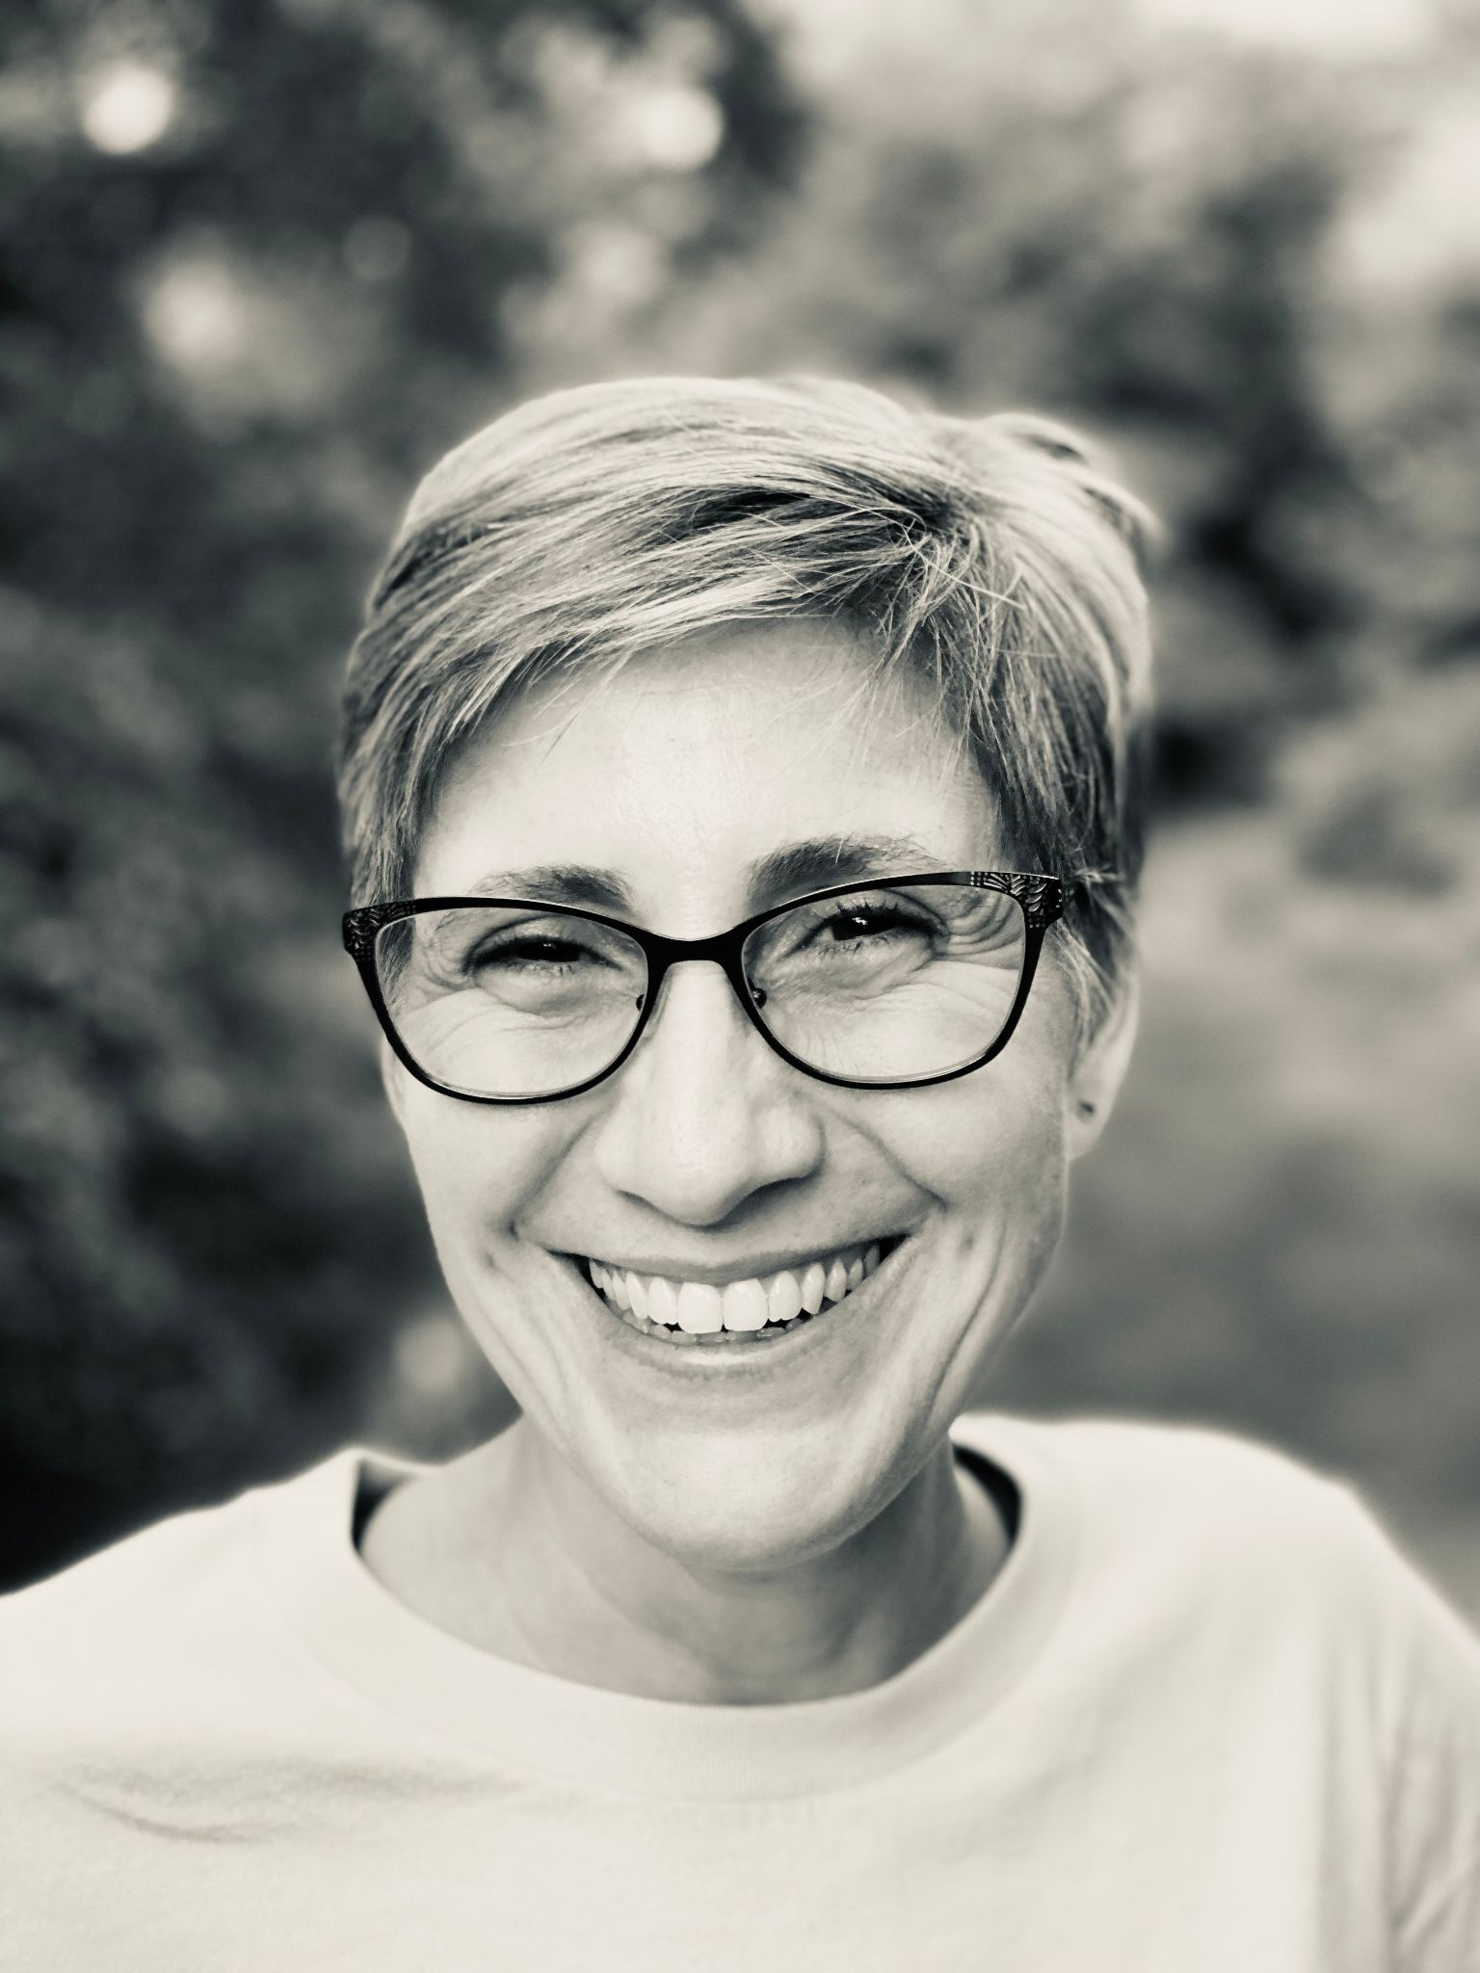
President-Elect’s Message

Dear SWSers,

I hope you’re all having a great start to Fall as we are navigating the complexities of living through a global pandemic. My sincere wishes of well-being go out to all of you in recognition that many of you may be grieving the loss of close relatives and friends and/or recovering from contracting COVID-19 yourselves. While the availability of vaccines has significantly lessened the threat of the pandemic, it has not neutralized it; therefore, we must keep active in collaborating with the many efforts to stop the spread of the virus and find new ways of living in these difficult times. In an attempt to overcome lockdown, people across the world have adapted their personal, familiar and social and labor activities and routines by mixing virtual with distanced and masked in-person mechanisms. Many SWSers have returned to the classroom or their work offices, while some continue to work entirely from home. Many others are in the process of finding (new) jobs at a time of uncertainty and scarcity. SWS has been providing additional services and resources to support members accordingly, making a serious and successful attempt at having a positive and concrete influence in the lives of our members. Included in these initiatives has been the careful planning of the 2022 Winter Meeting.

As you may recall, the first step we took was to circulate a survey to gauge members’ availability and preferences regarding the modality and possible locations of an in-person meeting according to infection rates back in May 2021. Based on the responses, it was clear that there was enough interest in planning a meeting that would include both in-person and virtual programming. With the assistance of Marisa Crame from HelmsBriscoe, we assessed the options in the top surveyed cities (New Orleans, Seattle and Albuquerque), and based on both infection and vaccination rates, we decided on New Mexico. Barret and I did site visits in September, after the Delta variant threat had decreased, and upon comparing what the various hotels offered in terms of safety protocols, conference services, amenities for participants, and budgets, we selected the Hyatt Tamaya Resort & Spa at Santa Ana Pueblo, New Mexico.

Those who were present at the wonderful meeting we had there when Bandana Purkayastha was President in 2013 will be able to confirm our enthusiasm in having the opportunity to gather there again. Owned by the Santa Ana Pueblo, the space combines a breathtaking geography with a spacious yet cozy architecture and restorative services and amenities that will allow for a retreat-like experience. We believe that reuniting in this particular environment will help us create, heal, and recharge as a feminist community. Considering affordability as another important aspect of our meetings, we secured a hotel rate which is comparable to our last in-person meeting at Paradise Point in San Diego in 2020. Moreover, we are providing a series of mechanisms to help members offset travel costs, including the increase of the cost share and options to pay a reduced registration rate. As usual, we will offer hearty hors d’oeuvres during the Thursday evening Welcome Reception, breakfasts on Friday, Saturday and Sunday mornings, lunch on Friday, and dinner on Saturday; and members will be able to indicate their dietary needs at registration. Childcare and a lactation room will be offered as well, taking into account safety protocols.

Regarding health matters, we were positively impressed with the hotel’s practices and happy with their disposition to accommodate our requests. Furthermore, following Centers for Disease Control (CDC) guidelines and upon consultation with the organization’s legal team, we developed a health and safety protocol and will continue to be alert for adjustments to be made if need be. We are aware that some members won’t attend in person due to health related matters; therefore, we are working out the details to have some of the programming live streamed and recorded for later viewing on our forthcoming YouTube Channel. We will also offer virtual roundtables and poster presentations and will hold business meetings online.

Beyond the dedication to work out the best logistics possible for this meeting, we have been working to design a provocative Call for Papers and stimulating conference with the Program and Local Arrangements Committees. Members of the Program Committee include: Alexis Grant-Panting; Andrea (Drea) S. Boyles; Chriss Sneed; Erika Busse-Cardenas; Erika Marquez; Esther Hernández-Medina; Ghassan Moussawi; Nancy López; Ӧzlem Altıok; stef shuster; Tracy Ore; Tristen Kade; Veronica Montes. Members of the Local Arrangements Committee include: Lisa Broidy, Georgiann Davis, Jessica Goodkind, Maricarmen Hernandez, Nancy López, Ranita Ray, and Assata Zerai. As we put together the programming for “Rethinking Feminist Sociologies in the Era of Global Pandemics,” we are aiming for a meeting that foregrounds intersectional, critical, reflexive, situated, action-oriented/community-based, activist, applied, public, counter-hegemonic, queer, trans, decentering, decolonial, liberatory, interdisciplinary, and transnational knowledges. Consequently, our plenaries will include activists, international speakers, and feminist scholars beyond sociology; and we will launch a new Presidential Award to celebrate the work of feminists from other disciplines who have been highly influential in the development of feminist sociologies globally. A Task Force on Interpretation and Translation is being formed to ensure the provision of a sustainable system to increase accessibility across languages. Additionally, we are expanding the format of presentations to also include posters, photo essays, poetry, theatre, scripts, art, film/documentaries, media and literary criticisms as well as other proposals. Furthermore, we are planning to showcase feminist “artivists” and will invite a feminist music band to our Saturday Banquet. Last, but not least, our Local Arrangements Committee has put us in touch with two fantastic organizations, Tewa Women United and MANA de Albuquerque, for our Silent Auction, which we will also include as part of our programming so we can learn from their activism and have a constructive dialogue bridging academia and community.

The Call for Papers for our 2022 Winter Meeting invites SWSers to engage in a collective rethinking of feminist sociologies given the new contemporary challenges we are facing. The global pandemic unleashed by COVID-19 exacerbated pre-existing social inequalities while simultaneously generating intersecting issues across socioeconomic, racial, ethnic, gender, sexual, geopolitical lines worldwide. As feminist sociologists, we were able to identify the inequalities that were intensified and were also ready to join forces with the many social movements devoted to dismantling systems and practices of oppression. However, we were frustrated with the arbitrariness of local, national, regional and international policy-making, the widespread resistance to be informed by science and the persistence of disciplinary and partisan fragmentation and mutual distrust, all of which delayed or prevented the imperative need of bridging across differences to collectively address a global threat to humanity. Moreover, we were puzzled with the ontological and epistemological crises that the coronavirus presented: assumptions about the form and nature of social reality as well as existing theories of knowledge and research methodologies were put into deep questioning. At our meeting, we will reflect on how this complex crisis challenges feminist sociologies. You can read the full call HERE.

We invite you to be a part of this joint reflection so that we can ensure that the relevance of feminist thought and practice becomes key to turning the page, end the era of extreme inequalities, and build alternative futures. The deadline for abstract submissions (extended from November 1) is now Friday, November 5th, submit here. Looking forward to meeting with you in January 2022!

Roberta Villalón
SWS President-Elect

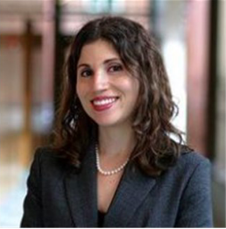
From the Executive Officer

The Executive Office is presently buzzing with the excitement of an in-person meeting upon us to kickstart 2022! I am absolutely thrilled that I will be able to see so many of you in-person at the end of January 2022. I reflect back on how much our organization has grown as we have had to pause our in-person meetings with virtual meeting offerings in Summer 2020, Winter 2021, and Summer 2021. I thank you all for your patience as we have pivoted and reimagined the possibilities of feminist engagement and support. I echo SWS President, Mignon Moore’s gratitude for the leadership from all our Council Members and from all of our leaders - from elected Committee Chairs, to elected Committee Members, to all our members who have really stepped up and provided support - whether it has been through words of encouragement to another member on a Feminist Support Group Call with our incredible Past President, Josephine Beoku-Betts, serving as a mentor via our Career Development programming, hosting or attending a Writing Group, or responding to a listserv message that gave support to someone who really needed it. Thank you to all of you - at all stages of your careers - who have carved out time for the SWS community. I celebrate you and I appreciate you.

Roberta Villalón, SWS President-Elect, and I traveled out to Albuquerque, New Mexico this past September 2021 for a site selection visit and had the opportunity to engage with some longtime SWS members and we welcomed some new members too! Here is a highlight from a breakfast meeting at the Indian Pueblo Cultural Center that I encourage those of you who can make it to the 2022 Winter Meeting to visit and explore.
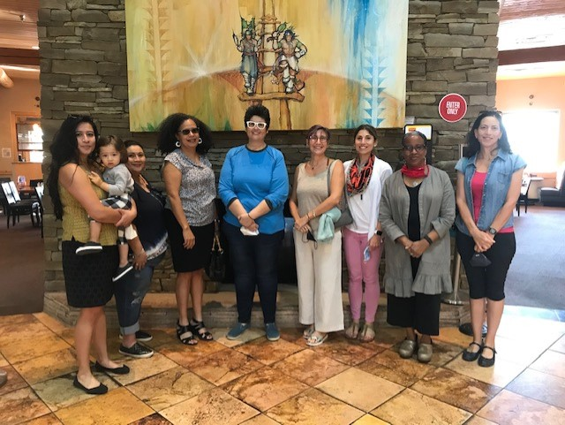

A group of SWSers who attended breakfast at the Indian Pueblo Cultural Center
As we head into the 2022 Winter Meeting planning, our first meeting in the era of COVID, I want to assure you that we are working to ensure a safe and positive meeting experience for all who can attend in person and for all who attend the virtual programming. We are working with the hotel’s audiovisual team to have live streaming/recording of the plenaries and other featured programming and we will be making more information available as we have that. Travel and gathering restrictions have eased, helping some of us to be able to network, gather, and share our research and ideas in person. Yet, we, as an organization, understand that not all can gather in New Mexico, so we are working hard to incorporate virtual possibilities to honor our commitment to inclusivity.

Please always feel free to call, text, or email me. Member engagement is truly the highlight of my day and I would love to hear from you…even if it’s just a quick “hello” without a question. We are an organization of just over 1,200 members! And, I look forward to growing even more this coming year as we continue our important work.

Barret’s email: swseo.barretkatuna@outlook.com
Barret’s cell: 860-989-5651

Barret Katuna
SWS Executive Officer

COMMITTEE NEWS & REPORTS

NOMINATIONS COMMITTEE

The Nominations Committee would like to thank everyone who agreed to run for office for the 2021 SWS Election. The next elected SWS Officers will begin their service to SWS at the 2022 SWS Winter Meeting. We have a strong, diverse, and representative slate of candidates and we look forward to their leadership of SWS moving forward. We strongly encourage all registered SWS members to play their own part by participating in the election process and by voting for their preferred candidates. The election ends on Sunday, October 31 at 11:59 pm EDT.

MEDIA RELATIONS COMMITTEE

CALL FOR BLOG POSTS - #FreeBritney: A current initiative of the Media Relations Committee is to expand the use of original content written by our members to post on the SWS Blog. SWS is a feminist organization that has a goal of sharing feminist research. One theme we aim to develop content around are the current issues faced by Britney Spears. As feminist scholars, we are all aware that her circumstances are indicative of larger structural issues and her story highlights many of the inequalities and misogynistic structures that women face in daily life. Britney’s issue is a feminist issue. Spears' situation highlights many facets of inequality, including the policing of women's bodies, reproductive rights, mental health stigma, disability rights, and so much more. To this end, the SWS Media Relations Committee would like to curate a series of blog posts, written by our members, that illustrate how Spears’ situation is not unique and instead is indicative of larger feminist issues. We seek blog posts (1500-2400 words) that are written for a larger audience. All current SWS members are encouraged to submit. Contact Erin Baker-Giese, Chair, Erin.bakergiese@minotstateu.edu with questions, submissions, and ideas for posts about this and/or other themes.

NEW! On The SWS Blog

"...International Pronouns Day" by Erin Baker-Giese

AWARDS COMMITTEE

EXTENDED DEADLINE

The deadline has been extended from October 1st, 2021 to November 1st, 2021.

Nominate or apply today!

Apply here: https://sws.memberclicks.net/awardsformoct1
Learn more HERE, or go to: https://socwomen.org/awards/

SWS Mentoring Award
The mentoring award was established in 1990 to honor an SWS member who is an outstanding feminist mentor. In establishing the award, SWS recognized that feminist mentoring is an important and concrete way to encourage feminist scholarship.

Feminist Activism Award
This annual award recognizes an SWS member who has made notable contributions to improving the lives of women in society, especially through activism.

Feminist Lecturer Award
Founded in 1985, this lectureship was created to recognize those whose scholarship employs a feminist perspective. The goal is to make these scholars more available to campuses where such a voice is unusual and/or unwelcome.

Undergraduate Social Action Award
The Undergraduate Social Action Award is given annually to recognize a student(s) making a substantial contribution to improving the lives of women in society through activism. The work honored by this award is central to the SWS goal to foster activism for women.

Cheryl Allyn Miller Award
This award recognizes a sociology graduate student, or a recent doctorate, whose research or activism constitutes an outstanding contribution to the field of women and work.

Social Actions Initiative Award
The Social Actions Initiative Awards is SAC’s efforts to directly support and encourage the social activism of SWS members. Awards are given out twice per year on a competitive basis until funds are fully dispersed. The social actions represented by this initiative are central to advancing the mission of SWS.

**If you are interested in making a gift to support any of our awards or scholarships, please contact Barret Katuna, Executive Officer, at swseo.barretkatuna@outlook.com, or make a gift via this form: https://sws.memberclicks.net/donation-form.

INTERNATIONAL COMMITTEE

SWS at the UN Commission on the Status of Women (CSW65)

Compiled By:
Solange Simões, SWS Lead UN Delegate
hara bastas, SWS International Committee Chair

The 65th Session of the Commission on the Status of Women (CSW65) on the theme of “women's full and effective participation and decision-making in public life, as well as the elimination of violence, for achieving gender equality and the empowerment of all women and girls” took place virtually from March 14th -26th, 2021.

Since 1999, SWS has been a Non-Governmental Organization (NGO) with consultative status with the United Nations (UN) Economic and Social Council (ECOSOC). Participation in the annual session of CSW is a major opportunity for SWS International Committee’s work at the UN. Every year SWS a) submits a Written Statement on the session’s theme, b) sends 20 delegates to the event, and c) organizes a panel as an NGOs parallel event.

Our CSW65 full statement, focusing on political inequality and violence against women is now officially online. The SWS Written Statement was co-authored with contributions from Solange Simões, hara bastas, Andrea (Drea) S. Boyles, Nicole (Nicky) Fox, Mollie Pepper, Vicky Demos, Susan Lee, Kristy Kelly, and Josephine Beoku-Betts.

Given the COVID pandemic, CSW65 was held virtually, and NGOs with consultative status were allowed to add more than the usual 20 delegates. SWS was represented at CSW65 by 28 delegates, faculty and students: Solange Simões, Lead Delegate to the UN Economic and Social Council (ECOSOC), Vicky Demos (ECOSOC), Andrea (Drea) S. Boyles (ECOSOC), Nicole (Nicky) Fox (ECOSOC), Mollie Pepper (ECOSOC), hara bastas (IC Chair), Kristy Kelly, Susan Lee, Jennifer Brown, Jacqueline Goodman, Nasra Abubakar, Zhanar Tuleutayeva, Adriana Jean Stacey, Gianna Lete, Kathlyn Elizabeth Elliott, Anita Forrester, Carmen V. Poston-Farmer, Emma Colarossi, Edelweiss Murillo Lafuente, Jessica Grace Cabrera, Maro Youssef, Esha Sraboni, Morgan Richards-Melamdir, Moly King, Katie M. Gordon, Selina Gallo-Cruz, Fauzia Husain, Katherine Maldonado Fabela.

We would like to acknowledge and thank Mollie Pepper for all her efficient work registering the SWS delegation and to Barret Katuna for always working closely with the SWS delegation.

In addition to attending the UN official meetings and parallel events, CSW65 SWS delegates also had the opportunity to participate in two special meetings:

- A Virtual Town Hall Meeting with Women's Civil Society and United Nations Secretary-General António Guterres: Moderated by UN Women Executive Director, Phumzile Mlambo-Ngcuka, the meeting was meant to provide an opportunity for women’s civil society organizations to engage with the Secretary-General on the session’s priority theme. A few NGO delegates had the opportunity to ask questions to Secretary Guterres, and SWS Lead delegate, Solange Simões, asked him on record about what has been done to make sure that the next UN Secretary General is a woman and a feminist.
- United States Mission to the United Nations - Virtual Discussion on United States Priorities for CSW65: Ambassador Linda Thomas-Greenfield made a presentation with members of the United States Mission to the UN and conducted the virtual discussion. Solange Simões, hara bastas and Susan Lee were invited participants. Susan is on record asking about the need for the US to ratify CEDAW, and Solange asked about initiatives to promote higher representation of women in political office, quoting recommendations made in the SWS Written Statement.

SWS Sponsored Parallel Event Panels

For CSWS65, Nicole (Nicky) Fox (SWS UN/ECOSOC delegate) organized two parallel events with the participation of faculty and graduate students’ research on this year’s main theme. Both panels were at maximum capacity with thoughtful engagement in the chat from participants and involved Q&A sessions from audience members (including feminist practitioners and women’s rights organizations activists). The ten presentations from SWS members included a range of case studies, from multiple geographic regions, utilizing various feminist methodologies, demonstrated the far reaching and diverse ways that feminist research can aide in better understanding women’s participation in all levels of political, economic and social life. It was a proud day for SWS and feminists fighting for gender justice.

Nicole (Nicky) Fox shares the following reflections on the panels: “I was thrilled to have the opportunity to assist in organizing two exceptional panels. The panels evaluated a range of barriers to women’s effective participation in public life, as well as the resistance strategies deployed by women from the most marginalized communities. Focusing on mothers in the United States criminal justice system, women on the front line of peace/equity movements, and working women struggling during the COVID-19 global pandemic, the quest for gender justice continues. Feminist strategies become necessary through mother work strategies to avoid the criminal justice system, techniques to prevent the co-optation of civil rights, and advocacy for policy that reflect their demands and expertise.”

PANEL 1: Barriers to Gender Equality and Feminist Strategies of Resistance
- Katherine L. Maldonado-Fabela, Ph.D. Candidate, University of California, Santa Barbara. “System-Impacted Motherwork: Homegirls Dodging Criminalization”
- Morgan Richards-Melamdir, Ph.D. Candidate, Graduate Center of the City University of New York. “Gender Equality, Instrumentalized Empowerment, and Decoupling in World Bank Discourse and Project Implementation”
- Molly M. King, Assistant Professor of Sociology, Santa Clara University & Megan E. Frederickson, Associate Professor of Ecology & Evolutionary Biology, University of Toronto. “The Pandemic Penalty: The Gendered Effects of COVID-19 on Scientific Productivity”
- Selina R. Gallo-Cruz, Professor of Sociology, College of the Holy Cross and Renée Remsberg, Wellesley College. “How They See Us, How We See Ourselves, and How We See Peace’: Reflections on Liberian Women’s Post War Experiences with International NGOs”
- Jessica Cabrera, Ph.D. Candidate, University of California, Irvine. “The Feminist Playbook for Winning Back Title IX”

PANEL 2: Women’s Mobilization, Feminist Claim-Making and the Fight for Social Change
- Maro Youssef, Ph.D. Candidate, The University of Texas at Austin. “Women’s Political Participation After Revolution in Tunisia”
- Esha Sraboni, Ph.D. Candidate, Brown University. “Women Making Claims on the State: The Role of Community Based Groups in Rural Bangladesh”
- Fauzia Husain, Postdoctoral Fellow, University of Toronto. “Women, Public Authority and Spectacular Agency”
- Andrea (Drea) S. Boyles, Professor of Sociology, Tulane University. “Black Women’s Activism: Leading the Progressive Movement at the Intersection of Political Participation, Backlash, and Victimization”
- Katie M. Gordon, Ph.D. Candidate, Stony Brook University. “Running as Resistance: Collective Action Framing and Women’s Candidate Emergence, 2016-2018”

Women’s Caucus at the UN - Toward a Feminist Foreign Policy for the United States Open Meeting

This very important session was organized by SWS Delegate, Susan Lee, in her role as the Chair of the United States Women’s Caucus at the UN. She shares her reflections below:

Susan Lee:
CSW65 was held virtually due to the pandemic, precluding the inspiring annual gathering of thousands of women from around the globe in New York. But the virtual session had an unexpected benefit with over 27,000 women registered for the NGO Virtual Forum, many times greater than usual. I value the CSW for its amazing kaleidoscope of women and girls, from powerful women in high places to grassroots women working on the ground. The virtual environment this year brought attendees right into local villages. In one session, a rooster crowed in the background as the NGO worker gave her presentation!
For this CSW, I focused on women and peace. The premier statement on women, peace, and security was developed at the UN with Security Council Resolution 1325 calling for greater inclusion of women in peace processes. I attended several events that featured women's efforts for peace. For instance, one session on South Sudan featured Dr. Angelina Bazugba from the University of Juba and Eunice Pikiyiko from Crown the Woman South Sudan. Their groups teach women to become peace-builders and to raise their voices in peace spaces. They train women in the details of peace agreements, for instance, and show them how to hold government officials accountable.
The session sponsored by my group, the United States Women's Caucus at the UN, focused on feminist foreign policy (FFP). Ritu Sharma and Aria Grabowski from the International Center for Research on Women pointed to countries that have committed to a feminist foreign policy such as Sweden, Canada, Mexico, and France. They explained key priorities of the FFP agenda including people, peace, and the planet: (1) prioritize bodily autonomy and freedom from discrimination, violence, and exploitation; (2) affirm the women, peace, and security agenda; and (3) ensure environmental integrity and justice. The panelists applauded action in the United States Congress during the CSW when Representatives Jackie Speier (CA), Brenda Lawrence (MI), Lois Frankel (FL), and Barbara Lee (CA) introduced a bill calling on the United States to commit to a feminist foreign policy.
I was particularly interested in sessions on Afghanistan. Ambassador Melanne Verveer from the Georgetown Institute for Women, Peace and Security led one session. The Afghan Ambassador to the UN, Adela Raz, expressed concern about the Taliban threat and asked for international condemnation of Taliban violence against women. Another speaker was Mavic Cabrera-Balleza from the Philippines, founder of the Global Network of Women Peacebuilders, who noted that peace negotiations must include meaningful participation by women and youth to get wide support for a lasting peace. She called for a reduction in global military spending and more funding for women's organizations, social services, and infrastructure. "Don't just invite women to the table," Cabrera-Balleza said. "Instead, reshape the table."
I also attended some sessions on widows, a particularly disadvantaged group. In one session, Heather Ibrahim-Leathers from Egypt, president of the Global Fund for Widows, talked about the problem of widows being disowned by their family, losing their land, and undergoing harmful traditional funeral practices. She emphasized the need for widows to have access to capital and explained her organization's Golden Rule: "She who has the gold makes the rules"!
In the same session, Meera Khanna of India, a leader of the Guild For Service, talked about the close link between widows and poverty. She explained how widows get marginalized in their husband's family as a way to prevent them from inheriting their husband's property. Her Guild's stance is that widowhood is not a cultural issue; it is an economic one.
I am very grateful to SWS for including me in the CSW delegation and opening the door to my participation in this informative and energizing event.

Delegate’s Reflections

We asked our delegates -professors, professionals and students - to share their reflections with CSW65. We are highlighting each reflection below as they provide us with critical and personal understandings as well as evaluations of the scope, theory, praxis, impact, and relevance of CSW and transnational and trans-local feminisms.

Andrea (Drea) S. Boyles
Despite the unprecedented effects of COVID-19 and in-person cancellation, this year’s CSW65 online was rewarding. I thought the change in venue was more valuable than the previous meetings for several reasons. I will share two; both of which have much to do with this nation's ongoing politically, contentious environment.
One, CSW65 made global education, activism, and advocacy readily and easily accessible to member nation-state delegations, and the broader public/global community. Although I enjoy and miss meeting in person, I welcomed the change and opportunity for more inclusion. I valued the fact that this year's meeting brought more of my students to the UN table so to speak, as advocates - a real-time, refreshing, and significant move - that some would likely not have benefited from otherwise. It is especially noteworthy that this access happened amid recent years of increasing hate, exclusion, and violence against women of color especially.
Two, and more direct, it mattered a great deal to me that I was able to present Black feminist work for the first time at the UN/CSW65. That is, call attention to widespread injustices and dangers for Black women particularly, historically, persistently, and increasingly as leaders of the progressive movement. I felt honored and appreciated the opportunity to do it. I guess it was the symbolism of it all for me. Black women in the United States have held frontlines, every time, across issues - unwavering, galvanizing, flipping states, and putting forth a 90% voting electorate in favor of national humanitarian candidates, policies, and practices. Likewise, it made sense that I should increase my involvement - visibility and space to articulate and build "community" - on the world's stage. This is especially true in the wake of the overtly racist national climate and countless murders of Black people like Breanna Taylor.
Finally, my CSW65 experience was informative and therapeutic. I drew from other sessions - global experiences, presenters, and presentations - while also paying it forward and advancing my own community. I am humbled by these occasions and greatly appreciative of my chances and role as an intersectional scholar and SWS UN ECOSOC delegate.

Vicky Demos
I attended the session on Violations of Indigenous Women’s Rights: Brazil, Guatemala and the United States. Indigenous people have suffered at the hands of colonizers in the form of the nation state. The nation state passes on a form of knowledge that is distorted, one in which indigenous people are dominated. Colonizers brought with them lifestyles that are detrimental to indigenous peoples including the construction of pipelines and mining associated. The construction of pipelines, frequently, is detrimental to the land and waterways of indigenous peoples and thus a violation of their human rights. In addition, they are associated with the establishment of “man camps,” which pose a threat to indigenous women’s safety.
Indigenous women (Mayan) who cross through Mexico and into the United States face their erasure as officials label them as Hispanic and speak to them in Spanish, a language they are not likely to know. Data needs to be disaggregated on the basis of language. There are 25 languages in the Mayan language group. Guatemala recognizes 20 of them. Young indigenous women migrate to the United States even when they have little money; enroute they often lose the little they borrowed, leaving them vulnerable to violence. COVID-19 regulations have meant that indigenous women are geographically restricted; they cannot go to work, and as has been true of women around the world, many have been locked in with their abusers.
*You can also read more about Vicky’s experiences and reflections on CSW65 in the Summer 2021 Issue of Network News.

Jacqueline Goodman
One truly heartening realization I had at CSW65 was how women all over the globe are speaking the dialect of feminism. That is, this year’s meeting made me realize that much of global feminist activism and policy is infused with feminist theories about of intersectionality, standpoint theory, transnational feminist networking, and a gendered lens, to name a few. Teaching graduate courses in a department of Women’s and Gender Studies (WGST) has often made me wonder if WGST had become just another academic discipline, co-opted into the ivory tower with the proper theory and method in its curriculum. This year’s CSW meeting disabused me of that concern. Feminism as both theory and praxis is alive and well!
For example, I attended the session on Feminist Foreign Policy, “Introducing the Growing Global Coalition for Feminist Foreign Policy” (FFP), which included government officials and Civil Society representatives from around the world. The Swedish Ambassador, Anne Bernes, reflected this explicit feminism in her discussion of the Feminist Foreign Policy approach. She said they used to focus on “Gender Mainstreaming” in Foreign Policy (where they’d assess the implications of all legislation, policy, and programs to discern their impact on gender, with the ultimate goal of achieving gender equality). Now, she says they use a “gender lens” in all their policy work, and place gender at the center of all their policy approaches. They assess the level of intersectionality in foreign policy and ask questions such as: 1) How is this policy/legislation disrupting power relations inherent in violence against women and girls?; 2) Who takes part in decision making in this policy? Are women equally represented in political positions?; and, 3) Do women have equal access to resources such as land, credit, loans? Their feminist foreign policy is framed as “a [feminist] approach, not a package. It is about putting gender at the core of everything you do…Feminist Foreign Policy is a movement, an agenda for change.”
Another example of this explicitly feminist approach to policy was reflected in the panel “Supporting Vibrant Women’s Movements and Leadership.” Indigenous woman, Melanie Omeniho, President of Women of the Meti Nation, receives funds from the Equality Fund (which supports feminist movements around the globe). Omeniho called for an “intersectional, gendered lens” to respond to the COVID crisis as she advises the Canadian government on Indigenous women’s economic recovery. This feminist approach, reading from the ground upwards, reflects Chandra Mohanty’s call to feminists to theorize upward, in the search for explanation and resistance to patriarchy in local arenas of resistance. This feminist approach is reflected in the Equality Fund’s goals.
These two short examples from the CSW meeting were inspirational for me. They reflect the fact that this is no longer simply women’s resistance to patriarchy, but an emergent feminist resistance to patriarchy at the local level, as well as at the private sector, and government policy levels. I was perfectly content with the virtual format in that it enabled me to attend more sessions than I would have previously been able to attend in person. However, while I don’t like the crowds at the UN, I do like the possibility of networking when meeting face to face.

Giana Lete
Are we actually working towards women’s full and effective participation and decision making in public life… or are we creating and reinforcing obstacles? The priority theme of UNCSW65 was “Women’s full and effective participation and decision making in public life, as well as the elimination of violence, for achieving gender equality and the empowerment of all women and girls.”
Knowing this, I was shocked that one of the side events I attended was firmly against full reproductive rights and comprehensive sex education. I cannot remember the title of this side event and it is not listed on the list of events on the CSW website. I did write down the names of the panelists, and at least two were part of the Worldwide Organization of Women (WOW), whose motto is “Faith, Family, Sovereignty.” At first glance, they might seem to be feminist in nature. On their WOW website, they outline their vision: “We believe in the divine worth and attributes of all women and acknowledge and value the inherent power women possess as an influence for good in the home, marriage, family, and community.” But notice that the list of “influences for good” does not include politics, government, leaders, or any other position where “decision making in public life” can be done as “full and effective participation”. They continue, “We connect and educate women and men of faith, uniting their influence to promote and advocate for the natural family and defend against social policy that weakens the natural family at the local, national, and international levels.” I interpret this to be that they indoctrinate people to become right wing, (specific) rule-abiding Christians, and connect people who are already there to consolidate their resources as a privileged group to influence, promote, advocate, impose, inflict, and wreak their ideology of what they call “the natural family,” while fighting against social policy that advocates for the rights of others, particularly reproductive and decision-making rights of women, persons of the LGBTQ+ community, atheists or people of other faiths, at the local, national, and international levels.
Repeatedly, in many other events during the two weeks, it was stressed that the advancement of the reproductive rights of women, and in particular Black and Brown women globally, was contingent on those very factors that the WOW panel was advocating against. One general idea that came up during many of the side events/workshops that I attended was that in addressing maternal health, ideologies, cultural norms, and policies that endorse, reflect, and perpetuate systemic and institutional racism in health care and patriarchal white supremacy need to be brought to the forefront. Efforts to bring them into interactive, inter- and inner- group discussions, is important, of course, and are necessary first steps. But we must also be united and (pro)active in a steadfast fight to dismantle them: coming together, creating tools, using these tools, pushing for change. Rather, the WOW panel was directly opposed and purposefully destroying our work in their commitment to strengthen the existing right-wing, nationalist, patriarchal white supremacy that blankets the globe.

Edelweiss Murillo
Events that focused on disability were of my interest, and it caught my attention that there were at least three events that included the voices of women with disabilities as protagonists.
The first event I attended on this topic, “Practicing feminist disability rights organizing. Strategies for collective action,” was a parallel event organized by CREA, “a feminist international human rights organization based in the Global South and led by women from the Global South.” The second was a panel, “Build Back Safer, Inclusively: Women with Disabilities Addressing Violence,” that discussed how funding affects feminist disability activists. The third event, "An Untold Narrative: Immigrant Women with Disabilities," Khadija Bari and Baksha Ali presented the work of RespectAbility, a non-profit organization based in the United States, “a diverse, disability-led nonprofit that works to create systemic change in how society views and values people with disabilities, and that advances policies and practices that empower people with disabilities to have a better future. [Their] mission is to fight stigmas and advance opportunities so people with disabilities can fully participate in all aspects of community.”
I found that conversation about disability, in a general way, revolved around institutional notions more than in critical ways. The transnational component of feminist activism was present in these events, especially because the first event was a conservatory amongst women activists with disabilities from Bangladesh, India, and Uganda. The second event addressed how violence against women with disabilities affects in Uruguay, Argentina, Costa Rica, Brasil, República Dominicana, Nicaragua, Panamá, Indonesia, Samoa, Rwanda, and others. The third event was specifically about immigrant women which offered a feminist understanding of migration effects on disabled women in a United States context.
Attending CSW65 has shown me, again, that networking is key and one of the most important elements for institutional and activist involvement. I also attended CSW64 in 2020 and, from these experiences, it seems to me that social media is gaining a central role in the deployment of a global feminist agenda. I have only experienced the virtual format, but I guess that face-to-face format might provide warmer connections between attendees, on the other hand, it has been great to virtually connect with women from across the globe.
I think that the only way to understand how women move the world is to take part in the CSW. I have to admit that global dynamics are a complex topic, but a great starting point to grasp geopolitical notions of women’s situations. In my case, the analysis of disability and feminist movements within the CSW65, has opened up my mind to new ways to steer my research dissertation. I am immensely grateful to the international committee of SWS for leading the way into transnational solidarities.

Carmen Poston Travis
While overwhelming, the size of the CSW65 surprised me. Before having been chosen as SWS delegate, I was severely unaware of the breadth of “Session.” I am challenged by some of the known gender inequities, efforts, and awareness around them that didn’t fully appear in the offerings. Areas that are clearly articulated as priorities within the Beijing+25 Platform and backed by goals of the UN’s 2030 Agenda for Sustainable Development, such as food and job security, and the disparities when it comes to women and girls, which impact mental and physical health wellness.
I registered for and attended the following events: North America and Europe Caucus; Exhale to Inhale Yoga & Relaxation; Conversation Circle: Feminist Movements & Leadership in the Time of COVID-19; Conversation Circle: Future of Education; Briefing with NGO CSWs and UN Women in the Regions; Maternal Health and Black Women in the United States.
In addition to having attended CSW65 as an SWS delegate, I had the great pleasure of presenting on a panel on the Education Crisis: Toward a Feminist Framework for a Post Pandemic World, coordinated by Dr. Kristy Kelley. My presentation focused on the Status of Women: Care and Security Considering a Crisis and Beyond based on a framework of an analysis of the Beijing 25 platform framework and two studies I had conducted.
My experience as both an attendee and presenter further confirmed my perspective of feminist movement organizing and that is there is more work to be done, more than ever. Although there has been movement in some areas toward gender equity, the COVID-19 pandemic set the movement back several steps in many areas.
As advocates for gender equality, we do not want to lose sight of the importance of the commitment and review of the Beijing Declaration and Platform relative to the care and security of women and girls as noted in my presentation. The Platform is more relevant than ever. Women need a foundation of support, care, and access to food security programs. What I discovered also is that women with jobs, particularly in the field of education, provide financial stability for their families during a crisis.
Going forward, a hybrid format for CSW, I believe, would be ideal. CSW should encourage, invite more organizations whose approaches, practices impact food insecurity that includes nutrition, provide solutions for a foundation of care, and promote education and training in the field of education. Organizers should work with researchers to analyze The Platform on various topics/factors to determine and encourage areas of focus for presentations and events to model effective, proven practices. In many areas, we know the problem – it is time to put effective practices on display. They should inform about the connections of certain practices and approaches and how they can address critical areas and related factors and/or implications such as a foundation of care for women, job security, food security, nutrition, and self-care.

Adri Stacey
At CSW65 I attended a round table event on gender, religion, and decision making in public life that discussed the relationship between gender and religion. It spoke about how justice delayed is justice denied. The speaker discussed how women bring the power of relationships between people and the environment around them. Never before have I thought of religion and feminism together demanding justice. I always pictured them as separate entities demanding justice in their own right. Another event that caught my interest was called, “Women in Leadership: Empowering Women and Girls”. One of the speakers used the phrase, “male takes you where you want to be, but woman takes you where you hope to be.” This concept of women inspiring hope and bringing empowerment is the key to many global and social issues we face today. It challenged my perspective of what I thought it meant to be an empowered woman and what it takes to be a person who empowers other women.
I have learned that there is so much more to the feminist movement. There were examples from around the world incorporating different theoretical and practical ideals into what it means to be a feminist and part of the ever growing, changing movement. My perspective has not only grown but widened. I would share with others that an intersectionality approach to everything that was discussed in the conference is key to understanding current issues and moving forward with practical solutions.
I was surprised at the number of experiences and different lifestyles that were presented at CSW. This is my first year attending CSW and I did not know what to expect. There was a lot happening. The fast pace of the conference, even though it was virtually formatted, was something I was not surprised about yet I did enjoy it.
I believe that the virtual format was understandable in that COVID-19 was and is an active threat to the health and safety of society. However, the virtual format inhibited the ability to talk with the women and representatives. Many of the video discussions felt more like webinars. I would have loved to discuss issues further and network more, but there was only time for the scheduled event specifically.
I would recommend that others who are interested simply attend and open their minds to learn. There is so much research being done and so many willing to share their teaching and knowledge. Create connections, tell your story, and listen to others. The sharing of knowledge that occurs at this event is vast and would be beneficial in building out many kinds of research and teaching.
CSW gave me the chance to hear what other feminists and feminist organizations had to say. It was inspiring, thought provoking, reassuring, and motivating all at once. It compelled me to do more for women and ultimately myself. While there were many things I have learned, my biggest takeaway was to keep listening. We as a society need to be constantly hearing women, learning from women, supporting women. Feminist movements are not just about advancing women’s rights. They are about bettering democracy since the empowerment of women is the empowerment of a successful society.

Shuchi Sanyal
Allow me to preface my statement that attending the CSW65 event has been a dream of mine since my freshman year of college, and so I am very grateful to have been selected for this opportunity. With that said, I strongly believe that this would have been a much more rewarding experience for me had it been hosted in-person. Although I completely understand why it was virtual, I simply found everything to be a bit too complicated and overwhelming especially as a first-time attendee. I think that there could have been increased transparency about the program and further consideration for Zoom fatigue - especially since I was attending classes at the same time! Nevertheless, I was able to attend the following sessions: ”Challenges or Opportunities? Women's Participation & Leadership in COVID-19 Recovery” and seeing Vice President Kamala Harris make her remarks on behalf of the United States!!!
There were a couple of other events, especially the Cities for CEDAW organized session, that I really wanted to attend but was unable to due to timing and schedule conflicts. A lot of the times when I am working with CSW NGO or similar organizations I notice I am in the minority as a young POC, and while the CSW65 did have more people of color, I still found myself to be one of the few from my generation. And so, I was able to provide a fresh perspective - or so I believe - on how this work has the potential to be intergenerational. If I am lucky enough to attend this conference again, I know that I would take better advantage of the situation to promote the good work we do at SWS, do some networking, and be a more lively attendee than I was able to virtually.

Zhanar Tuleutayeva
I was supposed to participate in CSW64 last year in March in New York, but it was cancelled due to COVID-19. It was upsetting for me and I was happy to attend CSW65 this time. Thank you so much for providing such an opportunity for me to participate! I enjoyed the sessions I could participate in. I participated mostly in sessions that covered topics such as ending violence against women, women and political representation, gender equal health and care workforce, because it was intersection of my research interests. Right now, I want to reflect on one of my favorite side events, “Gender Equal Health and Care Workforce: Enabling Women to Lead.” The main objective was to present the issue of women’s low representation in current leadership in health and care sectors and how it is affecting women. Additionally, the session presented solutions and ways in which women can participate in decision making in these fields.
First, according to the WHO Report on Global Health, Delivered by Women, Led by Men, gender leadership gaps are driven by stereotypes, discrimination, power imbalance, and privilege (Mwanza 2021). Global health is weakened by excluding female talent, ideas and knowledge, and women leaders often expand the health agenda, strengthening health for all. Dr. Iris Mwanza, one of the speakers of the event, presented that 70% of women are health workers, yet only 25% of women are health leaders and 23% of women are chief delegates to World Health Assembly 2020. This was eye opening for me because when I think about the healthcare industry, I think about it being female dominated, however it was sad and disappointing to realize that only one fourth of women are leaders in this field.
Next, I was surprised to hear that some countries’ leadership made such gender-blind decisions in the context of COVID-19, such as labeling maternity and reproductive health services as “not essential,” and that PPE was modelled on male body, which creates higher infection risk and indignity for women health workers. The last part was crazy to hear, because I knew that smartphones were designed to fit into an average male’s hand, but I did not know that such important medical equipment such as PPE was designed for men. Not all healthcare workers are men and how are they supposed to be protected if PPE does not fit them because of their gender? Lastly, session outlined four action areas that can create more representation in leadership:
- Building foundation for equality by removing restrictions on what types of professions women can occupy. There are 90 countries that still have these limitations for women.
- Addressing harmful social norms and sexist stereotypes that exist in our society. For example, break the stereotype that nursing is a female profession.
- Fixing workplace systems and culture, not women by creating quotas for women in leadership.
- Enabling women to achieve by developing formal or informal networks for women’s leadership development.
To sum up, it was a great side event that helped to raise awareness about the issue of low representation of women in healthcare. It was hopeful and empowering to listen to different speakers, specifically, Dr. Mwanza’s research stood out to me, so I am sharing my thoughts and feelings about it. Sometimes it feels like it is only me alone in this fight against the patriarchy and gender inequality, but hearing from different amazing women making changes around the world made me feel empowered. Once again, I understood the importance of an intersectional approach to solving problems and fixing the system. Considering women’s race, caste, class, disability, cultural background, education level and more is necessary in understanding complex decisions women make and how we can address differences between women. Once again, thank you for giving us, young scholars in women’s and gender studies, to participate in this global and influential conference!

The International Committee looks forward to hearing more from SWS members who engage the UN for research, teaching, and/or advocacy. We welcome contributions to the committee and to our work as an ECOSOC NGO. Opportunities to participate in the next SWS delegation to CSW will be announced in fall 2021. Watch the SWS listserv for more information or reach out to the International Committee Chair, hara bastas (ravinheart@hotmail.com), for more information.

TIMELY TOPICS

The Avenue to Academic Recognition of Feminist Scholarship:

Books or Articles?

By: Jerry A. Jacobs and Niki von Lockette

Research on women and minorities scholars in academia understandably tends to emphasize under-representation, marginalization, and barriers to success. Nevertheless, a number of women and minority scholars have risen to prominence despite a myriad of institutional obstacles. As part of a broader project on the role of books in sociological scholarship, we wondered what role books have played in the scholarship of prominent feminist and intersectional academics.

American feminist sociologist Jessie Bernard (1903-1996) was a prominent scholar and activist. Bernard authored a number of influential books following her retirement from teaching after mainly concentrating on journal articles during her earlier academic career. The Jessie Bernard Award has been bestowed by the American Sociological Association (ASA) since 1979 “in recognition of scholarly work inclusive of research, teaching, mentoring, and service that has enlarged the horizons of sociology to encompass fully the role of women in society.” We wondered whether the feminists who have been honored as recipients of the Jessie Bernard Award have tended to write books, articles, or both, and which of these avenues generated the most scholarly interest? The expansive criteria of this career achievement award allow us to compare books versus articles as avenues to academic recognition of critical scholarship.

Through our analysis of award winners’ publications, we find that all Jessie Bernard Award recipients published
some journal articles; most also published at least one book. In other words, in our field of sociology, books and articles are not mutually exclusive options. This fact led us to ask: which mode of scholarship predominates and which type of publication led to the most visible publications?

While Jessie Bernard Award recipients did not pursue a single publication strategy, books have featured prominently for many of these accomplished scholars. The top cited publication for 19 of 31 Jessie Bernard Award recipients was a book. In a more comprehensive review, we found that 14 Jessie Bernard Awardees published most of their top-cited works as books, 14 did so mostly via journal articles, and for three honorees the score was pretty much even.

For example, Barrie Thorne’s book Gender Play: Girls and Boys in School (1993) has been cited over 5,000 times (using Google scholar citation data). Indeed, this book is mis-cited (as “boys and girls in school”) more often than many leading journal articles are cited correctly! While Dr. Thorne (the 2002 recipient of the Jessie Bernard Award) published many journal articles, books feature prominently among her top-cited publications. In contrast, Cecilia Ridgeway (the 2009 awardee) mostly published her voluminous research in academic journals. While her book, Framed by Gender: How Gender Inequality Persists in the Modern World (2011), is quickly making its way to the top of Ridgeway’s citation board, the majority of her most cited works appeared in Gender & Society, American Sociological Review (ASR), and other prominent journals. Still other award recipients, including Arlene Kaplan Daniels (1995) and Myra Marx Ferree (2004), excelled in both formats.

In the early 1990s, women became editors of both flagship sociology journals (Marta Tienda American Journal of Sociology (AJS) in 1992, and Paula England ASR in 1994), signaling a potential shift toward greater openness to female scholars and feminist scholarship. Did Jessie Bernard award recipients shift from books to journal articles after this period?

We did not find any clear time trend. Some of the earliest recipients, such as Alice Rossi (1983), Joan Huber (1985) and Joan Acker (1989), mostly published articles, while some recent winners, including Christine Williams (2014) and Kathleen Gerson (2013), favored books as outlets.

We were curious as to whether women of color who received the Jessie Bernard Award pursued different publication strategies. Several of these honorees published prominent books (Rhacel Salazar Parreñas, 2019; Evelyn Nakano Glenn, 2005; Bonnie Thornton Dill, 1993; and Patricia Hill Collins, 1993), while others mostly wrote journal articles (Esther Chow, 2014) or published via both channels, including Bandana Purkayastha (2019) and Elizabeth Higginbotham (1993).

We examined these same issues for the women who were recipients of the Joseph Sandy Himes Award, the career achievement award bestowed by the Association for Black Sociologists. The Joseph Sandy Himes award winners were more frequently in the book camp than in the journal camp. This pattern held for the majority of the men who received this honor and for four of the five women recipients: Patricia Hill Collins (who was also a Jessie Bernard Award recipient); Joyce Ladner, Ruth Simms-Hamilton, and Lena Wright Myers. (Doris Wilkinson was the article-writing exception.) So similar to women overall, we see a slight proclivity toward books for women of color scholars as well. This strategy may reflect a preference for the review process of books over journals, or simply a desire to reach broader audiences; we cannot ascertain that from this data. However, it would be a fruitful dialogue to continue going forward.

We hope that these brief comments provide an opportunity to celebrate the careers and scholarship of these most
accomplished feminist authors, to reflect on today’s publication landscape, and to consider how we can create vibrant pathways to scholarly recognition that also facilitate the broad public dissemination of our ideas. We also recognize that there are layers of complexity regarding gender, race, and intersectionality that we have not fully grappled with in this short essay.

The complete list of Jessie Bernard Award recipients can be found on the ASA’s website (here). More details on the findings summarized here and a longer essay on the evolving roles of books and articles in the field of sociology are available from the first author.

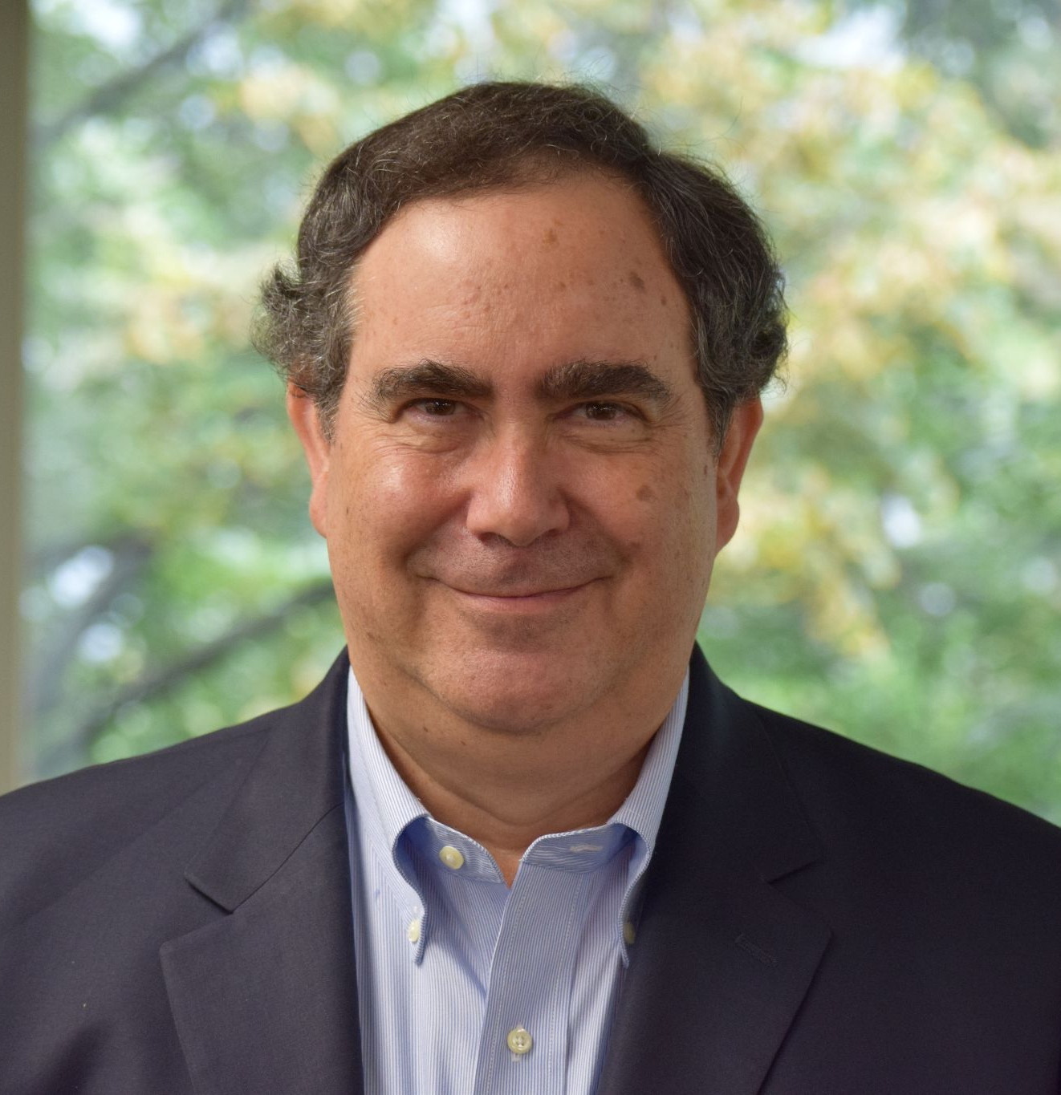
Jerry A. Jacobs, Professor of Sociology at the University of Pennsylvania, is the co-founder and first president of the Work and Family Researchers Network. Jacobs has written extensively about women’s careers and work-family issues. His six books include The Time Divide: Work, Family and Gender Inequality (2004) with Kathleen Gerson and the Changing Face of Medicine: Women Doctors and the Evolution of Health Care in America (2008) with Ann Boulis.

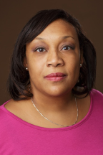
Niki vonLockette is Associate Professor of Public Policy and African American Studies at Penn State. Her work examines the impact of residential segregation on unemployment and wages for blacks and Latinos in metropolitan areas (Economic Geography, City and Community), and the effects of workplace occupational segregation on worker attitudes (Work and Occupations). She has served as consultant for the U.S. Departments of Labor and Commerce and the Federal Reserve Bank. She has contributed to The New York Times’ “Room for Debate” on low-wage workers.

**“Timely Topics” is a recurring short column (~1,000-words) in Network News. We are looking for submissions! Send your inquiries and ideas to the Editor at swsnewsletter@socwomen.org.

MEMBER ANNOUNCEMENTS

Publications

ARTICLES

- Christina Marie Chica, "Toward a Sociology of Global Comparative Placemaking." Sociology Compass.

- Farha Naz and colleague, “Gender-Based Differences in Flood Vulnerability Among Men and Women in the Char Farming Households of Bangladesh.” Natural Hazards.

- Marisela Martinez-Cola, “Collectors, Nighlights, and Allies, Oh My! White Mentors in the Academy.” Understanding and Dismantling Privilege.

- Barbara Sutton. "Reclaiming the Body: Abortion Rights Activism in Argentina." Feminist Formations.

- Mary Frank Fox and colleagues, “Publications About Women, Science, and Engineering: Use of Sex and Gender in Titles Over a Forty-six-year Period.” Science, Technology, and Human Values.

- Mary Frank Fox and colleague. “Gender, Family and Caregiving Leave, and Advancement in Academic Science: Effects across the Life Course.” Sustainability.

- Xuemei Cao and colleague, “Seeking Transnational Social Protection during a Global Pandemic: The Case of Chinese Immigrants in the United State.” Social Science & Medicine.

- Sarah Combellick, “’My Baby Went Straight to Heaven’: Morality Work in Abortion Online Storytelling.” Social Problems.

- S. L. Crawley and colleagues, “Smithing Queer Empiricism: Engaging Ethnomethodology for a Queer Social Science.” Sociological Theory.

- Danielle Czarnecki, “I’m trying to create, not destroy”: Gendered Moralities and the Fate o fIVF Embryos in Evangelical Women’s Narratives.” Qualitative Sociology.

- Jocelyn Elisa Crowley, “Sexual Harassment in Display Work: The Case of the Modeling Industry.” Gender & Society.

BOOK CHAPTERS

- Celeste Atkins, “Teaching Up: Faculty of Color Teaching About Privilege,” in Gender, Race, and Class in the Lives of Today’s Teachers: Educators at Intersections.

NEW BOOKS

Grasping for the American Dream: Racial Segregation, Social Mobility, and Homeownership

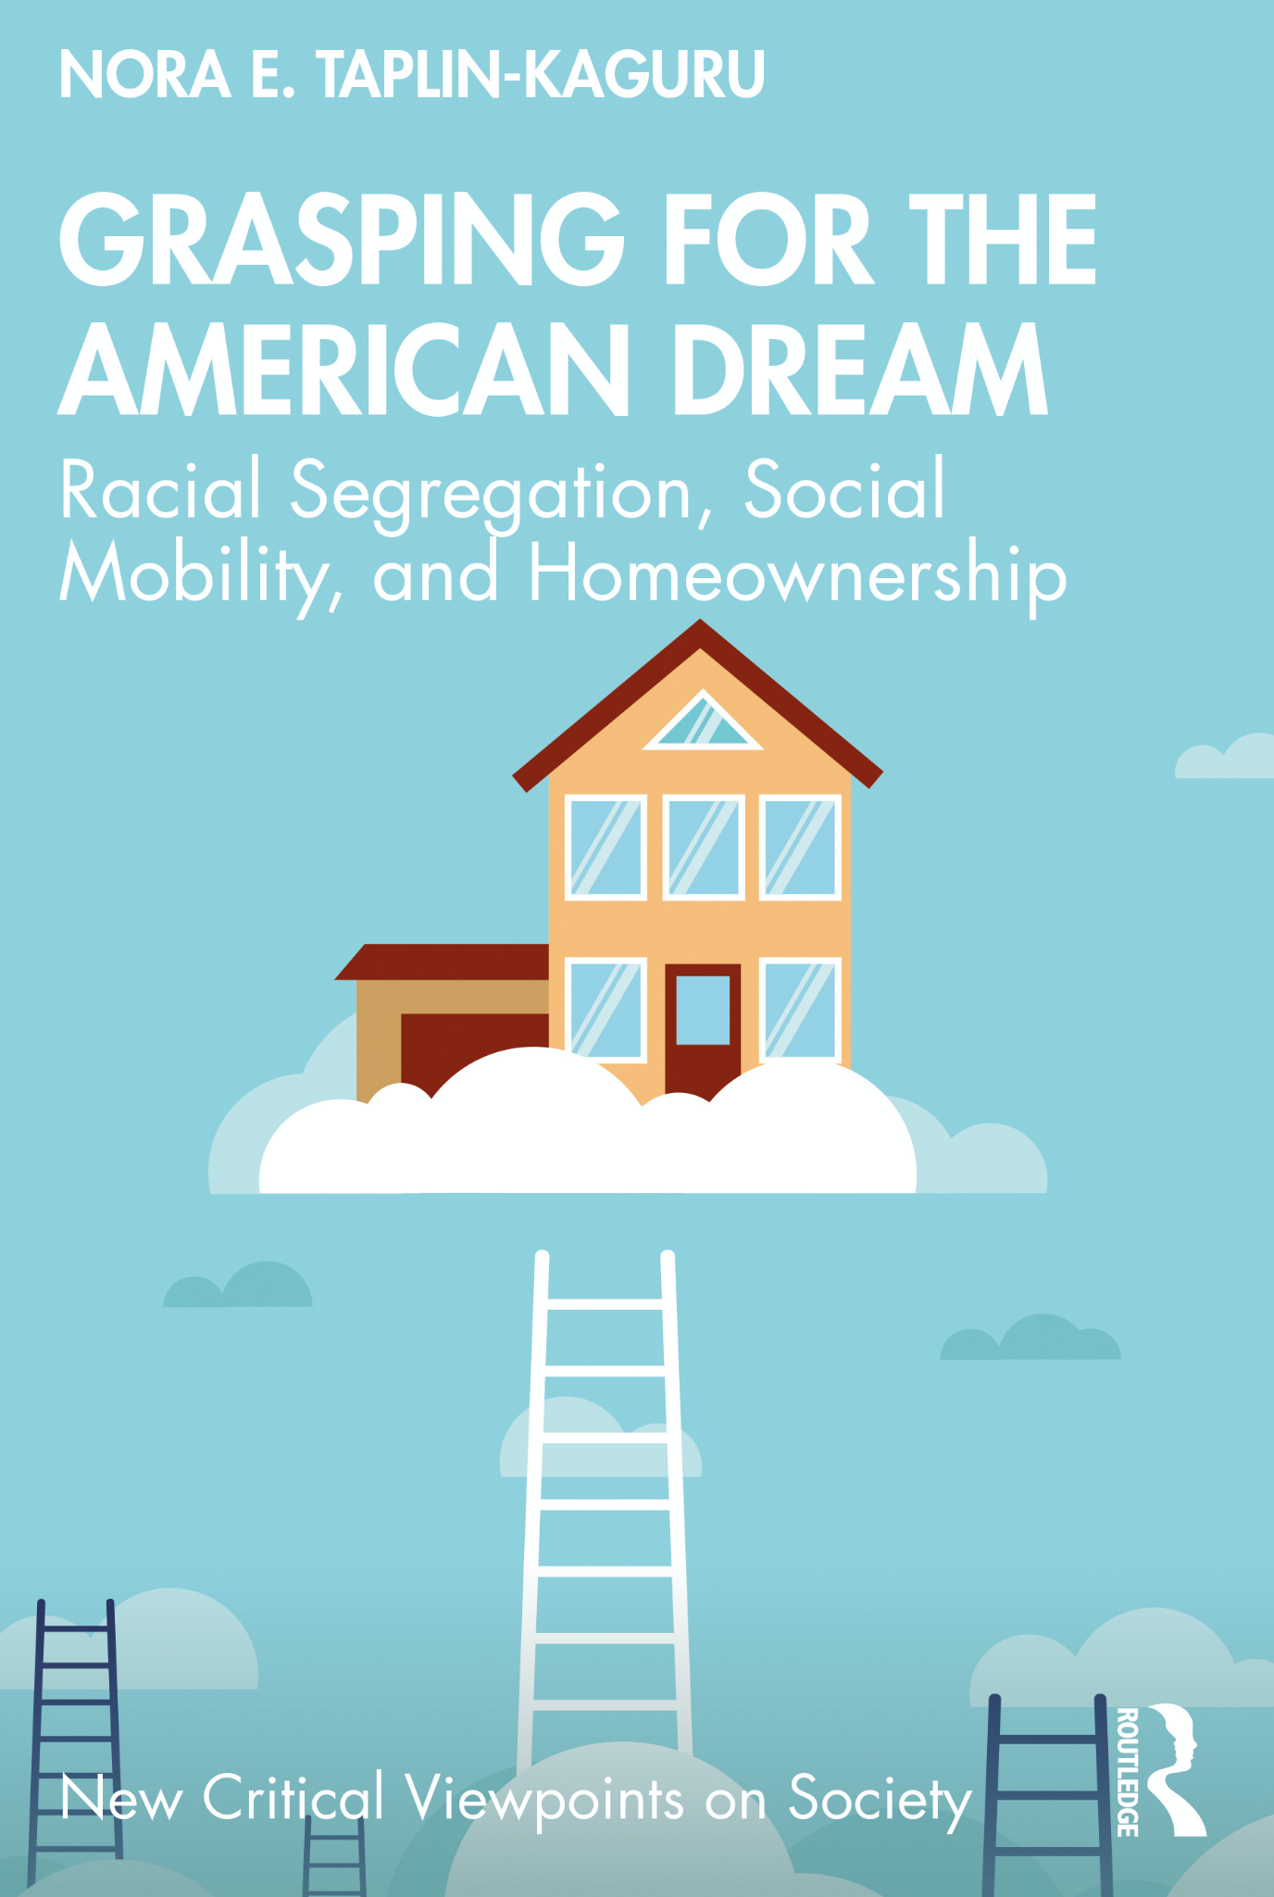
Nora E. Taplin-Kanguru announces the publication of a new book with Routledge (Discount Code: NTK21). African American homebuyers continue to pay more for and get less from homeownership. This book explains the motivations for pursuing homeownership amongst working-class African Americans despite the structural conditions that make it less economically and socially rewarding for this group. Fervent adherence to the American Dream ideology amongst working-class African Americans makes them more vulnerable to exploitation in a structurally racist housing market. The book draws on qualitative interviews with sixty-eight African American aspiring homebuyers looking to buy a home in the Chicago metropolitan area to investigate the housing-search process and residential relocation decisions in the context of a racially segregated metropolitan region.
Working-class African Americans remained committed to homeownership, in part because of the moral status attached to achieving this goal. For African American homebuyers, success at the American Dream of homeownership is directly related to the long-standing dream of equality. For the aspiring homebuyers in this study, delayed homeownership was a practical problem for the same reasons, but they also experienced this as a personal failing, due to the strong cultural expectation in the United States that homeownership is a milestone that middle-class adults must achieve. Furthermore, despite using perfectly reasonable housing search strategies to locate homes in stable or improving racially integrated neighborhoods, the structure of racial segregation limits their agency in housing choices. Ultimately, policy solutions will need to address structural racism broadly and be attuned to the needs of both homeowners and renters.
You can read more about Grasping for the American Dream here.

Abortion and Democracy: Contentious Body Politics in Argentina, Chile, and Uruguay
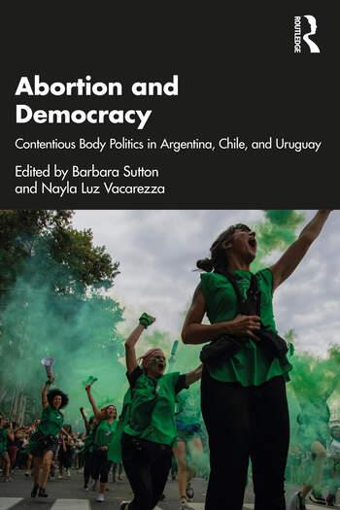
Barbara Sutton and colleagues announce publication of the new edited volume, Abortion and Democracy: Contentious Body Politics in Argentina, Chile, and Uruguay, with Routledge.

Abortion and Democracy offers critical analyses of abortion politics in Latin America’s Southern Cone, with lessons and insights of wider significance. Drawing on the region’s recent history of military dictatorship and democratic transition, this edited volume explores how abortion rights demands fit with current democratic agendas. With a focus on Argentina, Chile, and Uruguay, the book’s contributors delve into the complex reality of abortion through the examination of the discourses, strategies, successes, and challenges of abortion rights movements. Assembling a multiplicity of voices and experiences, the contributions illuminate key dimensions of abortion rights struggles: health aspects, litigation efforts, legislative debates, party politics, digital strategies, grassroots mobilization, coalition-building, affective and artistic components, and movement-countermovement dynamics. The book takes an approach that is sensitive to social inequalities and to the transnational aspects of abortion rights struggles in each country. It bridges different scales of analysis, from abortion experiences at the micro level of the clinic or the home to the macro sociopolitical and cultural forces that shape individual lives.

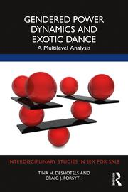
Gendered Power Dynamics in Exotic Dance: A Multilevel Analysis

Tina Deshotels and colleague, share news of their new book with Routledge, Gendered Power Dynamics and Exotic Dance: A Multilevel Analysis, which examines the social phenomenon of exotic dancing. Presenting a compelling multilevel analysis of dancer interactions, organizational practices, and institutional forces, this book challenges our understanding of sexuality and power.

Centering the voices and experiences of exotic dancers, this book explores the relationship between exotic dancing and power at the micro-interactional, meso-organizational, and macro-institutional levels, informing a feminist theory of power that seeks out systems of domination in order to challenge and change them. Through direct interviews and observations collected between 1993 and 2021 from 40 different clubs in the United States, Deshotels and Forsyth demystify the seemingly contrary findings about exotic dancing and power. They show how and why individual dancers can be simultaneously empowered and exploited beyond individual traits, interactions, or settings in the nexus of gender and power in exotic dancing.
The book will be useful for scholarly readers in the subject areas of sociology, cultural studies, gender/sexualities studies, sex work, and organizations theory. Written in a clear, accessible manner, this book will also appeal to a general audience interested in understanding the complex interactions of gender, power, feminism, and exotic dance.

After Genocide: Memory and Reconciliation in Rwanda
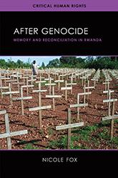
Nicole (Nicky) Fox’s new book, After Genocide: Memory and Reconciliation in Rwanda, is out with University of Wisconsin Press. In the wake of unthinkable atrocities, it is reasonable to ask how any population can move on from the experience of genocide. Simply remembering the past can, in the shadow of mass death, be retraumatizing. So how can such momentous events be memorialized in a way that is productive and even healing for survivors? Genocide memorials tell a story about the past, preserve evidence of the violence that occurred, and provide emotional support to survivors. But the goal of amplifying survivors’ voices can fade amid larger narratives entrenched in political motivations.

In After Genocide, Nicole Fox investigates the ways memorials can shape the experiences of survivors decades after mass violence has ended. She examines how memorializations can both heal and hurt, especially when they fail to represent all genders, ethnicities, and classes of those afflicted. Drawing on extensive interviews with Rwandans, Fox reveals their relationships to these spaces and uncovers those voices silenced by the dominant narrative—arguing that the erasure of such stories is an act of violence itself. The book probes the ongoing question of how to fit survivors into the dominant narrative of healing and importantly demonstrates how memorials can shape possibilities for growth, national cohesion, reconciliation, and hope for the future.

The New Gender Paradox

Judith Lorber celebrates publication of her latest book with Polity, The Gender Paradox. Today, in Western countries, we are seeing both the fragmentation of the gender binary (the division of the social world into two and only two genders) and its persistence. Multiple genders, gender-neutral pronouns and bathrooms, X designations and other manifestations of degendering are becoming common and yet the two-gender structure of our social world persists. Underneath the persistence of the binary are discriminatory norms against women and men’s power and privileges. So there is the continued need to valorize the accomplishments of women, especially those of denigrated groups. This book explores both sides of the paradox – processes in the fragmentation of gender that are undermining the binary and processes in the performance of gender that reinforce the binary, and the pros and cons of each. The conclusion of the book discusses why we haven’t had a gender revolution and how degendering would go a long way in creating gender equality.

Just Get on the Pill: The Uneven Burden of Reproductive Politics
Krystale E. Littlejohn’s new book, Just Get on the Pill: The Uneven Burden of Reproductive Politics, is available through University of California Press. You can read more about her work in her recent op-ed in TIME Magazine, her feature in Mashable, and in her guest interview with NPR-1A.

Understanding the social history and urgent social implications of gendered compulsory birth control, an unbalanced and unjust approach to pregnancy prevention.

The average person concerned about becoming pregnant spends approximately thirty years trying to prevent conception. People largely do so alone using prescription birth control, a situation often taken for granted in the United States as natural and beneficial. In Just Get on the Pill, a keenly researched and incisive examination, Krystale Littlejohn investigates how birth control becomes a fundamentally unbalanced and gendered responsibility. She uncovers how parents, peers, partners, and providers draw on narratives of male and female birth control methods to socialize cisgender women into sex and ultimately into shouldering the burden for preventing pregnancy.

Littlejohn draws on extensive interviews to document this gendered compulsory birth control—a phenomenon in which people who give birth are held accountable for preventing and resolving pregnancies in gender-constrained ways. She shows how this gendered approach encroaches on reproductive autonomy and poses obstacles for preventing disease. While diverse cisgender women are the focus, Littlejohn shows that they are not the only ones harmed by this dynamic. Indeed, gendered approaches to birth control also negatively impact trans, intersex, and gender nonconforming people in overlooked ways. In tracing the divisive politics of pregnancy prevention, Littlejohn demonstrates that the gendered division of labor in birth control is not natural. It is unjust.

Unfree: Migrant Domestic Work in Arab States

Rhacel Salazar Parreñas’ announces her new book, Unfree: Migrant Domestic Work in Arab States, with Stanford University Press.

A stirring account of the experiences of migrant domestic workers, and what freedom, abuse, and power mean within a vast contract labor system.

In the United Arab Emirates, there is an employment sponsorship system known as the kafala. Migrant domestic workers within it must solely work for their employer, secure their approval to leave the country, and obtain their consent to terminate a job. In Unfree, Rhacel Salazar Parreñas examines the labor of women from the Philippines, who represent the largest domestic workforce in the country. She challenges presiding ideas about the kafala, arguing that its reduction to human trafficking is, at best, unproductive, and at worst damaging to genuine efforts to regulate this system that impacts tens of millions of domestic workers across the globe.
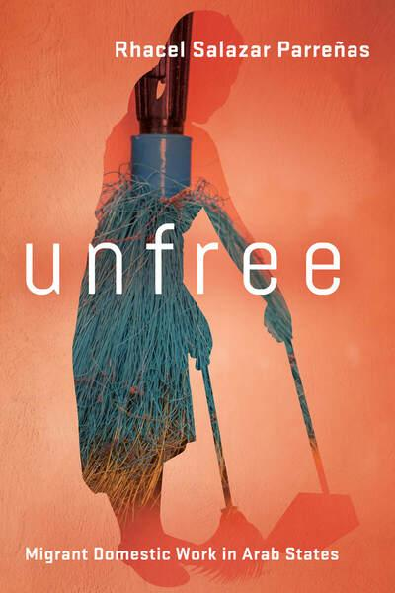
The kafala system technically renders migrant workers unfree as they are made subject to the arbitrary authority of their employer. Not surprisingly, it has been the focus of intense scrutiny and criticism from human rights advocates and scholars. Yet, contrary to their claims, Parreñas argues that most employers do not abuse domestic workers or maximize the extraction of their labor. Still, the outrage elicited by this possibility dominates much of public discourse and overshadows the more mundane reality of domestic work in the region. Drawing on unparalleled data collected over 4 years,this book diverges from previous studies as it establishes that the kafala system does not necessarily result in abuse, but instead leads to the absence of labor standards. This absence is reflected in the diversity of work conditions across households, ranging from dehumanizing treatment, infantilization, to respect and recognition of domestic workers.

Unfree shows how various stakeholders, including sending and receiving states, NGOs, inter-governmental organizations, employers and domestic workers, project moral standards to guide the unregulated labor of domestic work. They can mitigate or aggravate the arbitrary authority of employers. Parreñas offers a deft and rich portrait of how morals mediate work on the ground, warning against the dangers of reducing unfreedom to structural violence.

The Tolls of Uncertainty: How Privilege and the Guilt Gap Shape Unemployment in America

Sarah Damaske’s new book, Tolls of Uncertainty, is out with Princeton University Press.

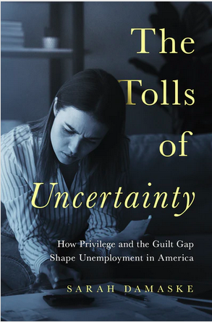
Through the intimate stories of those seeking work, The Tolls of Uncertainty offers a startling look at the nation’s unemployment system—who it helps, who it hurts, and what, if anything, we can do to make it fair. Drawing on interviews with one hundred men and women who have lost jobs across Pennsylvania, Sarah Damaske examines the ways unemployment shapes families, finances, health, and the job hunt. Damaske demonstrates that commonly held views of unemployment are either incomplete or just plain wrong. Shaped by a person’s gender and class, unemployment generates new inequalities that cast uncertainties on the search for work and on life chances beyond the world of work, threatening opportunity in America.

Following in depth the lives of four individuals over the course of their unemployment experiences, Damaske offers insights into how the unemployed perceive their relationship to work. She reveals the high levels of blame that women who have lost jobs place on themselves, leading them to put their families’ needs above their own, sacrifice their health, and take on more tasks inside the home. This “guilt gap” illustrates how unemployment all too often exacerbates existing differences between men and women. Class privilege, too, gives some an advantage, while leaving others at the mercy of an underfunded unemployment system. Middle-class men are generally able to create the time and space to search for good work, but many others are bogged down by the challenges of poverty-level unemployment benefits and family pressures and fall further behind.

Timely and engaging, The Tolls of Uncertainty posits that a new path must be taken if the nation’s unemployed are to find real relief.

Black Feminist Sociology: Perspectives and Praxis

Zakiya Luna and Whitney Pirtle have a new edited volume! Pre-order your copy of Black Feminist Sociology: Perspectives and Praxis today!
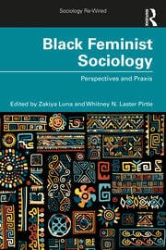
Black Feminist Sociology: Perspectives and Praxis brings together a diverse set of established and emerging scholars for a timely, accessible, and intellectually stimulating conversation regarding the foundations and state of Black feminist sociological thought.
Black Feminist Sociology: Perspectives and Praxis answers three broad questions:
- What is Black feminist sociology?
- What are the guiding principles, theories, methods, and practical applications of Black feminist sociology?
- What are the risks and rewards for practicing Black feminist sociology?
“Black Feminist Sociology offers new writings by established and emerging scholars working in a Black feminist tradition. The book centers Black feminist sociology (BFS) within the sociology canon and widens is to feature Black feminist sociologists both outside the US and the academy. Inspired by a BFS lens, the essays are critical, personal, political and oriented toward social justice. Key themes include the origins of BFS, expositions of BFS orientations to research that extend disciplinary norms, and contradictions of the pleasures and costs of such an approach both academically and personally. Authors explore their own sociological legacy of intellectual development to raise critical questions of intellectual thought and self-reflexivity. The book highlights the dynamism of BFS so future generations of scholars can expand upon and beyond the book’s key themes.”
Learn more about the book here: https://blackfeministsociology.com/
Read about all of the authors here: https://blackfeministsociology.com/read-the-book/

No Real Choice: How Culture and Politics Matter for Reproductive Autonomy

Katrina Kimport is delighted to share that her new book, No Real Choice: How Culture and Politics Matter for Reproductive Autonomy is out with Rutgers University Press! Katrina is available via Zoom to join to classes to discuss the book and/or the current state of abortion access and politics in the United States.
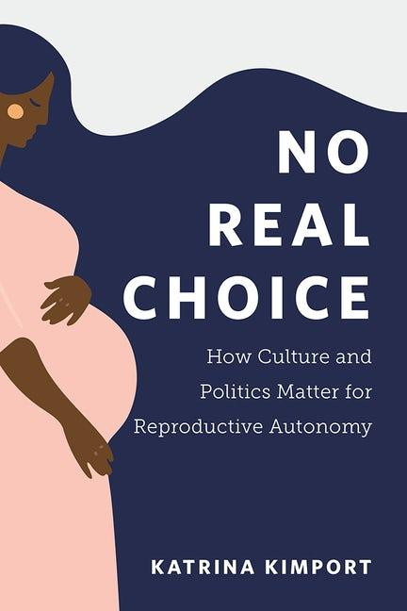
In the United States, the “right to choose” an abortion is the law of the land. But what if a woman continues her pregnancy because she didn’t really have a choice? What if state laws, federal policies, stigma, and a host of other obstacles push that choice out of her reach?

Based on candid, in-depth interviews with women who considered but did not obtain an abortion, No Real Choice punctures the myth that American women have full autonomy over their reproductive choices. Focusing on the experiences of a predominantly Black and low-income group of women, sociologist Katrina Kimport finds that structural, cultural, and experiential factors can make choosing abortion impossible – especially for those who experience racism and class discrimination. From these conversations, we see the obstacles to “choice” these women face, such as bans on public insurance coverage of abortion and rampant antiabortion claims that abortion is harmful. Kimport's interviews reveal that even as activists fight to preserve Roe v. Wade, class and racial disparities have already curtailed many women’s freedom of choice.

No Real Choice analyzes both the structural obstacles to abortion and the cultural ideologies that try to persuade women not to choose abortion. Told with care and sensitivity, No Real Choice gives voice to women whose experiences are often overlooked in debates on abortion, illustrating how real reproductive choice is denied, for whom, and at what cost.

This book is available for purchase through Rutgers University Press. For a 30% discount use the code 17M6662 at checkout.

Celebrations - Congratulations!!!

- Suzan Walters was awarded a NIH Career Development Grant for her work, “Intersectional Stigma Experiences, Pre-exposure Prophylaxis (PrEP), and Other Service Use Among People Who Inject Drugs.” She shares the following sentiments, “SWS was critical. Thank you for all your support. The Beth Hess scholarship was critical in my career and this would not have happened without it. Many thanks to you all for building such a supportive feminist community.”

- Pedrom Nasiri won the Canadian Sociological Associations’ 2021 Angus Reid Applied Sociologist Award.

- Chloe E. Bird received a 2021 American Sociological Association’s (ASA) Distinguished Career Award for the Practice of Sociology.

- Mangala Subramaniam received the 2021 Award for Advancing Diversity, Equity, and Inclusion from the American Sociological Association’s (ASA) Section on the Political Economy of the World-System.

- Mary Frank Fox was named Dean’s Distinguished Professor at the School of Public Policy at Georgia Institute of Technology. She reflects in this piece on her 20 years as Ivan Allen College ADVANCE Professor.

- Esther Hernández-Medina is a 2021-2022 Pomona College Humanities Studio Fellow.

Feminist Impact Work

- Stacy Torres published recent op-ed pieces in The Washington Post: “For years, I cared for ailing parents. Respite shouldn’t have come only with their deaths,” and “I lost my father to cancer — and my sister to vaccine refusal.” And in USA Today: “Why is American health care so inaccessible? It only got easy when my dad was dying," and “There's a time to work and a time to grieve. Mourning is its own kind of labor.”

- Mindy Fried and Chloe Bird were featured in recent pieces by Applied Worldwide: Making Sociology Count. The profiles are a joint collaboration between Applied Worldwide and SWS as part of a larger project with the intentions of: 1) providing students with examples of applied sociology, 2) providing market value to sociological skills and services, and 3) promoting the work of individual sociological practitioners and organizations. You can find a directory of all profiles included in this project here.

- Mangala Subramaniam and colleague share a new BEST PRACTICES TOOL: Examples for Documenting the Impact of COVID-19 on Faculty through the Susan Buckley Butler Center The Butler For Leadership Excellence and Purdue University.

- Mary Bernstein discusses same sex marriage on the Southern Queeries podcast and had her research on gun violence prevention activism featured in UCONN Today.

- Tsedale Melaku discusses the challenges women continue to face in the workplace, especially during COVID and racial upheaval, in an interview with CBS News.

- Amy Blackstone was featured in an article by CNN, “Why more women are deciding not to have kids.”

- Rachel Rinaldo was featured in an article from The Conversation, “Why some Muslim women feel empowered wearing hijab, a headscarf.”

- Anna Branch published her reflections about the persistence of race and racism in America from her perspective as a Black mother on nj.com.

- Stephanie Wilson shared a blog post on Applied Worldwide: Making Sociology Count, “Reproductive Justice as the Only Way Forward.”

- Mangala Subramaniam’s interview with Higher Ed Digest - International Edition was featured as the cover story for the July 2021 issue.

- Carole Joffe and colleague published an op-ed in The New York Times, “Even Texas Allows Abortions to Protect a Woman’s Life. Or Does It?”

- SWS members contributed articles to the most recent issue of Footnotes, a magazine of the American Sociological Association: Yvonne P. Sherwood, “Indigenous Womxn and Environment Justice: She & the Basket Folded Us In” and Maricarmen Hernández, “Pollution, Poverty, and Environmental Suffering: The Case of Informal Living.”

- Krystale Littlejohn was interviewed by NPR’s IA for the first episode in a series about birth control.

- Meghan Krausch shared her work at Truthout, “A Grim Winter Looms. These Activists Are Keeping Spirits Up Through Organizing.”

PROFESSIONAL OPPORTUNITIES & RESOURCES

- SWS 50th Anniversary Funds to Provide Direct Financial Support to Members in Crisis: SWS Council has approved the establishment of three funds to support the needs of our members. Grants from these funds are designed to be small awards to alleviate immediate needs. SWS can offer this funding in 2021 because of cost savings from not holding in-person meetings in Summer 2020, and Winter and Summer 2021.
SWS Member Emergency Fund ($20,000): During these uncertain economic times, we recognize that some members need immediate help, so we have strategized about how to offer modest relief. Members will be able to request one-time financial assistance with an economic setback and we will do our best to help them.
Victim Advocacy Fund ($10,000): The Victim Advocacy Fund will offer financial assistance to those in need of legal services because they have been the victim of a crime or of unfair treatment in the academy or in larger society.
Systemic Racism Fund ($10,000): The Systemic Racism Fund offers support to expressly combat systemic racism faced by our members during political protests, interactions with institutions, and other types of experiences.

Members can only apply for funding from one fund for up to $500 USD. Please see the form for more details.

Direct link to the form: https://sws.memberclicks.net/servicefunds50thanniversary

- HAVE YOU JOINED THE SWS LISTSERV? To send an email to the SWS listserv, please email the following email address: sws@lists.socwomen.org. If you have questions about your listserv setup, please email Natasha Santana at: nsantana@socwomen.org.

- FEMINIST RESOURCE COLLECTIONS FOR COURSE PLANNING AND BEYOND: Looking for feminist resources for the (re)design of a course? Check out the SWS member crowdsourced list of Global Teaching Resources on COVID-19 and SWS’s list of Black Feminist Scholars. The Gender & Society blog also has a pedagogy project that includes a series of teaching modules created by students from around the world that center topics important to the sociology of gender. Gender & Society authors and board members reviewed and edited these lesson plans to ensure that they will be helpful tools in building your syllabi.

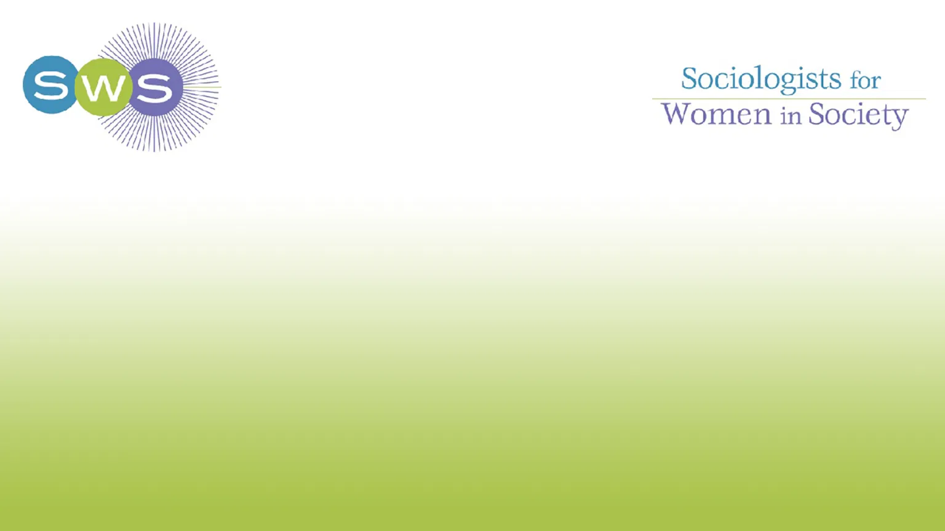
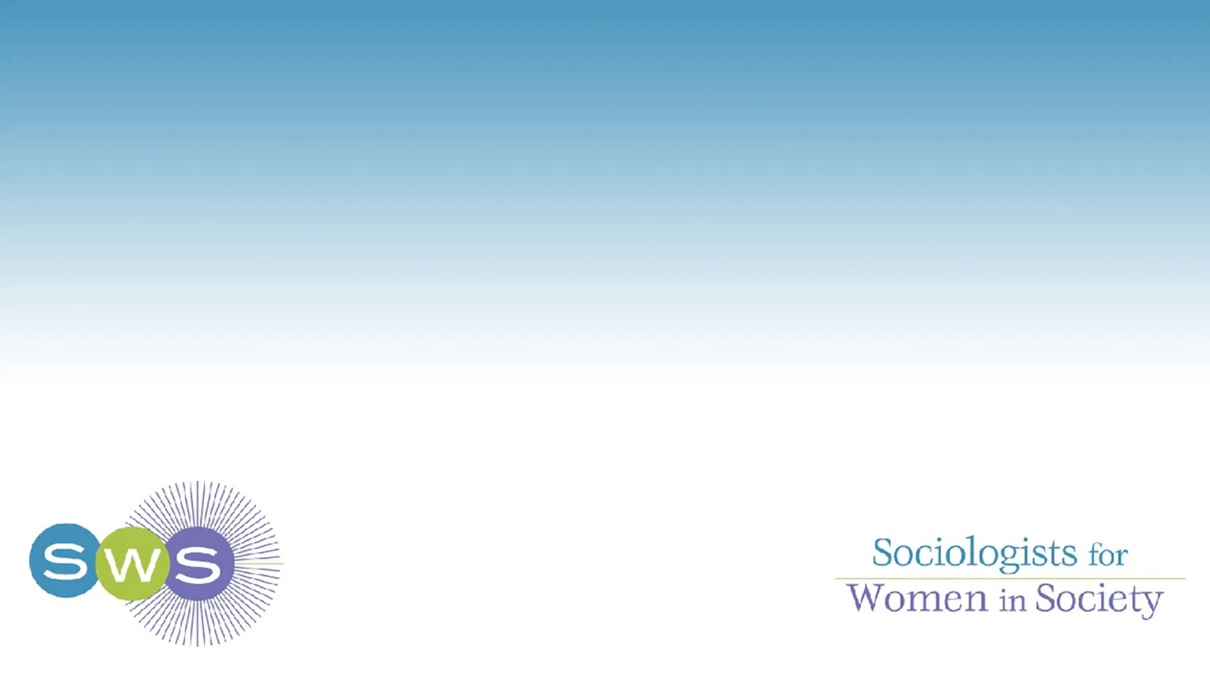
- SWS ZOOM BACKGROUNDS: SWS has created a collection of Zoom backgrounds for members! Please consider using one of the provided backgrounds for virtual pre-conference programming for the upcoming 2022 Winter Meeting, when attending professional meetings as a way to find one another, and/or to show your SWS Spirit! Download them here.

- BEYOND THE IVORY TOWER WORKSHOPS: Looking to bone up your op-ed writing skills or ways to “do public sociology”? Beyond the Ivory Tower two-day writing workshops, funded by The John Templeton Foundation, for natural scientists, social scientists, and philosophers looking to communicate their ideas to the public via articles and essays in major media outlets. The workshop is designed to benefit scholars with a range of experience writing for popular audiences. Led by The New York Times editor James Ryerson, who has two decades of experience working with and editing academics, where you’ll hone your skills writing public facing pieces that get published in major media outlets. “Twelve attendees will come out with a pitch-ready piece, ongoing weekly office hours through 2026, and all sorts of other knowledge and support. Attendees receive $2k to offset expenses.” Workshops are based in Boston, but virtual attendees can be accommodated. The next workshop is November 12th and 13th, 2021. But if you can’t make this one, they’ll be running 15 of these workshops over the next five years.

- COUNCIL FOR CONTEMPORARY FAMILIES (CCF) CALL FOR BLOG POSTS:
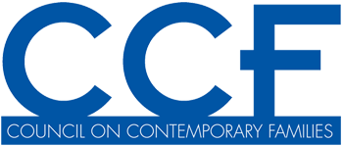
- Do you have a recent research paper out related to families or relationships, and want more people to know about it?
- Do you have a research-informed opinion on a current event related to families and relationships, such as COVID-19, the new child tax credit, the end of the eviction moratorium, or new laws about teaching critical race theory in schools?
- Do you have some interesting research findings that you had to cut from your last paper, but would make a great short stand-alone piece?
- Did you recently publish an op-ed on families or relationships that you have permission to repost?
- Are you interested in getting involved in more "public sociology"
The Council on Contemporary Families Blog at The Society Pages is interested in publishing your blog post! Posts should be 1-2 pages single spaced, and written for a general audience (avoid or explain jargon). Please contact editor Arielle Kuperberg atkuperb@uncg.edu with your ideas or post drafts.

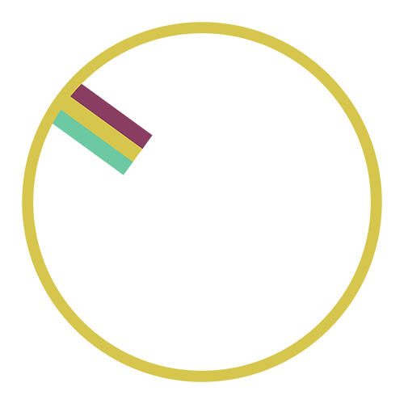
- You’re Invited! Society for Gender Professionals (SGP) Feminist Communities of Practice - Gender Circles: Hosted by Kelly Grace, Society for Gender Professionals (SGP) Secretariat-at-Large, SWS Member, and past SWS-SAIA Awardee. Café Description: Join us to learn more about the feminist theory and faces behind SGP’s communities of practice: Gender Circles! SGP Circles started as an opportunity to engage a community of gender professionals built on feminist principles and leaderless group approaches. This event celebrates the development of SGP Circles. Circle co-leads will share their experiences, approaches, and plans with the aim of engaging participants in developing existing Circles and creating new Circles based on common thematic and geographical interests. Participants can also expect to learn more about the research behind circles and their feminist leadership, get a chance to hear from some current Circles about the exciting work they have been accomplishing, and even find information on starting their own circle. Time and Date: Wednesday, November 17th at 9:00am Eastern Time. REGISTER HERE. For more information on SGP, visit: http://genderprofessionals.org/

- The Work and Family Researchers Network (WFRN) is seeking applicants for its 2022-2023 Early Career Work and Family Fellowships: The goal of the program is to help promising young scholars establish career successes and integrate them within the WFRN research community. Fellows receive a 2022 membership in the WFRN, conference registration, and $250 to attend an Early Career Fellowship Preconference (June 22nd, 2022) and the 2022 WFRN Conference (June 23rd-25th, 2022) in New York City. To be eligible, candidates must have received their doctorate in 2017 or later and have yet to progress into tenured or secure senior level positions. Information about the program can be found via this link, or apply directly here. The deadline for applications is November 1st, 2021. Questions about the program can be addressed to the program director, Lindsey Trimble O’Connor at lindsey.oconnor@csuci.edu.

- Eastern Sociological Society (ESS) Seeking Nominations for Greater Boston Community Service/Social Justice Organization for the Community Service and Activism Award: This award is presented annually to a community service and/or social justice organization working in the city in which the ESS meets during the particular year each award is given. The 2022 ESS meeting will be held in Boston. To be eligible for consideration, the organization must be working to address a significant social problem, empower marginalized communities, advance community involvement and social-political participation in underrepresented communities, and/or effect positive change in the neighborhood/city/state in which they conduct their work. The organization should be located in the Greater Boston area. This award comes with a $750 stipend and the possibility to engage in a conversation with scholars on a panel during the ESS annual meeting at which the award is given. To nominate an organization for this award, please send a letter (or letters) of nomination detailing how the group fulfills the above qualifications. Please include examples of the nominated organization’s work, copies of (or references to) any relevant published materials and/or press coverage, and contact information for both nominator and the organization. Please send nominations to the committee chair, Cinzia Solari (cinzia.solari@umb.edu). Deadline November 15th, 2021.

- Diasporic Womanisms and Indigenous Women’s Movements of the Global South Mini-Conference: The mini conference will be part of the Southern Sociological Society (SSS) conference which will be held in Birmingham, Alabama, April 6th - April 9th, 2022. See here for details.

- Mini-Conference on Reproduction: The mini conference will be part of the Eastern Sociological Society Annual Meeting at Boston Park Plaza Hotel in Boston, Massachusetts, March 10th - March 13th, 2021. ORGANIZERS: Derek Siegel (dpsiegel@soc.umass.edu), Lauren Diamond-Brown (diamonla@postdam.edu), Lauren Jade Martin (ljm@psu.edu), and Katie Slauson-Blevins (kslauson@odu.edu). ABOUT: The study of reproduction is a thriving area of research in sociology and offers an important site for examining the interrelationships between population, politics, medicine, technology, sexuality, gender, and race. Since 2012, the Eastern Sociological Society has sponsored a mini-conference on the Sociology of Reproduction in conjunction with its annual meeting. This mini-conference brings together scholars with a common area of research that might otherwise be divided across other subfields of Sociology. This year we welcome all papers related to the Sociology of Reproduction, but especially encourage those that engage with the conference theme, Strategic Sites and Ways for Sociology to Fight Inequality and Injustice. We are interested in scholarship broadly defined as research, teaching or more activism-oriented public sociology on issues of reproductive justice. We welcome papers that contribute to our understanding of reproductive experiences such as abortion and contraception, fertility and infertility, ART, surrogacy, pregnancy, birth, breastfeeding, pregnancy loss, motherhood, maternal morbidity and mortality, as well as related institutions such as reproductive technology, medicine, and midwifery. SUBMISSION INSTRUCTIONS: Those wishing to present papers in this mini-conference should submit an abstract of no longer than 250 words by November 1st, 2021 directly to the ESS Portal. Select “Organized Sessions,” input your abstract, and under “Session Type” select “Mini-conference on Reproduction.” We will notify you about the status of your submission by late November.

- Call for Editorship Proposals for Contexts, Journal of Health and Social Behavior, and the Rose Series: The ASA Publications Committee encourages applications for the editorships of Contexts, the Journal of Health and Social Behavior, and the Rose Series in Sociology. The official term for the new editor (or co-editors) begins in January 2023, with the transition starting in summer 2022. The editorial term is for an initial three years with an extension of one or two years possible. Proposals are due December 1st, 2021. ASA Council will appoint the new editor in March 2022. See complete application procedures and examples of previous successful proposals.

- CALL FOR PROPOSALS - The Africa Peace & Security Agenda: Lessons Learned and Future Directions, The 30th Annual Africa & Diaspora International Conference, April 28th-30th, 2022, Sacramento, CA, USA. The Center for African Peace & Conflict Resolution (CAPCR) at California State University-Sacramento, invites individual paper and panel submissions for its annual conference. The theme aims to examine, analyze and/or evaluate the status of various aspects of the Africa Peace & Security architecture including processes, institutions, and impacts, at the continental (Africa Union), regional (e.g., ECOWAS. IGAD, etc.), national, and local levels communities/systems. The analysis or discourse will include the intersectionality of the legacies of (neo)colonialism, resource exploitation, and electoral/political violence as well as contemporary challenges of social justice, environmental justice, violent extremism or identity conflicts, self- determination movements, and stable governance. For more information contact the program chairs Dr. Nicole (Nicky) Fox and Dr. Colins Imoh (capcr@csus.edu). Abstracts are due by November 1st, 2021. Please note that conference location and presentation format may change due to the prevailing COVID-19 pandemic related public health conditions and domestic/international travels restrictions.

- CALLS FOR PAPERS (CFP) & ABSTRACTS: View more details about these and other calls on SWS’s Learning Management System.

- Call for Submissions for Special Issue of SIGNS - “Complexities of Care and Caring” - Guest Editors Linda Blum (Northeastern University), Martha Albertson Fineman (Emory University), and Amber Jamilla (George Washington University) invite submissions for this special issue of SIGNS: Journal of Women in Culture and Society by December 15th, 2021. Read the full call here.

- Abstracts for Working Paper Series, Navigating Careers in the Academy: Gender, Race, and Class: Abstracts are now being accepted for the Spring 2022 issue of the Working Paper Series: Navigating Careers in the Academy: Gender, Race, and Class. The Susan Bulkeley Butler Center for Leadership Excellence, in partnership with ADVANCE-Purdue, introduced this Working Paper series for the first time in Spring 2018. The series serves as a means for documenting and sharing interventions, practices, and processes developed or utilized by those in the academy to navigate their careers. The series has two issues during an academic year - one in the fall semester and one in the spring semester The deadline for submission of abstracts for the Spring 2022 issue is January 14th, 2022. More information and submission instructions can be found here.

- Deadline Extension for Submissions to a Special Issue of Work and Occupations - “Precarious Employment and Well-Being During the COVID-19 Pandemic”: Submission for papers has been extended through November 22nd, 2021 23:59 PST. The original full CFP can be found here.

- Call for Papers: Special Issues of Teaching Sociology:

"Teaching Sociology by, for, and about First-Generation and Working-Class Persons": Guest Editors: Bob Francis, Colby King, Marisela Martinez-Cola, Mary Scherer, and Myron T. Strong. All submissions for and questions about this special issue should be sent to the guest editors at their shared email address tsfgwc@gmail.com. Initial abstract submissions are due February 1st, 2022. All accepted proposals will be peer-reviewed before publication. Read the full call here.

"Teaching and Learning a Humanistic Sociology": Guest Editors: Amy E. Traver (ATraver@qcc.cuny.edu), Hwaji Shin (hshin2@usfca.edu), and Malgorzata Bakalarz Duverger (bakam123@newschool.edu). While all submissions are welcome, they encourage those that address teaching and learning a humanistic sociology with first-generation and new-majority students, diverse learners, and adult or returning students, and those that unfold in often-ignored contexts like pre-college or dual-enrollment programs, community colleges, tribal colleges and universities, HSIs, HBCUs, graduate programs, and institutions of higher education located in the territories of or outside the United States.All submissions for and questions about this special issue should be sent to the guest editors. Initial submissions are due by July 1st, 2022; selected submissions will undergo peer review. Read the full call here.

SWS Virtual Feminist Engagement Opportunities

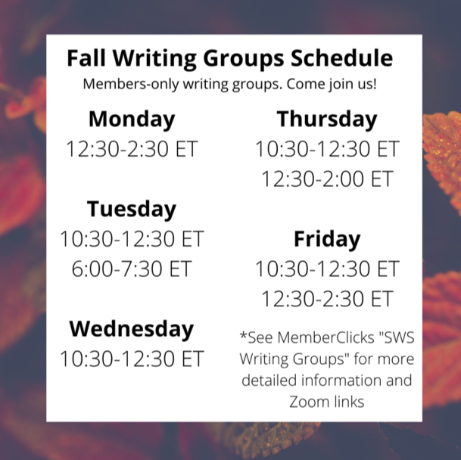

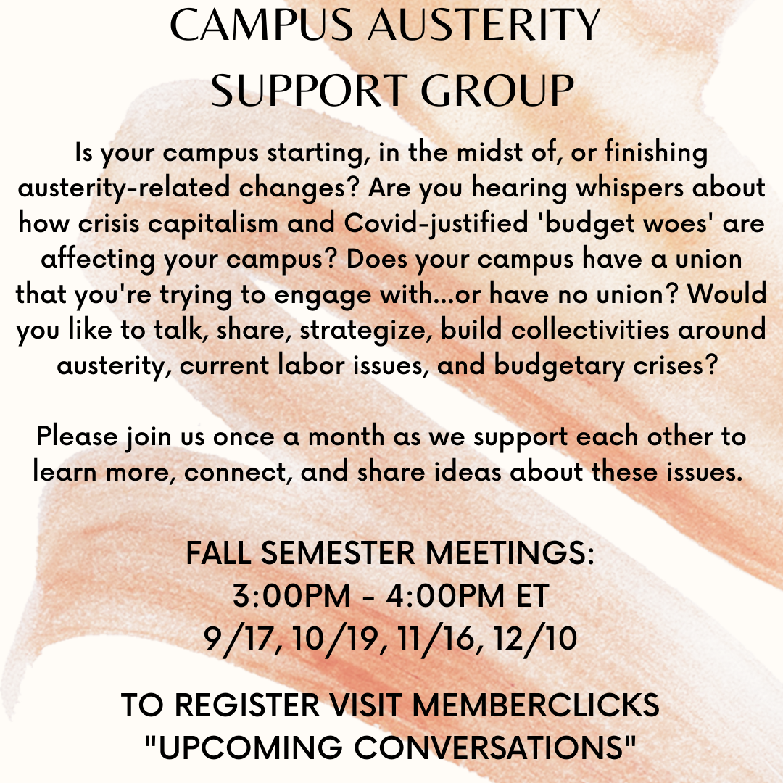
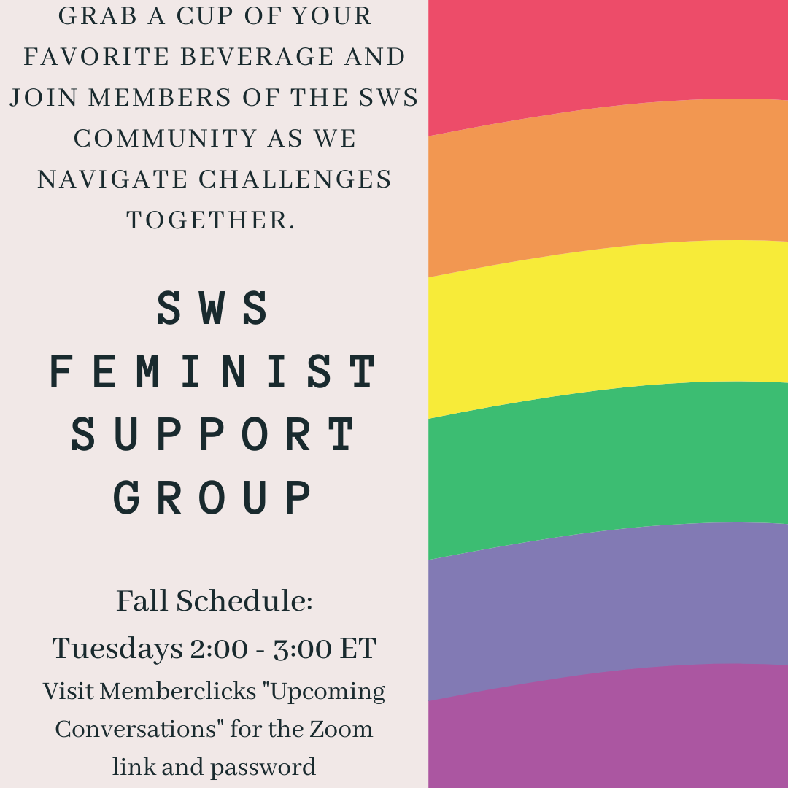

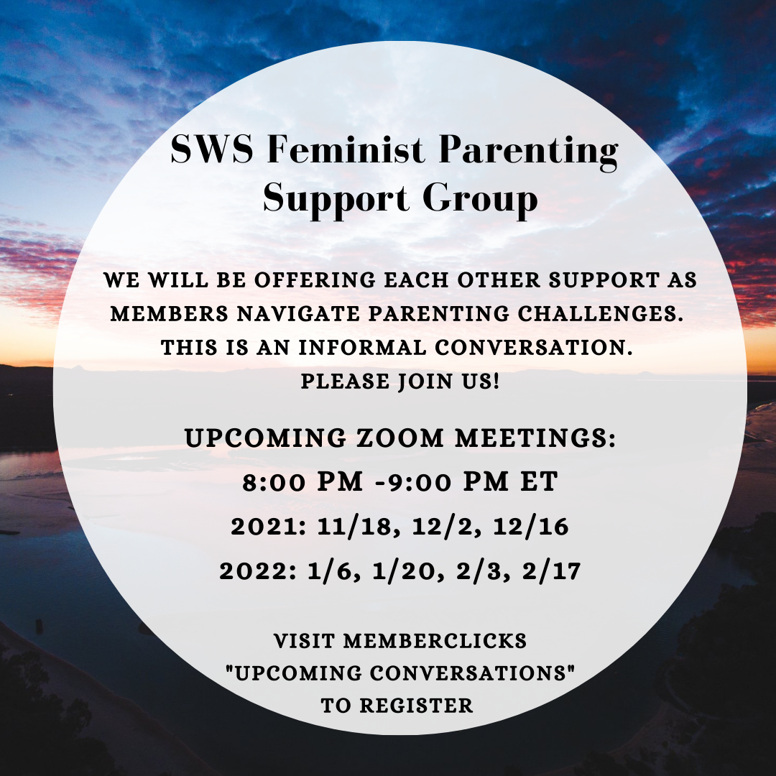
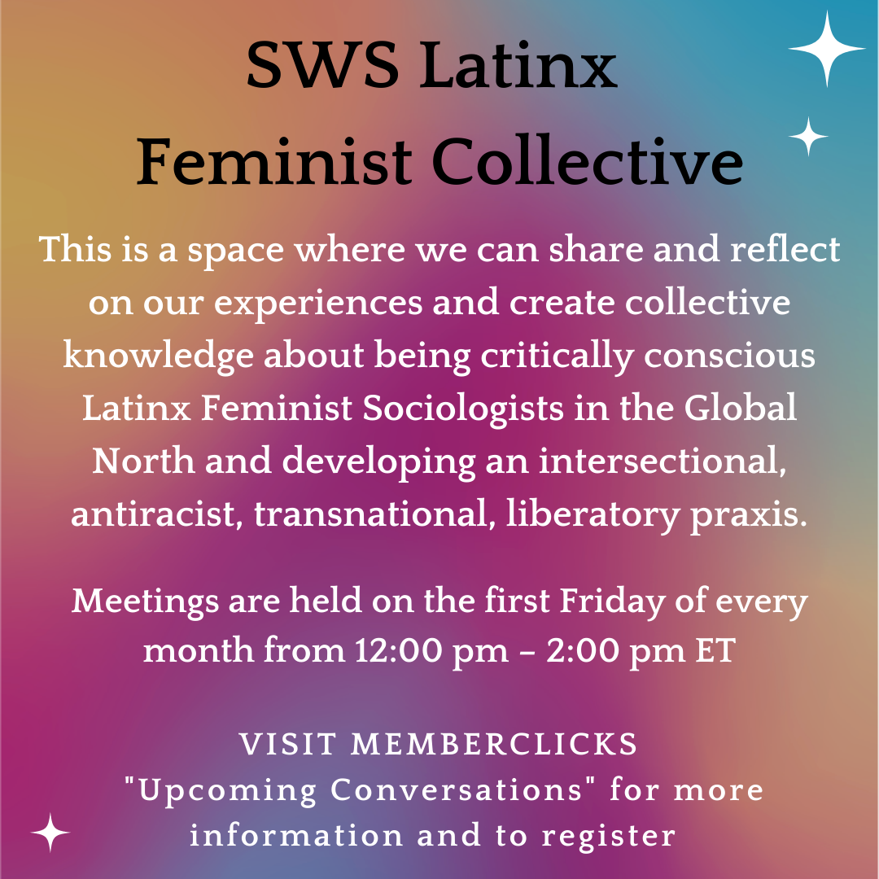

More information about all of these opportunities and resources can be found on the
SWS Member’s Portal MemberClicks: https://sws.memberclicks.net/

GENDER & SOCIETY
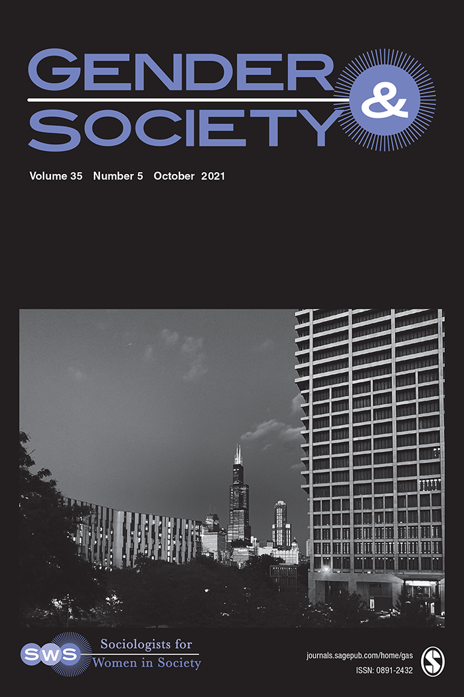

About Gender & Society: Gender & Society is a peer-reviewed journal, focused on the study of gender. It is the official journal of Sociologists for Women in Society, and was founded in 1987 as an outlet for feminist social science. Currently, it is a top-ranked journal in both sociology and women’s studies. Gender & Society publishes less than 10% of submitted papers. Articles appearing in Gender & Society analyze gender and gendered processes in interactions, organizations, societies, and global and transnational spaces. The journal primarily publishes empirical articles, which are both theoretically engaged and methodologically rigorous, including qualitative, quantitative, and comparative-historical methodologies. Gender & Society also publishes reviews of books from a diverse array of social science disciplines.

Call for Submissions for Special Issue of Gender & Society - “Race, Gender, and Violence in the United States”: Guest Editors Pallavi Banerjee (University of Calgary), Maria Cecilia Hwang (McGill University), and Rhacel Parreñas (University of Southern California) invite submissions for this special issue by January 15th, 2022. Read the full call here.

NEW! On The Gender & Society Blog

“Good” and “Bad” Women: Gender Performance in the Context of Class Stratification” by Sidra Kamran

“Occupational Gender Segregation: The Evolving and Paradoxical Process” by Margarita Torre and Jerry A. Jacobs

“On the Periphery: Women in Football Leadership” by Amée Bryan, AJ Ranking-Wright, and Stacey Pope

“Doing/Undoing Gender” by Yuchen Yang

“Not Model Behavior: The Pervasiveness of Sexual Harassment in the Modeling Industry” by Jocelyn Elise Crowley

“Who Pulls the Purse Strings in Couple Relationships: Divergent Gender Revolutions” by Yang Hu

“Women’s Work” and the Welfare State: New Analysis Quantifies How Gender, Class and Social Policy Shape Unpaid Care Work” by Naomi Lightman and Anthony Kevins

“A Black Girl’s Crown Changes the Game” by Dominique C. Hill

“We ‘Said Her Name’ and Got Zucked”: Black Women Calling-Out of Digital Platforms” by Kishonna L. Gray and Krysten Stein

SWS-CHAPTER UPDATES

SWS-South
SWS-South Early Career Gender Scholar Award
Junior scholars who are making a noteworthy contribution to our understanding of the sociology of gender will have an opportunity to apply for the Early Career Gender Scholar Award. Nominees should have authored groundbreaking work (that can include articles and/or a book) and which advances the scholarship of gender. As a “career” award, the awards committee will make decisions based on the nominee’s career thus far. While the award is for a gender scholar, consistent with trends in gender scholarship, intersectional work is welcomed.

Eligibility: Assistant professors, postdoctoral scholars, contingent faculty, research associates, or other early career scholars who earned their Ph.D. within the last six years are eligible for this award. Nominees may come from the applicant or from a third-party nominator and are due January 15th, 2022. Nominees must be affiliated with SWS-South (if not a current member, join here).

Nominations: Nomination may be submitted electronically to rallison@soc.msstate.edu and packets should include the following:
- One nomination letter detailing the merits of the nominee’s work,
- A copy of any articles or books* to be considered for the award,
- A current CV of the nominee.

*Please provide an electronic version of a book if at all possible. If hard copy, please email Rachel Allison at rallison@soc.msstate.edu to request mailing addresses for committee members and send each member a copy of the book.

Award winners will receive a plaque, alongside a one-year membership to SWS-South. In addition, the winner will be featured in the following year’s SWS-South newsletter and will present their work at an SWS-South/SSS special session.

Please send all nomination packets by January 15th directly to the SWS-South Awards Committee Chair: Rachel Allison at rallison@soc.msstate.edu.

SWS-South T-Shirts

SWS-South is excited to introduce a custom designed t-shirt to our members. The shirt is designed by one of our members. The t-shirts are in unisex adult sizing XS – 6XL. The shirts are Port and Co. PC 450, in the color Team Navy, and are 100% cotton. Also, in an effort to support small woman run businesses, the shirts are printed by The Dragonfly. There is a suggested donation of $18.00 per shirt (shipping included). Shirts will be shipped out in mid-fall. Use your SWS Member Clicks username and password (what you use to register for SWS-South), you can order here: https://sws.memberclicks.net/sws-south-t-shirt.

2022 WINTER MEETING
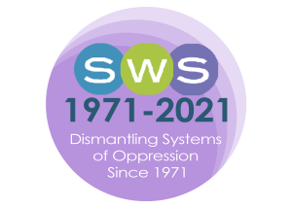

SWS 2022 Winter Meeting

“Rethinking Feminist Sociologies in the Era of Global Pandemics”

Santa Ana Pueblo, New Mexico

Thursday, January 27th - Sunday, January 30th, 2022

President-Elect: Roberta Villalón

“Thank you!” to the 2022 Winter Meeting Program Committee Members:
Alexis Grant-Panting, Andrea (Drea) S. Boyles, Chriss Sneed, Erika Busse-Cardenas, Erika Marquez, Esther Hernández-Medina, Ghassan Moussawi, Nancy López, Ӧzlem Altıok, stef shuster, Tracy Ore, Tristen Kade, and Veronica Montes

“Thank you!” to the 2022 Winter Meeting Local Arrangements Committee Members:
Nancy López, Assata Zerai, Jessica Goodkind, Maricarmen Hernandez, Ranita Ray, Georgiann Davis, Lisa Broidy

GENERAL INFORMATION:

The 2022 SWS Winter Meeting will be taking place in person!!! We are contracting with the Hyatt Tamaya Resort & Spa at Santa Ana Pueblo, New Mexico. You might recall that we had our Winter Meeting there in 2013 when Bandana Purkayastha was President. High vaccination rates, safety protocols, contributing to the Santa Ana Pueblo economy, and the beautiful location that offers a retreat-like experience for us to recharge as a feminist community guided our principles for making this selection. We will be contracting a room rate which is comparable to what SWS members paid for a room night at our last in-person meeting at Paradise Point in San Diego in 2020.

Moreover, to address affordability, we will provide a series of mechanisms to help members offset travel costs.

Recognizing that some members may not attend in person, we will have some virtual programming both before and after the 2022 Winter Meeting. We are also working out the details to have some of the programming live streamed or recorded for later viewing on our forthcoming YouTube Channel. Stay tuned for updates!

As in the past, we will offer childcare services, a lactation space, and gender-neutral restrooms, and we will accommodate dietary needs.

**For the most up-to-date information about the meeting visit: https://socwomen.org/winter-meeting-2022/

THEME AND CALL FOR PAPERS:

The global pandemic unleashed by COVID-19 exacerbated pre-existing social inequalities while simultaneously generating intersecting issues across socioeconomic, racial, ethnic, gender, sexual, geopolitical lines worldwide. As feminist sociologists, we were able to identify the inequalities that were intensified and were also ready to join forces with the many social movements devoted to dismantling systems and practices of oppression. However, we were frustrated with the arbitrariness of local, national, regional and international policy-making, the widespread resistance to be informed by science and the persistence of disciplinary and partisan fragmentation and mutual distrust, all of which delayed or prevented the imperative need of bridging across differences to collectively address a global threat to humanity. Moreover, we were puzzled with the ontological and epistemological crisis that the coronavirus presented: assumptions about the form and nature of social reality as well as existing theories of knowledge and research methodologies were put into deep questioning. In our 2022 Winter Meeting, we will reflect on how this complex crisis challenges feminist sociologies.

How should we rethink the way we do social science as feminist sociologists? How can feminist sociologists be more effective in advancing equity across geographical, political, economic, and intersecting social and cultural borders? How can feminist sociologists work together and learn from/with social movements activists and public forces? How can we best understand and also contribute to collective solidarities? How can feminist sociologies do better to restore current and prevent future crises? In this new historical time – one that has been described as the real beginning of the XXI century and labeled as ‘The Era of Global Pandemics’ by thinkers like Boaventura de Sousa Santos – we must urgently dismantle the forces that shaped history: from colonialism and capitalism (with its intimate accomplices, classism, racism, sexism, homophobia, transphobia, ableism, ageism and more) to the anthropocene. How can we update our feminist sociologies so that, instead of reacting to the inconsistencies of a new era, we can imagine a different future by shaping it proactively and creatively in the present? How could we engage with critical interdisciplinary and humanistic traditions to further enhance our modes of thinking and theorizing? In short, how can we imagine liberatory feminist sociologies in our times?

Join us in this joint reflection so that we can ensure that the relevance of feminist thought and practice becomes key to turning the page, end the era of extreme inequalities, and build alternative futures.

We welcome submissions for:
- Individual Papers for Panel Consideration
- Panels
- Workshops
- Book Salons (preference of books published in 2020, 2021, or set to come out in 2022)
- Roundtables (in-person or virtual)
- Poster Sessions (in-person or virtual)
- Open format:
- Photo essays
- Poetry, theatre, scripts
- Art
- Film/documentaries
- Media and Literary Criticisms
- Other

We welcome expressions of interest to serve as a Moderator as well.

Important Dates:
- Submissions Deadline: November 1st, 2021 - EXTENDED to November 5th, 2021
- Notices of Acceptance: November 30th, 2021
- Registration Opens: December 1st, 2021

2022 SWS Winter Meeting Submission System Is Now Open

SWS MEMBERS CLICK HERE

Through November 5th, 2021 at 11:59 pm Eastern Time

SWS 2022 Winter Meeting

COVID-19 Health and Safety Protocols

UPDATED: October 17th, 2021

SWS is carefully monitoring recommendations from the Centers for Disease Control and Prevention and others regarding the COVID-19 situation as we plan for the 2022 SWS Winter Meeting in Santa Ana Pueblo, New Mexico.

Meeting attendees will be required to follow all health and safety protocols mandated at the time of the meeting.

We are dedicated to ensuring our attendees have a healthy and safe meeting experience. Based on current information, we are implementing the following protocols:

- Vaccinations are a mandated requirement for participation in the 2022 SWS Winter Meeting. We will be collecting proof of vaccination from our attendees within our 2022 Winter Meeting Registration form. We are working out details regarding exemptions to this mandate. We understand that minors under the age of 12 years of age who may be participating in our childcare programming are not presently eligible for vaccines.
- All attendees must show a negative COVID-19 test result from a test taken within 72 hours prior to arrival to Santa Ana Pueblo, New Mexico. This includes all attendees’ children and guests who are participating in our programming. Lack of proof of a negative test result will prevent attendees from participating in the meeting. No exceptions. We will have an online submission system where attendees must upload proof of a negative COVID-19 test result.
- We will have a strict mask policy in all public spaces of the meeting hotel. Masks that completely cover your nose and mouth and fit snugly are expected to be worn by all individuals in accordance with CDC recommendations. Check this link for further information on masks.
- A 6-feet distancing policy will be maintained at all times while in the event spaces. Seating will be set up accordingly for all indoor and outdoor events, including receptions and SWS organized meals so when masks are taken off to eat or drink, we will still be distanced.
- The hotel staff will follow strict health and safety protocols, and the audiovisual support team will ensure cleanliness of microphones and other equipment.
- Hand sanitizing stations will be set up throughout the event spaces. Moreover, attendees must follow thorough hand washing CDC recommendations.
- Childcare services and lactation rooms will follow similarly strict health and safety policies.
- Meeting attendees will be asked to sign a COVID-19 waiver that will be part of the 2022 SWS Winter Meeting Registration form.
We will all play a role in keeping our meeting as safe as possible, so we expect attendees to be responsible and caring. If adjustments must be made due to changes reported by the CDC, we will communicate them promptly.
Please share any questions with SWS Executive Officer, Barret Katuna, at swseo.barretkatuna@outlook.com. Barret will compile a list of frequently asked questions and will post responses soon.

Questions??
Please direct questions to Barret Katuna, SWS Executive Officer, at swseo.barretkatuna@outlook.com.

Memories from the Site Visit for the 2022 Winter Meeting in New Mexico

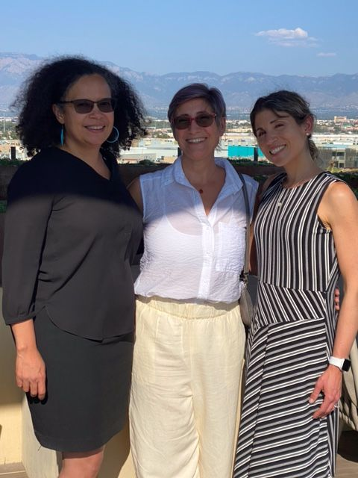
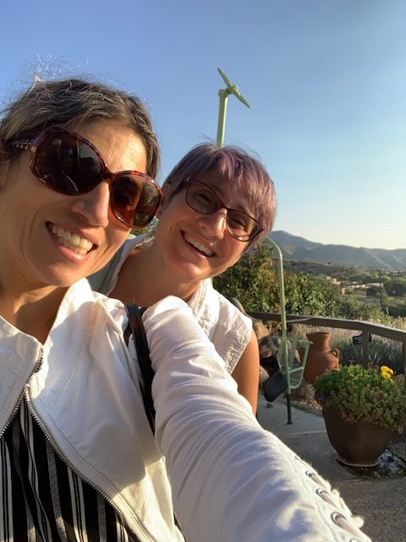

Nancy López, Roberta Villalón, and Barret Katuna in Old Town, Albuquerque | Barret Katuna and Roberta Villalón at the top of the Sandia Peak Tram
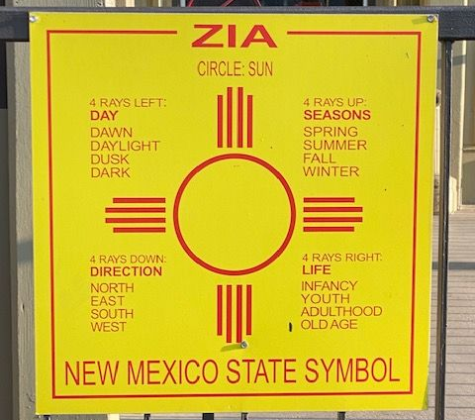
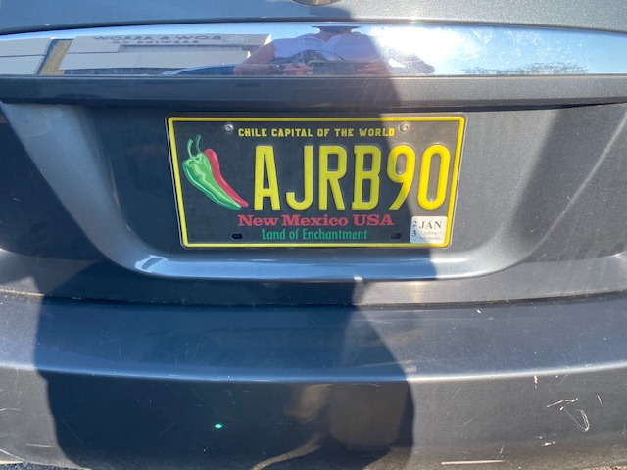

embers | SWS | Legal
- Join or Renew Today!  - MemberClicks  - Learning Management System | - About  - FAQs  - Contact  - Donate Now  - Membership  - 501 (c)(6) Information | - Terms of Use  - Privacy Policy
© 2021 Sociologists for Women in Society
Facebook
Twitter

Publication Team: Melissa D. Day (Editor), Natasha Santana (Assistant to the Executive Officer), Barret Katuna (Executive Officer of SWS)

