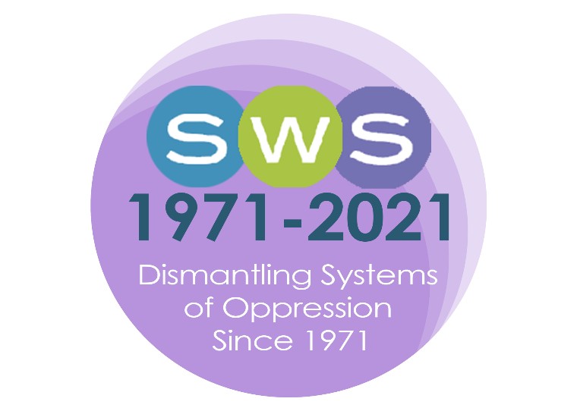

SWS 2021 Virtual Summer Meeting
“Retaining and Building an Inclusive Feminist Community”

Special thanks to the Program Committee!
2021 Summer Meeting Program Committee: Andrea Román Alfaro, hara bastas, Alexis Grant-Panting, Rebecca Hanson, Ghassan Moussawi, LaTonya J. Trotter, Barret Katuna, SWS Executive Officer, Natasha Santana, Assistant to Executive Officer, Shuchi Sanyal, SWS Intern, and Christelle Lachapelle, SWS Web Support Specialist.

Welcome to the SWS 2021 Summer Meeting!

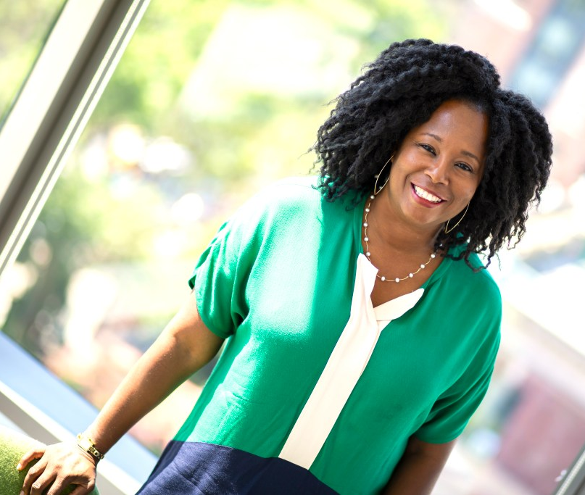
Hello and welcome to the 2021 Virtual Summer Meeting of Sociologists for Women in Society! Our theme, “Retaining and Building an Inclusive Feminist Community,” builds on the goals from our 50th Anniversary Winter Meeting. We have prepared an exciting range of sessions and events designed to encourage interesting conversations over the next two days as we gather in virtual spaces. I’d like to offer a special word of thanks to the 2021 Program Committee for their very detailed work organizing our sessions. They include Andrea Roman Alfaro, hara bastas, Alexis Grant-Panting, Rebecca Hanson, Ghassan Moussawi, LaTonya J. Trotter, and members of the SWS Executive Office: our dynamic EO, Barret Katuna, her assistant, Natasha Santana, our web support specialist, Christelle Lachapelle, and SWS intern, Shuchi Sanyal.
We have managed to pack quite a number of activities into the next 48 hours, so take a close look at the program and make note of the sessions you plan to “attend.” I would like to call your attention to the Presidential Plenary on Thursday evening, where we pay tribute to the mentorship, research and activism of our community member Sinikka Elliott, who passed away this past May. On Friday night I will host our “Drinks with a Famous Feminist” with Rutgers Sr. VP for Equity, Anna (Enobong) Branch, and invite you to make a cocktail or mocktail and join us for fun and conversation. We will also celebrate all of our inspiring awardees at the Summer Awards Celebration, so come through and show your love and support! Members can also attend our Business Meeting on Friday (starting at 12:45 pm EDT) to get a sense of where we are fiscally headed as an organization and to learn more about the work of our actively engaged committees.
As we build on 50 years of SWS we strive to continue to show, through deeds, our commitment to retaining and supporting an inclusive feminist community. I am thankful for the opportunity to lead SWS in this way.
Warmly,
Mignon

Here’s a quick guide to how to tweet during the SWS Summer meeting:
1. Follow @socwomen on Twitter
2. Find other SWSers to follow on Twitter (and add yourself if you’re not listed): http://bit.ly/SWSTweets
(capitalizations matter with this link, but not with Twitter hashtags or @’s).
3. During the conference, use the hashtag #SWS2021 and #SWSvirtual2021 so that others following the tags
can see your tweets.
You can use other tags to bring attention to different issues.
4. Any feminist sociology—related tweets about sessions, events, etc. should include @socwomen.
@Socwomen will do their best to retweet these during the conference.
2021 Summer Meeting Program
July 8, 2021 to July 9, 2021
(All times are in Eastern Time Zone)

Thursday, July 8, 2021
11:00 am – 12:30 pm Session/Workshop 1: Job Market 101: Navigating the Academic Job Search
Panelists:
- Brittany Battle, Wake Forest University
- Andrea Gómez Cervantes, Wake Forest University
- Amanda Gengler, Wake Forest University
- Shannon Malone Gonzalez, The University of Texas at Austin
- Sofia Locklear, University of New Mexico
In this workshop, we bring together a range of scholars to give advice about navigating the job market. Panelists include recent graduates who navigated the job market successfully during the pandemic, junior faculty who were recently on the market, and tenured faculty with search committee experience. As the pandemic continues and universities manage economic crises, academics face growing pressure around navigating the hidden curriculum of seeking and landing a job. In this workshop we will offer suggestions for:
- Preparing materials for the job market for a range of institution types
- Managing the application process
- Preparing for interviews and campus visits (virtual and in-person)
The workshop will also specifically address navigating the job market from Black, Indigenous, Latinx, and POC experiences. We will create a resource guide for attendees and offer space for questions regarding the many aspects of navigating the academic job market.
11:00 am – 12:30 pm Session/Workshop 2: Trauma Informed Feminist Pedagogies During the
Pandemic and Beyond
Organizers and Panelists:
- Elycia Daniel, Clark Atlanta University
- Kris De Welde, College of Charleston
- Andrea Hunt, University of North Alabama
- Heather Laube, University of Michigan, Flint
- Kylie Parrotta, California Polytechnic State University
Sponsored by Social Action Committee, Career Development Committee & Student Caucus

The impacts of trauma have been acknowledged by educators at all levels; with recognition that supporting students with histories of trauma, engaging students in learning, and providing resources and safe educational spaces allows them to succeed (Davidson, 2017; Trauma Informed Oregon). Most incoming college students have experienced DSM-IV Criterion A trauma (Read et al., 2011) and the higher risk of trauma on campuses increases the number of trauma-affected students who may be present in our courses (van der Kolk, 2019). Working with students through trauma-informed perspectives is an issue of equity and inclusion, particularly as trauma is experienced disproportionately and intersectionally by minoritized and marginalized students (Nordhoff, 2019). The 2020-2021 COVID pandemic forced a shift for most of us to exclusively virtual educational contexts to which we generally adapted swiftly, and with technologically mediated innovations and strategies. And while we faced a range of logistical challenges converting our classes to various online modalities, our pedagogies and approaches to student learning also necessarily expanded: we adapted to being increasingly responsive to and flexible with students, we helped them unpack and navigate police violence, local and global health disparities, relentless job loss, unexpected challenges with caretaking, and death all through intersectionally-minded, trauma-informed lenses. Our feminist pedagogical approaches facilitated these shifts, and also raise important questions for us as we move into a post-pandemic reality: How do feminist pedagogical practices intersect with trauma informed education practices (Imad, 2020a; 2020b)? How will we continue supporting students in their becoming sociologically mindful as we look to the future, while also creating trauma-informed spaces for healing from the last year? Join us for a discussion of these broad issues as well as what strategies worked and didn’t work in asynchronous, synchronous, and face2face formats, and at various institution types and from diverse positionalities.

References:
Davidson, S. (2017). Trauma-informed practices for postsecondary education: A guide.
Education Northwest. Available from:
https://educationnorthwest.org/northwest-matters/trauma-informed-strategies-postsecondary-educators
Imad, Mays. 2020a. “Trauma Informed Teaching and Learning.” Webinar:
https://www.youtube.com/watch?v=XqcTbipuFDQ&feature=youtu.be
Imad, Mays. 2020b. “Hope Matters.” Inside Higher Education.
https://www.insidehighered.com/advice/2020/03/17/10-strategies-support-students-and-help-them-learn-during-coronavirus-crisis
Nordhoff, Kaity. 2019. “Introduction to Trauma-Informed Classrooms: Inclusive Learning
Read, J., Ouimette, P., White, J., Colder, C., & Farrow, S. (2011). Rates of DSM-IV-TR trauma
exposure and posttraumatic stress disorder among newly matriculated college students. Psychological Trauma, 3(2),148-156. https://doi.org/10.1037/a0021260
Strategies for Educators.” MidAtlantic Equity Consortium.
https://maec.org/resource/introduction-to-trauma-informed-classrooms-inclusive-learning-strategies-for-educators/
Trauma Informed Oregon. https://traumainformedoregon.org/wp-content /uploads/2016/03/Trauma-Informed-Care-in-the-Classroom.pdf
Van der Kolk, Bessel. 2015. “The Body Keeps The Score Summary and Review.”
https://lifeclub.org/books/the-body-keeps-the-score-bessel-van-der-kolk-review-summary

12:45 pm – 2:15 pm Session/Workshop 3: Latinx Feminisms/ Femininismos Latinx:
A Workshop to Collectively Define its Activist Priorities/Un Taller para definer nuestras prioridades colectivas
Co-Organizers & Presenters:
- Roberta Villalón, St. John´s University
- Nancy López, University of New Mexico
- Erika Busse, Macalester College
- Verónica Montes, Bryn Mawr College
In this workshop, we will focus on collectively identifying the priorities that a Latinx Feminist framework should have regarding activist commitments to intersectional solidarity, including antiracism and liberatory praxis in our scholarship, teaching and service within and beyond the institutions where we work at. This workshop is a continuation of our roundtable on this topic in Summer 2020 and the workshop held this Winter 2021. As a follow up workshop our aims are twofold: a) the creation of a sustainable collective focused on a Latinx Feminist frameworks to build community and secure a space for safe and constructive reflection to further develop ideas, practices and actions from this perspective, and b) compile our experiences for an edited volume or journal special issue applying theoretical and practical explanation of the framework, and selected pieces on the variety of ways in which it can be applied Workshop participants will be invited to form part of our Latinx Antiracist Feminist Liberatory Collective, which is in its initial development phase and welcomes new members. This workshop will be bilingual. Translations will be available.
12:45 pm – 2:15 pm Session/Workshop 4: Researching Intimacies, Sexualities, Genders, and Selves:
Quandaries and Subjectivities
Presider and Organizer: R. Plante, Ithaca College
Presenters/Panelists (alphabetical):
- Zoe Hadley Ithaca College, “FGWB: Friend Groups with Benefits”
- Cara Landers Ithaca College, “Misogyny on the Internet”
- Shoshana Maniscalco Ithaca College, “‘You Can Figure That Out On Your Own’: How Young Women Who Have Sex with Women Learn about and Conceptualize Sex”
- Grayson Stevens Ithaca College, “Recognition, Reflection, and Resistence: Internalized Transphobia and Gender Beliefs amongst Transgender and Nonbinary Psychotherapists”
Is there anything left to uncover in feminist research on intimacies, relationships, gender, sex and sexualities? Don’t we know everything about the ways feminist researchers’ subjectivities are involved in their work? Taking overlapping and diverging tacks, these four undergraduate papers reflect a year of engagement with key questions of self, intimacies, and gender. Zoe Hadley’s interview research on “friend groups with benefits” explores novel approaches to queering relationships and sex, revealing the multiplicity of ways in which friends have sex with friends. Cara Landers describes some quandaries involved in studying entangled Internet misogynies, exploring the trouble with even the most hands-off research methods. Shoshana Maniscalco interviewed queer women about sexual selfhood, and discovered that there’s nothing simple about sexual scripting. And Grayson Stevens tries to unpack the structure and role of internalized transphobia among trans and gender nonbinary therapists. Taken together, these scholars explore novel research questions not only about aspects of selves, intimacies, sexualities, and genders but also about how newer researchers grapple with the quandaries of feminist sex research.
2:30 pm – 4:00 pm Roundtable 1: Inequalities and Social Movements
- Mary-Collier Wilks, University of Virginia, “Embodying Feminism: Donor Demands & Bodily Labor in Cambodian NGOs”
- Liz Mount, Flagler College, “Social Movement Aspirations and “Happy” Activists: How Class Impacts Understandings of NGOs Among Staff”
- Bernadette Barton, Moorehead State University and Ashley Currier, University of Cincinnati, “Queer Appalachian Activism in Rowan County, Kentucky”
- Suraj Kamdar, Independent Researcher, “Deconstructing/De-Brahminising 'Indian' feminists: Addressing the intended disconnect between feminists of/in India”
- Moderator: Christobel Asiedu, Louisiana Tech University

2:30 pm – 4:00 pm Roundtable 2: Labor and Work
- Deniz Yucel, William Paterson University, “Workplace Flexibility, Job Satisfaction, and Psychological Distress”
- Megumi Watanabe, Hiroshima University, “Gender and Engagement in Domestic and International Research: Stories of University Faculty in Japan”
- Yun Cho, University of Wisconsin Madison, “STEM occupational fields’ openness to academic trainings and demographic wage disparities among U.S. college graduates, 2009-2018”
- Samina Saifuddin, Morgan State University, “Measure What We Treasure: Gender (In)Equality in India, Bangladesh, and Mexico”
- Moderator: Tracy Ore, St. Cloud State University

4:15 pm – 5:45 pm Roundtable 3: Caregiving and Parenting
- Julie Eve Martin Aguilar, California State University- Northridge, “You feel like you’re doing everything alone”: Women’s experiences with Pregnancy & Childbirth during the COVID-19 Pandemic
- Aimzhan Iztayeva, University of Minnesota, “Work, Care, and Gender Inequality: Can Single Fathers Advance the Stalled Gender Revolution?”
- Xuemei Cao, University at Albany, State University of New York, “Mothering Adult Migrant Children: Later-life Mothering Through Childcare Support in Chinese Immigrant Families”
- Laura Bunyan, University of Connecticut and Barret Katuna, Sociologists for Women in Society, “Paradoxes of Power in Carework”
- Corinne Schwarz, Oklahoma State University and Leigh Welch, Oklahoma State University, "'It is Productive to Take Care of Yourself': Anti-Violence Frontline Work, Coping, and Emotional Labor During COVID-19."
- Moderator: Mindy Fried, Arbor Consulting Partners
4:15 pm – 5:45 pm Session/Workshop 5: The Conservative Backlash against Women's Rights around the World: Starting the Conversation on Trends and Possible Solutions
Organizer: Esther Hernández-Medina, Pomona College, Sister to Sister Committee
Moderator: LaTonya Trotter, Vanderbilt University, Sister to Sister Committee
Discussant: hara bastas, LaGuardia Community College, Chair International Committee
Panelists (and countries / regions they will talk about):
- Andrea (Drea) Boyles, Tulane University, United States / North America
- Esther Hernández-Medina, Pomona College, Dominican Republic / Central America and the Caribbean
- Rodica Lisnic, University of Arkansas, Countries to be determined / Eastern Europe
- Solange Simões, Eastern Michigan University,Brazil / South America
- Dao T. Nguyen, University of Pittsburgh, Vietnam / Southeast Asia
The objective of this session will be to examine the nature and implications of the conservative backlash against women’s rights and those of other marginalized groups such as the LGBTQ community and people of color that has been taken place around the world. The idea is to hear about countries/regions where this backlash has been particularly visible, discuss the ways in which this trend has taken place in their respective countries including the actors involved, the main themes they have taken as causes to mobilize their followers, their national and international allies, and the ways these conservative movements have made their ways into politics and (if it is the case) into government, and how this has negatively impacted women’s rights and the gender equality agenda.
The session will include two additional members: (1) a moderator who will contextualize the panel and explain how it emerged as a joint initiative between the Sister-to-Sister and International Committees (through the CEDAW Subcommittee), and a (2) discussant who will make the connections between the issues addressed on the panel and CEDAW as an instrument for fostering gender equality around the world.
Sponsored by: Sister to Sister Committee and International Committee
6:00 pm – 7:30 pm Welcome from Mignon R. Moore, SWS President
Presidential Plenary: Lessons & Legacies: Honoring the Life and Work of Sinikka Elliott
This session celebrates the life and work of Sinikka Elliott who passed away in May 2021.
As our summer meeting focuses on “Retaining and Building a Feminist Community,” this session honors Sinikka and provides an opportunity to reflect and imagine how Sinikka’s work and contributions will be carried forward.
Organizers:
- Mignon R. Moore, Barnard College and Columbia University
- Barret Katuna, Sociologists for Women in Society
- Ghassan Moussawi, University of Illinois, Urbana-Champaign
- Jennifer Reich, University of Colorado Denver
- Christine L. Williams, The University of Texas at Austin

Participants:
- Teaching and Mentoring:
  - Suki Xiao, University of British Columbia
  - Kayonne Christy, University of British Columbia
  - Joslyn Brenton, Ithaca College
- Research and Scholarship
  - Sarah Bowen, North Carolina State University
  - Jessica Fields, University of Toronto, Scarborough
- Public Engagement
  - Rashawn Ray, University of Maryland
  - Fabio Rojas, Indiana University Bloomington
  - Jennifer Reich, University of Colorado Denver

Friday, July 9, 2021
11:00 am – 12:30 pm Roundtable 4: Religious, Racial, Ethnic and Gender Formations
- Hala Alnagar, University of California, Merced, “Reclaiming Our Muslimness”: Intersectional Identities of Muslim American Women in Higher Education
- Shaafi Farooqi, University of California, Riverside, “Experiences of Pakistani-Heritage College Students: On the Borders of Stereotypes”
- Nazreen S. Bacchus, Farmingdale State College, SUNY, “Standing for Faith: Muslim American Women Contextualizing Hijab in Everyday Life”
- Elizabeth McElroy, University of Oklahoma, “Trends in Traditional Identities: The Cross-Lagged Predictive Power of Gender Ideology and Religiosity
- Fae Chubin, Bradley University, “Circumcision and Colonial Reason: Gendered Racism in American College Students’ Fictional Stories about Male and Female Circumcision”
- Moderator: Maro Youssef, University of Texas at Austin
11:00 am – 12:30 pm Roundtable 5: Healthcare and Embodied Practices
- Rebecca Bonhag, Baylor University and Laura Upenieks, Baylor University, “Inequality at the Doctor’s Office – The Influences of Gender, Race, and Education on Feelings of Patients about Their Doctors”
- Trang Thu Đỗ, Monash University, Australia and Andrea Whittaker, Monash University, Australia, “Re-configuring Breast Reconstruction in the post-cancer life: Perspectives from Central Vietnam”
- Laura Hart, Missouri State University, “Individualized Risk Management among Parents of Children with Cancer”
- Ashley Green, University of South Florida, “That Exposure Opens People’s Eyes a Little Bit”: Examining the Reflexivity Between Cultural, Institutional, and Personal Narratives of Transgender Identity
- Katherine Mueller, Syracuse University, “At the Intersection of Transgender and Disabled: Examining Patterns in Health Care Utilization”
- Moderator: Jessica Harrison, University of California, San Francisco
12:45 pm – 2:15 pm Business Meeting
2:30 pm – 4:00 pm Roundtable 6: Health, Beauty, and Sexuality Redefinitions
- Cassidy Boe, University of South Florida, “You Don’t Know Anything At All”: The Production of Knowledge on Fatness and Health in the Clinic
- Kearabetswe Mokoene, Wayne State University , “Beauty according to who? Discourses of Hair, Beauty and Body Image for Black Women in Contemporary U.S.”
- Lauren C. Garcia, University of Virginia, and Tabitha Fairchild, University of Oregon “Naturally Curly: Examining race talk and racism in curly hair Facebook groups”
- Zoe Lefkowitz, University of Colorado, Boulder, “Are LGBTQ Adults More Likely to Experience Disordered Eating Behaviors Than Their Heterosexual Counterparts?”
- Linda M. Blum, Northeastern University, and Kaitlyn Eri Lee, Northeastern University, “Dating at a Distance?: Disrupting Gender Asymmetries during the Pandemic”
- Moderator: Monisola Vaughan, Vanderbilt University
2:30 pm – 4:00 pm Roundtable 7: Feminist Theory and Feminist Communities
- Liz Del Tufo, Rutgers University, “Feminist Theory: What It Was and What It Is (To Me)”
- Rosalind Kichler, University of Nebraska, Lincoln, “A Life History Study of Second Wave Feminism and Lesbian Coming Out”
- Ziwei Qi, Fort Hays State University, April Terry, Fort Hays State University, and Tamara Lynn, Fort Hays State University, “Empowerment and Support in the Ivory Tower: Facilitating and Retaining a Feminist Community in a Criminal Justice Program”
- Lejla Mušić, Political Sciences Sarajevo, BH/COIL partnership prof programme SUNY College, Old Westbury, New York, “Feminist eco criticism, transecology and new feminist groups”
- Giselle Perez-Aguilar University of California, San Francisco and Jennifer James, University of California, San Francisco, “Trauma Healing as Resistance Among Formerly Incarcerated Black Women”
- Moderator: Crystal “Jack” Jackson, John Jay College
4:15 pm – 5:45 pm Session/Workshop 6: Creating Black Feminist Communities and Interventions in
Academia
- Zakiya Luna, University of California, Santa Barbara, “Black Feminist Sociology and Edited Volumes”
- Whitney Pirtle, University of California, Merced, “The Cite Black Women Collective and Citational Practice”
- Tashelle Wright, University of California, Merced, “Creating Black Spaces on New Campuses”
- Jasmine Kelekay, University of California, Santa Barbara, “ Transnational Black Feminism and Diasporic Connections,”
- Melissa Brown, “ Black Feminisms and Digital Space,” Stanford University
Together, these panelists represent the editorial team that has created the forthcoming edited volume, Black Feminist Sociology: Perspectives and Praxis (Routledge 2021) and its linked website. The panel will include discussion of the process of trying to integrate a Black feminist ethic into the often demoralizing process of publishing using example of the volume and other print and digital publications. They will also discuss how they brought their own life and research experience into the processes and the opportunities and obstacles they faced in their respective spaces, highlighting the importance of rethinking the concept of “space” to create supportive, long-lasting communities.
4:15 pm – 5:45 pm Roundtable 8: Social Control and Violence
- Lindsay Smith, George Mason University, “The most we have is through this screen”: The impact of communicative technology on women jail residents’ quality of contact and relationships”
- Jillian Sunderland, University of Toronto , “Media Discourse and Elite Boy Violence: How Power Structures Shape Attributions of Responsibility”
- Valérie Grand’Maison, University of Guelph and Iblin Edelweiss Murillo Lafuente, University of Florida, “Bodies that do not matter: Feminicide of women and girls with disabilities”
- Ella Siegrist, Washington University, St. Louis, “Racialized Carceral Consequences: Paternal Incarceration and the Well-Being of Black and White Mothers”
- Valérie Grand’Maison, University of Guelph, “Feminist Disability Mobilization Against Gender Violence”
- Moderator: Sara Tyberg, University of California, Santa Barbara
6:00 pm – 8:30 pm 2021 Summer Awards Celebration
Feminist Activism Awardee Talk, Ophra Leyser-Whalen (2020), University of Texas
at El Paso
Mixology Session Mocktail and Cocktail, Alexis Brown, Causing a Stir
Drinks with a Famous Feminist, Enobong (Anna) Branch, Rutgers University,
hosted by Mignon R. Moore, SWS President

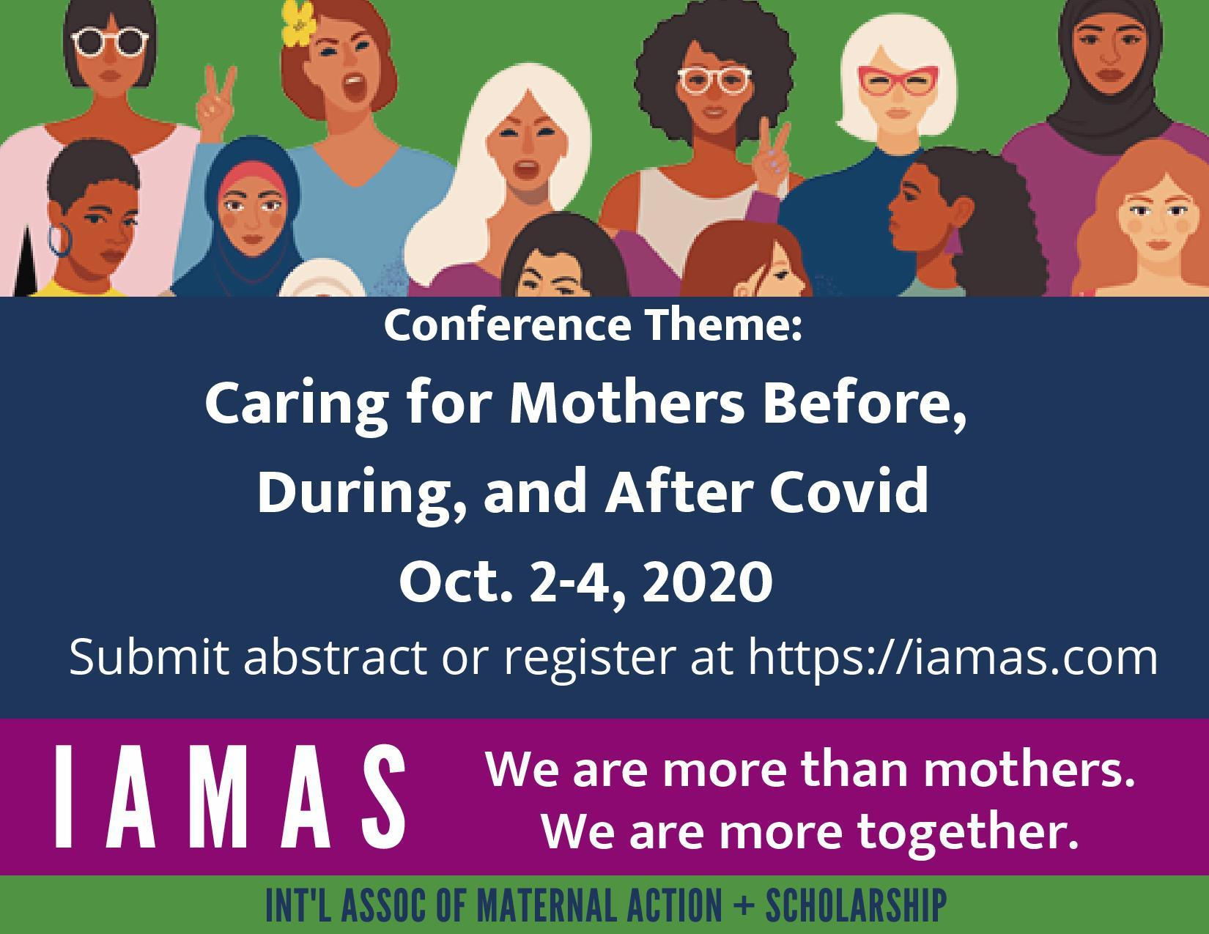
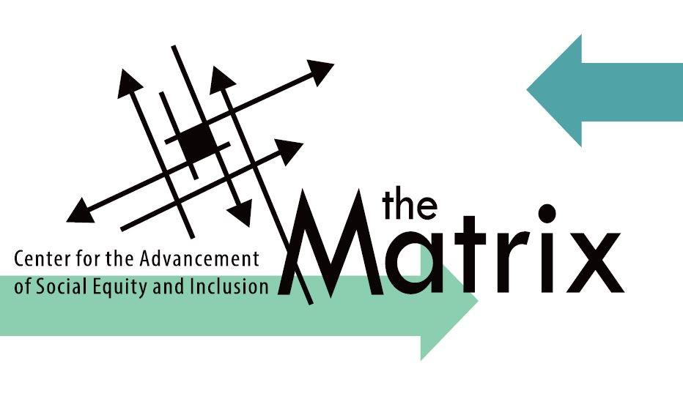
Special Thanks to the 2021 Summer Meeting Sponsors
