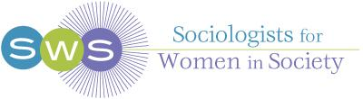
Network News
Fall 2020
President’s Column
From SWS President, Josephine Beoku-Betts
Greetings SWSers!
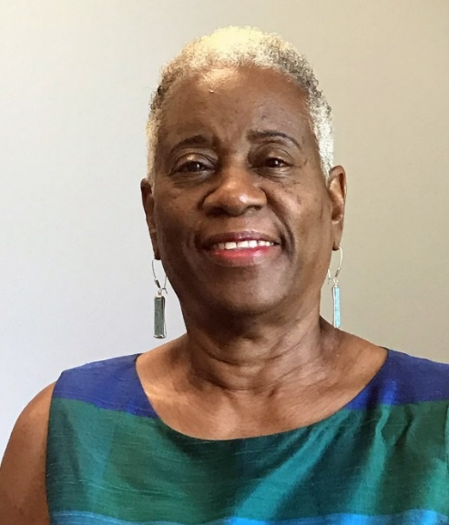
I hope you are all safe, healthy, and well-charged as we approach one of the most challenging national election seasons many of us will face in our lifetime. Now more than ever, we have to be ready to engage actively with this process in spite of the uncertainties we face, given the ongoing COVID-19 pandemic and continuing protests against systemic racism, white supremacy, and police brutality against Black and Brown people in our society. As Andrea “Drea” Boyles expressed in her recent Newsweek OpEd (Kudos to you Drea!), “The U.S still, by and large, does not support Black Lives institutionally.” Given our scholarship, research, teaching, practitioner, and activist skills as sociologists, and our ability to use our platform as a professional feminist intersectional organization, it is crucial that we participate in the ongoing dialogues and activist work individually and in collaboration with like-minded communities to bring about the structural and institutional changes we want to see. These are dangerous times that can lead to the growth and expansion of authoritarianism, populism, white supremacy, and to the erosion of what little exists as a democratic process. As a professional organization, we must lead by example for the next generation of SWSers who should not have to ask, “What did SWS do during the COVID-19 pandemic and protest movements against police brutality, systemic racism, and white supremacy?”
Thanks to all those who attended and helped make our first Virtual Summer Meeting a success. Special appreciation is extended to Barret Katuna (Executive Officer), Natasha Santana (Assistant to the Executive Officer), Christelle Lachapelle (Web Support Specialist), and the Program Planning Committee chaired by Marybeth Stalp, working in collaboration with Sasha Drummond Lewis (Sister to Sister Committee) and Solange Simões (International Committee). The meeting was well attended, and presentations and discussions were spirited and intellectually invigorating. The two thematic plenary sessions with past presidents over the decades and Gender & Society editors, marking the beginning of the SWS 50th Anniversary Celebrations, were well received and will go down as a significant part of our historical record. Thanks to Mignon Moore (President-Elect) with whom I co-chair the 50th Anniversary Committee and the 50th Anniversary Committee for their participation in organizing these events. Two other plenary sessions on “Sociological Research and Practice in Authoritarian Times” (organized by Josephine Beoku-Betts) and “Got Critical Race Feminist Studies? The Possibilities and Challenges of Institutionalizing Intersectionality in the Neoliberal University” (organized by Nancy López were also well attended and responded to. In addition to the plenaries, the various roundtables, workshops, poster sessions, award ceremonies, and committee meetings which took place simultaneously throughout the meeting were well attended and received. Thanks to all who organized and participated in these sessions. A special thank you goes to Barret Katuna for chairing all the roundtable sessions and the poster session.
Finally, I am excited to report that our first Workshop for High School Teachers on the topic “Teaching Intersectionality in the High School Classroom: Critical Race, Feminist Strategies for Student and Teacher Critical Inquiry, Praxis and Empowerment,” co-organized by Nancy López and I, was a tremendous success. I’d like to thank Nancy for her leadership in coordinating the workshop as well as Georgiann Davis, Ranita Ray, Florence Castillo, and Mary Ellen Sherman for volunteering their time to serve as co-facilitators of the workshop. We are planning a similar workshop on “Teaching Transnational Feminism in the High School Classroom,” with another group of co-facilitators, including a graduate student, for the 2021 Winter Meeting.
SWS Council, ably supported by the Executive Office, remains committed to building SWS into a more diverse, inclusive, and intersectional feminist professional organization. To this end, and since my last newsletter message, our membership has increased to over 1000. In addition, we continue to strengthen our ties with other professional organizations in our discipline. One area in which we’ve collaborated closely while producing our respective policy documents is the prevention of all forms of harassment. This initiative was originally spearheaded by past presidents Adia Wingfield and Tiffany Taylor. The policy document is now completed and has been reviewed and accepted by Council. You will be asked to review and consent to this policy when you complete your 2021 Membership Form. We have included a Victim Advocate in the policy and will share an External Consultant with some of our partner organizations.
I attended the virtual business meetings of several of our committees during the Summer Meeting and was most impressed by the various initiatives planned for the membership over the next year. One of the benefits of going virtual is that moving forward, committees can individually or collaboratively host online events to meet the needs of their members at minimal cost. The recently hosted event on “Tackling the Applied Job Market: A Group Consultation and Discussion” by the Career Development Committee provides a good example of how SWS committees will be supporting the needs and concerns of our members. Congratulations to Mindy Fried, Heather Laube, Trenton Halton, Shauna Morimoto, Sela Harcey, and Barret Katuna for putting together such an excellent event. There’s definitely more to come on the theme of mentoring, social media, and support from other committees.
Finally, heartfelt congratulations go to Bandana Purkayastha on a well-deserved nomination for the SHE Foundation’s “Aspired Women Inspire Award” by the University of KwaZulu-Natal (South Africa). Kudos to you Bandana.
Thanks to all SWSers for your dedication and commitment to advancing the mission and goals of our beloved SWS. Stay safe and well everyone.
Josephine

Message from SWS President-elect, Mignon Moore
Hello Everyone,

What a decade – I mean year – 2020 has been! And we are only two-thirds of the way through. To all who are managing to take things day by day, or hour by hour, or even minute by minute, I salute you. And to those who sometimes wake up, pull the covers over their head and go back to sleep to try again another day, I salute you as well. Whether you feel like you are moving forward, marking time, or going in circles, just know there are others in the struggle with you, and we will get through this together.

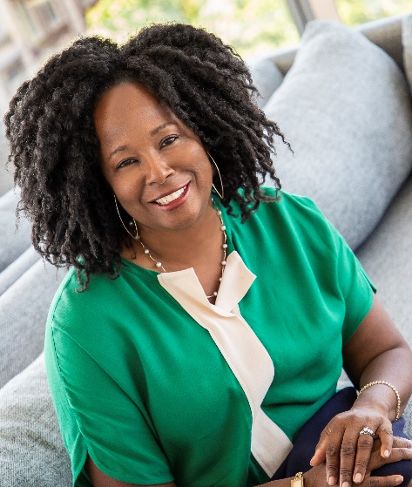
The (virtual) offices of SWS are hard at work putting together a strong Winter Meeting program to commemorate our 50th anniversary! The 2021 meetings will take place January 28 – 31, 2021 and the theme is “50 Years of SWS: Embracing the Past, Analyzing the Present, Anticipating the Future.” The challenges of the ongoing, worldwide health pandemic make our in-person participation uncertain. Whether we meet in-person in Jacksonville, FL, have a virtual meeting, or hold some type of hybrid event, our Winter Meeting will honor the contributions to and impact that SWS has had on the discipline, and shed light on the historical experiences of women in sociology. We will also look towards the future by exploring how to build and retain connections to one another in ways that will make everyone in our feminist community feel visible, included and heard.

Our program begins with a hearty range of pre-conference activities, including new member and officer orientations, student-mentor networking events, virtual mindfulness activities, a workshop on transnational feminisms for high school teachers, writing workshops, and other events that are still in development. Our conference will include three exciting plenary sessions. One will focus on what SWS has helped the discipline of sociology accomplish over the past 50 years, celebrating those who were there in the beginning and hearing from individuals who can share historical experiences about pivotal times in the organization’s development. A second plenary will ask hard questions about the work we need to do to continue to grow as a feminist institution. This session will emphasize three areas: (a) gender non-binary and trans scholars, and how to make their experiences and sociological research on these areas visibly important to the organization and beyond; (b) race and ethnicity, looking intersectionally when considering the experiences of women in SWS and in society; and (c) social class and the needs of scholars from under-resourced institutions or who have limited economic means. Gender, race and class continue to be at the forefront of considerations that must be attended to for SWS to flourish in the 21st Century. Our final plenary continues an earlier tradition of examining gender and leadership by inviting the heads of universities and major organizations to talk about their experiences as leaders. The 50th Anniversary Committee will also organize a special session to celebrate SWS. And this year, we will introduce a new type of session: Book Salons to celebrate books published in 2019 or 2020 that in some way relate to gender.

We hope our program will inspire our long-term leaders, motivate our young people and up and coming folks who are bringing fresh ideas to the study of gender, and encourage those who may be disengaged from SWS to return and help shape the next 50 years. Please come and share in this journey!

You can see the Call for Papers here. You can also access the Call using this link:
https://socwomen.org/announcing-the-call-for-papers-opening-of-the-sws-2021-winter-meeting-submission-participation-system/. It includes five different ways to participate on the program, including submissions to a roundtable, a paper session, or one of our new book salons; you can also submit a full session of papers or workshop panelists on a particular theme or topic; and we greatly need individuals to serve as moderators for our roundtables, sessions, and book salons. This meeting cannot take place without the support of the community, so please think about whether and how you might contribute.

I hope to see as many of you as possible in January!

Very best wishes,
Mignon

Greetings from the SWS Executive Office!

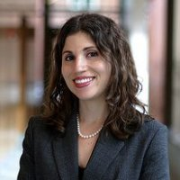
It has been such a pleasure getting to see so many of you throughout the past few months in all of the meetings that SWS has been hosting and sponsoring. I really want to emphasize that SWS is here for you at this incredibly challenging time in our lives. Please always feel free to email, text, or call me if you have any ideas about ways in which SWS can support you as you navigate the ongoing unrest in our society resulting from systemic racism and the persisting COVID-19 pandemic that has created so many unforeseen obstacles in our personal and professional lives. We continue to host the feminist support groups on Thursday afternoons from 2:30 pm - 3:30 pm Eastern Time and now also have periodic feminist parenting support groups too! SWS stands in solidarity with you.

As SWS President, Josephine Beoku-Betts has recapped, the 2020 Summer Meeting was a huge success thanks to your energy and engagement. I am especially grateful to the 2020 Summer Program Committee Members that included: Marybeth Stalp, Sasha Drummond-Lewis, and Solange Simões. I also wish to acknowledge the incredible support and efforts from the entire Awards Committee, led by Rebecca Hanson, SWS Awards Committee Chair, who led all of the Awards Presentations. We really were able to create a supportive and uplifting environment for our awardees, some of whom are brand new to SWS, to celebrate their significant achievements. If you haven’t had the opportunity to review the SWS Virtual Meeting platform where we have recordings of the plenaries and celebrations, there’s still time! The Virtual Meeting platform will close on November 5, 2020. Please review the directions that follow my message and please reach out to my assistant, Natasha Santana (nsantana@socwomen.org) if you have any questions about accessing the system. I learned quite a bit about virtual meeting planning throughout these past few months and I am incredibly grateful to my assistant, Natasha Santana, and web support specialist, Christelle Lachapelle, who helped me to navigate this new experience. The pandemic and tropical storm Isaias couldn’t stop us! My home office thankfully never lost power or Internet, but the majority of the town of Glastonbury/South Glastonbury lost power and had no Internet access as a result of so many fallen trees that aggravated power lines. SWS was unstoppable with 234 people who registered for our virtual meeting! To put it into context, we had 210 people who registered for the in-person New York City meeting in Summer 2019, so we really were able to provide continued engagement and hopefully didn’t miss a beat.

These next months are very busy times in the Executive Office. In October, we now have the 2020 Election of Officers under way where you have the opportunity to vote on the proposed amendments to the SWS Bylaws. Thank you in advance for your consideration of these amendments that the Task Force for Inclusivity, organized and led by Past President, Tiffany Taylor, worked so hard on developing. Voting ends on Thursday, October 22 at 11:59 pm EDT. In November, you will receive a reminder email to renew your membership for 2021. Please note that if you know of anyone who is interested in joining our feminist community, the best time to join for 2021 will be starting on November 1, 2020, given that memberships will then be processed through the end of 2021. Now is a great time to think about gifting memberships to your students or colleagues who are looking for feminist engagement via SWS. Please reach out to me if you’re interested in purchasing a gift membership for a student ($25) or non-student ($55). This year, we also have a new category for high school teachers ($40) too! Please think about gifting membership to friends and colleagues who are high school teachers! Thanks to the vision of Josephine Beoku-Betts and Nancy López, SWS Vice President, we have more exciting programming ahead for high school teachers, which you can read about in Josephine’s column.

I want to acknowledge all of the incredible work that SWS Committees are doing at this time to support our community. In particular, we had an exceptionally successful webinar in late September, hosted by the Career Development Committee, where we featured advice from Mindy Fried for those looking to learn more about how to broaden your focus on applied and non-academic career opportunities. A special thank you goes to Mindy for her expertise and to Trenton Haltom, Sela Harcey, Heather Laube, and Shauna Morimoto for their efforts in putting such a well-received and timely event together. Please stay tuned for more resources and mentoring opportunities to help guide your career development. I am also open to talk to you about my own shift in focus from academia to the nonprofit world. I have said it many times: this is clearly my “dream job” and I am so energized by this work. I am happy to chat with anyone who is looking to make a similar shift. Something that I am looking to develop in these last months of the year and into 2021 is some focused programming that looks at applied and non-academic opportunities through a geographically focused lens. To do this, I am looking to partner with SWS Chapters and members who are located in metropolitan areas with many applied and non-profit opportunities. Please stay tuned …

While we are on the subject of SWS Chapters … welcome to SWS-North and SWS Richmond, Virginia (RVA)! Tina Fetner and Pallavi Banerjee are co-chairing the SWS-North Chapter (serving Canada) with support from Pedrom Nasiri who is serving as Membership Coordinator. Gina Longo and Tara M. Stamm are supporting the work of SWS-RVA and there is an update in this issue of Network News where you can read about their plans. Also, welcome to Sylvia Pu, the new Chair of the SWS-Bay Area (CA) Chapter and thank you to Sarah Garrett for your past service as the lead of the SWS-Bay Area (CA) Chapter! Please email me if you’d like to learn more about starting an SWS Chapter.

As you can see, the work continues in the SWS Office even though we haven’t been able to meet in person since the 2020 Winter Meeting in San Diego. As you can see from President-Elect Mignon Moore’s message and the recent Call for Submissions and Participation, planning is well underway for the 2021 Winter Meeting (January 28-31, 2020) that’s scheduled to take place at the Hyatt Jacksonville.

Stay well and please stay connected as we are in the final months of 2020. I hope to see you soon!

Best wishes,
Barret

Virtual Meeting Platform

You should have received a Welcome Message from the Higher Logic Meeting System with instructions for logging in the first time. If you have any questions, please click HERE for more instructions, or go to this direct link: https://socwomen.org/sws-summer-virtual-meeting-starts-august-6-2020-august-6-10-2020/

In our Virtual Meeting Space, you will be able to access recordings and resources celebrating the 50th Anniversary of SWS in the TRACKS area of the Virtual Meeting Platform. The direct link to our Virtual Meeting Space is: https://sws.connectedcommunity.org/home

Once you're logged in, go to TRACKS in the top left hand area of the site and then click on the dropdown menu to get to All Tracks. There are many entries here, including Josephine Beoku-Betts’ Presidential Welcome Message, the Plenaries, Summer 2020 Awards Ceremonies, Past President Reflections for the 50th Anniversary, the Student Workshop on Navigating Graduate School, the CEDAW Workshop Materials from one of the International Committee’s Workshops, Council Member and Committee Chair Introductions, and more. Plenaries 1 and 3 specifically celebrate the 50th Anniversary of SWS, as you can see from the information below.

Plenary 1: Celebrating 50 Years of SWS through a Decades Perspective
Sponsored by the 50th Anniversary Committee
Organizer: Josephine Beoku-Betts, Florida Atlantic University
Moderated by: Mignon Moore, Barnard College and Columbia University
Participants:
Judith Lorber, Emerita at Graduate Center and Brooklyn College, CUNY (1970s)
Esther Chow, Emerita at American University (Graduate Student in 1969)
Patricia Yancey Martin, Emerita at Florida State University (1980s and 2010s)
Catherine Berheide, Skidmore College (1990s)
Marlese Durr, Wright State University (2000s)
Bandana Purkayastha, University of Connecticut (2010s)
Josephine Beoku-Betts, Florida Atlantic University (2020s)

Plenary 2: Sociological Research and Practice in Authoritarian Times
Organizer/Moderator: Josephine Beoku-Betts, Florida Atlantic University
Participants:
Mary Romero, Arizona State University, “Retrenching or Establishing a Sociology from the Margins”
Nazanin Shahrokni, London School of Economics, “Resilience in the Face of Adversity: Charting the Contours of Iranian Sociology”
Melanie Heath, McMaster University, “Studying the Religious Right: How to Unpack Intolerance”
Eloísa Martin, United Arab Emirates University, “Neoliberalism is the New Authorian: Reflecting on Teaching, Research, and Academic Freedom”

Plenary 3: A Conversation with Past and Current Gender & Society Editors
Sponsored by the 50th Anniversary Committee
Moderated by: Christine E. Bose, Emeritus, University at Albany
Participants:
Judith Lorber, Emerita at Graduate Center and Brooklyn College, CUNY
Margaret Andersen, University of Delaware
Beth Schneider, University of California, Santa Barbara
Christine E. Bose, Emeritus, University at Albany
Christine Williams, University of Texas at Austin
Joya Misra, University of Massachusetts, Amherst
Dana Britton, Rutgers, The State University of New Jersey
Jo Reger, Oakland University
Barbara Risman, University of Illinois at Chicago

Plenary 4: Got Critical Race Feminist Studies? The Possibilities and Challenges of
Institutionalizing Intersectionality in the Neoliberal University
Organizers: Nancy López, University of New Mexico and Josephine Beoku-Betts, Florida Atlantic University
Presider and Discussant: Nancy López, University of New Mexico
Participants:
Michelle Jacob, Professor, Indigenous Studies, University of Oregon, "Critical Race Feminist Studies needs to respect place and our Mother Earth"
Amanda Lewis, Professor, Sociology, University of Illinois-Chicago, Topic: TBA
Ruth Zambrana, Professor and Chair, Women Studies, University of Maryland-College Park, "Intersectionality as an Epistemic Standpoint: Who Tells the Story in The Absence of Chicana and Latina Voices"

SWS Committee Reports

Awards Committee
Rebecca Hanson, Chair

The virtual awards celebrations were a huge success thanks to Josephine and Barret! Also a huge thanks is due to our subcommittee chairs and members who put such careful consideration into choosing award winners and preparing comments for each ceremony! Although it was a bit overwhelming at the beginning, we walked away with some great ideas for the future.

During the virtual sessions we celebrated:
- Aisha Abimbola Adaranijo, winner of the Barbara Rosenblum Dissertation Scholarship
- Carmela M. Roybal, winner of the Esther Ngan-ling Chow and Mareyjoyce Green Dissertation Scholarship
- Brandi Perri, winner of the Beth B. Hess Memorial Dissertation Scholarship and Sandra Portocarrero, awarded honorable mention for her application
- Tannuja Rozario and Pedrom Nasiri for the Social Actions Initiative Award
- Shannon Malone Gonzalez and Sofia Locklear, our 2020 SWS-ASA Minority Fellows

The virtual awards ceremonies were incredibly special because faculty members and friends and family were able to attend and collectively celebrate the winners’ work mentoring students and engaging in activism and research. In the future, we hope to continue with these intimate virtual award settings, even as we transition back to in-person conferences.

On August 24th we held our bi-annual Awards Committee meeting, which gave us time to reflect on the summer awards ceremonies and discuss what we hope to accomplish this year.

If you are interested in participating in one of our subcommittees, or have questions about the awards, feel free to contact me (r.hanson@ufl.edu) or the relevant Subcommittee Chair.

Sister to Sister Committee
Sasha Drummond-Lewis and LaTonya Trotter, Co-Chairs
One of the most meaningful activities the Sister to Sister (S2S) Committee participates in each year is the selection of a graduate scholar of color for the Esther Ngan-Ling Chow and Maryjoyce Green Dissertation Scholarship. Shortly after our last report, we formally announced Carmela M. Roybal as the 2020 Chow-Green Dissertation award winner. Since then, we have spent time getting to know her and celebrating her at both the virtual 2020 Summer Meeting and our subsequent committee meeting. If you would like to watch (or re-watch) the recorded award presentation, it is still available for viewing on the meeting platform. We want to thank our subcommittee members one last time, Tracy Ore and Melissa Abad, for their participation during the review process.
During this year’s summer meeting, we moderated a workshop session on Virtual Activism. Given the two pandemics we are living through, it proved to be a timely and necessary discussion. We are thankful to the scholar-activist panelists who participated and provided insight into the logistics of conducting research on online activism and to the audience members who provided a safe space to discuss the hurdles our scholar-activists were encountering. The session left us all feeling inspired and supported. Two weeks after the meeting, we also held a virtual committee meeting where we updated members on previous and current issues at hand. We are now looking forward and beginning to prepare for the 2021 Winter Meeting. We are seeking volunteers to help us develop the S2S programming for the upcoming meeting so we invite any interested scholar of color to submit your name via email to be a member of our subcommittee. This is a great opportunity to contribute as a member of S2S and have a hand in constructing the upcoming programming. If you are unable to commit time but have ideas for panels or workshops, we would like to hear them so please email us your suggestions for programming.
We want to remind everyone that we have a Sister to Sister listserv as a private space for correspondence among S2S members between meetings. We invite you to post topics for discussion or announcements you wish to share in this safe space. If you do not have access to this listserv, please email us for instructions on how to be added. We continue to utilize our Facebook page and appreciate members posting invites to their events and seeking support for circumstances they are encountering especially during the current times. As always, any scholar of color desiring mentoring, or with suggestions or general inquiries, we encourage you to email us at sister2sistersws@gmail.com. We eagerly await to connect with you!

Newest Local Chapter: SWS-Richmond Chapter
By Gina Marie Longo, PhD
Virginia Commonwealth University
Faculty Advisor for SWS-Richmond

It is with great pleasure that we announce the newest chapter to the SWS organization: SWS-Richmond. Drs. Gina Marie Longo and Tara Stamm of the Sociology Department at Virginia Commonwealth University (VCU) signed the Memorandum of Understanding on July 6, 2020, which officially launched the chapter. Both will serve as the chapter’s faculty mentors. As a local chapter of SWS, SWS-RVA provides further meeting opportunities among feminist sociologists within the Greater Richmond, Virginia area, and surrounding cities to carry out the SWS mission. We are further committed to assisting and cooperating with our regional organization SWS-South’s activities, events, or initiatives wherever extra local outreach in the Richmond area is needed. Currently, VCU has a growing undergraduate and graduate program with more than 30 students expressing interest in joining our local chapter. Our goal is to expand our membership to faculty and students in other departments as well as other local universities and community colleges.
Future activities are being planned. We anticipate creating virtual meetups, which we hope will become face-to-face and/or hybrid gatherings as soon as the pandemic eases. Another chapter goal is implementing a student paper award to recognize the scholarship of our area students. As Richmond communities grapple with racial inequality and oppression, SWS-Richmond is dedicated to elevating feminist scholars of color and partnering with the SWS Sister to Sister Committee and area non-profits that are working on racial justice and anti-racism initiatives.
Please stay tuned to our chapter website https://socwomen.org/sws-richmond-virginia-rva/, which is currently under construction. For more information, please contact Gina Marie Longo at longog2@vcu.edu and Tara Stamm at tmstamm@vcu.edu.

Members’ Publications

Carolyn Cummings Perrucci, Mangala Subramaniam, and Robert Perrucci, “Gender and Publication in Two Longstanding Sociology Journals, 1960-2010,” International Journal of Contemporary Sociology, April 2020, 57 (1): 25-47.

Richard Hogan and Carolyn Cummings Perrucci, “Earnings Inequality in 2016 among Anglos, Latinxs, and Blacks,” Hispanic Journal of Behavioral Sciences 2020, 42(3): 363-380.
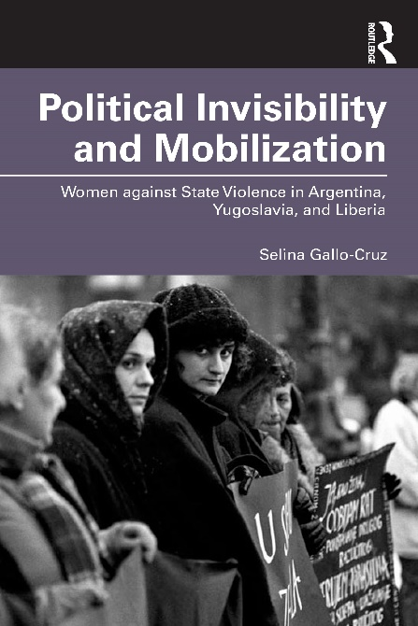
Selina Gallo-Cruz. Forthcoming, 2021. Political Invisibility and Mobilization: Women against State Violence in Argentina, Yugoslavia, and Liberia. Routledge. https://www.routledge.com/Political-Invisibility-and-Mobilization-Women-against-State-Violence-in/Gallo-Cruz/p/book/9780367465865
Political Invisibility and Mobilization explores the unseen opportunities available to those considered irrelevant and disregarded during periods of violent repression. In a comparative study of three women’s peace movements, in Argentina, the former Yugoslavia, and Liberia, the concept of political invisibility is developed to identify the unexpected beneficial effects of marginalization in the face of regime violence and civil war. Each chapter details the unique ways these movements avoided being targeted as threats to regime power and how they utilized free spaces to mobilize for peace. Their organizing efforts among international networks are described as a form of field-shifting that gained them the authority to expand their work at home to bring an end to war and rebuild society. The robust conceptual framework developed herein offers new ways to analyze the variations and nuances of how social status interacts with opportunities for effective activism.

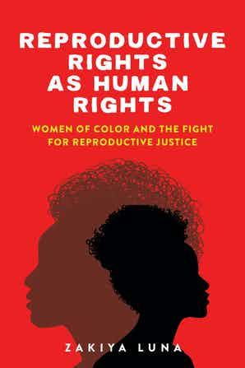
Luna, Zakiya. 2020. Reproductive Rights as Human Rights: Women of Color and the Fight for Reproductive Justice (NYU Press).

Reproducing Rights as Human Rights reveals both the promise and the pitfalls associated with a human rights approach to the women of color-focused reproductive rights activism of SisterSong.
How did reproductive justice—defined as the right to have children, to not have children, and to parent—become recognized as a human rights issue? In Reproductive Rights as Human Rights, Zakiya Luna highlights the often-forgotten activism of women of color who are largely responsible for creating what we now know as the modern-day reproductive justice movement. Focusing on SisterSong, an intersectional reproductive justice organization, Luna shows how, and why, women of color mobilized around reproductive rights in the domestic arena. She examines their key role in re-framing reproductive rights as human rights, raising this set of issues as a priority in the United States, a country hostile to the concept of human rights at home. An indispensable read, Reproductive Rights as Human Rights provides a much-needed intersectional perspective on the modern-day reproductive justice movement. (Discount code LUNA30)

Policing Black Bodies: How Black Lives are Surveilled and How to Work for Change, co-authored by Earl Smith and Angela Hattery (University of Delaware) was selected by Furman University's Department of Sociology as the 2020-21 Common Read book. All students enrolled in “Introduction to Sociology” at Furman University during the fall 2020 or spring 2021 semesters will be required to read Smith and Hattery's book. Smith and Hattery also will travel to Furman (in person or via zoom) in the spring of 2021 to meet with sociology students to discuss the book.

Fahs, Breanne, Swank, Eric, and Shambe, Ayanna 2020. “‘I Just Go With It’: Negotiating Sexual Desire Discrepancies for Women in Partnered Relationships.” Sex Roles, 83:226-239.

Fauzia Husain, 2020. “Halal Dating, Purdah, and Postfeminism: What the Sexual Projects of Pakistani Women Can Tell Us about Agency,” Signs: Journal of Women, Culture and Society, 45(3): 629-652.

Thomas Janoski, Cedric de Leon, Joya Misra, and Isaac Martin. 2020. (Eds.) The New Handbook of Political Sociology. Cambridge: Cambridge University Press.
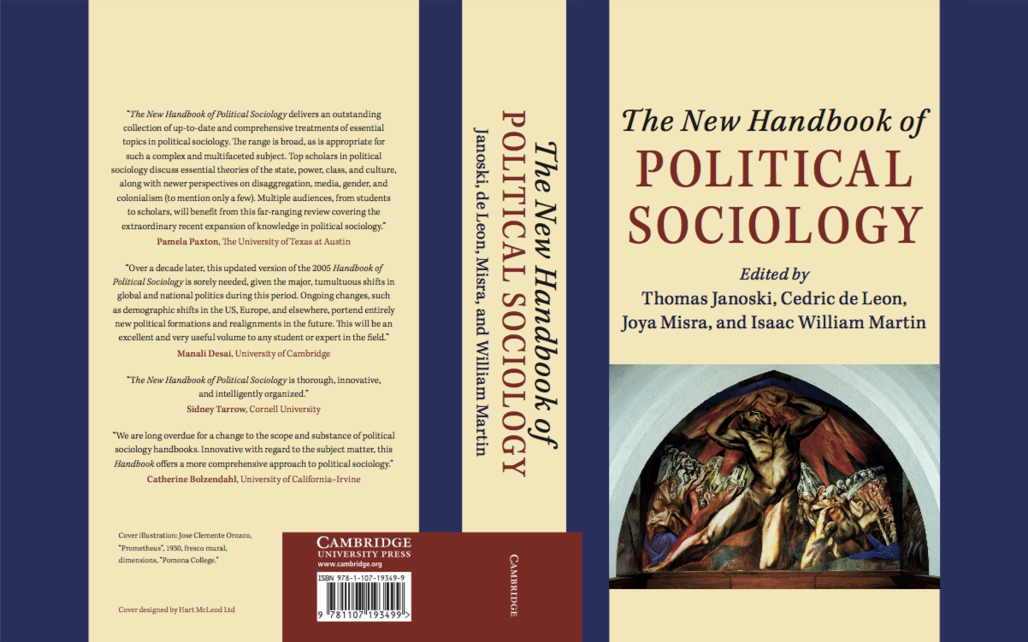

Congratulations to Beth B. Hess Memorial Dissertation Scholarship Awardees
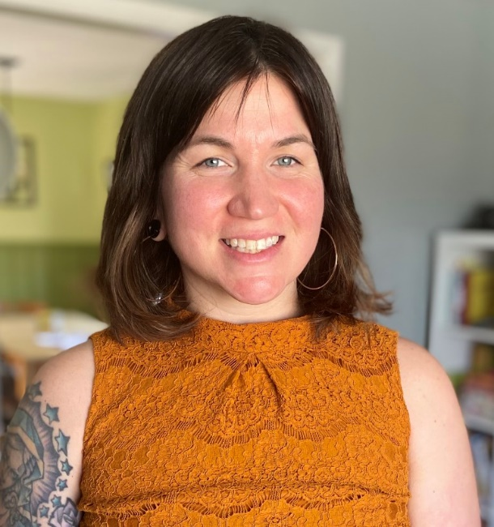

This year’s Beth B. Hess Memorial Dissertation Scholarship Award winner is Brandi Perri. Brandi is a self-described third-generation janitor who has overcome enormous personal challenges to become a rising sociology star and exemplary teacher and mentor. Brandi had two unsuccessful attempts at starting college before she attended Austin Community College (ACC). At ACC, Brandi found connection with other students who, like herself, were working full time even as they yearned to learn. She also encountered a faculty member who, despite Brandi’s struggles with her coursework, “never made me feel like a D student.” Instead, Brandi recounts, she “made me feel like a valued student, even if I was not a model student.” Like Brandi, her professor was juggling multiple jobs, even as she worked at ACC. Previously, it had not occurred to Brandi that someone with a similar background could pursue a position in academia.

Inspired to tap into her own potential and consider new possibilities, Brandi transferred to SUNY Purchase to finish her Bachelor’s degree. At SUNY Purchase, Brandi discovered sociology. Using her new insights and methodological tools, she could finally explore the questions of identity and inequality that fascinated and challenged her. Brandi quickly recognized that the approach of intersectionality was central to both her life and to her research. Brandi’s teaching and research agendas are guided by two central questions: “How do our intersectional identities shape how we interact with the world around us? And what does this tell us about inequality?”

Pursuing a doctoral degree in Sociology at UMass Amherst has allowed Brandi to delve deeply into these questions. Her dissertation “Born to the Broom: The Relationship between Identity Work among Janitors” “considers how the interactions among a diverse janitorial crew at a public school reflect the larger institutional environment when services are being privatized.” Her central research questions are: (1) What are the day-to-day experiences of janitors in educational institutions? (2) Through what processes are social boundaries produced and maintained among janitors? and (3) How do janitors’ experiences and relationships with each other in the workplace reflect the political climate within the educational system, their union, and the larger culture? To explore these questions, Brandi is collecting ethnographic data, conducting interviews, and performing content analysis of formal documents from unions and the corporation. Her work builds on previous research on service work but, importantly, considers how race, gender, and social class inform experiences in this “invisible” profession. Impressively, Brandi has already spent over 2000 hours working on-site with the janitorial crew and completed fifteen interviews. She is well on her way to completing her dissertation, and also has multiple publications under review.

In addition to her innovative and important research agenda, Brandi is an exceptionally committed teacher. In fact, she has won multiple awards in recognition of her teaching, including the SAGE Teaching Innovation Award. During her time at UMass Amherst she has been recognized with both the Best Teaching Award (2019) and Best Teaching Assistant Award (2018). As Brandi notes, when she decided to pursue a Ph.D., she vowed to use her education to make campus experiences more accessible for working-class students through teaching and mentorship. She has already designed and taught ten classes at UMass Amherst and Greenfield Community College. She uses her own experiences as a queer student from a working-class background to inform her pedagogy. Brandi supports her students as they guide one another through deeper explorations of the course materials. Using her own experiences as a framework and example, she encourages her students to think critically about their own experiences and biases in relation to the narratives and research they analyze.

Brandi’s teaching, research, and mentorship truly embody the spirit of Beth Hess. We have no doubt that Brandi, like Beth, will change lives, inspire the next generation of sociologists, and engage in activism and research that will erode deep social inequalities. We are delighted to honor her and her work with the 2020 Beth B. Hess Memorial Scholarship.

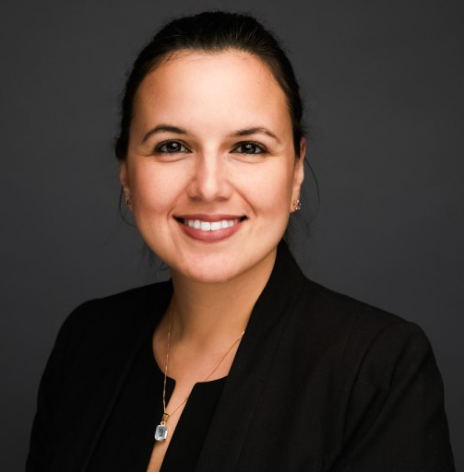
The Beth B. Hess Memorial Dissertation Scholarship Subcommittee recognizes Sandra Portocarrero with the 2020 Honorable Mention. Sandra began her academic trajectory at Berkeley City College (BCC), an institution that reflects the San Francisco Bay Area’s ethnic, cultural, and socioeconomic diversity. Without any family support, she worked for years at various restaurants before transferring to the University of California, Berkeley. She is currently a doctoral student in Sociology at Columbia University. In her three-article dissertation, Sandra examines diversity, equity, and inclusion management practices in organizations, focusing on processes. She seeks to understand what people talk about when they talk about diversity, equity, and inclusion, and how this meaning making process has an impact on organizational behavior.

Along with these areas of focus, she maintains a strong interest in the relationship between education and inequality. At Columbia, Sandra co-chaired the Graduate Students of Color Alliance, and founded the Intimate Conversations with Women in Academia series in the Sociology department, a once a semester meeting between professors and graduate students who identify as women. The subcommittee is confident that her personal experience, scholarship, and public advocacy, reflect the characteristics of the Beth B. Hess Memorial Scholarship Award and Berkeley City College’s belief “in the power of education as the engine for cultivating a democratic society, where the hopes and dreams of the community are nurtured.”

Memorandum from SWS Council
July 17, 2020

On July 15, 2020, SWS Council voted to adopt this Black Lives Matter Research Statement to acknowledge and condemn exploitative practices taking place by sociology faculty members that put both undergraduate and graduate volunteer researchers in dangerous situations that may result in death. This statement is an adaptation of the American Sociological Association's Black Lives Matter Research Statement that is dated July 9, 2020.

This statement, released by SWS underscores that both undergraduate and graduate students must be protected from being asked by faculty members to participate in such research. SWS also underscores that if students volunteer to bear the risks associated with such research, that poses dangers that can even be fatal, that they receive payment or another form of academic compensation, such as co-authorship on a future publication.

Thank you for your attention to our Black Lives Matter Research Statement and please circulate this statement within your disciplinary network and beyond.
Please Note: Here is a direct link to this research statement on the SWS website: https://socwomen.org/sws-black-lives-matter-research-statement/

In solidarity,
SWS Council

SWS Black Lives Matter Research Statement
As Black Lives Matter protests are ongoing in the United States and around the world, numerous sociologists are viewing these protests not only as opportunities to push for social change, but also as opportunities to better understand how social movements work. Given the emergent nature of these protests, some sociology faculty members working with students on collective action research may rely on students to collect data at these protests. While these protests may provide opportunities for student researchers, there are associated risks to be taken into account.

Therefore, sociology faculty should be careful not to ask students to put their bodies at risk for the sake of faculty research. The risk for these students is two-fold: the risk of COVID transmission and the risk of police brutality at the protests. Police use of force, chemical weapons, and tactics like kettling and arrests are still common, and their deployment is unpredictable. For students of color, the risks of suffering targeted police violence are even greater.

While Institutional Review Boards (IRBs) are in place to ensure ethical treatment of research subjects, we do not have the same guidelines for ethical treatment of student researchers. As scientists, we should not assume that all students (graduate and undergraduate) will fully understand the scope of risks associated with this type of research. In the event that fully informed students choose to participate, then the risks and costs we ask students to bear must be proportional to the benefits they receive in terms of payment or academic compensation, such as co-authorship.

Under no circumstances should students be asked to volunteer for this type of research given the power differential between students and faculty. Volunteering poses an additional layer of risks because unlike paid research assistants, volunteers are not even covered by any form of institutional protection. If volunteer students were to be harmed (arrested, kettled, tear gassed, or even killed) at these protests, the university is not liable to represent them or compensate them.

Faculty members should keep in mind that undergraduate and graduate students may feel pressured to do this kind of research to maintain good relationships with their faculty advisors and mentors. As sociologists, we have the responsibility to remain aware of the power relationships in our educational programs. It would be unethical and exploitative to add our research projects to the list of structural inequalities our students face. Our students and the discipline of sociology deserve better.

CALL FOR APPLICATIONS
New Editor of Network News

The Publications Committee of Sociologists for Women in Society is pleased to announce a search for the next Editor of our newsletter, Network News. Network News is the official newsletter of Sociologists for Women in Society and is published four times a year. The newsletter is sent to all SWS members via email and is available through PDF and Microsoft Word formats on the SWS website. The Editor will serve a four-year term beginning January 1, 2021 and ending in December 2025. The Editor is responsible for the editorial content of four issues per year, including solicitation of articles for publication and copyediting them, beginning with the Spring 2021 issue, and reports to the Publications Committee at the SWS Winter and Summer meetings.

The Editor envisions, commissions, and edits engaging essays on a variety of topics including: upcoming meetings, activities of international partners, organizational direction and debate, initiatives and their rationales. The Editor works with committee chairs and others leading our activities to develop short essays that emphasize readability and engagement, about how the organization is developing, thus keeping people “in the loop” who cannot attend in-person meetings. The Editor also can commission provocative essays or “backstage” articles (with word limits) on how the organization has changed over time, current discussions and debates, and where SWS is going. In order to keep each issue to 24-28 pages, we expect to begin with 1-2 articles and slowly increase over the course of the editorship.

The SWS Executive Office gathers informational material, does the layout, and arranges the production and email circulation of the newsletter and its posting on the SWS website.

The Publications Committee seeks an Editor with editorial experience and deep connections to SWS. SWS will provide the Editor with a stipend of $500 per issue and up to $500 travel costs per SWS meeting ($1,000/year), to enable attendance, as well as reporting to the Publications Committee. We will publish up to 4 issues a year. If housed in an institution, editorial applications should indicate if that department/college will offer any supplemental travel costs or support beyond what is provided by SWS. Expected 2021 deadlines for the issues remain the same as in the past: 3/15 for the Spring issue, 5/15 for Summer, 9/15 for Fall, and 11/15 for the Winter issue, and similar article length limits.

A preliminary discussion of the work, key issues, and resources provided/needed is encouraged, with the Co-Chairs of the Publications Committee, Bandana Purkayastha (bandana.purkayastha@uconn.edu) and Yasemin Besen-Cassino (beseny@mail.montclair.edu, and the current editor, Marjukka Ollilainen (mollilainen@weber.edu). Members of SWS are urged to apply and/or suggest colleagues who might be encouraged to apply.

Applications should contain a statement of interest, including editorial experience; a vision for the future of Network News; a description of any supportive resources from a relevant institution; and Curriculum Vitae by November 1, 2020 via email to: Bandana Purkayastha (bandana.purkayastha@uconn.edu) and Yasemin Besen-Cassino (beseny@mail.montclair.edu) Co-Chairs, SWS Publications Committee. Recommendations will be made by December 1, 2020 and the new Editor will begin January 1, 2021.

Direct link to the Call for Applications on SWS website: https://socwomen.org/call-for-applications-next-sws-network-news-editor/
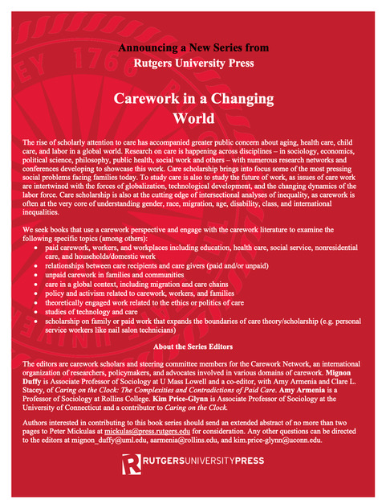
NEW - In the Classroom on the Gender & Society website Teaching Modules!

By MaryAnn Vega and Seth Behrends

When the current Gender & Society team took over the journal, we were pleased with the In the Classroom project but also envisioned new ways to bridge the publication of new feminist research to teaching. The current Editor, Barbara J. Risman, assembled a graduate student Editorial Board who met to discuss the new and exciting things we could bring to the journal. The Managing Editors—MaryAnn Vega, Seth Behrends, and June Macon—were charged with facilitating this board. One of us, MaryAnn, has always been particularly interested in pedagogy. As a first-generation college student, MaryAnn was never a big fan of journal articles as an undergraduate. Thus, we wanted to link the journal articles to other readings, videos, and learning exercises in order to create full teaching modules for the contemporary classroom. We also are producing podcasts by our authors.

At Gender & Society, we believe that if learning is happening in such creative ways, our pedagogical project should be growing to meet these new needs. Sociology of gender constantly changes, and the media we use to teach sociological concepts are in flux as well. As teaching assistants and instructors, we have witnessed podcasts, YouTube videos, quiz websites, memes, and articles used as tools to teach the sociological imagination. Students analyze their favorite albums to talk about gender-based violence. Such pedagogical tools show us that learning happens across a variety of digital forms.

The Pedagogy Project has been created—built by the graduate student Editorial Board and facilitated by the Managing Editors. Graduate students on the student Editorial Board have chosen to create teaching modules based on Gender & Society articles in their own areas of expertise. These are usually peer reviewed by both the author of the article at the center of the teaching module and a member of the Editorial Board. This fall, we are rolling out this new contribution of Gender & Society to teaching feminist sociology. Check it out! We have modules on campus sexual assault, masculinities, contraception, and intersectionality in digital media. We will continue to add modules each semester, so do keep an eye out for new content before you write your next syllabi!

The first set of modules contributions by:
Yuchen Yang, Melissa Kinsella and Jihmmy Sanchez on “Men and Masculinities”
MaryAnn Vega on “Sexual Violence”
Lara Janson on “Challenging Intersectional Inequality through Digital Media Images”
Jane Pryma on “Contraception”

More modules will be added every semester so when you are updating your syllabi, take a look!

Announcements and CFPs

Pacific Sociological Association 92nd Annual Meetings/Conference. March 18-21, 2021. San Diego, CA. President: Sharon K. Davis, University of La Verne. Theme: The New Normal and the Redefinition of Deviance. For more information see www.pacificsoc.org. Note: Pending status of the COVID-19 pandemic, conference may be onsite and/or virtual.

Call for SWS United Nations ECOSOC (Economic & Social Council) Delegate
from the International Committee

If you are interested in becoming more involved with SWS, consider becoming one of five delegates to represent SWS as a NGO with consultative status at the United Nations. You will be joining our amazing feminist team led by Solange Simões with Vicky Demos, Nicky Fox, and Mollie Pepper.

Requirements:
- SWS member, with at least one-year membership in the IC.
- Three-year commitment to serve as UN representative. SWS members may serve up to two consecutive terms, beginning and ending after our August Summer meeting.
- Can be located anywhere globally.
- Willingness to fulfill responsibilities and duties as follows:
(1) Assist in coordinating SWS participation/attendance at the annual session of the UN Commission on the Status of Women (CSW) and any other UN meeting; (2) Attend some portion of the annual session of the UN CSW in New York City in March with partial funding from SWS; (3) With other SWS UN Representatives, prepare annual reports for Network News on ECOSOC sessions; (4) Report to International Committee meetings on ECOSOC participation; (5) Assist in preparing SWS’s Quadrennial Report to the UN; and 6) Participate in other SWS UN activities such as preparing written and oral statements and SWS panels at CSW.
If interested, please email a 300 word statement with your contact information to Solange Simões (ssimoes@emich.edu) and hara bastas (ravinheart@hotmail.com) by Friday, November 20th. Collectively, the subcommittee will make the decision by the end of 2020.

Congratulations to SWS Social Actions Initiative Award Winners
Tannuja Rozario and Pedrom Nasiri

(Photo of Tannuja Rozario on the left)

Tannuja Rozario is a Ph.D. student in Sociology and earned her Advanced Certificate in Feminist Studies at the University of Massachusetts, Amherst. Currently, she is working on her dissertation about reproductive health experiences of Indo-Caribbean women. Her project is funded by the National Science Foundation. Tannuja’s passion for advocacy and research stems from her background as an Indo-Caribbean immigrant. At a young age, she witnessed gender-based violence and reproductive injustice in Guyana, causing her to realize that Indo-Caribbean women experience gender inequality. As an activist, she became an Executive Board Member of South Queens Women’s March—a gender justice organization in South Queens, New York that fosters empowerment and provides resources for women and gender non-conforming folks. Based on her research with community members, she realized that conversations on maintaining healthy relationships and sexual empowerment are integral to reproductive justice.

Tannuja’s project, “Healthy Relationship Series for Indo-Caribbean Women and Gender Non-Conforming Folks in South Queens, New York,” is the first-ever healthy relationship series Indo-Caribbean community in Richmond Hill, NY. The healthy relationship series will include workshops on healthy relationships, consent, sex positivity, and healing. These workshops will invite community activists, students, professors, healing justice coaches, and healthy relationship coaches to come together to help an under-resourced community that continues to witness the deaths of many community members to gender-based violence.
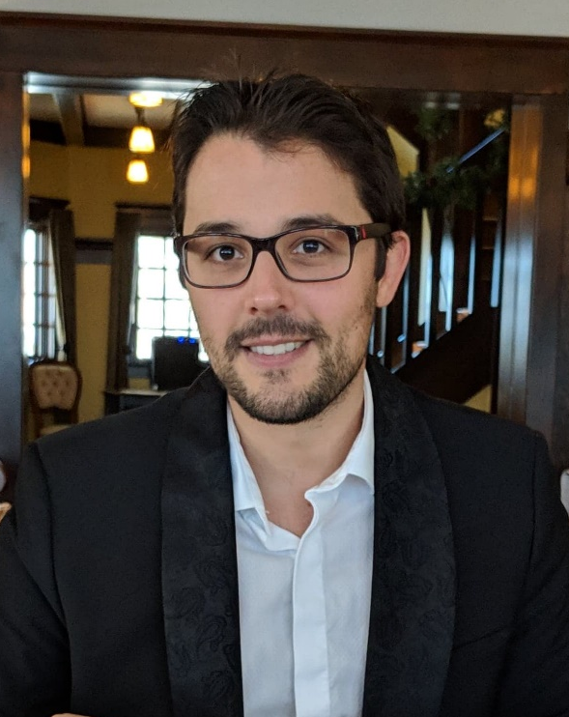
(Photo of Pedrom Nasiri on the left)

Pedrom Nasiri is a Joseph-Armand Bombardier doctoral student in the Department of Sociology, at the University of Calgary, under the supervision of Dr. Pallavi Banerjee. Their doctoral research employs critical phenomenology and intersectionality to examine how the increasing prevalence of polyqueer families articulate with ongoing racial, gender, and class formation projects. Pedrom completed their M.A. at the University of Toronto in the Department of Social and Cultural Anthropology, where they explored the experiences of Queer Muslim refugees in the Canadian asylum apparatus.
Much of Pedrom’s work is guided by critical social theories that emphasize the need to employ academic theory and inquiry to address everyday social injustices. Pedrom has worked with various governmental and non-governmental agencies across Canada to address long-standing inequities in healthcare and social service systems. Pedrom has been recognized for this work by The Order of St. John, the Lieutenant Governor of Alberta, and the Governor-General of Canada.

Funds will facilitate focus groups and interviews across the Fall of 2020 with polyamorous women inhabiting a diversity of identities. The data gathered from focus groups and interviews will be used to implement a five-day series of workshops as well as printed materials on the subject of violence, financial literacy, and trauma in polyfamilies. The project is in line with SWS’s Mission to engage in social justice projects to advance the well-being of women in society.

Pedrom would like to extend their sincerest thanks to the SWS Awards Committee, the SWS Social Actions Initiative Award Subcommittee, Pallavi Banerjee, Julie-ann and Mansour, and the Social Sciences and Humanities Research Council of Canada.

In 2016, SWS Council approved the Social Action Committee’s (SAC) proposal to support more direct social action of SWS members. The Social Actions Initiative Awards provide a way for the SAC to directly support and encourage the social activism of SWS members. Awards are given out twice per year on a competitive basis until funds run out. The social actions represented by this initiative are central to advancing the mission of SWS. Both of the award winners this funding cycle will each receive $500 to support their social activism projects. Special thanks go to the Social Actions Initiative Award Subcommittee: Ruth Marleen Hernández (Chair), Penny Harvey, Rosalind Kicher, and Sam Harvey.

Career Announcements

Tristan Bridges and Zakiya Luna all earned tenure in University of California, Santa Barbara (UCSB) Department of Sociology. Congratulations, Associate Professors!

Publishing in Academic Journals: Some Advice

By Margaret L. Andersen, Former Editor, Gender & Society

Are you considering submitting an article for publication in an academic journal? The following advice was first published in 1995 in the “From the Editor” section of Gender & Society. I have made modest revisions in the original article to reflect changes that have happened since in the publication of academic journals. No longer do people prepare or send their papers in paper format, as was the practice during my years as Editor (1990-1995). Yet, even with the current practice of electronic submission, this advice still pertains, and I offer it in the spirit of mentoring that SWS embraces.

When I left graduate school, no one had told me much about the process of submitting articles for publication. Of course, then it was not so critical for those on the job market to have had this experience. Still, early in my career, it seemed to me that good articles had sprung full blown from the minds of authors. As much as I knew that knowledge was socially constructed, I never thought about the process by which rough drafts (or even loose ideas) became publishable papers. It is in the spirit of demystifying that process that I offer these thoughts.

Before submitting your paper to a journal for review, have it carefully read by supportive colleagues who will give you serious, but constructive, criticism on the paper. Preferably, this should be someone with experience in publishing. Although it may make you feel better, it does not help to have someone read it who simply tells you how good your work is without questioning whether the paper is framed by a central research question from which the methodology is developed and articulated; whether the argument is clear; whether the paper makes an analytical contribution or simply reports the results of your project; whether the conclusions are warranted; and whether the paper is well written. You should be prepared to revise your paper after this initial reading, possibly many times, before you submit it to a journal.

If possible, have the paper read by someone with expertise in the subject area and someone without such expertise but who has a general interest in the subject. This will help you avoid writing to such a specialized group that no one else will understand it or care. You should not submit papers to journals just to “test the water” and see what will happen. Remember that once a paper is rejected, it usually cannot be resubmitted to the same journal. It is wise to send your paper only when you think it is well developed and ready for formal review. Nonetheless, do not wait too long to send your work out for review. Perfectionism is a trap that will impede your career development. I know many scholars who are so fearful of facing criticism that they spend years preparing papers that are then never completed. Supportive colleagues can tell you when your paper is ready for submission. If you do not have such colleagues in your department, you must create them by participating in regional and national meetings, corresponding with people with similar interests to yours, and asking peers and mentors to help you develop your work.

It is also important, especially for junior scholars, to have multiple works in the pipeline. The process of journal review takes time; while you are waiting for a decision on one paper, you should be working on others. Part of the trick of getting one's work published is being able to manage multiple projects at the same time—all of which are in different phases of development. This is not easy, but, in my experience, it is characteristic of all successful scholars.

Serving as a reviewer yourself is a good way to learn how to develop good journal papers. Reviewing others' work helps you see how good papers are crafted and how authors develop strong arguments. Don't be shy about letting journal editors know that you are interested in reviewing papers for their journal. You can send a brief email, along with your vita, telling the editor (or a member of the editorial board) your areas of expertise and methodological strengths. Some journals use graduate student reviewers. It will help your own work to read others' papers and to see "inside" the reviewing process.

When you are ready to submit your paper, be sure that you know the focus of the journal where you are sending it. Most editors will not look at papers unless they are submitted through the formal review process. Journals should have a statement of purpose on their web page. Even better, look at the recent issues of the journal. If your work is historically based and the journal you are considering publishes mostly quantitative, contemporary work, you are wasting precious time sending it there for review. Ethical norms of scholarship prohibit authors from submitting one paper to more than one journal at a time. Don't risk your reputation by doing this. The likelihood of your paper being sent to the same reviewer by different journal editors is high.

When you are ready to submit your paper, pay close attention to the journal's style guidelines. This is not just a matter of appropriate citation style. Most journals have guidelines about an article’s length and they are usually strictly applied. I know of one major social science journal that routinely returns papers that are even one page over the stated limit. Page and word limits may include tables, figures, notes, and references so understand the particular protocols of the journal where you are submitting. Don’t try to fool editors by using small fonts, narrow margins, and minuscule footnotes—you will only irritate the editor. If you do not follow the stated guidelines, you may find your paper returned without being reviewed.

A common mistake many authors make is thinking they must cite every piece of vaguely relevant literature in a single article. Your purpose in a journal article is not to cite everything that has ever been written on your subject. Cite only those works that are directly quoted or directly relevant to your argument. Likewise, if a point is really important, it should go in the text. Don't use footnotes to add extraneous arguments or to elaborate small points unless it is really necessary. Authors should recognize that journal editors are given strict page limits by the publisher. Every page an author uses up is less space for another's work.

Send the editor a "clean" copy. A sloppy presentation tells reviewers that the research may be sloppy, too. Papers with numerous typographical errors and poor grammar are likely to be rejected. Obviously, people make mistakes and there is room for some error, but not if it is excessive.

Remember also that good writing matters. As Howard Becker points out in Writing for Social Scientists, poor writing results in theoretical errors. Using the passive voice, for example, eliminates human agency. Writing in the past tense deadens your presentation. Using unnecessary words does not make your ideas seem more complex; it obfuscates them (such as using the phrase "the way in which" instead of just saying "how"). Editors and copy editors will check your work and improve it, but the responsibility for clarity, accuracy, and style is ultimately your own. When I was editor of Gender & Society, I often rejected papers because they just wore me out as I tried to swim through dense prose.

Journals differ in their editorial practices. At some, decisions are made by the full editorial board; at others, associate editors make a final recommendation to the editor. Refereed journals use a system of blind review—that is, reviewers do not know the author's name, nor do authors know who the reviewers are (unless the reviewers voluntarily identify themselves). Authors should not put identifying information in their papers. I have seen reviewers recommend rejection simply because the author slipped their identity (advertently or inadvertently) into a paper. Authors should delete all identifying references; these can be added later if the paper is accepted.

Finally, if you get rejected, don't be discouraged and give up. Keep in mind that, if an editor rejects your paper, the paper is not necessarily bad. A paper may be more appropriate for another journal. Frankly, given limited space, editors can publish only the very best papers they get. Most often, rejected papers are simply underdeveloped. After venting your disappointment at rejection, take the reviewers' advice seriously and rework the paper for another journal. Remember that everyone has had papers rejected, myself included. You should not, though, resubmit your paper to a different journal without first revising it based on reviewers’ comments. Again, your paper may end up in the hands of someone who has already reviewed your paper, and nothing is more likely to produce a second rejection than having ignored the reviewer's advice after the first round.

If you are asked to revise and resubmit, do so. You can frequently tell from the editor's letter how encouraging the response is but realize that a revise and resubmit decision is not an acceptance; your paper may still be rejected. Authors should expect criticism from the reviewers and the editor. Sometimes reviews are contradictory, although, more often than not, they note related problems in the paper. Don't just get angry at reviewers. If they missed your point, it's because it was not clear.

The editor’s letter should direct you to the most important areas that need revision and it may try to reconcile conflicting reviews. Even if you are mad at the reviewers, follow their advice, but recognize that reviewers can be wrong. The editor may tell you if she agrees or disagrees with particular reviewers but certainly the editor’s letter should give you direction for revising the paper. A good practice, as hard as it can be, is to share your reviews with a trusted, but critical colleague who can help guide you through re-working your paper.

If you resubmit a paper, write a letter to the editor explaining how you have responded to the reviewers' criticisms. Keep this within a reasonable length, but address the key points reviewers made, noting how you addressed them or, in cases where you did not, explain your decision. Some editors may give you a revise and resubmit a second time, although journals and editors differ in their practices.

If you get an "accept, if” letter, understand that this acceptance is contingent on making the changes that the editor notes. If your paper is accepted, pay close attention to the line editing and queries of the editor.

In the end, understand that by the time an article is published, in addition to those who reviewed the paper prior to submission, it has likely been reviewed by different reviewers, the editor, and possibly deputy editors. This is proof that good work is a collective process!

Margaret L. Andersen is the Elizabeth Goodman and Edward F. Rosenberg Professor Emerita at the University of Delaware. She is the author of several books, including her most recent, Getting Smart about Race: An American Conversation and Thinking about Women: Sociological Perspectives on Sex and Gender, 11th ed. She currently coaches junior faculty in the National Center for Faculty Development and Diversity’s Faculty Success Program.

SWS Past Presidents and Officers Recall Decades of Feminist Sociology

To celebrate and commemorate the 50th Anniversary of SWS, the 2020 Summer Meeting organizers invited SWS Past Presidents and Officers from five decades to share their recollections of the organization and issues they dealt with in their role. Network News will be publishing these essays throughout the 50th Anniversary celebration year. This issue features essays from Past Treasurer, Marcia Texler Segal, and Past President, Vicky Demos, who served in those roles in the 1970s and 1990s, respectively.

Marcia Texler Segal:
One of the first 100 members of SWS, I served as Social Issues Co-chair, 1973-74, and Treasurer, 1978-80. My strongest memories of that first decade are of our work inbuilding an organization that was both professional and feminist. We were making it up as we went along. For example, Betty Frankle Kirschner wrote to Juliet Saltman and me that “the caucus” aka “the steering committee,” wanted us to run to be co-chairs of the committee. But our bylaws—then a work in progress—did not allow for that, so we each were asked to indicate in our statements that we would invite the other to co-chair. When those elected discovered that our terms were not specified either, an ad hoc committee was formed to poll officers about term dates and lengths and make a recommendation.

Pam Roby was president during the years that I served as Treasurer. I was the fourth treasurer, following Penny Maza who assured me that it was not a burdensome position. Records were kept in a ledger. I have vivid memories of carrying our money in my purse, less conspicuous than a cash box, during and after meetings. There was more cash than checks and, of course, no credit cards. Because we did not have a permanent location or an executive officer, each treasurer set up her own accounts. I believe mine was in my university credit union.

We had few formal financial policies in the first decade. In the 1980s Finance and Budget Committees were formed and, as a Past Treasurer, I sat on both. Funds were so limited in the early years that committee chairs were asked not to request the $25 allotted for their activities until needed. At various points, we created and sold pins and scarves as fundraisers. Members were asked to seek speaking engagements in cities where we met and to donate their honoraria to SWS. Campuses in those cities were asked for sponsorships.

Winter Meetings had a retreat-like atmosphere and were used primarily to conduct business and socialize. Fast friendships and critical mentorships were formed at those meetings. Summer Meetings were where programming that was devoted to professional concerns, not research, occurred.
SWS began asking candidates for ASA elections about their commitment to equal opportunity within ASA and on their campuses in 1972. Then as now, some candidates were supportive, and some declined to respond. Regional and local SWS chapters were formed during that first decade with the national organization serving as a model. Following SWS’ lead in interactions with ASA Council, North Central SWS petitioned NCSA Council to have an observer attend Council meetings to assure attention to gender-related interests and the participation of NC-SWS members on committees.

In our first decade, a small group of people were doing the work of feminism in sociology; the same names appear and reappear in records from SWS, our regional chapters as well as ASA and SSSP.

Vicky Demos:
During the time I was SWS President, 1993-1994, the organization grew in two interrelated ways: it became an official feminist voice expressing its concern about gender inequality, and it began organizing for efficient handling of bureaucratic tasks by hiring its first executive officer.

In the broader society, in our institutions of higher education, and in SWS, the sources of bias and the ways they manifested themselves in tenure/promotion processes were only beginning to be understood. The law professor Kimberlé Crenshaw coined the term “intersectionality” in 1989. That word did not yet become a part of the feminist sociologist’s lexicon in 1993. Rather, in Gender & Society and other sociological journals, the term “jeopardy” was used to refer to deviations from whiteness, maleness, and middle-classness. At the 1993 Midyear meeting in Raleigh, NC, SWSers learned more about discrimination and the place of race and gender in class action suits through a presentation made by the Discrimination Committee’s Chair, Rose Brewer, now professor of African American and African Studies at the University of Minnesota.

In 1973, an East Indian woman chemistry professor, Shyamala Rajender, who had been teaching as a visiting professor, filed a class action suit claiming discrimination on the basis of national origin and sex against the University of Minnesota. Dr. Rajender had been continually rejected when she applied for a tenure-track position. In 1980, the university agreed to a consent decree which was enforced from 1980-1991. The class consisted of all faculty women and non-student women staff members at all campuses of the university. Dr. Brewer commented on the impact the case had for colleges and universities, and, more importantly, she explained that Rajender was expected to choose between making her case on the basis of sex or national origin/race. In retrospect, it is clear that we and the society had a great deal to learn about gender discrimination as an intersectional reality.

At the 1993 Midyear, SWSers agreed that I should write a letter to the institution of one of our members who had a discrimination case indicating concern about the situation. In addition to the ASA candidate survey, the letter was a way in which the organization claimed a position of authority in the greater sociological landscape.

SWS has been described as being in tension between gemeinschaft and gesellschaft (Segal, 1995). I stepped into that tension when I became President, for it was in that year that we hired our first executive officer. There had been members who were wary of SWS becoming bureaucratic, but there were also members who saw no way around the need for an executive officer to handle membership fees and other responsibilities in a large organization. That first year was difficult: not only did the executive office have to be set up, but operations had to be computerized, and there were difficulties in working with the software.
Finally, what I remember most about my term as President is the passion of those SWSers who attended meetings. Everything was discussed and re-discussed as people stated their positions, but also hoped for consensus on major issues.

Reference:
Segal, Marcia Texler (1995) Building an Organization: The Early Years. Unpublished Manuscript.

Hey Jane! Advice on Service Loads

Service is always an important issue, but particularly in the context of COVID-19 and racial unrest, when the burdens of remote work, mentoring, online teaching and managing campus pandemic response has shifted faculty workload, while many of us are heavily invested in antiracist work on campus and in our communities. Research shows that women and faculty of color are shouldering more of these burdens, particularly as the work of home schooling and caregiving is more likely to fall to women, and with women faculty of color and their families more vulnerable, experiencing emotional stress and navigating health crises. Thus, we have slightly modified this version of Hey Jane!, drawing attention to managing service obligations, but also keeping in mind that much of this advice about documenting time spent, noting increasing burdens, and tracking the impact of these issues on research productivity is especially applicable right now in managing the workload issues that faculty are currently facing. In addition, we emphasize that it is important to highlight that mentoring students of color and advocating for faculty diversity and inclusion are critical to our institutional missions.

***

Welcome to Column 26 of Hey Jane! This is a project of the SWS Career Development Committee. Questions and answers are generated by the committee and SWS members. Answers are compiled from several anonymous sources. All columns are archived on our committee’s page on the SWS website.

Hey Jane! How Should I Negotiate What Seems Like an Ever-increasing Service Burden? How Can Administrators Develop Best Practices for Service for Faculty?

Service is a central part of academic jobs, even though it is often one of the least-favored and least-rewarded parts of the job. The key issue to keep in mind here is that you need to (a) identify departmental/university expectations regarding service and (b) develop strategies that allow you to protect your time for the activities that matter the most for your own career and professional development as well as job satisfaction.

Approaching your department and university like an ethnographer is a good beginning. Take careful notes, ask questions, and try to identify what the expectations are for service obligations for faculty in your rank. It is easy to over-perform if you don’t have good data on what others are doing. Research suggests that women faculty of all ranks do more service than men in the same ranks, while being engaged in major service positions (especially as an undergrad advisor) can slow women’s progress toward tenure and promotion. These positions are less likely to slow men’s progress, even as men are less likely than women to do them. Failure to meet service expectations can be more burdensome for women than for men. Not unlike parenting, women are less rewarded for doing it than are men and are punished more than men for failing to do it well.

Carefully document all of the service you do, from serving on committees to organizing talks and giving guest lectures. Really anything that takes up your time and is not directly related to your teaching or research is a contribution to your department or university. While it may seem that “everyone does this stuff,” in fact, some faculty are much more likely to do the minutiae that gives their departments life – and variation in service time is patterned in gendered ways. In addition, if you keep careful track of these obligations, it makes it easier to say “no” to additional burdens.

Choosing what sorts of service to focus on can be difficult. Use your field notes to identify which service work is most valued, which takes the most time and effort, etc., and then try to negotiate your service work in ways that allow you to participate in the running of your department/university without becoming completely overburdened. Boundaries between teaching, mentoring, and service can be murky. At some institutions, service related to teaching and advising is valued and included as a criterion in the tenure review. Always pay attention to how much service other faculty in your department are doing and ask them questions about how they choose what to focus on.

If you are asked to serve and are uncomfortable saying no, ask what the service entails in terms of expected responsibilities and time commitment and then say, “What a wonderful opportunity! Let me check my schedule and get back to you.” Then either talk to a trusted colleague about whether this service would be valuable for your career before you respond. If you know you want to say no, simply get back to the person with a “So sorry I won’t have time for that this year, but please keep me in mind for the future,” or “I wish I could, but I won’t be able to give it the time and attention it deserves this semester.” If there are others who might be equally appropriate for this service, suggest these alternatives. By conveying enthusiasm when you first receive the request, you will leave your colleague with a much better feeling about you than if you brusquely say “no thanks.” Even if you know you want to accept a service commitment, you might still say you want to think about it before you respond. That communicates that you are a thoughtful person who monitors her time carefully. Your chair or another trusted or influential colleague may be a useful ally. You may be able to say “XX has advised me to limit my service commitments until I am further along here.”

It is important to distinguish between service for your department and service for the college and/or university. All faculty are expected to do service for their departments. Not all faculty are invited to do service for the larger institution. Being invited to do so is often itself a mark of your positive reputation. Accordingly, you may want to treat these invitations quite seriously. If they come at a bad time, it is fine to decline. However, you may want to consult with your chair first to assess the meaning and importance of these requests. Furthermore, some institution-level service requests may also be caught up in politics you’d rather avoid (or politics of which you’d like to be a part!). Again, consultation with your chair and trusted senior faculty is a good idea. And for those of you who are administrators, when the service is completed, a note of appreciation to the faculty member with a copy to their chair, is always a good idea.

If service is a central part of promotion and tenure, you should certainly be engaging in it. If you are mostly judged on teaching and research, try to protect your time for those activities, without entirely “checking out,” as being a good colleague is important. If it is impossible to avoid a major service obligation, you should ask for course releases, RA/TA or work-study assistance, or other support that will allow you to protect your research/teaching time. Even if you don’t receive these incentives, you will have made it clear that you are focused on these activities.

If you are an assistant or associate, ask the chair or dean what the service expectations are for faculty in your rank, and then discuss whether all faculty are meeting those expectations. If you are an active participant in any interdisciplinary programs, clarify with your home department or dean how that service weighs in your overall contribution. If you face many demands for service, which you think will impede your progress toward associate or full, have a frank conversation about your career goals with your chair/dean. Let them know what you hope to do, and get their advice on how you can achieve those goals. Let these administrators develop a “stake” in you by asking them for their help.

Those who hold administrative positions should take responsibility for establishing expectations and norms for service and communicating those expectations to department chairs. Department chairs should develop transparent spreadsheets of service work over 5 year cycles, so that it is clear that there is equity in how service is being apportioned. Deans should similarly guide chairs to track the details of service contributions of their faculty over set time frames and to expect that analyses of these allocations of service responsibilities be a component of annual departmental reports to the dean. At the college level, deans should analyze service patterns by rank and by unit, attending to the equity of allocations. Such analyses might lead to compensation for unusually high levels of service and appropriate responses to unusually low levels of service.

One particularly thorny category for administrators is assessing the quality and time commitment that goes into various forms of service. For example, it is a truism that women, minorities, and especially minority women are sought out for mentoring and advising to a disproportionate level by minority and women and minority women students (and, as senior faculty, by junior faculty). At some institutions, there are systems for “counting” these forms of service/teaching, both in the formal sense of independent studies and in more informal ways. In attempting to quantify these extra workloads, administrators may attempt to assess how much time actually goes into these. Some faculty devote hours – useful hours – to each student. Others don’t. Assessing these investments can be extremely difficult. To the extent that you keep records of your own work in these areas (for example, readings lists for independent studies), you can help your own chair (and dean) assess your contributions. Moreover, in the current social and political environment, these efforts squarely support diversity, inclusion, equity, and anti-racist goals that universities espouse. Highlight how critical your performance of this service is to your department and university and how central it is to their values and mission.

Another sad fact about service is that those who are most efficient and detail-oriented regarding service work are rewarded with ... more service. Rather than allowing yourself to overperform, try to recognize that YOU do not need to take on every piece of service that needs doing. It is important to realize that much service can be done at a “C+” rather than “A” level with little negative impact. In other words, even if you are pretty sure you will do a better job than a colleague, it is okay for that colleague to do it. Likewise, even if you are capable of doing an amazing job, perhaps an adequate one will be functionally equivalent.

It is crucial to recognize that you do not need to do everything yourself. Remember the idea that on airplanes, in the case of an emergency, parents are told to put the oxygen mask on themselves before their children. If you are unable to get your research/teaching done well because you are trying to manage all of the service that gets thrown your way, your career may be hampered, which in the long run will hurt many more people. In addition, if you do a great deal of service work that you don’t enjoy, you may become resentful and burned out. It’s simply not worth the risk; find ways to maintain your balance and your enjoyment in your job.

Conversely, if you really enjoy service work – and this is not as unusual as our column may make it seem – be sure you communicate that to your chair and possibly also your dean and develop understandings with them about how your service contributions will be recognized. As one example, you might talk with a dean about the importance of being awarded a sabbatical in recognition of completing some particularly weighty college-level service.

Try to be thoughtful about what service is most important (e.g., recruitment) and make choices accordingly. Also, recognize that it is possible to choose to let some service work go. If regularly cleaning out the department refrigerator is a thankless task that no one wants to take on, consider getting rid of the refrigerator! It is sensible for departments/colleges to rethink their committee structures and sizes in order to ensure that faculty are not needlessly doing more service than necessary. This is something both chairs and deans should also do, periodically assessing the service tasks in their units, and feeling free to drop tasks that do not ultimately matter.

CAVEAT to all professional advice: Always check with your departmental colleagues, chair, dean, etc. to find out what the norms and expectations are in your institution.
I hope this helps!

Career Development Committee Hosts “Tackling the Applied Job Market” Session
By Heather Laube and Shauna Morimoto, Co-Chairs

On Friday, September 25th, the SWS Career Development Committee hosted a session, led by Mindy Fried, entitled, Tackling the Applied Job Market — A Group Consultation and Discussion. Mindy began the session by framing the discussion, including “why” applied sociology is an important option; “what” we as sociologists bring to the world of applied sociology; and “where” applied sociology jobs can be found. Two participants presented questions they have about applied sociology and their job search, and Mindy provided advice and consultation that led into small group conversations. Here is a summary of the key advice that Mindy provided including a summary of the key discussion points.

Applied sociology is an active way to apply our theoretical and methodological skills outside the academy. Sociologists bring a broad lens that frames our understanding of the world. We have specific content knowledge and methodological skills. Sociologists have tools for collaboration that we have developed in our teaching, writing, and learning, and we work independently. We know how to communicate about the issues we care about and can translate our knowledge into practice by delving into specific research questions or finding solutions to particular problems.

Why might you choose applied work? It is always smart (and perhaps now especially) to broaden professional options. Applied work may be a better fit for you in terms of your needs, lifestyle, or the kind of work environment in which you can thrive. You may have a desire to have an impact in the applied world through your research, writing, and speaking.

How can you position yourself for this kind of work? Build your skills in research methods. Often we think of quantitative methods as especially marketable, but qualitative and mixed methods are also valuable. Qualitative sociologists can provide the story behind the numbers. Be able to talk about how a theoretical perspective underpins your works. Demonstrate you can work collaboratively and that you can also work independently. Think carefully about what drives your interest in the work or in a particular organization. That will help you determine how what you have to offer will fit and to translate the skills you have gained in academia to that setting.

As you investigate possibilities, consider reaching out to people who are doing things that are interesting to you and ask them for insight and resources. You can also ask them for an informational interview. This is not necessarily a stepping stone to a job, rather a way to access a network. Ask them to explain the kind of work they do in their position. What drew them to the work? What makes them happy about the work? Ask for suggestions about professional associations and other advice on making connections with people who do this kind of work.

Stay tuned for more insight and support from the SWS Career Development Committee and Mentoring Program.

Summer 2020 Gender, Professions & Organizations Writing Workshop Moves Online

By Ethel Mickey, Melissa Abad, Sharla Alegria, and Kathrin Zippel, 2020 workshop co-organizers, along with Laura Kramer, Rodica Lisnic, and Elizabeta Shifrin

Creating and sustaining a community has proven to be especially challenging this year amidst the COVID-19 pandemic. The Gender, Professions & Organizations Writing Workshop strives to be a productive and supportive community for attendees as part of the pre-conference activities available to SWS members at both the Winter and Summer Meetings since 2011. When SWS Council announced in April that the 2020 Summer Meeting would be virtual, we quickly agreed as this year’s workshop organizers that we wanted to be part of the online program. What seemed like an easy decision to move the workshop online was followed by a number of challenges, including logistical concerns, but also larger questions about how to create feminist virtual spaces that are inclusive and accessible to our diverse membership.

On Friday, July 31, over 60 feminist sociologists working broadly in the fields of gender, professions, and organizations from across the globe came together on Zoom for a day of peer mentoring, focused writing time, and socializing. While the day was in many ways a success, we also hope to improve our program as we move forward, thanks in part to feedback from this summer’s workshop attendees. In this column, we want to briefly share some history of the group, describe choices we made when planning the online workshop, and reflect on the implications of some of these choices.

This feminist writing community was born out of the need to connect with feminist sociologists engaging in similar research questions, and to create a physical space to meet and write together during busy conference weekends. While the workshop started with a group focused on gender, science, and academic careers, it has since expanded to include scholars studying professions and organizations more broadly. The first group met through involvement with large, institutional transformation projects on US campuses funded by the National Science Foundation ADVANCE program. The goal of ADVANCE is to change universities to make women professors more successful, not by fixing the women but by fixing the institutions. Kathrin Zippel, one of the groups’ original co-organizers, writes: “We were all experiencing daily struggles with our feminist advocacy work on our own campuses, and we wanted to conduct research and publish about our ADVANCE projects as sociologists.”

Typically our workshop begins with us hugging old colleagues and friends, shaking hands with newcomers, and then clamoring to re-arrange furniture and shuffle chairs into a big circle. We go around introducing ourselves and our work, and we state aloud our individual writing goals for the day. The workshop is organized around two independent writing sessions, one in each the morning and afternoon. We sit down in silent solidarity and commit to doing scholarly work – no emails, no administrative work. A highlight for many is the lunch break, when we venture into the host city to share a meal together. Many collaborations, mentorships, and friendships have formed during these lunches.

After lunch, the focus shifts towards networking and building collaborations. We circle up again as a group, check in on how the morning writing went, and then share any projects that would benefit from collaborators. We disperse, with some folks choosing to write independently for the afternoon, while others pair off and step out to discuss research. The shared snacks usually come out around this time (especially the chocolate) to sustain us through the end of the day. We conclude with a final discussion of what we accomplished, what barriers to writing or research we might face, and swap strategies. We leave the workshop simultaneously tired and energized, with most participants grateful for new connections, and to have gotten some work done during an otherwise demanding weekend.

At first, trying to recreate this close-knit, feminist setting on a virtual platform felt nearly impossible. How do we create a safe space for people to feel comfortable describing works-in-progress or writing challenges? How do we allow room for informal socializing and conversations that might spark new research ideas and collaboration? How do we have fun and maintain the mission of the workshop? These were some questions and priorities we considered in our initial conversations, but we also had logistical concerns about timing—What about time zones? Should we still host the day before ASA, or to another date when we have more flexibility?—as well as registration numbers and which online meeting platform to use.

A clear benefit of moving the workshop online was improved accessibility, as participation required no traveling and no registration fees. While we typically must cap the group size to about 25-30 participants, depending on conference room capacity, this year we doubled our size. We quickly realized that breakout rooms would be necessary to facilitate a group this large, so we opted to use Zoom to host the workshop. To accommodate folks working in different time zones, all working from home with various other work and care commitments, we maintained the format of two independent writing sessions. Each session began with a brief welcome and orientation to the group and then introductions and goal-setting in breakout groups of 4-5 people each. Then everyone turned off their cameras and microphones to write independently for 90 minutes. We encouraged folks to use the chat function to pose questions to the whole group or privately message individual participants they hoped to connect with, perhaps scheduling meetings offline to discuss research. We concluded each session with a return to our small groups to check back in on our writing.

The highlight of the virtual workshop was the first “Feminist Salo(o)n,” a social event at the end of the day to bring the whole group together. This structured happy hour of sorts included a moderated discussion with two invited scholars, Drs. Melissa Abad (Stanford VMWare Women’s Leadership Innovation Lab) and LaTonya Trotter (Vanderbilt University) to speak briefly on their work, writing, and their views of the future of sociological research in the areas of gender, profession, and organizations. We used multiple features of Zoom for inclusive participation and to create broader discussion, including the chat function and hand raising. Everyone brought their beverage of choice and a snack for this less formal event.

While we received much positive feedback from this year’s workshop participants, moving the workshop online was not without its challenges. As sociologists, we know that virtual platforms like Zoom, Google Meet, and Skype can exacerbate inequities that occur during work meetings and conferences, as power dynamics and status shape speaking time, frequency of questions, and interruptions. We were grateful for resources on inclusive online practices shared on the SWS listserv, including this e-book by CV Harquail, Bringing Feminist Practices into Online Work Sessions. Certain strategies, like having participants add pronouns to their Zoom name and using the gallery view to see everyone at once, proved helpful in fostering inclusion but others fell short. While we encouraged folks to type “RTS” in the chat to “request to speak,” interruptions still happened, with people occasionally speaking out of turn. We all still have much to learn about creating equitable and inclusive virtual working spaces, and we look forward to improving our practices the next time around.

This workshop continues to evolve. It started first with just a lunch meeting during the leadership meetings of the ADVANCE projects in Washington DC and then grew to include drinks and dinner before starting to meet bi-annually the day before the SWS and ASA meetings. To keep the workshop relatively low cost, SWS and ASA have given us meeting rooms. If participants plan to attend the meetings, the costs for the workshop include the extra night of accommodations if necessary, one lunch in a restaurant, and contributing to shared snacks. For the organizers, this also means no applications for funding are necessary.

Several collaborative research projects have evolved from this group, including an edited volume of Advances in Gender Research, edited by Vasilikie Demos, Catherine White Berheide, and Marcia Texler Segal, the book, Pathways, Potholes, and the Persistence of Women in STEM Fields: Reconsidering the Pipeline, edited by Enobong Hannah Branch, and a forthcoming special issue of Gender & Society, edited by Julia McQuillan. We have supported each other’s advocacy and career progress, and in each session we proudly celebrate everyone’s accomplishments: dissertations, articles, books, first jobs, tenure, promotion to associate and full, and retirements. We have created a vibrant network of over 120 feminist scholars that is purposively welcome to others, including graduate students, non-tenure-track faculty, and scholars working outside of academia.

So while there were no hugs or shared meals at this year’s workshop, there was plenty of intellectual engagement, writing, and laughter. We are looking forward to next year, when the Gender, Professions, and Organizations Writing Workshop will celebrate its 20th workshop – and while it remains to be seen whether we will meet virtually or in person, we are confident that the legacy of this group will continue, evolving to meet the current moment. For those looking for more information on the workshop, including connecting with participants in our online community and email list, please contact Ethel Mickey at emickey@umass.edu. We hope to see you at a future workshop.

