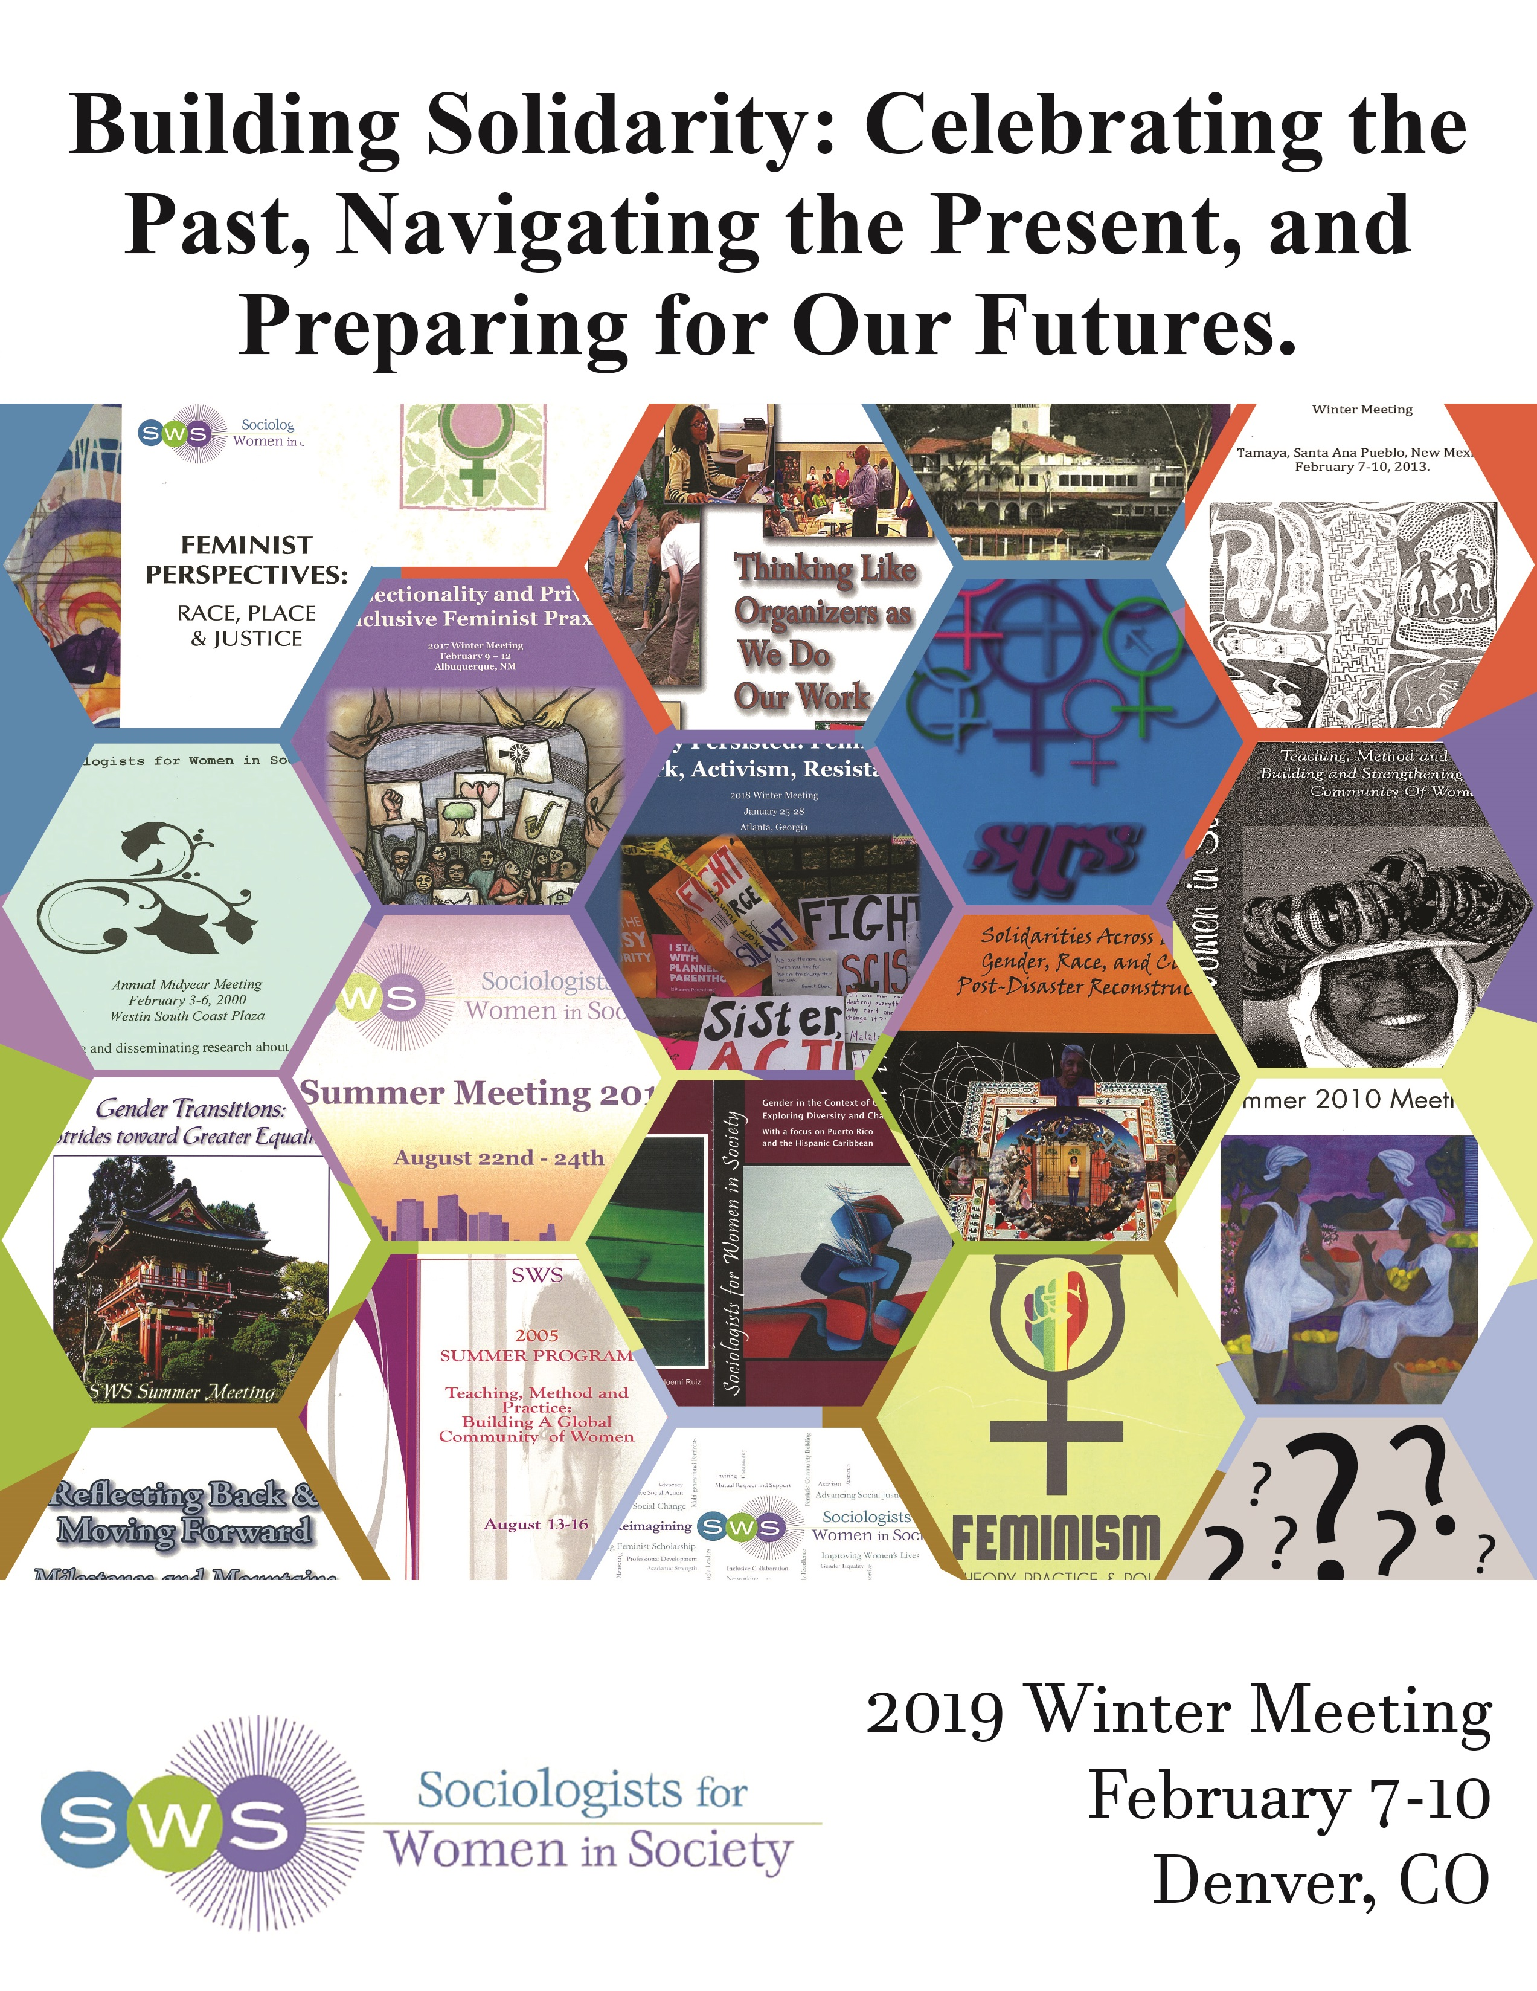
MAP
There are 3 floors that are of concern to the meeting: breakfast on 4th and meetings will be held on 2nd and 3rd floor. = Gender Neutral Bathrooms = Lactation Space
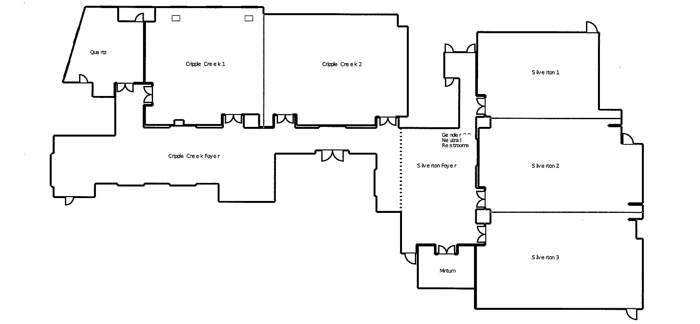Second:

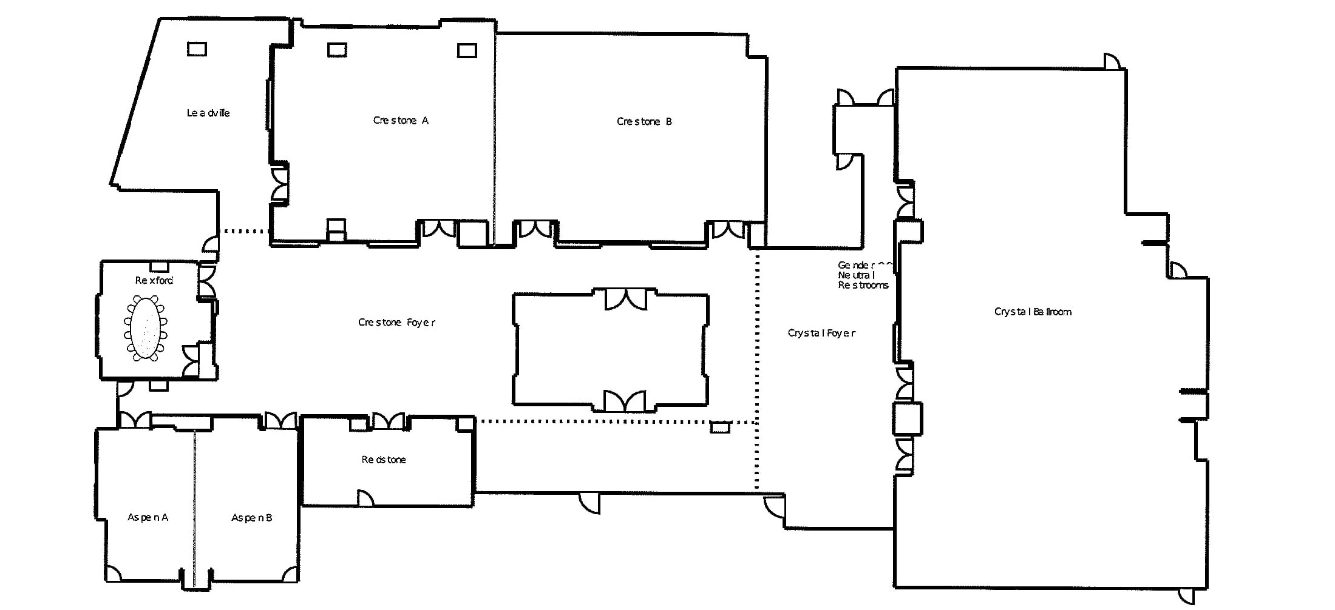Third Floor:

Contents
Hotel Floor Plan ………………………………………………………………………..…………………………2
About the Cover ………………………………………………………………………..…………………………4
President’s Message…………………………………………………………………………….…………………6
SWS Community Agreement…………………………………………………………………...………………...7
Open Committee Meetings…………………………………………………………………...…………………...8
Open Committee Missions……………………………………………………………………...………………...9
2018 SWS Officers and Chairs ………………………………………………………………..………………...10
Full Program……………………………………………………………………..…………….………………...11
Sponsorships……………………………………………………………………..…………….………………...28

Frequently Asked Questions
What is the Wi-fi Code in the Meeting Space?
1. Connect to SSID: Embassy-Meeting
2. Launch Internet Explorer or other Browser
3. Enter Access Code
Internet Access Code: SWS2019
*passwords are not case sensitive*

How do I submit my receipts for the SWS Cost Share?
After returning home from the Winter Meeting, you will submit your Cost Share form and receipts via the MemberClicks platform. Please hold onto your receipts and do not email them to the Executive Office. We will only be processing these via this online submission system. This is the same process that all attendees will follow (Award Winners, Officers, Chairs, and all Members). Please make sure that you notify the hotel staff at check-in if you are splitting the cost of the room with others. Then, they will be able to easily issue separate receipts to you upon your checkout. Please anticipate receiving your cost shares within 4 weeks of submitting your form. Review the SWS Cost Share Policy here: https://socwomen.org/meetings/sws-cost-share-policy/

Local Arrangements: Click HERE to access the Guide for Local Activities/Restaurants/Things to Do

Here’s a quick guide to how to tweet during the SWS Winter meeting:
- Follow @socwomen on Twitter
- Find other SWSers to follow on Twitter (and add yourself if you’re not listed): http://bit.ly/SWSTweets (capitalizations matter with this link, but not with Twitter hashtags or @’s).
- During the conference, use the hashtag #SWS2019 so that others following the tags can see your tweets. You can use other tags to bring attention to different issues.
- Any feminist sociology-related tweets about sessions, events, etc. should include @socwomen. @Socwomen will do their best to retweet these during the conference.
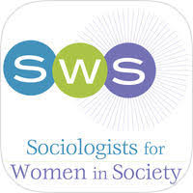
Introducing the SWS Winter Meeting Application:
The SWS Meeting App helps meeting attendees to stay connected during the meeting and offers a way for non-attendees who are members to stay current on the meeting's events. Attendees can arrange for meetups through the app and there will be some documents that supplement presentations here. Attendees can follow the program of events and be made aware of updates or announcements via this app.
Links to download:
Android: https://play.google.com/store/apps/details?id=memberclicks.sws.org
Look for this icon!
Apple: https://itunes.apple.com/us/app/sws-meeting-app/id1449847052?mt=8

About the Cover:
At the very top of the program cover is the theme of the 2019 SWS Winter Meeting: “Building Solidarity: Celebrating the Past, Navigating the Present, and Preparing for Our Futures.”
The main image is a graphic inspired by a patchwork quilt image found by SWS President Tiffany Taylor. The quilt-inspired graphic features images of covers from previous SWS meetings. Natasha Santana, Assistant to the Executive Officer, worked with President Tiffany Taylor’s vision to create this cover image.
Some of the previous meeting themes, that can be read on the images of the covers include:
- Feminist Perspectives: Race, Place & Justice
- Thinking like Organizers as we do Our Work
- Intersectionality and Privilege: Inclusive Feminist Praxis
- They Persisted: Feminism, Work, Activism, Resistance
- Teaching, Method and Practice: Building and Strengthening A Global Community of Women
- Solidarities Across Borders: Gender, Race, and Class in Post-Disaster Reconstruction
- Gender Transitions: Strides toward Greater Equality
- Gender in the Context of Globalization: Exploring Diversity and Change
- Reflecting Back & Moving Forward: Milestones and Mountains on the Road to Equality
The very last hexagon in the graphic is filled with question marks.

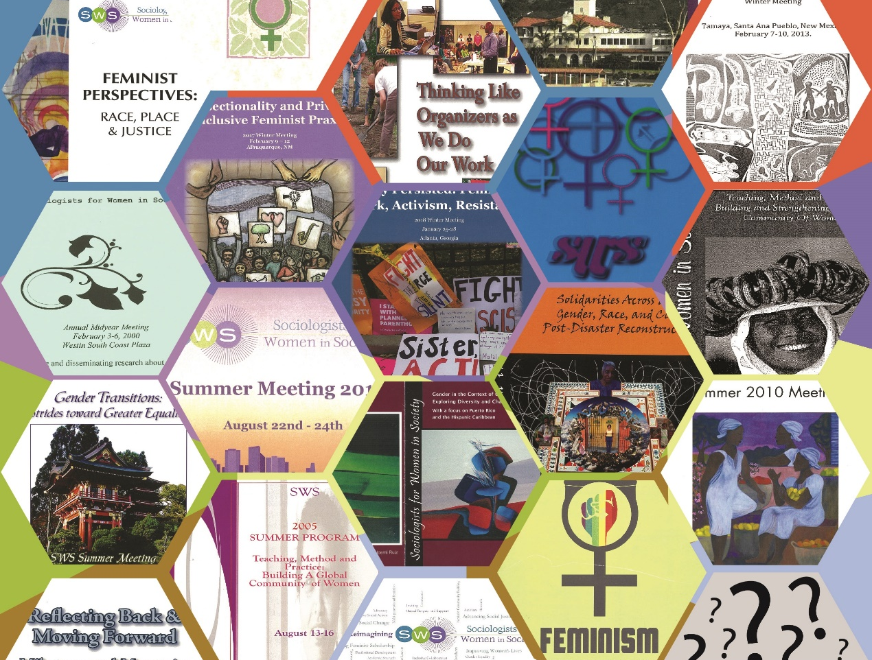
President’s Message

Hello SWS and welcome to Denver! I think we are going to have an amazing Winter Meeting! The theme of the meeting is Building Solidarity: Celebrating the Past, Navigating the Present, and Preparing for Our Futures.
We have some fun celebrations planned to honor the past that I think you will enjoy. Of course, we will have our Thursday evening Welcome Reception. We will also have a special reception, which I have been calling “Books and Brews” on Friday evening to highlight members’ books and give us a chance to meet the authors. Of course, we will have our biggest celebration, our Banquet and Charity Auction. This year we will raise money for an all-volunteer organization, Girls Rock Denver. This great organization works to: “empower girls and gender expansive youth through music education, creation, performance and community, working to put instruments in their hands to unveil what they already possess in their feet, fingertips, vocal cords, hearts and minds.” Let’s raise some money!

To help us navigate the present, we will learn from Dr. Shanesha Brooks-Tatum in this Friday plenary workshop about self-care. Throughout the meeting, we will have many opportunities to learn different self-care practices, from yoga to meditation, to Zumba and our drop-in craft room. Please take advantage of these opportunities. Additionally, we will have concurrent sessions Friday to help us navigate the present, but also prepare for the future. White members will attend the implicit bias session. Members of color will attend the session on surviving academia. The goal of these sessions is to learn skills so that we, as individuals and as an organization, can better uphold our community agreement and fulfill SWS’s mission.

As we prepare for the future, many of us may see the need for greater community engagement. If you are like me, you may have no idea how to even begin doing this kind of work! Saturday, we will have a plenary with knowledgeable panelists with a range of experiences to discuss the challenges and successes of this work. We will also have “how to ____” sessions earlier that day in which members can get very practical advice on becoming more involved in various community engagements.

Everyone always says planning a meeting is a ton of work, but you just do not realize how much work until you do it. Special thanks to Barret Katuna and Natasha Santana in the Executive Office. An amazing group of volunteers helped make this meeting possible. Thanks to Jax Gonzalez, Mary Virnoche, Glenda Walden, Diane Kholos Wysocki, Abby Ferber, and Marni Brown who assisted with local arrangements. And thanks to Regina Baker, Pallavi Banerjee, Katrina Bloch, Andrea “Drea” Boyles, Kris DeWelde, Minwoo Jung, Laura Kramer, Sancha Medwinter, Veronica Montes and Chriss Sneed for all their work on the Program Committee. We not only have an amazing and very full program, these folx were willing to take some risks and try out some new things.

Lastly, I wish to remind members that we are holding our meeting on the land of Native American people and for members to take a moment to acknowledge the ongoing consequences of colonialism in the United States. Specifically, we hold our meetings on land once inhabited by the following nations: the Apache nation, the Arapaho nation, the Cheyenne nation, the Pueblo tribes, the Shoshone tribe, and the Ute nation. Further, there are three tribes whose territory once extended to Colorado, including the, Comanche tribe, the Kiowa tribe, and the Navajo tribe. For more information about Native Americans in the area, members might be interested the linked activities and places.

I look forward to learning with you and to building solidarity in the coming days!

Tiffany
SWS President (2019-2020)

Thank You to the following local Denver businesses for their support in making our 2019 Winter Meeting such a success.
Lady Justice Brewery
Wild Women Winery
http://www.winerycolorado.com/store/#.XEuE2C2ZNTY
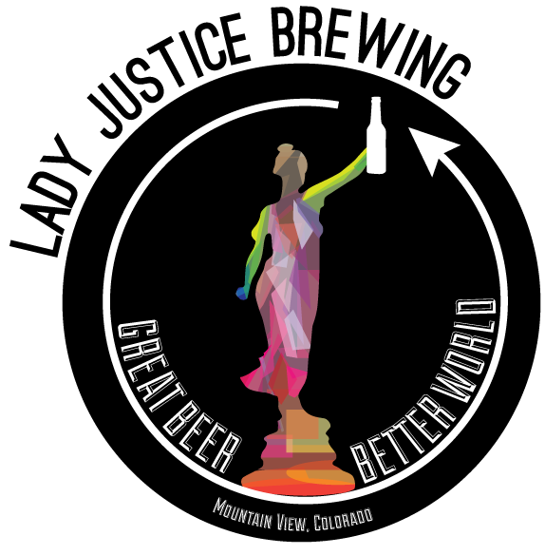
http://www.ladyjusticebrewing.com
Ceremony Center for Healing
http://ceremonyhealing.com/tribe/
The Tattered Cover
https://www.tatteredcover.com

SWS Community Agreement:
We come together to advance our feminist social justice work, and at the same time strive to embody those values within the operation of our organization. Thus, we agree to:
- Work to create a welcoming and inclusive climate (including cultivating relationships with new members and people we don’t already know)
- Treat each other with respect, in our verbal as well as body language
- Assume the best of each other
- Agree to disagree at times
- Encourage all members to play an active role in this organization, no matter how long they have been involved (check out the Bylaws, committee descriptions, and Operations and Procedures Manual on our website to learn more about the organization. All minutes are also available to support informed participation around ongoing issues)
- Be willing to make mistakes
- Strive to have patience and empathy for others
- Focus on the point, not the person
- Remain open minded to diverse ideas and practices
- Be aware of who is/is not contributing to discussion and be prepared to take space/make space. Actively listen to other voices
- Be honest, including letting others know when something makes us feel uncomfortable
- Not pass along rumors or gossip; there are always multiple versions to every story
- Value the service and commitment of all of our previous and current officers and chairs, as well as the many other volunteers that contribute their time and passion to SWS
- Avoid wearing perfumes or other strong scents
- Others?
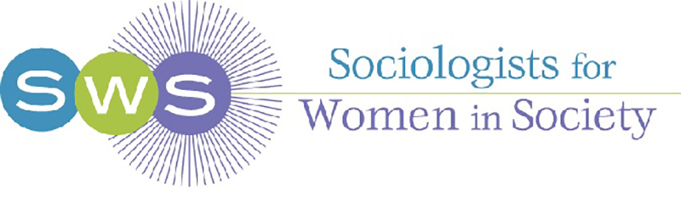
The Mission of Sociologists for Women in Society

Sociologists for Women in Society is a nonprofit professional feminist organization dedicated to:

- Encouraging the development of sociological feminist theory and scholarship
- Transforming the academy through feminist leadership, career development, and institutional diversity
- Promoting social justice through local, national, and international activism
- Supporting the publication and dissemination of cutting edge feminist social science.

Open Committee Meetings

We need YOU to help SWS fulfill our mission! Every Participant is Strongly Encouraged to attend an Open Committee Meeting:

SWS Committee: Day Time Room
International Friday 4:15 pm – 5:15 pm Silverton 2
Dis. & Acad. Justice Friday 8:00 am – 9:00 am Crestone A
Career Development Friday 9:15 am – 10:15 am Crestone A
Social Action Saturday 3:30 pm – 4:30 pm Cripple Creek 2
Sister to Sister Friday 9:15 am – 10:15 am Crestone B
Student Caucus Saturday 8:00 am – 9:00 am Cripple Creek 1
Awards Friday 8:00 am – 9:00 am Aspen B
Membership Friday 4:15 pm – 5:15 pm Aspen B
Media Relations Friday 9:15 am – 10:15 am Cripple Creek 2
Subcommittee

Open Committee Missions
Awards:
overseeing the awards nomination and selection process for all SWS awards, most of which are given annually.

Career Development:
supporting the professional development of feminist sociologists at all stages of their careers.

Discrimination & Academic Justice:
guiding the organization’ s response to a member’s allegations of discrimination based on gender, sexuality, race/ethnicity, disability, age and other identities within sociology or that involve SWS members and identifying structural and institutional issues in academia that are pertinent to gender, race, sexual orientation and other marginalized groups.

International:
providing the organization with direction in supporting global and transnational feminist scholarship and gender justice, including maintaining SWS’s role as a non-governmental organization member of the United Nations and our collaboration with other international feminist organizations.

Membership:
recruiting new members, helping to integrate them into the organization, and serving as liaison between the national organization and local and regional affiliates.

Media Relations (Subcommittee):
disseminating feminist sociological research to the public particularly in which there is public debate and/or which are lacking a feminist sociological perspective, conducting workshops in order to train members to work effectively with media, and creating a structure to help members engage in media, especially at local levels.

Sister to Sister:
guiding SWS toward becoming a fully inclusive organization, including identifying obstacles toward that goal, informing the leadership and members, and supporting networking and mentoring relationships among members across race/ethnic lines.

Social Action:
engaging SWS in projects that facilitate achieving its goal of promoting social justice through local and national activism and via members’ research, teaching and community service.

Student Caucus:
promoting the interests of students in SWS through overseeing the SWS student listserv, coordinating student functions at Summer and Winter Meetings, and undertaking projects designed to increase and maintain student membership in SWS and meet the needs of student members.

2019 Officers and Chairs
 | Council
Past President | Adia Harvey Wingfield | ahwingfield@wustl.edu
President | Tiffany Taylor | ttaylo36@kent.edu
President-Elect | Josephine Beoku-Betts | JBeokubetts@yahoo.com
Past Treasurer | Ronni Tichenor | rtichenor@me.com
Treasurer | Veronica Montes | vmontes@brynmawr.edu
Treasurer-Elect | Roberta Villalón | villalor@stjohns.edu
Vice President | Nancy López | nlopez@unm.edu
Secretary | Christin Munsch | christin.munsch@uconn.edu
Student Rep. | Jax Gonzalez | jax.gonzalez@colorado.edu
Parliamentarian | Melanie Heath | mheath@mcmaster.ca
 | Committee Chairs
Awards Committee Chair | Marybeth C. Stalp | marybeth.stalp@uni.edu
Discrimination & Academic  Justice Co-Chairs | Katie L. Acosta  Shweta Adur | kacosta@gsu.edu  sadur@calstatela.edu
Career Development | Shauna A. Morimoto | smorimot@uark.edu
Membership | Nancy López | nlopez@unm.edu
National and Local Collab | Nancy López | nlopez@unm.edu
Nominations | Adia Harvey Wingfield | ahwingfield@wustl.edu
Personnel | Adia Harvey Wingfield | ahwingfield@wustl.edu
Publications | Sharon Bird  Heather Laube | sharon.bird@okstate.edu  hlaube@umflint.edu
Sister to Sister | Sasha R. Drummond-Lewis  Andrea “Drea” Boyles | srdlewis@umflint.edu  aboyles@lindenwood.edu
International | hara bastas | ravinheart@hotmail.com
Investment | Catherine Berheide | cberheid@skidmore.edu
Social Action | Ruth Marleen Hernández | ruthmarleen@gmail.com
Student Caucus | Jax Gonzalez | jax.gonzalez@colorado.edu
 | Executive Office
Executive Officer | Barret Katuna | swseo.barretkatuna@outlook.com
Assistant to Executive Officer | Natasha Santana | natasha.santana@uconn.edu
 | SWS Publications & Media
G&S Journal Editor | Jo Reger | reger@oakland.edu
G&S Book Review Editor | Catherine Richards Solomon | gsbooks@quinnipiac.edu
Network News Editor | Marjukka Ollilainen | mollilainen@weber.edu
Social Media Coordinator | Wendy Christensen | christensenw@wpunj.edu
Publicity Specialist | Sheila B. Lalwani | sheila.b.lalwani@gmail.com

SWS Winter Meeting

Denver, Colorado

February 7 – 10, 2019

Audiovisual Guide: * = Microphone, ** = PowerPoint, *** = Microphone & PowerPoint

Thursday, February 7, 2019

8:00 am – 5:00 pm Registration Table is Open 3rd Floor Outside of Crystal Ballroom
8:00 am – 5:00 pm Graduate Student Lounge Open Quartz Boardroom
8:30 am – 4:30 pm Pre–Conference Writing Workshop: Gender, Cripple Creek 2
Professions, and Organizations
8:30 am – 4:30 pm Pre–Conference Workshop: Society of Gender Silverton 2
Professionals (SGP)**
8:00 am – 6:00 pm Drop–in Craft Space Open Aspen B
10:00 am – 11:00 am Personnel Committee Meeting (Closed Meeting) Leadville
12:15 pm – 1:45 pm Operating Budget Management I (Closed Meeting) Leadville
2:00 pm – 3:00 pm Meditation with Marnie Quinn, Ceremony Center Silverton 3
for Healing
3:15 pm – 4:45 pm Council I (Closed Meeting) Leadville
3:00 pm – 4:30 pm Cross–stitching with Blake Martin, NC State University Aspen B
3:30 pm – 4:30 pm Meditation with Marnie Quinn, Ceremony Center Silverton 3
for Healing
5:00 pm – 6:00 pm Meet with Hand Welcome Program Matches, Mentoring Silverton 2
Programming, and Welcome
5:30 pm – 7:00 pm Celebrating the Past: Welcome Reception with Silverton 2
Committee Tables, Manager’s Reception***
7:00 pm – 8:15 pm SWS Distinguished Feminist Lecture, Julia McQuillan, Silverton 2
University of Nebraska–Lincoln***

Friday, February 8, 2019

6:00 am – 9:30 am Embassy Suites’ Cooked to Order Breakfast Breakfast Area
7:00 am – 7:45 am Yoga with Sara Walsh, Ceremony Center for Healing Silverton 3
8:00 am – 5:00 pm Registration Table is Open 3rd Floor Outside of Crystal Ballroom
8:00 am – 5:00 pm Graduate Student Lounge Open Quartz Boardroom
8:00 am – 5:00 pm Childcare Open Aspen A
8:00 am – 5:00 pm Drop–in Craft Space Open Silverton 3
8:00 am – 9:00 am Breakfast with Scholars, Sponsored by Crystal Ballroom
Student Caucus*
8:00 am – 9:00 am Investment Committee Meeting I (Closed) Rexford
8:00 am – 9:00 am Awards Committee Meeting Aspen B
8:00 am – 9:00 am Discrimination & Academic Justice Committee Meeting Crestone A
8:00 am – 9:00 am Yoga with Sara Walsh, Ceremony Center for Healing Silverton 3
9:15 am – 10:15 am Jewelry Making with Abby Ferber, Silverton 3
University of Colorado Colorado Springs
9:15 am – 10:15 am Cross–stitching with Blake Martin, NC State University Cripple Creek 1
9:15 am – 10:15 am Nominations Committee Meeting (Closed) Leadville
9:15 am – 10:15 am Sister to Sister Committee Meeting Crestone B
9:15 am – 10:15 am Career Development Committee Meeting Crestone A
9:15 am – 10:15 am Media Relations Subcommittee Meeting Cripple Creek 2
10:30 am – 12:30 pm Plenary: Implicit Bias Matters* Silverton 1
White members please attend this workshop with expert trainers from the Matrix Center. During this interactive session, participants will explore how and why implicit bias matters to their roles in academia. By the end of the workshop, they will be able to define implicit bias, explain its relevance, and enact strategies and techniques for mitigating implicit bias.
    - Andrea Herrera, University of Colorado Colorado Springs
    - Brenda Allen, University of Colorado Denver, Anschutz Medical Campus, Matrix Center for the Advancement of Social Equity and Inclusion
10:30 am – 12:30 pm Plenary: People of Color Coping Survival/Thriving Session* Silverton 2
SWS members of color, please attend this interactive workshop geared toward creating a space for folx of color to discuss the challenges and problems they experience in academia and come up with coping strategies. Here academia is defined broadly and, includes, academic institutions, conferences, publishing and other entities. The dialogue will take place between five senior members of color who are the panelists and the audience many of who will be junior scholars of color. The session also affords the opportunity for junior members of color to discuss issues with the panelists in smaller round tables. All folx of color are welcome.
- Margaret Abraham, Hofstra University
- Marlese Durr, Wright State University
- Bandana Purkayastha, University of Connecticut
- Adia Harvey Wingfield, Washington University in St. Louis
- Mary Romero, Arizona State University
- Presider: Pallavi Banerjee, University of Calgary
Organizers: Pallavi Banerjee, University of Calgary, Regina Baker, University of Pennsylvania and Sancha Medwinter, University of Massachusetts Amherst
12:30 pm – 2:00 pm Lunch and Business Meeting 1*** Crystal Ballroom
2:00 pm – 4:00 pm Plenary: Navigating the Present: Self–Care Crystal Ballroom
Workshop with Shanesha Brooks–Tatum, The Life
Balance & Wellness Institute***
4:15 pm – 5:15 pm Publications Committee Meeting I (Closed) Leadville
4:15 pm – 5:15 pm Membership Committee Meeting Aspen B
4:15 pm – 5:15 pm International Committee Meeting Silverton 2
4:15 pm – 5:30 pm Upsetting the Tenure/Non–Tenure Track Hierarchy: Crestone A
An Interactive Conversation
Description: This session will be a conversation about the academic hierarchy that positions tenure–track faculty above non–tenure line faculty with respect to prestige, power, and material gain. Panelists are interested in and represent both contingent and competitively–hired, contracted, full time non–tenure line faculty. We will discuss national trends, issues of inequity, and ways to flip the narrative and conditions that frame non–tenure track jobs as “plan B’ when in reality many of us prefer this option. If possible, please read Julie Shayne’s blog post on the topic in Conditionally Accepted prior to the session: www.insidehighered.com/advice/2018/09/28/colleges–need–make–concrete–changes–improve–working–conditions–senior–non–tenure

Panelists:
- Gillian Niebrugge–Brantley: The George Washington University & ASA Task Force on Contingent Faculty
- Julie Shayne: University of Washington Bothell; School of Interdisciplinary Arts & Sciences; Gender, Women & Sexuality Studies
- Cynthia Deitch, George Washington University: Women's, Gender, and Sexuality Studies Program
- Molly Monahan Lang: Penn State Erie; Sociology
- Molly S. Jacobs: UCLA; Department of Sociology

4:15 pm – 5:30 pm Feminist Strategies for Academic Advancement: Dialogues Crestone B
About What We Are Glad/Wish We Knew
Participants
- Emily Kazyak, University of Nebraska-Lincoln
- Laura Hirshfield, University of Illinois College of Medicine at Chicago
- Zakiya Luna, University of California, Santa Barbara
- Carla Pfeffer, University of South Carolina
- K. Scherrer, Metropolitan State University of Denver
4:15 pm – 5:30 pm Film Screening and Discussion with Experts – Crystal Ballroom
The Naked Truth: Death by Delivery
(Sponsored by Social Action Committee and Sister to Sister Committee)***
Fusion TV’s documentary, The Naked Truth: Death by Delivery, highlights the racial health disparity between Black and white women within the context of maternal mortality. On average, Black women are 3-4 times more likely to die from pregnancy-related complications than white women, regardless of wealth and education. The film is followed by a Q&A panel of healthcare experts who will continue the discussion of maternal (and infant) mortality.
Panelists:
      - Dr. Cathleen Appelt, Assistant Professor, Duquesne University
      - Demetra Seriki, Certified Professional Midwife with A Mother's Choice
      - Heather Thompson, Deputy Director with Elephant Circle
      - Deidre Johnson, MBA, CEO & Executive Director, The Center for African American Health
Presider: Evonnia Woods, Missouri Organizer, Reproaction
4:15 pm – 5:30 pm Strategies for Responding to Hostile Climates Workshop Silverton 1
(preference for roundtable presenters in this timeslot)
Erika Marin–Spiotta and Blair Schneider, ADVANCEGeo Team
This short, interactive session describes academic practices and institutional structures that allow for sexual harassment and other hostile behaviors to persist, discusses initiatives to address harassment as research misconduct, and provides training in personal intervention strategies to protect and support targets of harassment. As a result of this session, participants will be able to identify: (1) different ways in which sexual and other types of harassment can manifest in research environments; (2) strategies for bystander intervention, and (3) resources for cultural change in academic institutions and professional societies.
4:15 pm – 5:30 pm Aging in Academia: Feminist Issues Cripple Creek 2
      - Wendy Simonds, Georgia State University
      - Elisabeth Burgess, Georgia State University
      - Laura Kramer, Professor Emerita
4:15 pm – 5:30 pm Critique Me Session (Sponsored by: Cripple Creek 1
Career Development Committee)
5:00 pm – 6:00 pm Student Reception (Meet & Greet) Silverton 3
6:00 pm – 7:00 pm Books & Brews to Celebrate the Present Outside Crystal Ballroom
7:00 pm – 9:00 pm Hosted Dinners Offsite

Saturday, February 9, 2019

7:00 am – 10:30 am Embassy Suites’ Cooked to Order Breakfast Breakfast Area
7:00 am – 7:55 am Zumba with Ruth Stamper, University of Kansas (Music Setup) Silverton 3
7:45 am – 9:15 am Gender & Society Editorial Board Meeting (Closed) Aspen B
8:00 am – 5:00 pm Registration Table Open 3rd Floor Outside of Crystal Ballroom
8:00 am – 5:00 pm Childcare Open Aspen A
7:55 am – 8:55 am Yoga with Sara Walsh, Ceremony Center for Healing Silverton 3
7:55 am – 8:55 am Student Caucus Meeting Cripple Creek 1
7:55 am – 8:55 am Meeting with Sociological/Academic Organization Leaders Leadville
(Council Members, Executive Directors, etc.)
9:00 am – 5:00 pm Drop–in Craft Space Open Silverton 3
9:00 am – 10:30 am Roundtables Session 1* Crystal Ballroom
Table 1: Bodies, Weight and Embodiment
- Crossing the Troll Bridge: The framing of fat bodies on social media – Amanda Levitt, Wayne State University
- Intersex Pride, Fat Shame: The Paradox of Bodily Autonomy – Georgiann Davis, University of Nevada, Las Vegas
- The Gender Disparity of Weight Loss Surgery – Leslie Pierce, North Carolina State University
- Weight as Status: Experimental Results – Bobbi Reidinger, Kent State University
Discussant: Georgiann Davis, University of Nevada, Las Vegas

Table 2: Substance Use and Misuse
- The Pain of Poverty: The medicalization and criminalization of nonmedical prescription drug use – Michelle Smirnova, University of Missouri – Kansas City and Jennifer Owens, University of Missouri–Kansas City
- A Gender Paradox in Adverse Childhood Experiences, Sexual Victimization, and Mental Health History among Young Opioid Users in New York City – Kelly Quinn, NYU Rory Meyers College of Nursing Behavioral Sciences Training in Drug Abuse Research Postdoctoral Trainee
Discussant: Perry Threlfall, George Mason University
Table 3. Rethinking Crime, Criminalization and Punishment
- Student Engagement as a Seed for Radical Potential – Jeannette Hernández, University of Nevada, Las Vegas?/Doctoral Student
- Under the Punitive Aegis: Deviant Dependency and the Family Justice Center Model – Victoria Piehowski, University of Minnesota
- Intersectionality & Attitudes Towards Police in North Minneapolis – Amber Joy Powell, University of Minnesota – Twin Cities
Discussant: Andrea (Drea) S. Boyles, Lindenwood University
Table 4: Constructions of Crime and Punishment
- Carceral Dissonance: The Contradiction of Ending Homelessness through Policing – Korey Tillman, University of Nevada, Las Vegas
- Return to Grace: Judico–therapeutic diversion in the control of prostitution – Lillian Jungleib, University of California, Santa Barbara
- Money Bail in Nashville: A Critical Examination – Michelle Joyner, Middle Tennessee State University
- State Crime SVU: An analysis of research on untested sexual assault kits and state response – Kelly Faust, Saint Mary's College – Notre Dame, IN
Discussant: Kylie Parrotta, Delaware State University
Table 5: Transgender Experiences: Self Narratives, Policies, and Family Members
- Sexual Regulation and Sexual Politics: The Emergence of Trans Femininity in California Men’s Prisons – Joss Greene, Columbia University
- What Does It Mean to be a Man? Trans* Men and Gender Ideology in the South – Baker Rogers, Georgia Southern University
- Finding Adulthood: Trans Narratives on Coming of Age – Jonathan Jimenez, University of Nevada, Las Vegas
Discussant: Emily Fairchild, New College of Florida
Table 6. Gender, Pronouns and the Binary
- Theorizing Non–Binary Gender Achievement – Helana Darwin, Stony Brook University
- Gender–Neutral Pronouns: Undoing Gender or Creating More Identity Choices? – Abigail Saguy, University of California, Los Angeles
- Pronoun Trouble: Gendered talk in the context of social change – Amelia Hill, University of California, Los Angeles
Discussant: Harry Barbee, Florida State University

Table 7: Gender Performances
- Problematizing the (A)politics Underpinning the "Dueling Masculinities" of Jamtronica Music Festival Subcultural Scenes – Kaitlyne Motl. Georgetown College
- What Kind of Man Reads Playboy? A Goffmanesque Analysis of Masculine Ideal – Shelby Clark, University of Arkansas
- “I am too Fat to be an Otter, But Not Fat Enough to be a Bear”: The Negotiation of Desirable Bodies on Grindr – Ian Whalen, University of Colorado, Boulder
- Presentations of Femininity for Female Athletes in Male Dominates Sports in the Northeast – Kalli Williams, Northeastern University
Discussant: Jean Van Delinder, Oklahoma State University
Table 8: Gender: Outcomes and Intersections
- The Uneven Benefits of Warmth – Christianne Corbett, Stanford University
- Effects of Social Class Threat on Presented Gender Identity – Katharine Khanna, Columbia University
- The Multiple Meanings of Age – Sasha Johfre, Stanford University
Discussant: Kristy Kelly, Drexel University and Columbia University
Table 9: Race, Ethnicity and Doing Gender
- (Race)ing identities: Racial and Ethnic Expressions of Men in The Las Vegas Street Car Scene –Celine Ayala
- Gendered Management of the Racial Hierarchy – Radha Modi, Florida State University
- The Influences of Cultural Globalization on Gender and Ethnic Identity – Koyel Khan, University of Connecticut
- Doing (traditional) gender in urban American Indian communities: reasserting or relinquishing women's power? – Michelle Jacobs, Wayne State University
Discussant: Michelle Jacobs, Wayne State University
Table 10: LGBTQI+ Acceptance and Marginalization
- Google, Tell Me. Is He Gay?: Masculinity, Homophobia, and Gendered Anxieties in Google Search Queries about Sexuality – Emma Mishel, New York University, Tristan Bridges, University of California Santa Barbara, and Mònica Caudillo, University of Maryland
- ‘The Gays Do It Up Right’ but ‘If You Want Something Done, Have a Dyke Do It’: Gay Aesthetics and the Marginalization of Lesbian, Bisexual and Queer Women in Southern Festival Life – Amy Stone, Trinity University
- Pegging Privilege: An Alternative Approach to LGB/TQ+ Allyship and “Safe Space” Trainings – Madelyn Glasco, Northeastern University
Discussant: Penny Harvey, Georgia State University
Table 11: Sexuality
- “My family and friends thought it was a horrible idea”: The Classed, Gendered Project of Young Adult Women’s Intimacy Choices – Cristen Dalessandro, Pacific University
- Black, Sexual Minority Women after the Great Migration: Cultural Straddlers in Search of Sexual Autonomy and Economic Freedom – Estela Diaz, Columbia University
- Comfort before Action: The effects of comfort on activism in LGBT and racial communities – Eliza Thor, University of Nebraska–Lincoln
Discussant: Jamie O'Quinn, University of Texas at Austin
Table 12: Romantic Relationships
- Intimacy and Globalization: An Ethnography in Máncora, Peru – Anna Hidalgo, Columbia University
- Daddy, I Need Some Money: An Exploration of Sugar Arrangements in a Technologically Advanced Era – Megan Keeling, University of Arkansas
- Young Adult Women’s Depressive Symptoms Across Romantic Relationship Statuses: The Intersectional Influences of Race–Gender and Educational Attainment – Brittany Hearne, University of Arkansas
Discussant: Gina Marie Longo, University of Wisconsin, Madison Law School
Table 13: Privilege, Marginalization, and Competing Resources
- “She Can Hang”: College Women, Tokenism, and the Patriarchal Bargain – Katie K. Rogers, University of Texas at Austin
- I'm Not with Her: Gender Strategies Employed by Politically Conservative Women – Lisa Hummel, Stanford University
- Fandom Fragility: How Traditionalist Backlash in Sci–fi Reinforces Patriarchy and White Supremacy – Michael Kreiter, Kent State University
- Being Brown in a Ski Town: Discourses of Racism, Sexism, and Class Stratification – Kyle Anne Nelson, University of Northern Colorado
- Tourism, White Supremacy, and Tripadvisor as one Place for Resistance – Abby Ferber, University of Colorado Colorado Springs
Discussant: Katrina Bloch, Kent State University at Stark
Table 14: Medical Sociology
- Women's Health Qua Health – Ashley Kim, Vanderbilt University
- Death and Sexism: A Quantitative Analysis of Physician–Assisted Death – Aubrey Limburg, University of Colorado Boulder
- Rise and Fall of Hysteria as a Medical Diagnosis – Angela DeLuccia, University of Nebraska–Lincoln
- The Body as a Temple, Bought at a Price: The Form and Function of Cosmetic Surgery in Young Women's Lives – Sara Veljic, University of Colorado Boulder
- Discussant: Angela DeLuccia, University of Nebraska–Lincoln
Table 15: LGBTQ Health
- LGBTQ Symbolism within Medical Culture: An Assessment of Interaction Patterns between LGBTQ Patients and Medical Providers – Lindsay Toman, Wayne State University
- Hidden Curriculum in Medical Education on LGBTQ Health – Jessica Herling, Virginia Tech
- Rurality, Connectedness, and Happiness: Creating a Pathway for Rural LGBT Mental Health – Emma Finken, University of Nebraska–Lincoln
- Dynamics of Familial Resistance to Identity and Mental Stressors among LGBTQ+ Latino/a Young People – Rachel Schmitz, Oklahoma State University
Discussant: Jax Gonzalez, University Colorado Boulder
Table 16: New Directions in Reproductive Health Policy
- ‘The Calculus We Do’: Advocacy for Long–Acting Reversible Contraception in Texas – Anna Chatillon, University of California, Santa Barbara
- A Critical Examination of Unintended Pregnancy Prevention in U.S. Health Policy: Historical Trends and Recent Developments – Lindsay M. Stevens, Princeton University
- ‘Why HB 40 Passed’: Black Space Making in Reproductive Health Policy Movement – Aalap Bommaraju, University of Cincinnati
Discussants: Emily S. Mann, University of South Carolina and Krystale Littlejohn, Occidental College
Table 17: Reproductive Health
- The many different faces of surrogacy – challenges of gestational carriers in the US – Anabel Stoeckle, Wayne State University
- "There's No ICD–10 Code for That:" Understanding Psychiatry in Reproductive Health – Jessica Harrison, UCSF–SBS
- “I’ve made it this far. He ain’t going to let me down now”: Women’s faith across the infertility experience – Katherine Kafonek, University of Delaware and Ann Bell, University of Delaware
- Doctor, Doctor, Give me the News: Patient Satisfaction in the Infertility Diagnostic Process – Brianne Bombach, University of Texas at El Paso and Ophra Leyser–Whalen, University of Texas at El Paso
- The Erased Women: Legitimization Processes and China's Changing Population Management Policies – Wenjie Liao, North Carolina State University
Discussant: Caity Collins, Washington University at St. Louis
Table 18: Youth, Reproduction, and Sexual Health
- Sex Differences in Contraceptive Method Use Among Teens – Hilary Flowers, UCLA
- “No one had to tell me that it was bad, but I just knew it was.”: Telling True Stories about Sex – Mary Robertson, California State University San Marcos
- “We sorta talked about it, but then we didn’t”: Teen Parents and the Complexity of Abortion Discourse – Jennifer Beggs Weber, University of West Georgia
Discussant: Lauren Marie Guyer, University of Northern Colorado
Table 19: Maternal Health and Motherhood
- A Critical Analysis of Post–Partum Depression Protocols & Accounts: Some Early Findings and Reflections – Richelle Dykstra–Crookshanks, Slippery Rock University
- Postpartum Depression in the News Media – Harmony Newman, University of Northern Colorado and Lauren McDonald, University of Northern Colorado
- A Mosaic of Stigma: theorizing why there is internal and enacted stigma against doulas – Adelle Monteblanco, Middle Tennessee State University
Discussant: Carrie Lee Smith, Millersville University
Table 20: Abortion: Stigma, Politics, and Advocacy
- Clandestine No More: The Struggle for Abortion Rights in Argentina – Barbara Sutton, University at Albany, SUNY
- Embodied Experiences of Surgical and Self–Managed Medication Abortion Care in a Highly Restrictive Context – Kathleen Broussard, University of Texas at Austin
- Politics and Practice: Abortion care, Stigma, and Practice in the U.S. – Rebekah Getman, Northeastern University
- We Do It by Just Being Ourselves: Gender and Abortion Stigma Management through Advocacy – Andréa Becker, CUNY Graduate Center
Discussant: Erika Busse, Macalester College
Table 21: Sexual Health and Reproduction
- The Sex of Contraception: Exploring how and why contraceptive responsibility becomes gendered – Jamie Manzer University of Delaware, and Ann Bell University of Delaware
- Multicultural Marketing and the Exclusion of Asian Americans: A Content Analysis of HPV Vaccine Advertisements – Kim–Phuong Truong–Vu University of Colorado, Boulder
Discussant: Sinikka Elliott, The University of British Columbia | Vancouver Campus | Musqueam Traditional Territory

Table 22: Sexual Assault and Misconduct in Schools
- The Impact of Gender On Campus Sexual Assault: Where Does Responsibility Lie? – Lisa Dilks, West Virginia University, Alexis Hilling, Kent University, and Brittany Kowalski, West Virginia University
- “I Could Never Tell My Parents”: Barriers in Queer Women’s Disclosure of College Sexual Victimization to Family Members – Nicole Bedera, University of Michigan, Kristjane Nordmeyer, Westminster College, and Kathryn Holland University of Nebraska, Lincoln
Discussant: Angela Hattery, George Mason University
Table 23: Sexual Violence in Higher Education
- “I Don’t Like How Men are Usually the Victims”: Men’s Fear of False Allegations and Misunderstandings about Rape – Nicole Bedera, University of Michigan
- Responsible Employees Question the Title IX System: When Civil Rights Programs Adopt Legal Logics and Blend with Power Interests – Jessica Cabrera, University of California, Irvine
- The Politics of Sexual Violence at State University: 1972–2017 – Nona Maria Gronert, University of Wisconsin
- Beyond Title IX: Exploring Justice for Survivors/Victims of Campus Sexual Assault – Chelsea Ullman, The George Washington University
Discussant: Nona Maria Gronert, University of Wisconsin–Madison
Table 24: Sexual Violence and Constructing Consent
- A Scary Time for Young Men: Masculinities and Sexual Consent – Julia Metz, Northern Illinois University, Kristen Myers, Northern Illinois University, and Patricia Wallace Northern, Illinois University
- Consent (sub)Culture: The Experiences of the BDSM Community – Kayla Cagwin, Kent State University
Discussant: Danielle Currier, Randolph College
Table 25: Sexual Harrassment/violence
- Beyond #MeToo: Missing Marginalized Voices and Feminist Responses – Cynthia Deitch, George Washington University
- Gender Threat: The Effects of Men's Unemployment on Sexual Harassment – Yasemin Besen–Cassino, Montclair State University
- Female Brass Players and Self–Reported Sexual Harassment – Patricia Maddox, University of St. Thomas
- Shifting paradigms in campus on campus climate surveys on sexual misconduct – Solange Simões, Eastern Michigan University
- Where Romance Meets Stalking: How Heteronormative Beliefs Perpetuate Stalking Culture – Andréa Becker, CUNY Graduate Center, and Jessie Ford, Columbia University's Mailman School of Public Health
Discussant: Laura Logan, Hastings College
Table 26: Sexual Abuse and Violence
- Affirmative Consent and Victim Blaming Before and After #MeToo – Sophia Boutilier, Stony Brook University
- Pulling Back the Veil: Sexual Abuse in Evangelical Settings – Ashleigh McKinzie, Middle Tennessee State University, and Patricia Richards, University of Georgia
- Disrupting a Culture of Silence: Sexual Assault among Arab American Muslim Women – Salam Aboulhassan, Wayne State University
- Romantic Relationships of Survivors of Commercial Sexual Exploitation – Gianna Stover University of Northern Colorado, and Angie Henderson, University of Northern Colorado
- Sex Trafficking Victims’ Road to Recovery: An Analysis of Exit Strategies – Angie Henderson, University of Northern Colorado, Cassie Sileo, University of Northern Colorado, and Megan Lundstrom, University of Northern Colorado
Discussant: Ashleigh McKinzie, Middle Tennessee State University
Table 27: Food and Environment
- Feast and Famine? Manhood, Womanhood, and Food Production in a Changing Global Climate – Elyse Neumann, University of Kansas
- Veggies Against Barriers: Feminist Methodologies of Gardens for Women in Correctional Settings – Daniela Jauk, Oriana House, Inc., and Sharon Everhardt, Troy University, AL
- Environmental Decline and Changing Gender Practices – Kari Norgaard, University of Oregon
- In the Absence of Whiteness: Quapaw Land Sovereignty, Media Representation and Public Awareness of the Tar Creek Superfund Site​ – Ruth Stamper, University of Kansas Discussant: Tracy Ore, St. Cloud State University

9:00 am – 10:30 am Roundtables Session 2 Crestone B
Table 28: Inequality in Work Places
- Using Data to Inform Industry Stakeholders and Policy Makers about Gender and Racial/Ethnic Inequalities in the Construction Trades – Maura Kelly, Portland State University
- The racialized and gendered representations of multiculturalism from an elite firm approach – Ryeora Choe, University of New Mexico
- Leaders are White Men...Or are They? Race and Gender Intersectionality for Peer Leadership Evaluations – Judith Rosenstein, United States Naval Academy
- Queerphobia, Racism and Labor Markets: A Study on Job Searching and Evaluation Bias – Abby Arellanes, North Carolina State University
- Messy boundaries and crossed lines: Workplace sexuality as a driver of gender inequality in the workplace – Chloe Hart, Stanford University
Discussant: Tricia McTague, Eastern Michigan University

Table 29: Gender, Work and Organizations
- Girls Work, Too: Structures of Work for Women and Girls in Financially Unstable White Families –Annaliese Grant, University of Wisconsin – Madison
- Agriculture as Carework: Performing Femininity in a Male–Dominated Occupation – Rebecca Shisler, North Carolina State University, and Joshua Sbicca, Colorado State University
- Overlooked? A Historical Analysis of Nonstandard Work for Women in Non–metro Areas – Brooklyn Mills, North Carolina State University
Discussant: Susan H. Lee, Boston University College of General Studies

Table 30: Inequality in the Workplace
- Exploring linkages between organisational culture and gender equality actions – A case study of a Danish knowledge–intensive company – Ea Utoft, Northeastern University
- The Growth of Feminist Biology – Jeffrey Lockhart, University of Michigan
- TOKEN FATIGUE: Stress of Racialization and Gendering as Bodies Out of Place – Jihyun Shim, UCLA
- Occupational Devaluation at the Intersection of Race and Gender – Katie Wullert, Stanford University
- Bystander Training Workshop Development – Yun Ling Li, University of Massachusetts Lowell
Discussant: Sancha Medwinter, University of Massachusetts Amherst

Table 31: Navigating Inequality: Parenthood and Child Outcomes
- The Impact of Mothers on the Racial Identity Making Process of Black Women with Natural Hair in the United States and the Dominican Republic – Ruby Bafu, University of Wisconsin–Madison
- Balancing Family and Work: The Role of Social Networks on Mexican–American Women’s Workforce Participation and How Perceptions of Mothering Affect Women’s Well–Being – Karen Martinez, Kent State University
- Parenting Kids: Child Custody, Gender, and Parenting – Adriana Ponce, University of Michigan
- Working on the Parents: Parent Educators and Parent Identity – Mary Ann Kanieski, Saint Mary's College
Discussant: Regina Baker, University of Pennsylvania

Table 32: Navigating Parenthood
- Fathering at the Brims of Society: An Examination of the Relationship between Fatherhood and the Desistance Process – Patricia Becker, University of Delaware
- Exploring the Stress Narrative of Christian and Secular Homeschooling Mothers – Erin Baker, Wayne State University
- Negotiations of Choice among Voluntarily Childfree Women – Amanda Shigihara, California State University Sacramento
- Mothers’ Sense–Making about Gendered Children, Childhood Health, and the Influence of Technology – Stefanie Mollborn, University of Colorado Boulder, Jennifer Pace, University of Colorado Boulder, and Paula Fomby, University of Michigan
Discussant: Shannon Davis, George Mason University

9:00 am – 10:30 am Roundtables Session 3 Crestone A
Table 33: At the Intersection of Work and Family
- Wonder Woman: The Pros and Cons of Child Friendly Work Spaces – Nicole Jenkins, University of Nevada Las Vegas
- Medical Marriages: Analyzing the Lives of Physician Spouses Using a Mixed Methods Approach – Molly Monahan, Lang Penn State Erie, The Behrend College
- Emotion Work and Identity Work: A Qualitative Analysis of Ohio Welfare–to–Work Managers’ Professional Identities and Use of Feeling Rules – Brianna Turgeon, Jacksonville State University, Kaitlyn Root, The University of Akron, and Tiffany Taylor, Kent State University at Kent
- Flexing Balance in the New Economy: Gender, Family, and Work in the New Economy – Megan St. George, Wayne State University
Discussant: Brianna Turgeon, Jacksonville State University

Table 34: Education and Occupational Success
- The Perfect Match: The Factors That Influence Finding a Job After Earning a PhD – Andrea Johnson, University of Nebraska Lincoln
- STEM Faculty Networks and Gender: Implications for Career Outcomes and Inclusion – Ethel Mickey, Wellesley College
- Career trajectories framework for female, nonwhite, non–US baccalaureates in STEM – Yun Cho, University of Wisconsin – Madison
- Restricted by Gender? Parents, Self–Motivation, and STEM Occupational Expectations – Kriti Singh, University at Buffalo, The State University of New York, Seong Won Han, University at Buffalo, The State University of New York, and Lois Weis, University at Buffalo, The State University of New York
- Contesting Common Knowledge: Gender and Publication Productivity in STEM – Jackie Krasas, Lehigh University
Discussant: Rodica Lisnic, University of Arkansas, Fayetteville
Table 35: Unequal Educations
- Contending with the Double Bind: How Student–Parent Expectations About College and Mobility Matter for First–Generation Experience and Outcomes – Melissa Osborne, University of Chicago
- Exploring URM Undergraduate Social Science Students’ Perceptions of Student Success – Amy Leisenring, San Jose State University
- The First Year: Academic Stress and Health among Undergraduate College Students – Laura Simon, Mercer University
Discussant: Freeden Blume, Oeur Tufts University
Table 36: Gender, Career, and Mobility
- Mobility among Academic Leaders: How does the Reputation of Universities Matter? – Kathrin Zippel, Northeastern University, and Rebekah Getman, Northeastern University
- An investigation on the experience as being a female Chinese academic – Shunan You, Northeastern University
- The Gendered Organization of Medical Schools – Livia Baer–Bositis, Stanford University
- Welcome Home: Higher Education Community, Inclusion, and Policy in Gender Restrictive Institutions – Megan Nanney, Virginia Tech
- I had no idea what a non–sexist education meant: The “feminist May” in Chile and its impact on the legal academia. – Maria J Azocar, University of Wisconsin Madison
Discussant: Laura Kramer, Laura Kramer Consulting

Table 37: Politics and Activism
- Policy whiplash: the paradoxes of women’s “empowerment” and pro–women policies in the Carolinas – Mary Robbins, UCLA
- Pushing for Change for Women: Strategies With and Without Legal Protection for Union Activism – Carissa Froyum, University of Northern Iowa
- Secularization, Public Religious Authority, and Group Subjectivities in the 2016 American Presidential Election & 2018 Kavanaugh Hearings – Amber Nelson, Marian University
- The Evolution of Gendered Partisanship: A Comparative Analysis of “The Year of the Woman,” 1992 and 2018 – Morgan Matthews, University of Wisconsin–Madison
Discussant: Carissa Froyum, University of Northern Iowa

9:00 am – 10:30 am Roundtables Session 4 Cripple Creek 2
Table 38: Politics, Social Movements, and Change
- Starticipants: How Celebrity Leadership is Changing Political Engagement – Tanya Cook, Community College of Aurora, and Jamie Puglin–Baker, Stony Brook University
- With Friends Like These, Who Needs Enemies?: Allyship, Conflict, and the Complex Dynamics of ‘Call Out’ Culture – Jaime Hartless, University of Virginia

Discussant: Wendy Christensen, William Paterson University
Table 39: Gender, Feminism and Social Change
- European Political and Policy Discourses Surrounding the "Crisis" of Multiculturalism in Europe, and its Affect on Muslim Women in European Cities – mehr mumtaz, University of North Texas
- Men Wage War, Women Wage Peace?: Feminist Peace Movements in Israel – Sophie Schor, University of Denver– Josef Korbel School of International Studies
- Mexico as a Locus for Feminist Transnational Activism Against Feminicidio – Isabel Geisler, Northeastern University
- Indigenous Ngöbe women’s social and political participation and the role of fist fighting – Carolina Quesada Cordero, Universidad de Costa Rica
- Servants of Gender Equality The Representation of Domestic Work in Spanish Policy Debates– Pilar Gonalons Pons
- Discussant: Minwoo Jung, University of Southern California
Table 40: Inequality, Policy, and Social Change
- Menstrual Hygiene Management and the Environment – Darcy Sullivan, University of Kansas
- The Intersectional Politics of Neoliberal Urban School Reform Resistance – Hava Gordon, University of Denver
- Discussant: Kamryn Warren, University of Northern Iowa
Table 41: Parenting and Navigating Borders
- “What kind of a parent are you?”: The experiences of Syrian and Yazidi refugee Mothers in Calgary” – Negin Saheb Javaher, University of Calgary
- Gendering Deportability: Undocumented Mexican Parents Articulating Deportation Concerns –Cassaundra Rodriguez, University of Nevada, Las Vegas (UNLV)
- Parental Stress in the Families of Parachute Kids from Mainland China – Kimberly Gan, San Diego State University
- Lost in Translation: The (Unseen) Gendered Experience of International Student Families – Isabel Fandino, University of Calgary
Discussant: Pallavi Banerjee, University of Calgary
Table 42: Migration
- Bhutanese Refugees in Salt Lake City and Seattle – Shobha Hamal Gurung, Southern Utah University
- Gendered Transitions: The Case of Syrian’s Forced Migration to Egypt – Nada Ali Ramadan, UCLA
- Black Feminist Thought and Double–Consciousness for Identity Development among Sub–Saharan African Refugees – Oluchi Nwosu, Randolph Vanderbilt University
- Social Determinants of Health: Examining Recently Arrived Refugees’ English Acquisition and Psychological Distress – Charlisa Christian, University of New Mexico
Discussant: Shobha Hamal Gurung, Southern Utah University

9:00 am – 10:30 am Roundtables Session 5 Silverton 1
Table 43: Media, Inequality, and Presentation
- Transmedia Fandom: Race & Gender in New Media Spaces – Whitney Hunt, Wayne State University
- The Princess is in Another Game: Examining Gender Representations in Independent Video Games – Emily Cabaniss, Sam Houston State University, and Grace Nicholl, Sam Houston State University
- Liminal Spaces in “Women’s Comedy”: The Political Potentialities of Pleasure – Robyn Swink, University of Missouri, Columbia
- A Mixed Methods Analysis of 2012–2016 U.S. Mass Shootings Media Coverage – Maya Chatterjee, University of California at Santa Barbara
- Writing Freedom: Race, Faith and Gender in the Black Press – Erica Hill–Yates, Delaware County Community College
Discussant: Erica Hill-Yates, Delaware County Community College

Table 44: "Feminist Statistics": Quantitative Methods in Feminist Research and Feminist Approaches to Quantitative Research
- “Feminist Statistics”: Quantitative Methods in Feminist Research and Feminist Approaches in Quantitative Methods – Melody Waring, University of Wisconsin–Madison, Myra Marx Ferree, University of Wisconsin–Madison, Ariane Ophir, University of Wisconsin–Madison and Kelsey Wright, University of Wisconsin–Madison
Discussant: Melody Waring, University of Wisconsin–Madison
Table 45: Qualitative Methods
- Becoming Reinvented: Intimacy and Feminist Ethnography – Sohoon Yi, Rice University
- Thinking About Methods: Qualitative Techniques for Conducting Research with Children – Blake Martin, NC State University
- The ‘One Percent’: Access, Boundaries, and Feminist Methodologies for Studying Elites – Megan Neely, Stanford University
Discussant: Barbara Risman, University of Illinois at Chicago
Table 46: Positionality and Research Methods
- Studying at the Boundary: Strategic Liminality in Ethnographic Research – Daanika Gordon, Tufts University
- Insider Status, Researcher Positionality, and The Feminist Enterprise: The Balancing Act of Conducting Qualitative In–Depth Interviews with Survivors of Trauma. – Naghme Morlock, Gonzaga University
- Confronting Whiteness in the Academy: Critical Engagement with Research and Practice – Alice MillerMacPhee, University of Nebraska–Lincoln and Bekah MillerMacPhee, University of Idaho
- Discussant: Anna Muraco, Loyola Marymount University
Table 47: Methodology
- Pregnancy and Qualitative Fieldwork: Reflexivity, Rapport, and Precarious Work – Melissa Day, University of New Hampshire
- “How will you give back?”: Reflecting on Feminist Methodologies – Firuzeh Shokooh–Valle
- Enhancing Research Literacy: The Benefits of Podcasting in Sociological Research – Brianna VanArsdale, University of Delaware, and Ann Bell, University of Delaware
Discussant: Margaret Weigers Vitullo, Deputy Director, American Sociological Association
Table 48: Research Methods: Context and Positionality
- Sometimes an insider and sometimes an outsider – Fatema Zohara Loyola, University Chicago
- No Barrio Home Field (Site) Advantage: A Discussion on the Intersectional Limitations of Sociological Methods – Marisa Salinas, UC Santa Barbara
- Intersectionality and Hybrid–Effects Models: Impacts of Immigration on Within– and Between–City Wage Inequalities by Race, Education and Gender – Eiko Strader, George Washington University
- Feminist Methods in an Anti–Feminist Context – Alison Crossley, Stanford University, The Clayman Institute for Gender Research
Discussant: Roberta Villalón, St. John's University

Table 49: Pedagogy
- Pedagogy in Action: Active Learning in Classical Theory and Honors Introduction Courses – Victoria Reyes, University of California, Riverside, and Karin Johnson, University of California, Riverside
- Communication Pedagogy for More Diverse and Inclusive Society: Comparative Study of Woostories and Human Library – Armel Lee, College of Wooster
- Transformation Intersectional Capital: Critical Self–Reflexivity and Truth Telling Among Ethnic Studies High School Teachers in NM – Nancy López, University of New Mexico
Discussant: Kris De Welde, College of Charleston

9:00 am – 10:30 am Strategies for Responding to Hostile Cripple Creek 1
Climates Workshop
(For folks not presenting at roundtables)
Erika Marin–Spiotta and Blair Schneider, ADVANCEGeo Team
This short, interactive session describes academic practices and institutional structures that allow for sexual harassment and other hostile behaviors to persist, discusses initiatives to address harassment as research misconduct, and provides training in personal intervention strategies to protect and support targets of harassment. As a result of this session, participants will be able to identify: (1) different ways in which sexual and other types of harassment can manifest in research environments; (2) strategies for bystander intervention, and (3) resources for cultural change in academic institutions and professional societies.
10:45 am – 12:00 pm “From Armchair to Rocking Chair: The Radical Potential Silverton 1
of Feminist Children’s Literature” with Carolyn Choi,
LaToya Council, and Chelsea Johnson, University of
Southern California
10:45 am – 12:00 pm Dollmaking to Ease trauma of Yazidi refugees with Silverton 3
Negin Saheb Javaher, University of Calgary
10:45 am – 12:00 pm Community Gardening, Canning, and Preserving Food Cripple Creek 1
with Tracy Ore, St. Cloud State University
10:45 am – 12:00 pm “Scholar Activism: Community Engaged Research for Cripple Creek 2
Graduate Students and Faculty” with Chaniqua Simpson,
North Carolina State University and Austin Johnson, Kenyon College
10:45 am – 12:00 pm “(Fun With) Subversive Crafting: Complicating Femininity, Crestone A
Feminism, and Craftivism" with Marybeth C. Stalp, University of
Northern Iowa
10:45 am – 12:00 pm “How Community–Engaged Research Methods Enriched Crestone B
my Sociological Research on the Maternal–Child Health Crisis.”
Cathleen Appelt, Duquesne University
10:45 am – 12:00 pm #MeToo Panel (co–organized by the Sister to Sister Silverton 2
Committee and Discrimination and Academic Justice Committee)*
The #MeToo movement has been crucial in demonstrating how routinized, pervasive yet also under-addressed the problem of gender-based violence, especially sexual harassment and assault, has been in everyday spaces. In this well-timed session, panelists provide an overview of the work they have completed, and activism they have engaged in, to address the issue of discrimination and sexual harassment. They discuss particularly the pertinence and implications of the #MeToo Movement for academia as well as the possibilities and challenges it presents to higher education. Specifically, the discussion will center Tarana Burke as the founder of the movement and address the practice of whitewashing and the exclusion of sexual violence/exploitation of Black women and other women of color.
- Andrea (Drea) S. Boyles, Lindenwood University
- Kathrin Zippel, Northeastern University
- Erika Marin–Spiotta, ADVANCEGeo Team
- Eun–Shil Kim, Director of Asian Center for Women’s Studies at Ewha Womens University, Seoul, South Korea
Presider: Shweta Majumdar Adur, California State University, Los Angeles
10:45 am – 12:00 pm Yoga with Sara Walsh, Ceremony Center for Healing Silverton 3
12:00 pm – 1:30 pm Lunch and Business Meeting II* Crystal Ballroom
1:45 pm – 3:00 pm Global Feminist Partner Lecture, Sponsored by the Silverton 2
International Committee Eun–Shil Kim, Director of Asian
Center for Women’s Studies at Ewha Woman’s University*
1:45 pm – 3:00 pm For Us By Us: Strategies for Creating and Maintaining Silverton 1
POC Spaces In Academia and Why It’s Important,
Sponsored by Sister to Sister Committee
- Celine Ayala, University of Nevada, Las Vegas
- Jeannette Hernandez, University of Nevada, Las Vegas
- Nicole Jenkins, University of Nevada, Las Vegas
- Vanessa Nunez, University of Nevada, Las Vegas
- Karen Villa, University of Nevada, Las Vegas

1:45 pm – 3:00 pm Embodied Pedagogy: Practices, Puzzles & Possibilities Cripple Creek 2
for Queering the Classroom
- Leah Marion Roberts, Vanderbilt University
- Jax Gonzalez, University of Colorado, Boulder
- Julia Meszaros, Lebanon Valley College
- Melissa Jane Welch, University of Northern Colorado
1:45 pm – 3:00 pm Feminist approaches to researching, preventing and Crestone A
addressing campus sexual and intimate partner violence
- Emma Porter, University of Denver
- MaryAnn Vega, University of Illinois-Chicago
- Angie Hattery, George Mason University
1:45 pm – 3:00 pm Preparing the Media Pitch, Sponsored by the Media Crestone B
Relations Subcommittee
1:45 pm – 3:00 pm Publications Committee Meeting II (Closed) Rexford
3:15 pm – 4:30 pm How Do We (Not) Talk About Our Own Cripple Creek 1
#MeToo Stories in Our Classes?
To share or not to share? How much of my #MeToo story to share? How should I introduce and debrief my story? How do I use it pedagogically, to help students think about the theories and realities of sexual violence? How do I use it as a feminist scholar, to help students reflect on their own #MeToo stories as survivors, family or friends of survivors and as perpetrators? What would be the effect of sharing my #MeToo story on myself, my teaching and interactions with students and colleagues?
These are some of the questions that this workshop plans to address. We will start the discussion with three presentation on specific classroom activities from classes that engaged the topic of sexual violence in the fall of 2018 at the time of the Senate Hearings for Justice Kavanaugh’s nomination to the Supreme Court.
Panelists:
- Svetla Dimitrova, University of Arkansas at Fort Smith
- Kathleen Krueger, Anne Arundel Community College
- Alana M. Berry, University of North Georgia–Gainesville & Georgia State University
3:15 pm – 4:30 pm Queer Leadership and Activism Cripple Creek 2
- James Stair, Mercer University
- Daniel Crum, Mercer University
3:15 pm – 4:30 pm Creating and Managing a Professional Website, Crestone A
Sponsored by the Media Relations Subcommittee
3:15 pm – 4:30 pm Workshop on How to Engage in International Research Silverton 1
Collaborations Process and Culture
- Kathrin Zippel, Northeastern University
3:15 pm – 4:30 pm National Security Crisis for "Who"? A Critical Silverton 2
Conversation on DACA and Immigration
(Sister to Sister Sponsored Session)*
There has been a surge in xenophobic, racist, and nationalist forces shaping the criminalization and dehumanization of immigrants of color in the US and globally. Panelists will attend to the subjective and targeted use of “National Security Crisis” for invoking racial/ethnic and group threats at the United States’ southern border and toward undocumented immigrants of color. Amid a persisting humanitarian crisis that has involved separating Latinx parents from their children, banning predominately Muslim countries from the US, and migrants from African countries being deported at high rates, panelists will highlight the role(s) of academia and feminist academics and practitioners especially in extending awareness, education, outreach or activism as a counter to increasing impromptu policy changes, ensuing mass criminalization, and state-sanctioned violence.
Moderator: Sasha Drummond-Lewis, University of Michigan-Flint
Panelists:
- Roberta Villalón, St. John's University
- Veronica Montes, Bryn Mawr College
- Pallavi Banerjee, University of Calgary
3:30 pm – 4:30 pm Jewelry Making with Abby Ferber, Cripple Creek 1
University of Colorado Colorado Springs
3:30 pm – 4:30 pm Social Action Committee Meeting Cripple Creek 2
3:30 pm – 4:30 pm Investment Committee Meeting II (Closed)
3:30 pm – 4:30 pm Awards Committee Sponsored Session on the Crestone B
Awards Application
4:45 pm – 5:45 pm Plenary: Preparing for our Future: Community* Silverton 2/3
Engagement and Scholar Activism
As we prepare for the future, we might consider being more engaged in our communities. We might even want to become scholar activists. But what does it mean to be engaged in our community or to be a scholar activist? How and where do we do we begin? The panel of experts in this plenary will discuss their experiences doing this work, including how they got started, as well as the challenges and benefits of community engagement/scholar activism.
Panelists:
- Chaniqua Simpson, North Carolina State University
- Austin Johnson, Kenyon College
- Carrie Lee Smith, Millersville University
- Jeanne Flavin, Fordham University
Presider/Panelist: Ranita Ray, University of Nevada, Las Vegas
6:30 pm – 11:00 pm Celebrate the Future: Dinner, Auction & Dancing* Crystal Ballroom
Auction Beneficiary: Girls Rock Denver
Auction Organizers: Ophra Leyser-Whalen, The University of Texas at El Paso, Kamryn Warren, University of Northern Iowa
Auctioneer: Marybeth C. Stalp, University of Northern Iowa and Marybeth’s colleagues at University of Northern Iowa

Sunday, February 10, 2019
7:00 am – 10:30 am Embassy Suites’ Cooked to Order Breakfast . Breakfast Area
8:00 am – 12:00 pm Registration Table Open 3rd Floor Outside of Crystal Ballroom
8:30 am – 11:30 am Guided Hike with Penny Harvey, Offsite, Meet at Registration Table
Georgia State University
9:00 am – 10:00 am Yoga with Sara Walsh, Ceremony Center for Healing Silverton 3
9:00 am – 10:30 am Closing Exercise/Goal Setting/Meditation/ Crestone B
Rejuvenation Session
10:45 am – 11:45 am Operating Budget Management II (Closed) Rexford
12:00 pm – 1:30 pm Council Meeting II (Closed) Rexford

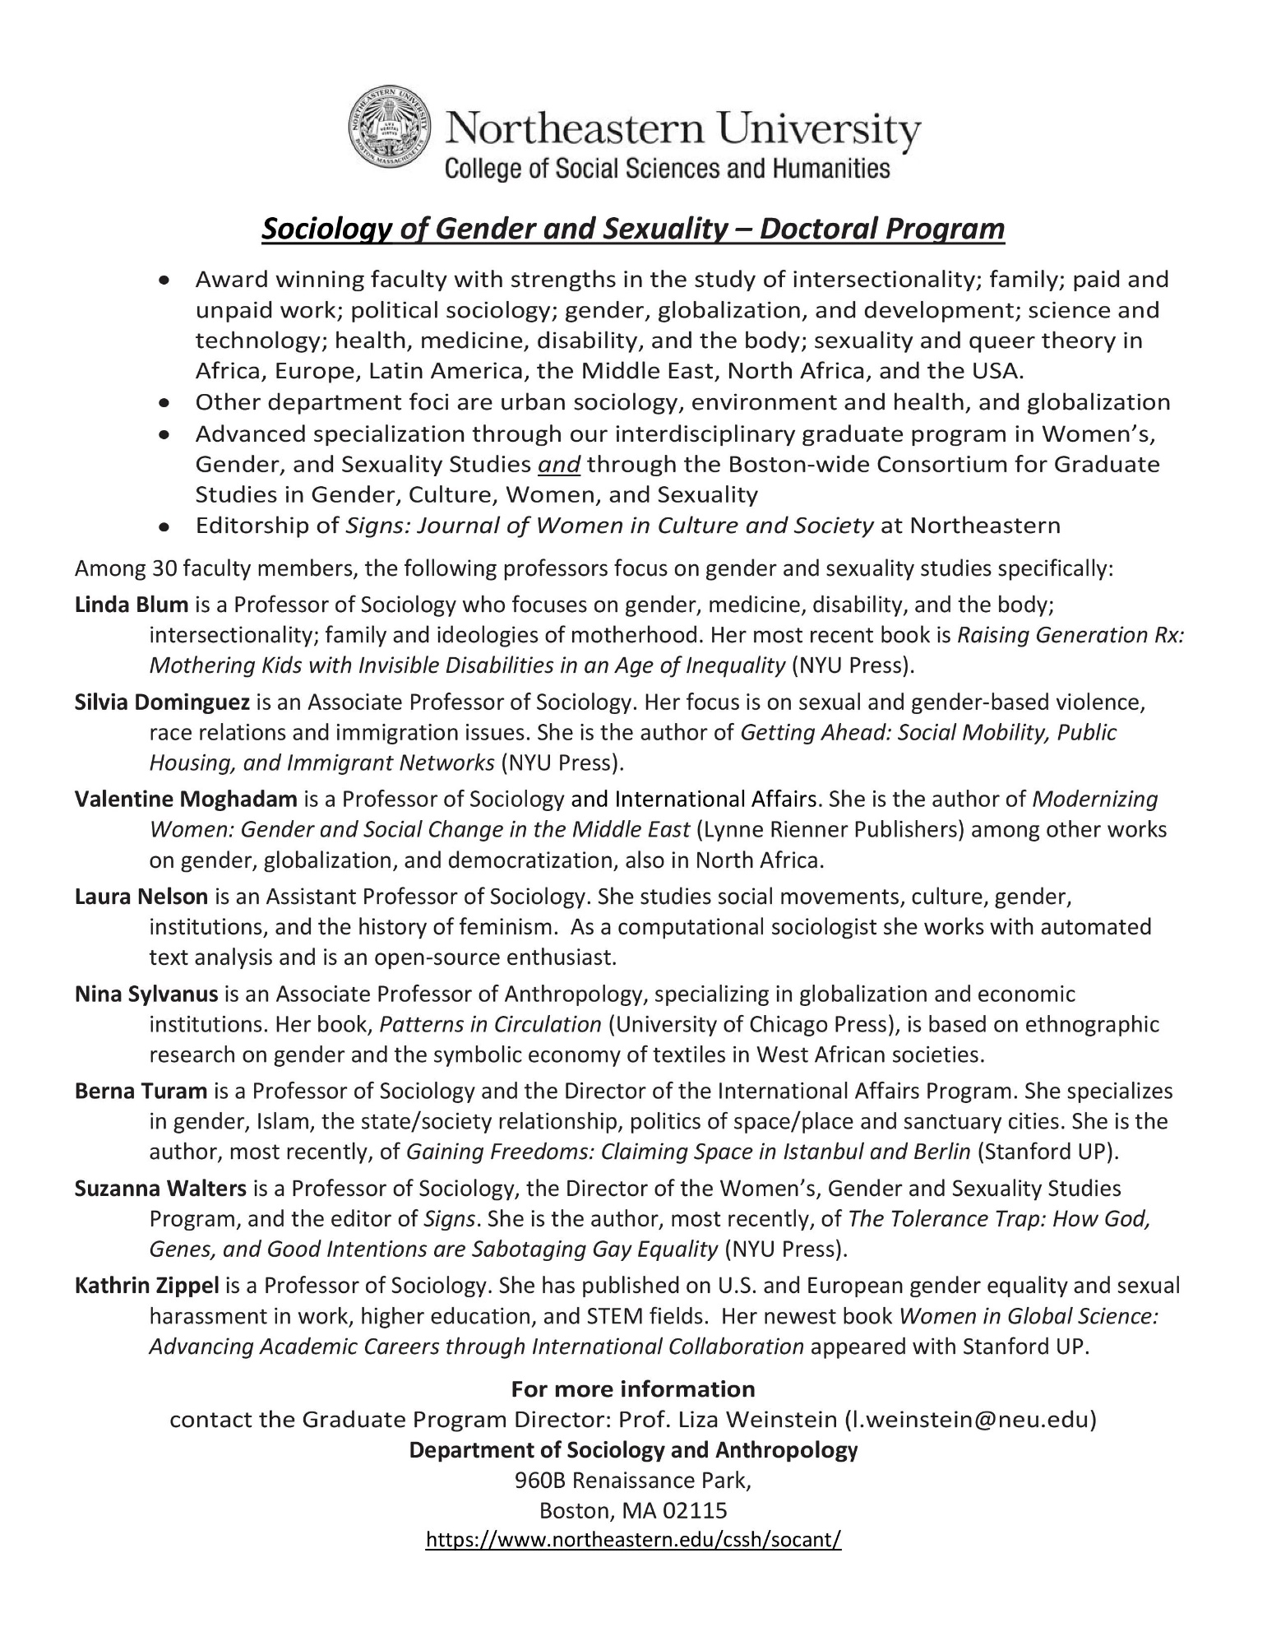
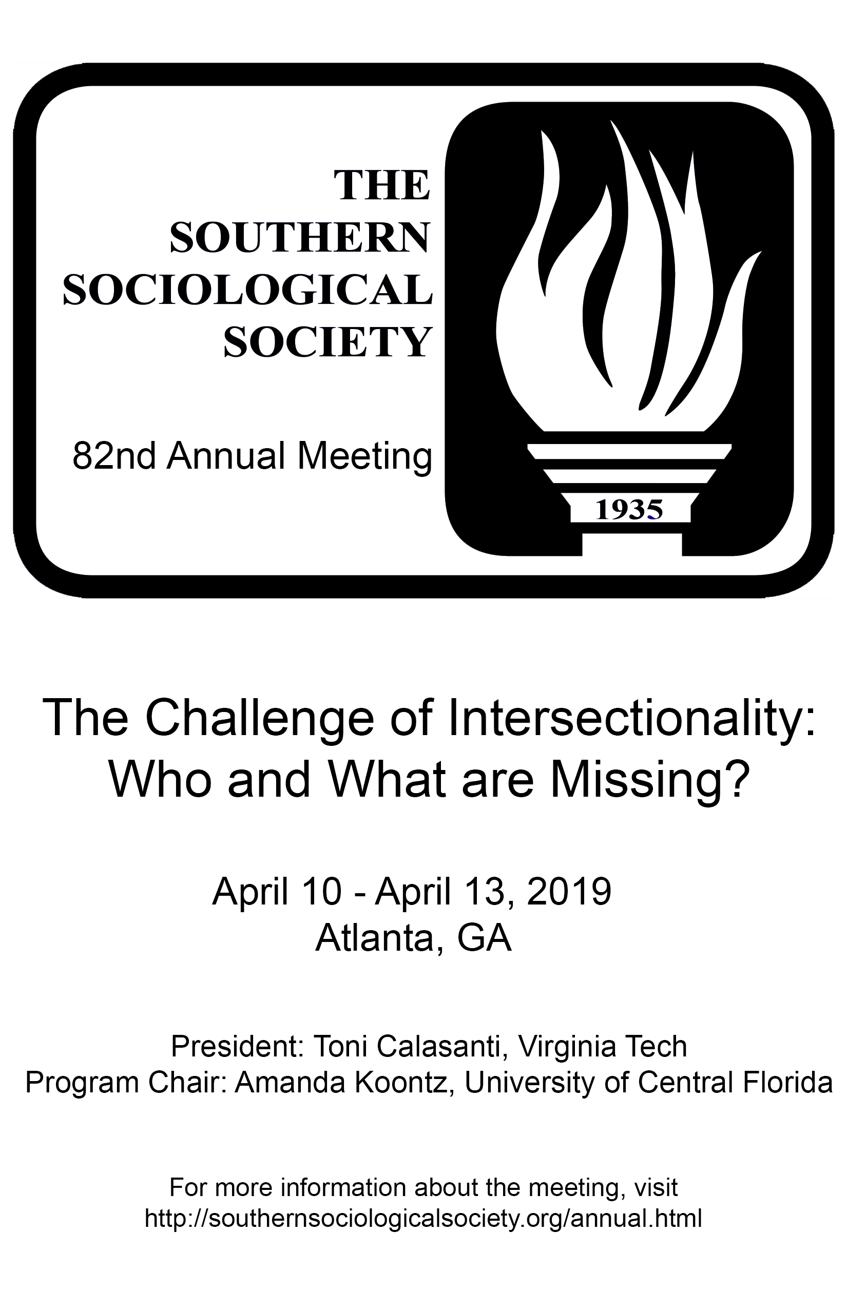
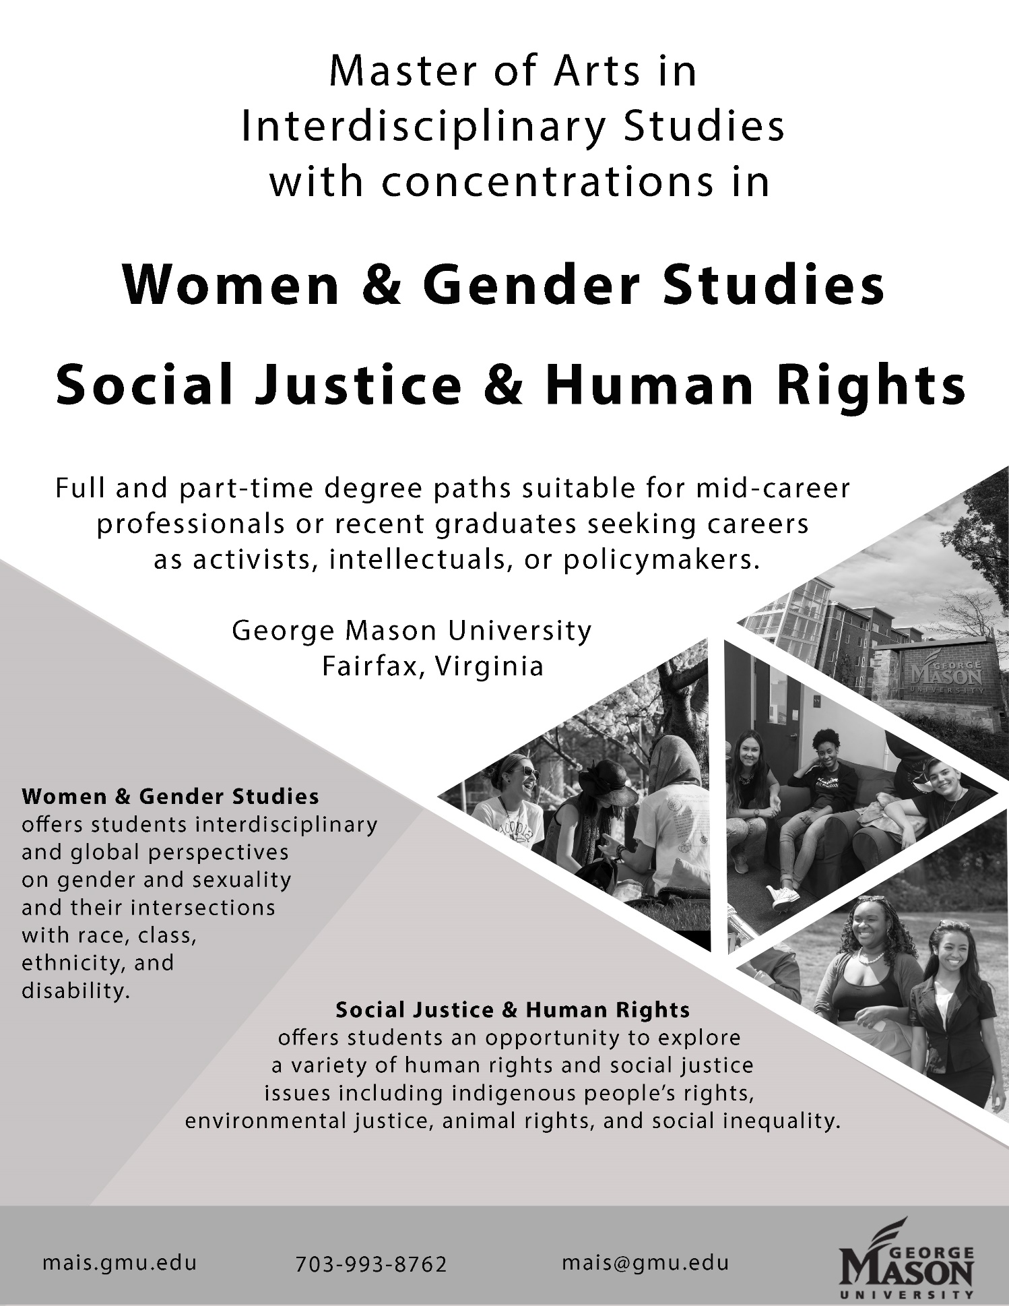
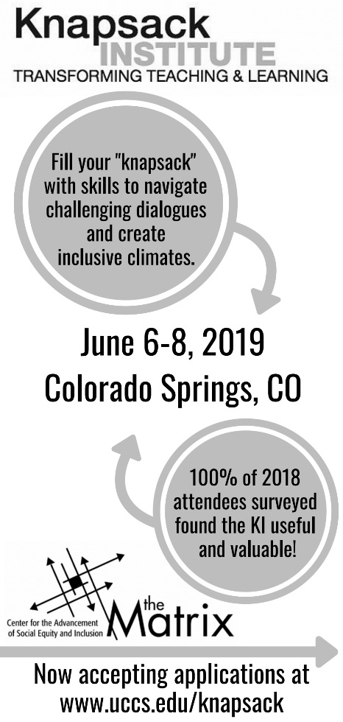

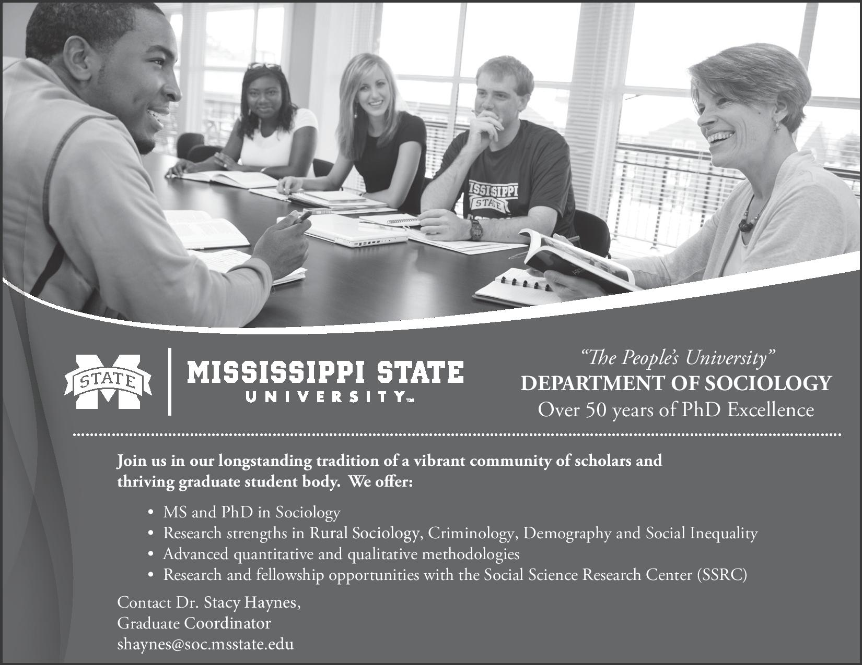

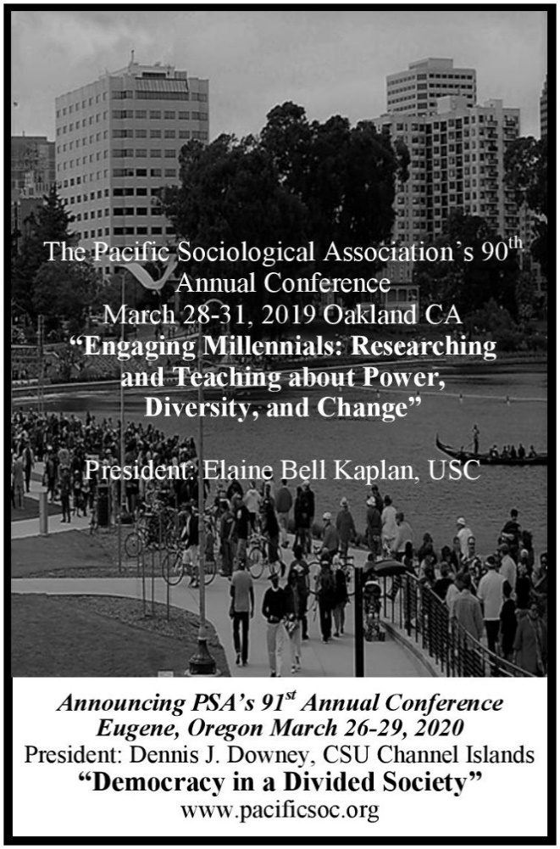
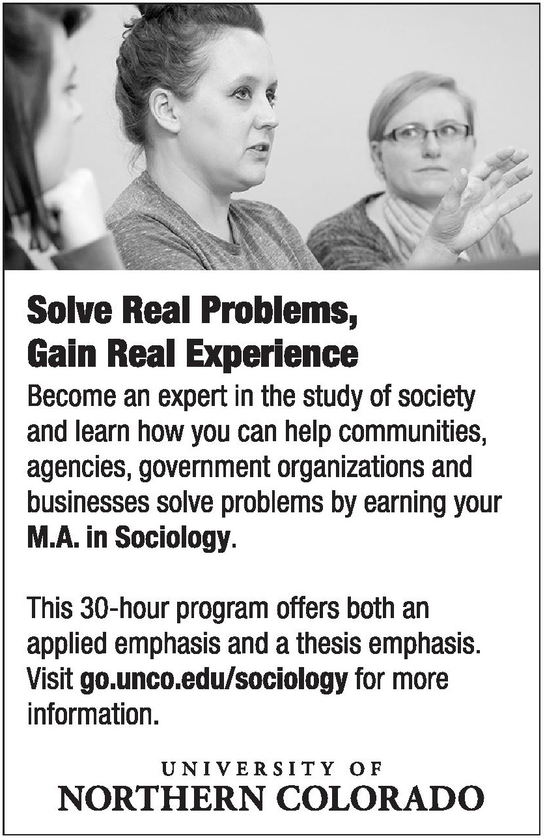

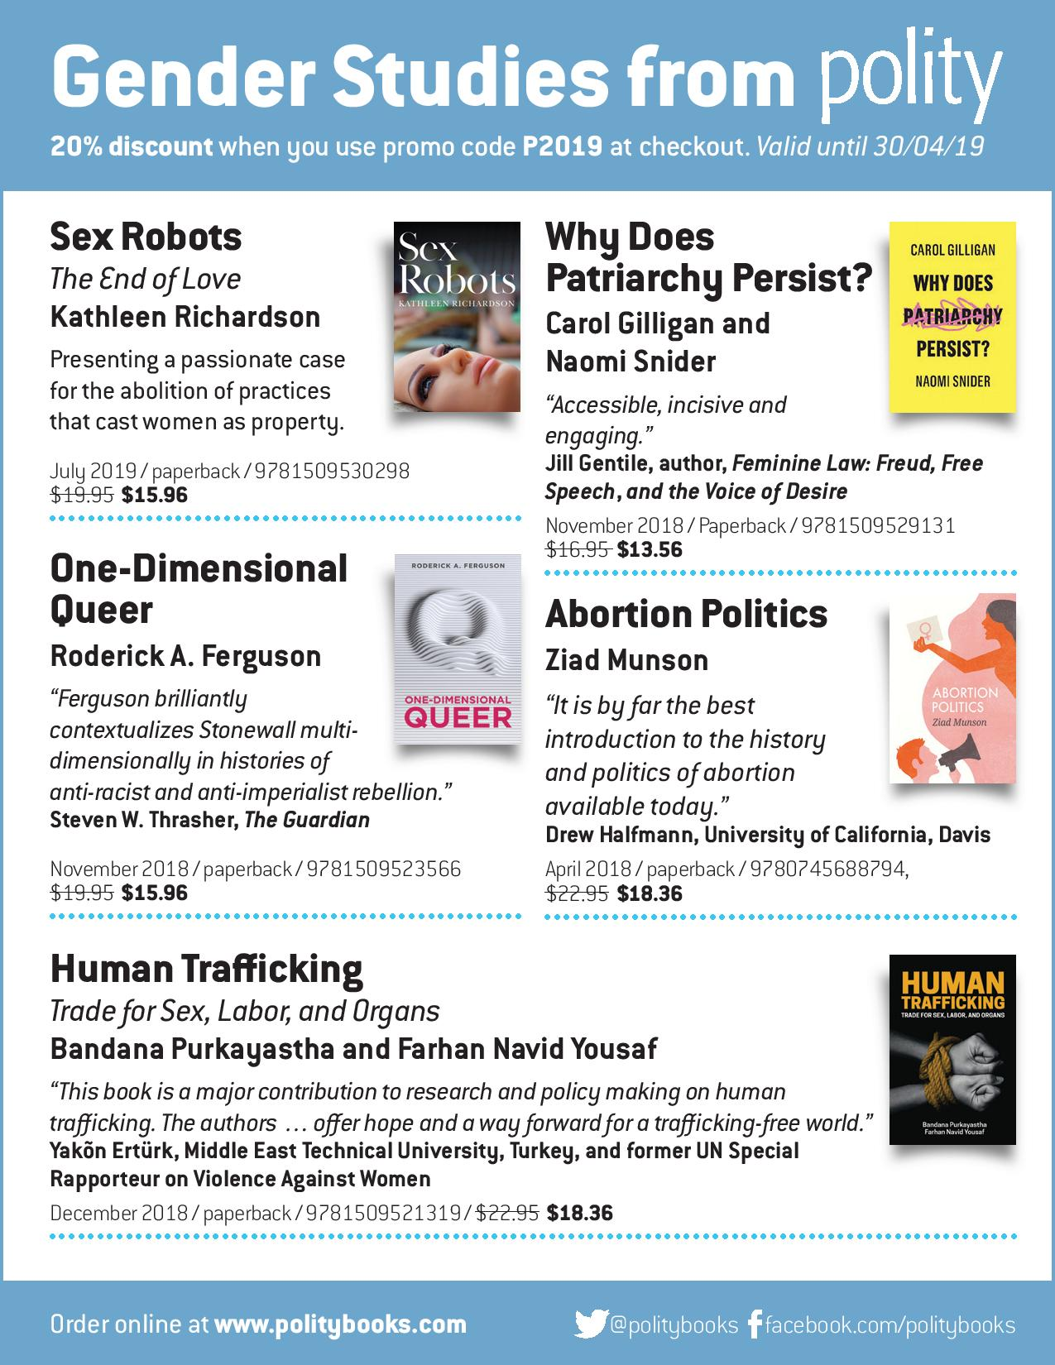

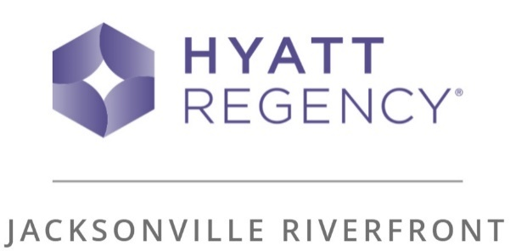
___________________________________________________________________
SWS Winter Meeting 2021 & 2025
January 28 – 31, 2021
January 30 – February 2, 2025
225 East Coastline Drive Jacksonville, Florida, United States, 32202
+1 904 588 1234
Hyatt Regency Jacksonville Riverfront

Planning for Denver Climate
(Adapted from advice given in the ASA Summer Meeting Program in 2012)
Denver Climate: The arid conditions bring only 8 to 15 inches of annual precipitation, with more than 300 days of sunshine a year. The mild weather is due in part to the city’s altitude: 5,280 feet above sea level, or exactly a mile high. Drink Water! Before your trip to Denver, and while you are here, drinking plenty of water is the number one way to help your body adjust easily to the higher altitude. The low humidity in Colorado keeps the air dry, so you need about twice as much water as you would normally drink. Monitor your alcohol intake. In Denver’s rarified air, golf balls go ten percent farther … and so do cocktails. Alcoholic drinks pack more of a wallop than at sea level. It is recommended that you go easy on the alcohol in the mountains and in Denver, as its effects will feel stronger here. Eat Foods High in Potassium. Foods such as broccoli, bananas, avocado, cantaloupe, celery, greens, bran, chocolate, granola, dates, dried fruit, potatoes, and tomatoes will help you replenish electrolytes by balancing salt intake. Watch your physical activity. The effects of exercise are more intense here. If you normally run 10 miles a day at home, you might try 6 miles in Denver. Pack for Sun. There’s 25 percent less protection from the sun, so sunscreen is a must. Dress in layers. Check the weather and pack appropriately. Because Denver is closer to the sun, it can feel much warmer than the actual temperature during the daytime, but then become very chilly after sundown. Enjoy! The air is just thinner here and drier. Follow these tips and you will likely not even notice the difference.
NOTES

NOTES

